In Timor Leste, UN Police "Refused" to Help Horta, Decline to Answer Questions
By Matthew Russell Lee
February 11, 2008
The Inner City Press
Original Source: http://www.innercitypress.com/un1timor021108.html
UNITED NATIONS, February 11 -- In the aftermath of a daring double-assassination attempt in Timor Leste, there were questions concerning the UN that no one, it seemed, wanted to answer. After President Jose Ramos Horta was shot, UN police secured the area but did not move to help or transport him, according to the Australian Broadcasting Corporation. Inner City Press raised this very report at the noon briefing at UN headquarters on Monday, and was told that the UN had not been in charge of Ramos Horta's security. Fine -- but why, once he was shot, didn't they help?
After the Security Council adopted a somewhat fill-in-the-blanks Presidential Statement, deploring the shooting and calling for calm, Inner City Press asked the statement's proponent, South African Ambassador Dumisani Kumalo, about the ABC's report. Amb. Kumalo replied that it was not helpful to be assessing blame. Video here. But will the shooting cause any changes in the security mandate of the UN Mission in Timor Leste, UNMIT? Amb. Kumalo said he didn't think so. When the shootings took place, the head of UNMIT, Atul Khare, had been in New York to briefing the Council on Thursday. He set off flying for Dili, but it "takes time" to get there, Amb. Kumalo said.
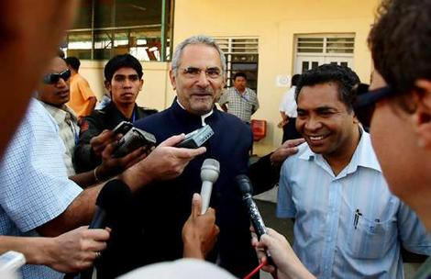
Jose Ramos Horta in happier times: UN Police not shown then or now
The injunction not to blame anyone is not followed by Ramos-Horta's brother in law Joao Carrascalao, who is also the leader of the Timorese Democratic Union and a member of the State Council. Carrascalao told ABC that "we advised the United Nations Police who went to the scene but 300 meters before reaching there, they refused to proceed and the President was lying on the road... more than half an hour bleeding and losing a lot of blood. The United Nations Police didn't take action until the Portuguese General got there. That's one of the worst things that could happen to this country; have police from everywhere, everyone within one system and mostly looking after themselves than looking after the situation here."
In a press conference Dili, in the Obrigado Barracks, Khare's fill-in Finn Feske-Nielsen was asked why "UN Pol[ice] attended the incident where the President was shot this morning, yet didn't approach him to give him medical assistance." Feske-Nielsen said "we shall obviously look into it to see." Watch this site.

