UNICEF Pays Consultants Up To $600 a Day, Its US Fund Twice That, Audits and Veneman Still Withheld
By Matthew Russell Lee
February 11, 2008
The Inner City Press
Original Source: http://www.innercitypress.com/un1unicef021108.html
UNITED NATIONS, February 11 -- UNICEF pays consultants up to $625 a day, but the National Committees which used UNICEF's name to raise money apparently pay up to $1200 a day. As UNICEF Germany is engulfed in scandal, repeated requests for UNICEF chief Ann Veneman to answer questions were met Monday with a series of terse written responses. Asked to confirm or deny KPMG's report that UNICEF Germany spent 18% of the funds it raised on administration, spokesman Christopher de Bono responded that "it is the responsibility of each National Committee, overseen by its governing board, to manage these costs." But do the costs in Germany represent 18% of the money contributed? Mr. de Bono says that further response will have to await a review conducted by a senior UNICEF fundraising official, Philip O'Brien, and that these issues were not even discussed at UNICEF's Executive Board meeting held at UN Headquarters in late January.
Inner City Press' thrice-repeated request that Ann Veneman answer questions, about UNICEF Germany, compensation, and her role in the Gucci-sponsored event on February 6 which Gucci publicly claimed "celebrated" the opening of its store on Fifth Avenue, was met Monday by the following written response by Mr. de Bono, that Ms. Veneman "participated in a briefing in Room 226 in December 2007... Decisions regarding her engagement with the media are based on the issues concerned and the many other important matters on her schedule."
So a scandal in which the Chancellor of Germany has demanded greater transparency from UNICEF, director Dietrich Garlichs has been forced to resign and funders are walking away in droves is not an "important matter"? In all of 2007, Ms. Veneman did a total of two press conferences in the UN's briefing room, both time participating in the launch of a report with two or three other briefers. Between October 12, 2006 and October 17, 2007 -- more than year -- Ms. Veneman did not appear once in the UN's briefing room. This did not allow for any questions about UNICEF's actual operations. It should be noted that even Kemal Dervis of the UN Development Program, when questions arose about his agency's operations away from headquarters, came to the Security Council stakeout to take questions from the press. Apparently that is beneath Ms. Veneman.
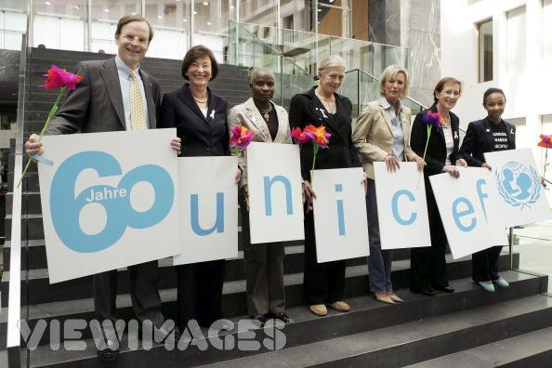
UNICEF's Dietrich Garlichs, at left, $1200 a day consultants and Ann Veneman not shown
Non-responsiveness makes a difference. Whereas UNDP has now proposed at least a mechanism by which member states could see internal audits, if not copy them, when Inner City Press asked for UNICEF's policy in this regard, he responded that UNICEF's "current policy is that we do not make these audits available. However, UNICEF is currently working with the inter-agency process on a joint policy that will allow UN entities to share this information with Member States in a consistent manner."
This is an old and recycled answer, one superseded by UNDP, one of the agencies that UNICEF claims to be working with. While UNICEF acknowledges that KPMG "identified problems in internal business processes that must be addressed," UNICEF apparently is comfortable not showing audits of these business processes even to the countries which fund UNICEF's work. While a new policy was brought up by management at UNDP's Executive Board meeting last month, at UNICEF's meeting, the issues was not raised, including by management. Asked why by Inner City Press, de Bono did not answer. Nor have questions about UNICEF's operations in Sri Lanka and the Democratic Republic of the Congo, parts of which has long been pending, being answered. The DR Congo questions involve UNICEF's seeming participation in impunity for recruiters of child soldiers, a topic to be discussed Tuesday by the Security Council. Watch this site

