UN Assembly's President Is Employed By Media Group, Refuses to Disclose Payments, Stepping To Reform
By Matthew Russell Lee
April 3, 2008
The Inner City Press
Original Source: http://www.innercitypress.com/un3pgafunding040308.html

UNITED NATIONS, April 3 -- The President of the UN General Assembly, Srgjan Kerim, is still under contract to his previous private sector employer, the WAZ media group, but the amount WAZ is paying him is called "confidential" by Kerim's spokesman. In mid-March, Inner City Press asked President Kerim about how he is paid. In response, Kerim called for a reform under which the Office of the President of the GA would be funded by the UN, since "it is the right of those who pay to ask favors." Kerim called this situation "unbearable."
In light of these statements, Inner City Press for two weeks has asked Kerim's spokesman Janos Tisovszky to with all due respect confirm or deny that Kerim is paid by WAZ, and how much. On April 3, Tisovszky wrote to Inner City Press that the government of the Former Yugoslav Republic of Macedonia "has made an arrangement with Dr. Kerim’s employer the WAZ media group allowing for the one year release of Dr. Kerim to take up his duties as the GA President. This agreement allows for maintaining his contractual status with the media group. Dr. Kerim has a five year contract with WAZ and the details of that contract are confidential."
Even while awaiting a reform, which Kerim to his credit has said he will push for, to have the position of PGA funded by the UN itself, it seems clear that outside payments to the sitting President of the GA, particularly from private corporations, should be disclosed. In this case, it is a media company. It has been argued to Inner City Press that the only conflict of interest would be if this media company got "scoops" about the UN's work. But if this secrecy is accepted, why couldn't future funders be military contractors, oil companies, or even armed non-state parties? While some have pointed about that previous GA presidents received funding from outside the UN, it appears that in previous cases this was only from the president's own government, and not from private corporations, which raise separate conflict of interest questions of first impression.
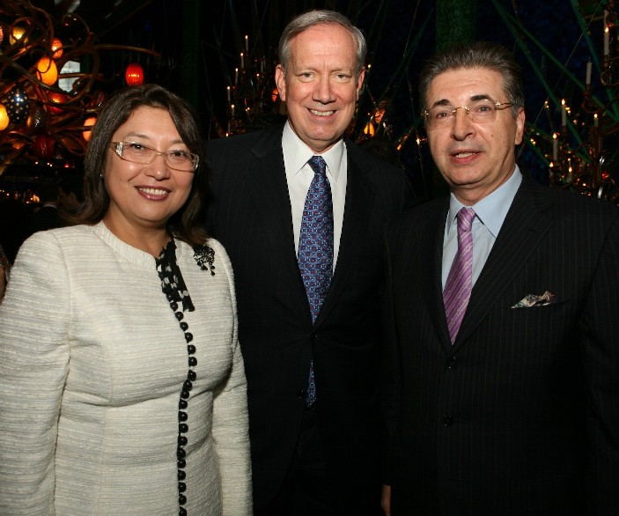
Srgan Kerim with Kazakh Ambassador and George Pataki, WAZ funding not shown
Indonesia's Ambassador Marty Natalegawa has told Inner City Press that the proposed reform, that the PGA be paid by the UN, should not be quickly adopted without thinking of the ramification for other UN committees that he say have similar outside-funded presiding officers. But do these allow for outside funding for corporations? In amounts that are not disclosed?
To Mr. Tisovszky's credit, certain other of Inner City Press' questions were answered, for example that "no staff member is paid out of the $280,000 budget as this is specified for only to cover official travel, official hospitality, miscellaneous staff expenditures (e.g. temporary assistance, compensatory time off, overtime) and other expenditures, if applicable (e.g. phone charges, newspaper subscriptions, specialized computer software, etc)." French Ambassador Jean-Marie Lacroix had said that perhaps the $280,000 provided should be better used. But divided by 19 staff, it would mean less than $15,000 each.
Tisovszky also answered how many people work in the Office of the PGA -- nineteen -- and what countries they come from: "Brazil, Estonia, Finland, France, Germany, Japan, Rwanda and Slovenia as well as from the President’s own country." This last phrasing seems an attempt to avoid having to choose between the controversial "Macedonia" and the unwieldy "FYROM."
News analysis: Since this name dispute led to a Greek veto and a FYROM walk-out from this week's NATO meeting in Bucharest, circumlocution is understandable. What is not acceptable is for the self-described highest official in the UN to be receiving payments from a private corporation and to refuse to disclose their volume.

