Check against delivery

Human Rights Council 34th Session

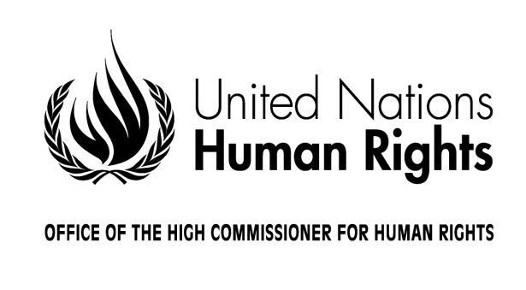

Opening Statement by
Zeid Ra'ad Al Hussein
United Nations High Commissioner for Human Rights

Geneva, 27 February 2017
Excellencies,
Distinguished Heads of State and Government,
Secretary-General
President of the General Assembly,
President of the Human Rights Council,
Distinguished Ministers, Colleagues and Friends

Just a few hundred yards from where we are today, the League of Nations was dissolved, finally and formally on 8 April 1946. Aside from some successes, it was stymied by military aggressions, the absence of the United States and the withdrawals of Germany, Italy, Japan and the USSR. Its treatment of colonialism was undermined from the outset by rejection of the principle of non-discrimination.

In reaction, the authors of the United Nations Charter placed this principle of non-discrimination in the second paragraph of the preamble.

We, the peoples of the United Nations vowed “to reaffirm faith in fundamental human rights, in the dignity and worth of the human person, in the equal rights of men and women and of nations large and small.” This commitment was made immediately after the determination “to save succeeding generations from the scourge of war” – before all other language devoted to peace and security; before all language devoted to development.

This is, I believe, an important point for us to grasp. Human rights was placed in the preamble of the UN Charter not as the last or a third pillar or as some literary flourish. It was there, it came first, human rights was viewed as the necessary starting condition, because on 26 June 1945, the day of the Charter's signing, killing on a scale hitherto unknown to humans had only just come to an end, with cities across the world pulverized and still smoking, monuments to immense human malevolence and stupidity.

The delegations understood that only by first accepting fundamental human rights could all else – durable peace, and success in development – become possible. It is a point, which even today – perhaps especially today – needs to be absorbed, by many political actors who only see human rights as tiresome constraints – or indeed, by people who have enjoyed many of their rights since birth, and simply do not realise how much they mean.

When a State accedes to a human rights treaty, enshrines those obligations in constitutional and domestic law, and implements them, then with the passage of time the average citizen – the individual holder of those rights – may take them for granted. It is like breathing air. One does not think several thousand times a day about the need to inhale oxygen – even though one's very existence depends on it happening, each time. Only when the air supply is cut off does its significance become shockingly acute.

Similarly, it is only when rights are no longer upheld, the individual concerned understands with sharp clarity just how critical they were to a meaningful, dignified existence.

For political leaders who today wage campaigns against universal human rights, or threaten withdrawal from international or regional treaties and the institutions which uphold them, it is worth recalling what the world has achieved over seven decades – and what we all stand to lose if their threats succeed in choking off universal human rights.

After the creation of the UN, ground-breaking multilateral rights-based treaties were negotiated and adopted: the fourth Geneva Convention, the Refugee Convention, and the two great international Covenants which, alongside the Universal Declaration, form the universal bill of human rights.

The two Covenants, together with other core international human rights treaties and their treaty bodies, were constructed to protect a broad range of civil, political, economic, social and cultural rights. To strengthen prohibitions against torture, enforced disappearance, racial discrimination, discrimination against women. They upheld child rights, the rights of migrant workers, and persons with disabilities.

Today they are reinforced by this Council, with its independent experts and Universal Periodic Review.

My Office, working with regional and national institutions and civil society at all levels, ties it together as one system – a singular point of reference, which we commonly refer to as the normative framework of international human rights law, for the promotion and protection of human rights for all people, everywhere.

But what has this actually meant to people around the world? How consequential will it be? After all, even before World War II notable progress had been achieved in a number of countries: ending slavery; expanding universal suffrage and worker’s rights; ending use of the death penalty, and placing limits on the cruelty of war.

And yet World War II destroyed all – almost. Because the flicker of progress could not be extinguished, and in the seven decades after the War it grew again, and its momentum was even stronger. Colonialism was ended, segregation and apartheid were removed. Pervasive dictatorial rule was rolled back, and the rights of an independent and free press re-asserted. Social protections were strengthened. Women’s rights came to the fore, and so too children’s rights, the rights of indigenous people and the LGBTi community, and many others – all of them determined to be free from discrimination and injustice.

As transportation compressed distances and travel, and people moved and mixed on a scale never seen before, it also became clear: humanity is indivisible.

Without a commitment to fundamental human rights, to the dignity and worth of the human person and to the equal rights of men and women and of nations large and small, our world will become chaos, misery and warfare.

Of all the great post-war achievements, it is this assertion of the universality of rights in human rights law that may be the most noteworthy.

Ever-growing numbers of people now know that torture is prohibited in all circumstances. That arbitrary arrest and detention, the denial of due process, repression of peaceful protests and free speech – including the role of the press – are violations of rights. They know they have a right to development, to decent food, water, health, housing, education and more.

The people know. They know the “dignity and worth of every human being.”

The unprecedented marches of 21 January this year were not, I believe, about a particular individual or government – although many saw them as such. I believe the marches were for the rights of women, the human rights of women, for all of us, for a fair and inclusive humanity. I was proud members of my staff took part. We must stand up for human rights. When humans understand fully they have rights, it is next to impossible to make them un-know it.

To those political actors who, as in the days of the League, threaten the multilateral system or intend to withdraw from parts of it, the sirens of historical experience ought to ring clear. We will not sit idly by. For we have much to lose, so much to protect. And our rights, the rights of others, the very future of our planet cannot, must not be thrown aside by these reckless political profiteers.

I ask you to uphold the rights of all, and to stand with us.

