The Media Intifada: Bad Math, Ugly Truths About New York Times In Israel-Hamas War

August 21, 2014
By Richard Behar
Forbes
http://www.forbes.com/sites/richardbehar/2014/08/21/the-media-intifada-bad-math-ugly-truths-about-new-york-times-in-israel-hamas-war/
It’s a “media intifada,” notes Gary Weiss, an old colleague and one of the world’s top business investigative reporters. He is referring of course to the ongoing war in Gaza, where journalists working for American news outlets have, he says, “become part of the Hamas war machine.”
As more than a month has passed since Israel began its Operation Protective Edge in Gaza, it’s high time to dig through the carnage that many of my colleagues from major U.S. media outlets are leaving behind—especially the New York Times.
On August 11th, the normally Israel-averse Foreign Press Association in Israel conceded what those closely following the war coverage already knew: That Hamas has been intimidating foreign reporters. In a harsh statement, it condemned the terrorist group for “the blatant, incessant, forceful and unorthodox methods employed by the Hamas authorities and their representatives against visiting international journalists in Gaza over the past month.”
This is hardly surprising, as who can expect a terrorist group to treat reporters nicely—except perhaps many reporters themselves? But what is surprising is that New York Times’ Jerusalem bureau chief Jodi Rudoren undermined her own newspaper—quickly denouncing the FPA’s statement. She said in a tweet that she wasn’t aware of any such harassed reporters, even though she concedes she spent only one week in Gaza herself during the height of the conflict. In an email to the FPA, she said that the FPA’s statement could be “dangerous” to the “credibility” of the foreign press who are covering the conflict. “Every reporter I’ve met who was in Gaza during war says this Israeli/now FPA narrative of Hamas harassment is nonsense,” she tweeted. [Boldface type hers.]
I agree that there’s a lot of nonsense being disseminated about Israel’s war with Hamas, and about the media role in the conflict. And I agree that there is a danger—if people believe that the media, including the New York Times, provides a fair picture of the war in Gaza. (I would argue it is not.)
Since late July, I’ve conducted an in-depth look at the credibility of the media coverage, plus interviews with military experts and some journalists covering the war. Among other things, I’ve discovered that the Times’ most important reporter in Gaza for the past few years has used the late Yasser Arafat as his profile photo on Facebook, and, in a second photo, praised the former Palestinian leader. This suggests that the Times may have less to worry about in terms of Hamas intimidation than others in the press corps. Indeed, this Times reporter’s parallel pieces for Qatar’s Al Jazeera since the war began can only be pleasing to the terrorists.
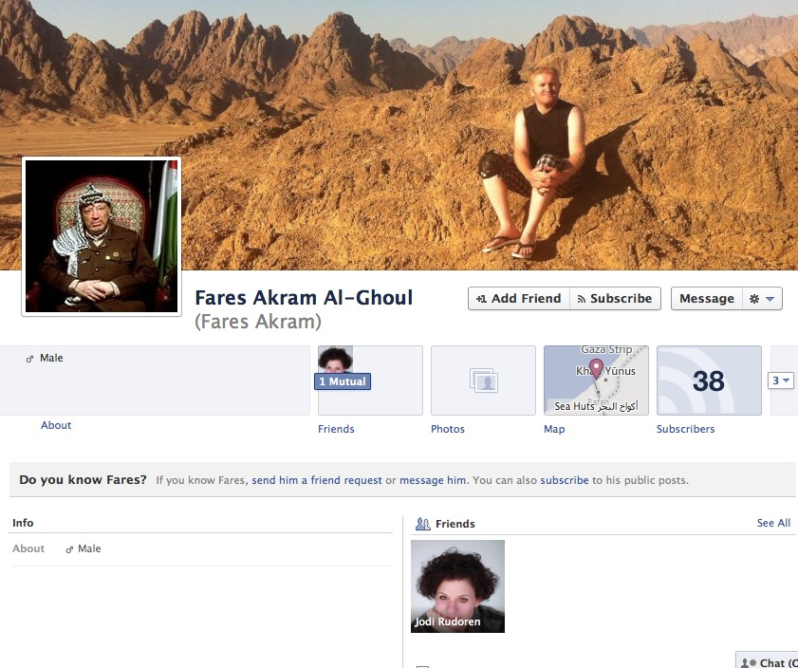
HIS MAN ARAFAT: Screenshot of a Facebook homepage of Fares Akram, the New York Times’ most important Gaza-based reporter
. My results are hardly complete, as it’s impossible to keep up with all the coverage while the fighting ensues (and rockets have again been fired at Israel today, hours before the end of a lengthy truce.) I’ll be focusing heavily on the Times, because it is, without question, the most important media outlet in the world, in terms of setting the table each day for other outlets. It is also widely regarded as the most authoritative media outlet in the world for international coverage. Since the operation (now clearly a war—albeit interspersed with ceasefires) began on July 8th, so much of the Western coverage has been predictably skewed against Israel—through those time-honored journalism tools of sloppy and lazy reporting, superficiality, nuance, omission, lack of historical knowledge, or flat-out agenda-driven lies and bias.
Journalism ethics professors and historians take note: You are bearing witness, with few exceptions, to some of the most abysmal overseas reporting since Hearst’s New York Journal in 1898 got us into the Spanish-American War and Walter Duranty of the New York Times was ignoring Stalin’s crimes in the 1930s. “We’re not just talking bad journalism,” says Weiss. “We’re talking about journalism that functions as a tool of a terrorist organization, Hamas: breathlessly pushing its narrative, whether cowed by its threats, sympathetic to its cause, or simply ignorant.”
It’s not for lack of personnel. Israel’s Government Press Office says just over 700 foreign journalists from more than 40 countries have come to Israel to cover the war (joining the 750 already there). But only a few of them are doing their jobs right—that is, moving beyond the surface imagery and the heavy-handed (and wrong) “David and Goliath” agenda being advanced by the fascistic, death-worshipping terrorist group Hamas.
I raised the topic last week with Ambassador Ido Aharoni, Consul General of Israel in New York. “As someone who is a student of the media and a former journalist,” he says, “I find it bizarre— journalistically and morally—that after a month of intense fighting between Israel and Hamas, there were hardly any images shown in Western media of Hamas terrorists holding guns or Hamas terrorists engaged in hostile activities against Israel. It’s as if there’s only one side, and this could be a result of two reasons: Either journalists are looking for the easy story, the available story, what’s in front of their eyes. Or they’re being intimidated by Hamas. And I believe that what we’ve probably had is a combination of both.”
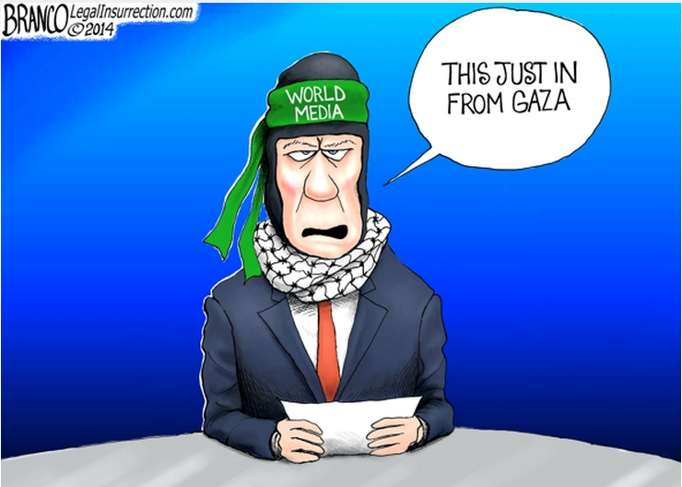
Cartoon courtesy of Legal Insurrection
. This epidemic of journalistic malpractice is contributing to the pain and loss of life that Palestinians in Gaza are suffering—as it helps to empower Hamas, which has been designated a terrorist organization by the U.S., the EU, Canada, Japan, Egypt and Jordan. (This designation is too often not-fit-to-print by the New York Times and other media outlets.) In turn, this no doubt helps spread oil on the rising and frightening anti-Semitism we’re seeing in Europe and elsewhere.
And that is no accident. Hamas’s rarely-mentioned 1988 charter is a throwback to 1930s Nazi anti-Semitism, pure and simple, with a genocidal intent that is unambiguous. Indeed, Hamas is the spiritual successor to the anti-Semitic Haj Amin al-Husseini, the Palestinian leader who famously met and worked with Adolf Hitler and his henchman Heinrich Himmler, chief of the SS and architect of the Final Solution, as he aligned the Palestinian Arab cause with the Axis during World War II.
You might say that the battle that Hamas is fighting is not a new one at all, but a continuation of Hitler’s unfinished business from World War II. If this all sounds new to you it’s no wonder—the media rarely delves beyond the surface into Hamas’s ideology and historical antecedents. But that is but one of many problems with the coverage of the Israel-Hamas conflict, and not even the worst.
(Note: If readers alert me to anything I’m mistaken about in this article, I will, unlike many of my colleagues, correct it. Again, events move too quickly during a war to follow everything, especially in a 24-7 Internet news world.)
Here is a sampling of what the Times, and the media in general, feel is not fit to print:
*** Proof of the use by Hamas of civilians as human shields has finally been ably exposed by reporters for media outlets in Finland, France, India, Italy, Japan, Russia, and others—but not by news organizations with greater resources at hand such as BBC, CNN, the New York Times, the Wall Street Journal and numerous others. (A too-brief exception: the Washington Post.) Sadly, the Associated Press has failed dismally. As for Reuters, in 2011, its new editor-in-chief, Stephen Adler, promised to bolster the newswire’s enterprise reporting. In some ways he has, but its coverage of the Israeli-Palestinian conflict continues to be weak and riddled with falsities.
*** In late 2012, during Israel’s Operation Pillar of Defense in Gaza, I examined the Facebook page of Fares Akram—the most important Gaza-based reporter for the New York Times. His profile photo was not of himself, but of PLO leader Arafat. A second photo, still in his album, waxes poetically about Arafat in the context of “heights by great men.” But Arafat, among many things as the longtime leader of the Palestinians (the 1972 Munich Olympics massacre comes to mind), opted for the Second Intifada in 2000, rather than accept a generous peace offer from Israel. Before he died, he said on TV that dead Palestinian children are good for the cause. In 2009, following an Israeli air strike that tragically killed his father and a cousin, Akram wrote that “I am finding it hard to distinguish between what the Israelis call terrorists and the Israeli pilots and tank crews who are invading Gaza.” Akram, a Palestinian resident of Gaza, has also published more than a dozen dispatches for Al Jazeera, parallel to his Times reporting, since the war began last month.
*** Abeer Ayyoub, another Palestinian resident of Gaza and former Times reporter there (until 2013), was boycotting all products made in Israel before and after her Times gig. Her Facebook posts and stories for other publications in 2014 are hostile to Israel.
DICTATOR’S TREASURE: The network’s Qatari owners are funding and sheltering Hamas leaders
. *** Now more than ever, it is incumbent on our mainstream media community to scrutinize Al Jazeera America, the TV news network that is working hard to gain a foothold in American living rooms. Many big-name U.S. journalists have been lured there—the latest, Pulitzer Prize-winning business journalist David Cay Johnston (long at the New York Times)—despite the fact that it’s owned by the dictatorship of Qatar, which funds Hamas and gives shelter today to the terror group’s top leaders. Few major reporters in the U.S. will publicly discuss this Al Jazeera America-Hamas connection. Perhaps some of them want to keep their future job prospects open, given the turmoil and cutbacks in the traditional media world—and the fat paychecks that Al Jazeera America is dispensing.
“Al Jazeera is the long hand of the regime of Qatar that abuses its endless resources in order to support and fund terror organizations all over the globe, including al-Qaeda, says Kobi Michael, who served until recently as Deputy Director General of Israel’s Ministry of Strategic Affairs (where he also ran the Palestinian desk.) “They use Al Jazeera in order to destabilize the moderate Arab regimes by encouraging and supporting political Islam.”
*** The arithmetic of civilian casualties in Gaza is one of the principal media crimes in this war. It became obvious weeks ago that major Western journalists routinely swallowed the huge civilian-casualty figures dished out to them by Gaza’s Ministry of Health, a bureaucratic arm of a terrorist group that was shown to have lied about such figures in past wars. In some cases, reporters cite numbers instead from the United Nations, which gets its numbers from—surprise—the Hamas ministry, a dubious source of information, akin to relying on the Reich Health Office for German civilian-casualty statistics during World War II. On many occasions, major American news outlets haven’t bothered to even attribute the numbers to either the ministry or the UN—simply reporting as fact that “most,” or “the majority” or the “vast majority” of casualties in Gaza are civilians.
At the very least, readers or viewers should be told by those reporters (or their editors/producers) to take the figures with some salt. Meanwhile, Israel’s best research institute on the subject, the Meir Amit Intelligence and Terrorism Information Center, is to this day all but ignored by Western media. And yet they are the only independent outfit that takes the time to match the names of the dead with known terrorists. Their results thus far (with 450 deaths analyzed) show that approximately half are civilians. Based on prior wars with Hamas, it’s highly likely that, in the final analysis, the majority of the dead will have been terrorist operatives.
When the first 72-hour ceasefire (broken by Hamas) began on August 5th, the New York Times quickly tried to play catch-up with reality by posting an “analysis” that day about the reliability of casualty figures. (It was also published on the newspaper’s front page on August 6th.) The Meir Amit center was mentioned in passing, not given the depth its numbers deserved, and by then the damage had already been long done by the newspaper, which had doggedly advanced the Hamas narrative in its news and editorial pages.
*** Crossing over to Britain, the reports and dispatches of one of that country’s top newsmen (Jon Snow, known as “the face of Channel 4 News”) is a parody of journalism, and arguably is helping to fuel the tide of Israel- and Jew-hatred that is sweeping Britain and Europe. His Twitter feed is said to be the most popular among UK news hosts.
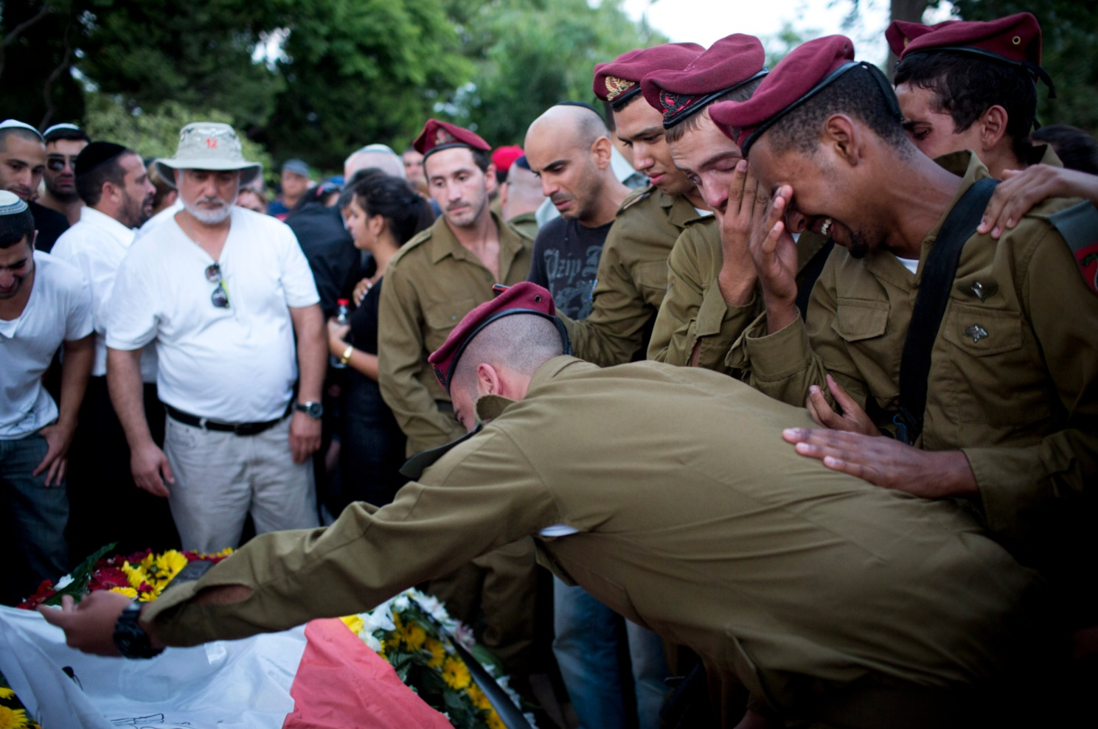
HERO’S FAREWELL: Funeral of 20-year-old Israeli soldier Bnaya Rubel, killed on July 19th by a Hamas gunman who suddenly emerged from a tunnel. With rare exceptions, Western journos are not interested in telling the stories of Israel’s fallen. (photo: Oren Ziv/ActiveStills)
. CIVILIAN SHIELDS? WHAT CIVILIAN SHIELDS?
On July 27th, I spoke at length with a reporter in Gaza who is covering the war for a major, highly respectable U.S. media outlet that has enormous resources. Regrettably, the reporter insisted on not being named, as his company wouldn’t permit it. Our talk took place just as Gaza-based reporters for smaller, non-English-speaking media outlets were beginning to reveal proof that Hamas was using civilian centers (such as schools, hospitals, dense residential neighborhoods—even the main hotel in Gaza City where reporters are staying) as rocket-launching sites.
Q: Israel received severe condemnation from many world leaders after a strike on Al-Shifa, Gaza City’s largest hospital. [Evidence is now showing that it was actually an errant Hamas missile that hit it.] Are Hamas leaders and fighters using it as a base for operations?
A: It’s not the fighters who are there, and they’re not using the hospital to launch rockets from, they’re using it to see media. These are Hamas spokesmen [at the hospital], not leaders. This is also something that has not been understood fully. There are probably a couple of reasons [for holding press conferences there]. It’s a safe place. Israel doesn’t kill spokespeople. Also, it’s a good place to get journalists, as we’re passing through the hospital, since that’s where the bodies are coming in. It’s a place journalists have to go anyway.
This has been a brilliant strategy by Hamas, although any skeptical reporter would have seen through it—and a couple did. Why are press conferences being held in a hospital, as opposed to another location such as the main hotel where they stay? Surely, hotels are also fine places for Hamas to “get journalists” to come to.
Clearly, Hamas wants the reporters to have to see the dead and injured on a regular basis if they want access to spokespeople. It safely gives lazy reporters a constant stream of tragedies to write about. A seasoned reporter would have surmised that this could be the perfect location for Hamas’s leaders to operate from, especially below the first floor. And, in fact, that is what happened.
Moreover, this was nothing new. In 2006, PBS’s Wide Angle aired a documentary showing how gunmen move through the corridors of that hospital, intimidate the staff, and deny them access to protected locations inside the facility—where the camera crew was forbidden from filming.
On the same day I spoke with this reporter, I also reached out to Eado Hecht, an independent defense analyst who has taught military theory and history at the IDF Command and General Staff College. He currently works with the Begin-Sadat Center for Strategic Studies (Israel’s leading think tank), and sits on the board of The Journal of Military Operations, whose CEO A.E. Stahl tells me, “Regarding military history, and Israeli military affairs in particular, I have yet to meet anyone as knowledgeable as Eado.”
I asked Hecht about what I call “human-shield blindness,” a rare medical condition that afflicts American reporters based in Gaza— from the New York Times to CNN and Reuters. “As to foreign journalists seeing things, I am certain they are seeing the use of supposedly innocent buildings for military purposes, but most are either too scared to report this or ideologically motivated not to,” he said. “Yesterday [Aug 1st], a Finnish reporter did talk shortly about the use of Shifa hospital to launch rockets after seeing it with her own eyes. But who watches Finnish TV except the Finns? The use of fear to influence journalists is not new—it has been happening for decades. The ideological motivation is not new either—many of the camera crews are locals.”
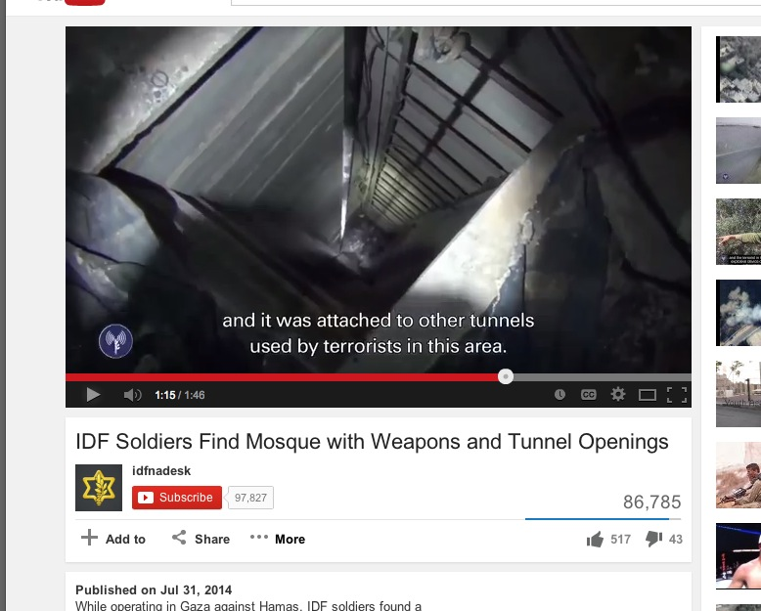

HOLY OF HOLIES! The IDF says 331 rockets have been shot from mosques in Gaza. This mosque reportedly had a 46-foot-deep tunnel shaft that connected to other tunnels. (source: IDF)
. Fortunately, it wasn’t just a Finnish reporter who earned her pay (although she later showed her own biased stripes by tweeting that she didn’t want it used a “tool of propaganda” by people “looking for excuses to Israeli actions in Gaza”). Hamas’ operations at the same hospital were the focus of a report by a French-Palestinian journalist for France’s Libération. He said that Hamas had summoned him to Al-Shifa Hospital, where he was interrogated by a group of young fighters and told to immediately leave Gaza without his papers; he later asked the newspaper to take down the story.
“No Israeli missile hit the [Al-Shifa] hospital,” says military expert Hecht. “It was a Hamas rocket, one of approximately 300 that have malfunctioned and landed inside Gaza instead of in Israel. Apparently there are also cases in which Hamas deliberately bombarded its own residential areas to blame Israel (this was not the case at Shifa)—but the only evidence is not good enough to prove it. Shifa hospital has been identified by the IDF as providing cover to a network of underground rooms and tunnels that serve it; they have simply stated that under Shifa is the most developed and senior Hamas command post and left it at that. There are certainly many Hamas security personnel around the hospital (they can be seen in the background in TV reports) and they have used the hospital as a launch site for rockets.”
To his credit, William Booth of the Washington Post wrote back on July 15th that Shifa “has become a de facto headquarters for Hamas leaders, who can be seen in the hallways and offices.” Two days later, Booth and colleagues Sudarsan Raghavan and Ruth Eglash reported that a group of men at a mosque in northern Gaza said they had returned “to clean up the green glass from windows shattered in the previous day’s bombardment.” But those men, the Post wrote, “could be seen moving small rockets into the mosque.”
Bottom-line: With the exception of the Washington Post, audiences in America might need to turn to other countries to follow the war, as well as any future wars between Israel and Hamas.
A sampling:
AUSTRALIA: On July 23rd, Peter Stefanovic of Australia’s Channel Nine News tweeted: “Hamas rockets just launched over our hotel, from a site about two hundred metres away. So a missile launch site is basically next door.”
BRITAIN: Financial Times’ Jerusalem correspondent John Reed noted that Hamas fired two rockets from a launch site “near Al-Shifa hospital, even as more bombing victims were brought in.”
CANADA: On July 20th, Patrick Martin of the Globe and Mail reported that he saw a pair of long-range rockets fired from “very near a UN school filled with more than 1,000 people seeking refuge.” He also noted that two gunmen were disguised as women; one of them had his weapon “wrapped in a baby blanket and held on his chest as if it were an infant.” Canadian Broadcasting Corp (CBC) reporter Derek Stoffel says outright what so many of his American colleagues won’t: “Hamas uses Palestinian civilians as human shields.”
FINLAND: Finnish reporter Aishi Zidan confirms that a rocket was launched from a parking lot at Al-Shifa Hospital.
FRANCE: On August 2nd, a rocket was launched close to where a correspondent for France 24, inside Al-Shifa Hospital, was broadcasting. “Rockets were just shot right next to where we are standing, so I’m not going to sit here, stand here very long, because usually there is a [IDF] strike just moments after this occurs,” correspondent Gallagher Fenwick stated. The rocket, was fired from about 160 feet away from a hotel where foreign reporters were staying. “This type of setup is at the heart of the debate,” Fenwick observed. “The Israeli army has repeatedly accused Palestinian militants of shooting from within densely-populated civilian areas and that is precisely the type of setup we have right here. Rockets set up right next to buildings with a lot of residents in them.” (Palestinian kids can be seen playing near the rocket launchers).
INDIA: A reporter for NDTV (New Delhi Television) witnessed a rocket silo under a tent just outside his room in a hotel where he and his team were staying. The reporter, Sreenivasan Jain, then filmed the rocket being fired. The hotel is located in a dense residential neighborhood, close to a UN facility. [See three screenshots below.]
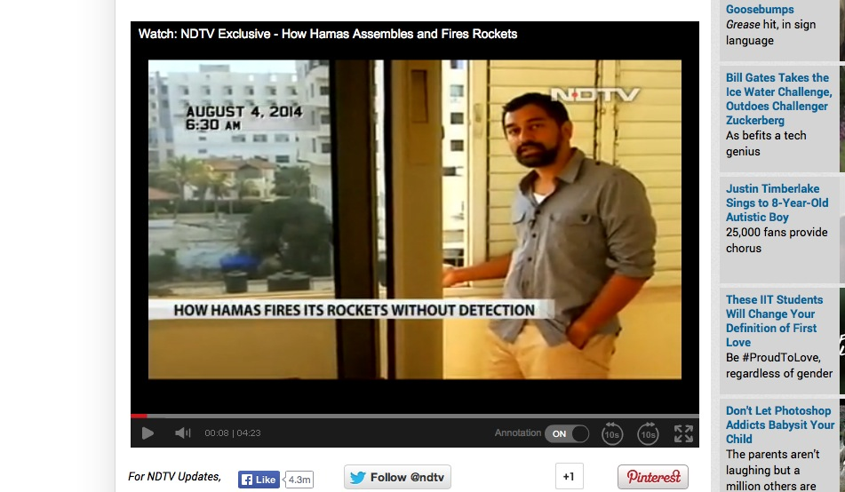
ROOM WITH A VIEW: Reporter for India’s NDTV shows viewers a blue tent outside his hotel where Hamas terrorists assembled a rocket
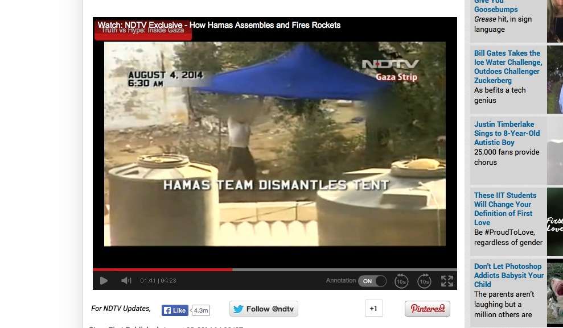
PEEK-A-BOO: A close-up by NDTV of the tent where a Hamas terrorist used shrubbery to try and hide that rocket
WHILE THE TIMES SLEPT: Reporters from NDTV captured footage of Hamas rocket fired from outside their hotel
. ITALY: On July 29th, Gabriele Barbati, an Italian reporter for Radio Popolare Milano tweeted: “Out of Gaza far from Hamas retaliation: misfired rocket killed children yday [sic] in Shati [a refugee camp]. Witness: militants rushed and cleared debris.” Nine children died. Barbati followed his tweet with another: “IDF Spokesperson said truth in communiqué released yesterday about Shati camp massacre. It was not Israel behind it.”
JAPAN: A correspondent based in Gaza for a Japanese daily wrote that Hamas “tries to use evacuating civilians and journalists by stopping them and turning them into ‘human shields’… strategy is also aimed at foreign journalists.” He recounted how some 20 journalists were blocked by Hamas from going through a checkpoint into Israel, after Hamas staffers falsely told them that the IDF had closed it. In fact, it appeared that the terrorists were plotting to have the reporters stuck there for (and right inside) a pending airstrike.
RUSSIA: RT (formerly Russia Today) correspondent Harry Fear was told to leave Gaza after he tweeted that Hamas fired rockets from near his hotel. In another tweet, Fear called the Al-Wafa rehabilitation hospital in Gaza “the hospital with human shields.”
SPAIN: A Spanish journalist named Fernando Gutiérrez, writing for Diario Melilla Hoy tweeted on August 9th that “Hamas launched a battery of rockets from the press hotel. What was their intent? To provoke Israel to kill us?”
Even Al Jazeera America comes in for some credit, but only fleetingly. On July 31st, its Jerusalem correspondent, Nick Schifrin—he joined the network in February—had to rush away from a live report when an Israeli missile struck a building about 300 feet behind him. “From that field a few days ago we saw rockets launched towards Israel,” he later told viewers. “And that’s what we’ve seen a lot over the last few weeks. These rockets are launched or embedded really within civilian neighborhoods, in residential neighborhoods, and eventually almost every single one is targeted by an Israeli air strike.”
I took a screenshot [see below] of Schifrin just as an Israeli missile was striking the building behind him. But a few days ago I went back to see if I could get a better shot, and couldn’t find the video. Apparently it had been removed by the network.
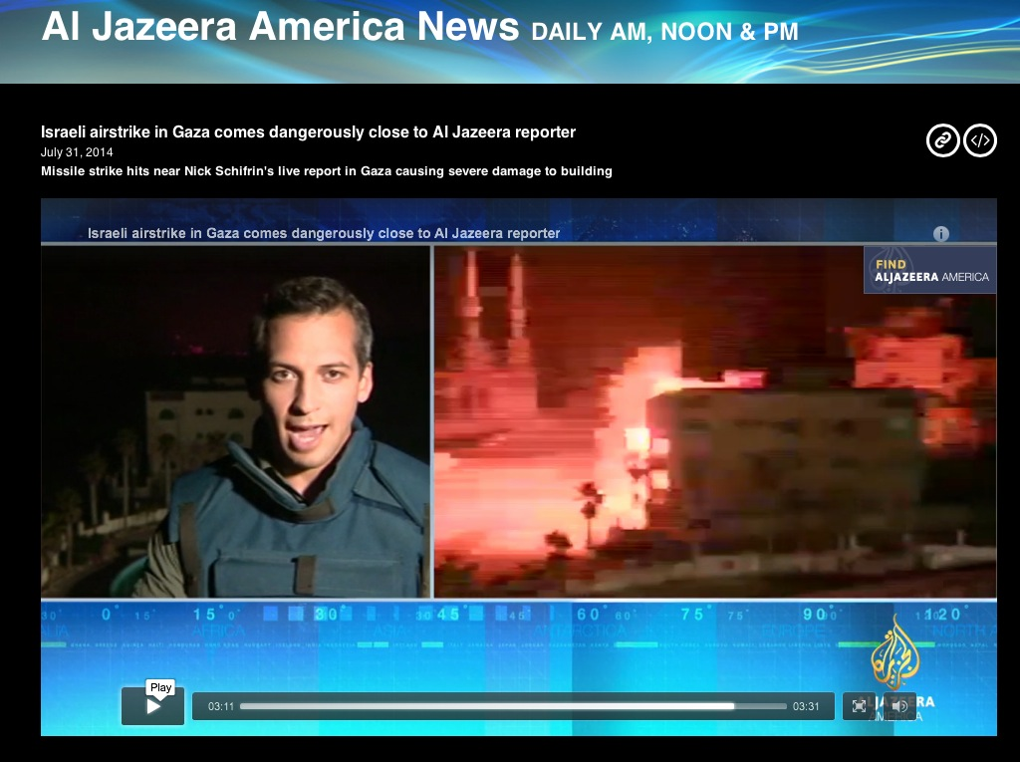
ABRACADABRA: Nick Schifrin of Al Jazeera America witnessed an Israeli air strike (right) on a building behind him. He explained to his viewers that “we’ve seen a lot” of Hamas rockets “embedded really within civilian neighborhoods, in residential neighborhoods.” But Nick’s report seems to have been embedded into the network’s trash bin.
. Some foreign reporters have been so spooked by Hamas that they don’t even have the guts to step forward and talk about it after they leave Gaza. An Israeli filmmaker named Michael Grynszpan told me last week that he was filming on a Tel Aviv street when he and a colleague “met this nice guy. He told us that he was a Spanish journalist and even showed us his press card.” The journalist told the filmmakers that he had just come back from Gaza. They asked why they don’t see TV reporting of Hamas leaders, gunmen, and rocket launches—only civilian casualties.
The Spanish newsman responded that he had, in fact, seen Hamas fighters launching rockets close to his hotel, but that if he’d dared to point his camera at them, “they would simply shoot and kill us.” (Grynszpan’s colleague, Max Wildenhaus, adds: “He said they had snipers and would shoot them.”)
When Grynszpan asked the Spanish reporter if they could film him saying that, “he freaked out” and “almost ran off.”
Fortunately, there are some prominent individuals who live in Gaza who have more courage. Take Archbishop Alexios, the Strip’s most prominent Christian among a population of about 1,500 adherents there. On August 9th, he showed Christian Broadcasting Network (CBN News) a church compound where Hamas had fired rockets from, despite the fact that he had opened the church doors to 2,000 Muslims seeking shelter from the war. “Islam is the rule of this place,” he said, “and whatever Hamas says we must obey or face consequences.”
Curiously, Reuters’ reporter Nidal Al-Mughrabi took the time to interview Archbishop Alexios two weeks earlier (on July 22nd), when the Christian leader complained to him that Israeli aircraft bombed a nearby field, causing shrapnel to land on the church and damaging graves. But Reuters hasn’t yet returned to the scene to report that the church was used as a rocket launch site—by Hamas. Nidal?
In the case of the Wall Street Journal, its correspondent based in Egypt, Tamer El-Ghobashy, tweeted a photo of rubble with the explanation: “An outside wall on the campus of Gaza’s main hospital [Al-Shifa] was hit by a strike. Low level damage suggest [sic] Hamas misfire.” Soon after, he deleted the tweet.
His Gaza-based colleague, Nicholas (Nick) Casey, also tweeted that he wondered how patients at Al-Shifa felt about their hospital being used for press conferences. He even ran a photo of a Hamas spokesman giving a briefing there. He then deleted the tweet, as well.
I reached out to Casey to see if he would discuss the matter on-record, as he and El-Ghobashy have received some criticism for deleting their tweets. A response came instead from the newspaper’s headquarters in New York. “Neither the reporters themselves nor any editors would in any way censor our journalism out of fear or favor,” wrote Journal editor in chief Gerard Baker. “We publish what we find. Our reporting from the Middle East is unsurpassed in its fair and accurate portrayal of the issues, and regular readers of our daily articles from Gaza and the Middle East know this to be true. Our many courageous reporters around the world often take considerable risks and incur significant hardship in defying efforts by authorities and other forces to bend the truth. We are beholden to no-one but our readers.”
I was intrigued that Baker used the famous ‘fear-of-favor’ line from rival Times’ founder Adolph Ochs. After all, the Journal’s coverage of the war certainly does surpass the Times’s.
Clearly, the preponderance of the evidence is that reporters have indeed been intimidated, and that there is a reason for the intimidation—Hamas has a lot to hide. The media, in other words, is part of the story. Yet this is a story that does not exist to the readers of the New York Times, which include the policymakers in Washington.
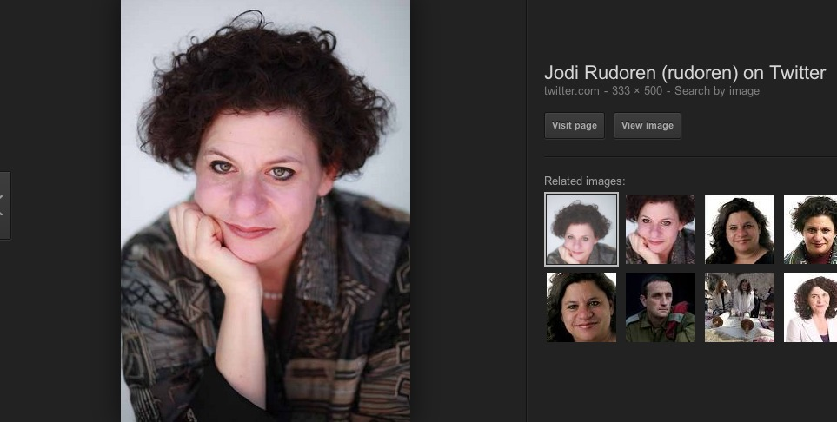
ASLEEP AT THE SWITCH: New York Times’ Jerusalem bureau chief Jodi Rudoren. If her team can’t or won’t do true enterprise reporting during this war, then why not at least cite the other reporters who have? (screenshot: Twitter)
. Earlier this week, Israel released updated figures that are startling: The IDF says 30 rockets were shot by Hamas from UN facilities, 248 rockets shot from schools, and 331 from mosques. One wonders: If the New York Times isn’t doing its own fresh reporting on such matters, why not at least follow the information and footage that the IDF releases of rockets being fired from residential areas, and then interviewing the residents there? Or why not suck it up and at least cite other media outlets for what they have found?
Finally, rockets have been discovered being stored inside three UN-run schools since the war began. “The militants, Hamas, and the other armed groups, they are firing also their weaponry, the rockets, into Israel from the vicinity of these [UN] installations and housing and so on,” John Ging, director of the U.N. Office of Humanitarian Affairs, told Canada’s CBC. “So the combat is being conducted very much in a residential built up area.”
Hamas’s position on this could not be clearer. On Al-Aqsa TV in Gaza on July 8th—the first day of the war—the terror group’s spokesperson, Sami Abu Zuhri, called on Palestinian civilians to serve as human shields. “The people oppose the Israeli fighter planes with their bodies alone… We, the [Hamas] movement, call on our people to adopt this method to protect the Palestinian homes,” he declared.
A week later, the Hamas Interior Ministry issued guidelines for who it called its “activists” on social media: “Don’t forget to always add ‘innocent civilian’ or ‘innocent citizen’ in your description of those killed in Israeli attacks on Gaza… Avoid publishing pictures of rockets fired into Israel from city centers… Do not publish or share photos or video clips showing rocket-launching sites or the movement of resistance [forces] in Gaza… Avoid entering into a political argument with a Westerner aimed at convincing him that the Holocaust is a lie and deceit.”
The Times’s Rudoren wrote about this groundbreaking news, but only one sentence from it [the “always add ‘innocent civilian” instruction], and only in a larger story about how Israelis and Palestinians are similarly using social media to further their beliefs and positions. Thus, she diluted and muddied up the significance of the ministry’s video.
I’m having trouble finding any other major media outlet in North America (aside from Canada’s Globe and Mail) that has even cited the ministry’s statement at all. And it’s been more than a month. On this, and on so much else in my article, viewers and readers must turn to the Jewish press for the information, or—no matter their political leanings—to the conservative press. It shouldn’t have to be that way.
I found similar results regarding a Hamas urban-combat manual that the IDF on August 4th reported capturing. The manual refers to civilians as helpful “pockets of resistance” that cause all kinds of problems for Israeli soldiers who Hamas acknowledges are trying to minimize civilian deaths. It also discusses the benefits for Hamas when civilian homes are destroyed.
(As the old Columbia Journalism Review would say, a “laurel” to CNN, Fox News, the New York Post and States News Service for writing about the manual. And a “dart” to the New York Times and other big mainstream outlets for ignoring it. Do they not believe it’s genuine? If that’s the case, say so. Otherwise, readers and viewers would surely find it valuable.)
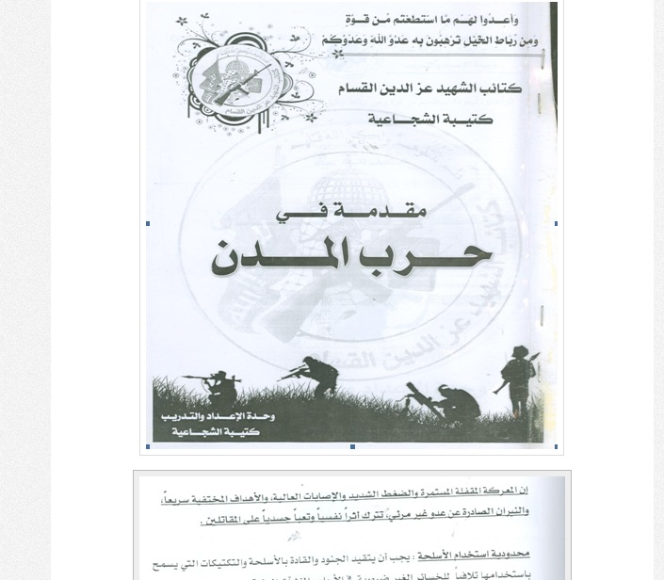
BUT IT’S IN ARABIC: The IDF announced the capture of a Hamas urban-combat manual that lays out the benefits of using civilians as human shields. For the New York Times, it’s apparently not fit to print. (source: IDF)
. Although by then I knew the answer, on August 3rd I asked Kobi Michael (the former Israeli strategic-affairs official) if he believes that Western reporters were seeing civilian centers—mosques, schools, hospitals—being used as shields, but not reporting it. “Are you kidding me?” he responded. “Do you have any doubt about it? It is a question of life or death most times, and biased journalists who don’t care about truth, motivated by hatred to Israel and sympathy to Hamas in other cases. In other cases, there are journalists who are looking for the touching story, for the title, for the excitement and—in these cases—the more the scenes are horrible and bloody the better.”
So what’s an American reader or viewer to conclude about all this? Perhaps to amp-up your satellite dish, and quickly learn a few foreign languages, if you want to closely follow this war.
Khaled Abu Toameh, a highly-regarded Arab-Israeli journalist (born in the West Bank), had this advice for foreign media five years ago in an article about turning a blind eye to Hamas atrocities: “Journalists who are afraid to report the truth should not be covering a conflict like the Israeli-Arab one. They should go back to their editors and demand that they be reassigned to cover sports or the environment. As long as such journalists continue to operate in the region, Hamas will feel safe to bomb as many mosques as it wants and to kill as many Palestinians as it wants.”
In other words, if you can’t stand the heat, get out of the desert.
Israeli defense analyst Hecht makes three valuable observations about the media coverage, worth publishing in full:
* “First, my experience is that Western media in general is more about telling interesting stories than of giving the actual facts. This is often true also of Israeli media, which is no different than that of the rest of the Western cultures. I have truly lost faith in Western ‘free’ media as a good source of information for topics on which I am not fully conversant from my own studies. In fact, often I prefer looking at the non-free media because I am then able to assess the bias and adjust accordingly.
* “Second, very few journalists who cover wars really understand any of what they are seeing and hearing. This was so clear in the famous [U.S. General Norman] Schwarzkopf interviews during the 1991 war against Iraq. One supreme example is the case in which he showed them photographs of destroyed Scud Launchers in western Iraq. Anyone with a modicum of intelligence and who had actually seen what Scud launchers looked like (i.e. bothered to look at photographs in the enormous weapons literature available on the market) could see that he was lying (they were actually civilian fuel tanker trucks destroyed by the American air force). But the journalists in the briefing all swallowed the show.

“This is just an example, I have seen and heard so many more that I stopped keeping track. These journalists may be very professional at sniffing out information and at writing interesting articles, but quite frankly totally unprofessional in anything pertaining to the wars they were covering. This is true not only on the technical military aspects. The amount of nonsense I have seen and heard on what was going on in Syria over the past 3.5 years or Iraq—what are Syria and Iraq, what makes them tick, etc., is simply astounding. And back to our little corner, the same is true of anything to do with the Arab-Israeli conflict: our geography, demography, cultures, military aspects, political aspects, etc. They throw out a few statistics, quote a few ‘good sound bites,’ tie them together nicely with a ribbon and really do not get the issues. As a friend put it sarcastically, it is the [CNN’s Christiane] ‘Amanpour Effect’: she lands in a country she has never been in and within a couple of hours is explaining to the world all the intricacies of the local situation with a fake confidence of someone who had studied the place for decades.
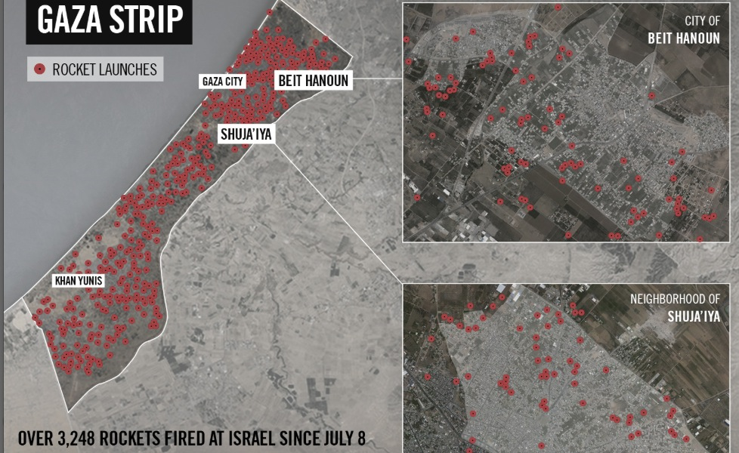
BLOOD CELLS EVERYWHERE: An IDF map of the locations of rockets launched from Gaza from July 8th to August 4th. (Still awaiting a map from Hamas, in case the terrorist group disagrees.)
- “Third, more than most other conflicts, reporting on the Israeli-Arab conflict is agenda-driven. Just today I rifled through a piece on Gaza written for a British paper that would have made Goebbels proud. All that was missing was a repeat of the allegation that Jews use the blood of Christian children for Passover bread. Of course, not all anti-Israeli writing is that extreme—there are shades of anti, but often the facts are twisted to suit the ideology rather than provided dispassionately and objectively and then analyzed. For example: an article written a couple of years ago castigating Israel for being a benevolent environment for homosexuals (Tel Aviv is one of the favorite tourist centers for European homosexuals on vacation), not because we actually do not care what a person’s sexual preferences are, but as a deliberate propaganda move—”pinkwashing”—to hide our inherently evil natures vis-à-vis the Arabs. Though obviously I am more pained by the examples that attack me and my people, this is just as true, if generally less extreme, of pro-Israeli writing. I truly believe that setting out the objective facts (as close as anything can be called objective) would change the general trend of most writing on Israel from hostile to at least understanding, if not agreeing, with us. In Israel we joke that the BBC is actually the PPC—Palestine Propaganda Corporation. That is the way we see most of Western media, though in this particular war the handling has been slightly more even (emphasis on slightly)—perhaps because of the effects of the carnage of the Arab Winter over the past four years.” .
A “VAST MAJORITY” OF CIVILIAN CASUALTIES
Let’s move to the civilian body counts in Gaza.
As I mentioned earlier, the New York Times marched quickly to get a front-page story online (on August 5th) and into print the next day—immediately following the commencement of the first 72-hour ceasefire. It’s a story they could, and should, have done weeks before.
What the Times did not do was use history as a guide when Operation Protective Edge began a month earlier—as to how to cover and interpret civilian casualty figures reported by Hamas. Indeed, in 2008, Brett Stephens of the Wall Street Journal wrote that at the height of the “so-called al-Aqsa Intifada [2002], I reviewed Israeli and Palestinian casualty figures, sticking to Palestinian sources for Palestinian numbers and Israeli sources for Israeli ones. Much was then being made in the Western media of the fact that three times as many Palestinians as Israelis had been killed in the conflict—evidence, supposedly, that despite the suicide bombings, lynchings and roadside ambushes perpetrated daily against Israelis, Palestinians were the ones who really were getting it in the neck.”
Stephens continued: “But drilling down into the data, something interesting turned up. At the time, 1,296 Palestinians had been killed by Israelis—of whom a grand total of 37, or 2.8%, were female. By contrast, of the 496 Israelis killed by Palestinians (including 138 soldiers and policemen), there were 126 female fatalities, or 25%. To be female is a fairly reliable indicator of being a noncombatant. Females are also half the population. If Israel had been guilty of indiscriminate violence against Palestinians, the ratio of male-to-female fatalities would not have been 35-1.”
Today, we can marvel at how one big news outlet after another has violated a golden rule of journalism: If your source has an ax to grind, at least tell the reader—and certainly you must cite the source in your account. Moreover, be consistent from one article to the next (i.e. don’t attribute the Gaza civilian casualty rates to a source in one story, only to not attribute it to anybody in another.) The Times is guilty of this in Gaza, as we’ll see below.
Recall my talk on July 27th with the major reporter in Gaza who declined to be named. I questioned him about the civilian body counts. “You’re right to be suspicious of any government figures in a war where the government is also taking part in the fighting,” he concedes, “and certainly because Gaza doesn’t have many other tools to defend itself in public opinion, their trying to inflate the public opinion around the death toll would make sense.”
But then he adds this caveat: “The reason why we’re using the [Hamas] government figures is because they’re tracking pretty well with the UN figures too.”
I asked whether the UN is simply relying on the Hamas government figures for its own. “I think the UN is relying on the Gaza ministry for the names,” he explains. “I’m not sure how much independent verification they are doing.”
He continued: “Actually, the Gaza ministry hasn’t broken out civilian numbers, what they often do at the end of the day is to say X number were children, X number were women, and X number were elderly men. And of the remainder, X number are fighters and X are not. But there’s not gonna be any way to tell from that number who’s who. Elderly men could also be fighters, some of the women could potentially be fighters, although that’s very unlikely with Hamas.”
The biggest problem with this reporter’s explanation is that it was being provided to me off-record, and not to his media outlet’s audience.
Moreover, some, if not many, of the kids could also be fighters. Earlier this year, a handful of media outlets exposed Hamas military-training summer camps for kids aged 6-16 in Gaza. Did the Western press corps in Israel pay any heed? (Reuters and NBC News, to their credit, did a slideshow and photo blog, respectively. The New York Times didn’t even touch it, although its reporter Akram lives in Gaza and surely must know about the camps.)
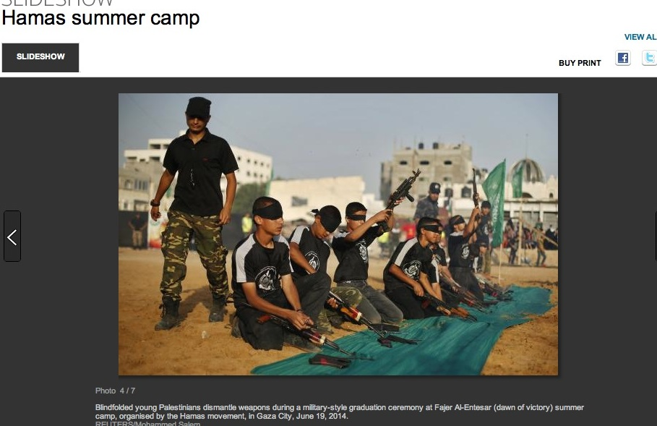
READY TO ROAST MARSHMALLOWS, KIDS?: A Gaza summer camp. Were any of these children among the “civilian casualties” that Hamas is claiming? (screenshot: from a Reuters slideshow in June)
“Nobody has accurate casualty figures except the Gaza hospitals that receive the wounded and dead,” points out Israeli military expert Hecht. “They are also the only ones who know whether the injury was indeed incurred by military action or by an ordinary every day accident—these do not stop because there is a war on. The UN has no ability or incentive to check the real figures. The IDF simply claims that the number given by the Palestinians includes the combatants and tries to count them with intelligence information (getting the names and comparing them to the lists it has compiled of Hamas members and so on). A true and accurate accounting will take a long time to acquire all the information, so it is always behind in the media race.”
I asked Hecht for his best estimate of civilian casualties. “According to the numbers given so far, the IDF thinks that about half the total number declared by the Palestinians as killed are actually combatants,” he says. [That figure also jibes with what the Amit Meir center is finding; more on that later.] After Cast Lead [2008-9], nearly two years passed before a Palestinian minister inadvertently let slip that the IDF figures then were correct.”
Hecht adds that, for all its attempts to prevent civilian casualties, “the IDF does not claim total success; only that relative to what other armies do in similar circumstances it is making a greater effort than anyone else. From the testimony I have heard and read from other wars I can say that it is true. War is a confusing mess and mistakes will invariably be made.”
True enough. In fact, a groundbreaking study ignored by my colleagues came out in June, a month before the Israel-Hamas war started. A prominent group of American public health experts found that civilian casualties constituted 85% to 90% of the 248 armed conflicts in the world since the end of World War II. While even one civilian casualty in Gaza is a tragedy, if Israel comes in at 40-50% (or even 60%), given the complexities and civilian-shielding in Gaza, what they’ve accomplished will be a model for future warfare.
The last time the U.S. fought a Gaza-like battle was in Fallujah, Iraq, in 2004. Some 800 civilians were killed and at least 9,000 homes destroyed. On August 8th, the U.S. began air strikes on ISIS (while the rest of the Arab and Western world sits and yawns), and it remains to be seen what the percentage of civilian casualties there will be.
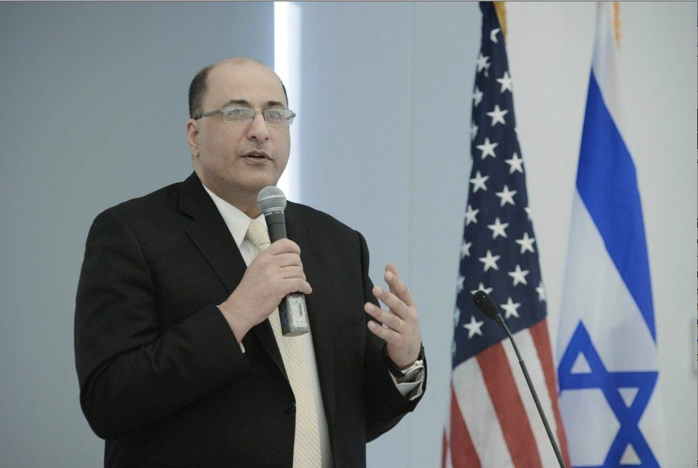
GETTING REAL: “If the only criteria for the Western media to measure the moral validity of any military campaign is the number of civilian casualties, then Germany was clearly the victim in WWII—hands down,” says Ambassador Ido Aharoni, Israel’s Consul General in New York.
.
It’s also easy to forget that in WWII, over one million German civilians died at Allied hands, compared with only 67,000 British and 12,000 Americans civilians. “If the only criteria for the Western media to measure the moral validity of any military campaign is the number of civilian casualties, then Germany was clearly the victim in WWII—hands down,” points out Ambassador Aharoni.
“This is not to say that we don’t have to work hard to minimize civilian casualties,” he adds. “But it cannot be the only way you measure the morality of a military campaign. There are other considerations. For example, the fact that a democratically-elected Hamas won the largest share of votes [in 2006] among 1.8 million Palestinians, they are directly and indirectly responsible for their situation—just as the German people voted for Hitler and were responsible for their situation…The first two years after Israel pulled out in 2005, Gaza was ruled by Abu Mazen [Palestinian Authority President Mahmud Abbas). So, willingly the people of Gaza voted for Hamas and preferred Hamas over Abbas. It was their choice.”
In 2009, retired British officer, Colonel Richard Kemp, who served in Afghanistan and was involved with planning operations in Iraq, testified before the UN on Operation Cast Lead, the IDF's operation in Gaza from 2008-9: "…the Israel Defence Forces did more to safeguard the rights of civilians in the combat zones than any army in the history of warfare." Contrary to media inflation, there is nothing to indicate that the IDF’s conduct this time around has been anything different. More recently, Kemp told Newsweek, “There is an automatic assumption that what the IDF are doing here is brutal, is wrong, is illegal and is different from what we would do in the British or American forces, but the reality is that the IDF are fighting a very similar enemy to the one that we fought in Afghanistan and Iraq and they use very similar tactics.”
A reason the Israelis are prepared to continue attacking even when they know there’s going to be a high civilian death toll, says Kemp, "is that they know this [Hamas] is going to be a direct, immediate and lethal threat to their people… The Israelis are explaining it but many people don’t want to hear it. And no explanation counts for anything if you show me a photograph of a dead baby on a mortuary slab or four dead boys lying on the beach.”
[By the way, other than in Newsweek, you won’t find Kemp’s defense of Israel mentioned in any major Western media outlet.]
Perhaps anti-Israel crusaders this month would be happier about the whole situation if more Israeli civilians were dying-by-rocket. Sarah Tuttle-Singer, the new-media editor at the Times of Israel puts it perfectly: ”Do we need to line up somewhere and let Hamas have a free shot at us for you to understand that we are dealing with a terrorist organization hell-bent on destroying us even at the expense of their people?,” writes Tuttle-Singer, who tells me that she and her two young children are traumatized by all the rockets, sirens and hours spent in bomb shelters. “ How many of us have to die for people to understand the extent of Hamas’s evil? Will six million do it for you?”
One of Israel’s most famous novelists, Amos Oz, has long been a hero among the country’s left wing. But he recently turned the tables on a reporter from Deutsche Welle (a German broadcaster) to point out the moral dilemma that Israelis currently face.
Oz: “I would like to begin the interview in a very unusual way: by presenting one or two questions to your readers and listeners. May I do that?”
Deutsche Welle: “Go ahead!”
Oz: Question 1. What would you do if your neighbor across the street sits down on the balcony, puts his little boy on his lap and starts shooting machine gun fire into your nursery? Question 2. What would you do if your neighbor across the street digs a tunnel from his nursery to your nursery in order to blow up your home or in order to kidnap your family? With these two questions I pass the interview to you.”
Later in the interview, Oz said: “I have been a man of compromise all my life…But even a man of compromise cannot approach Hamas and say: ‘Maybe we meet halfway and Israel only exists on Mondays, Wednesdays and Fridays.’”
A month after the 9-11 terror attacks, which killed more than 3,000 civilians, I went on a ten-week assignment for Fortune magazine to Pakistan, to try and follow terrorism’s money trail. I also struck a joint venture with CNN, owned by the same media parent (Time Warner). I worked at times out of CNN’s makeshift bureau in a hotel in Islamabad, where I witnessed how much obsessive coverage was being planned and done of civilians killed as a result of the U.S bombing of Afghanistan. It was so over-the-top that CNN’s then-chairman Walter Isaacson approved a memo to all staff saying that CNN should show civilian casualties, but should put them in context and not focus disproportionately on them. (The memo also stated that correspondents must talk about how the Taliban are using civilian shields.)
The CNN correspondents in Islamabad were furious.
Getting back to the UN reliance on Hamas civilian casualty figures, I brought up the problem with Kobi Michael, the ex-Israeli national security official I’ve cited previously. (Michael today is a senior research fellow at the Institute of National Security Studies, an Israeli think tank.) “UNRWA [United Nations Relief and Works Agency] has very limited capabilities and it can only have figures of its own from its clinics and shelters, all other figures are provided by Hamas,” he says, adding: “There are at least two or three cases where Israel was accused of shelling UNRWA schools and a market where there is evidence for a possibility that it was Hamas failure [in the] shelling.”
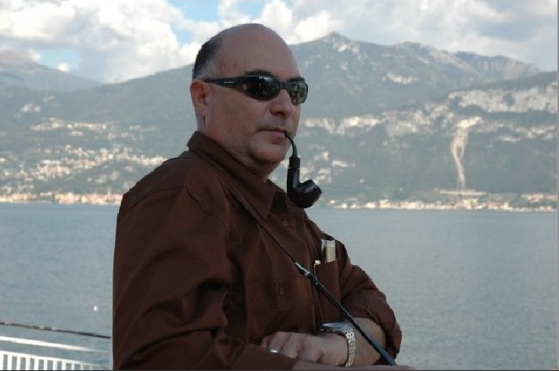
HARD MATH: Based in part on numbers-fudging by Hamas in past wars, ex-Israeli national security official Kobi Michael (pictured above) predicts that—in the final analysis— “at least 60% of Palestinian casualties are not innocent citizens.”
. He continues: “As we knew in previous operations, Hamas lies and minimize its casualties in order to score points in the international domain as well as in the domestic one—and to create the victory-and-achievement image. As it was found after Cast Lead when Hamas declared about 49 casualties while Israel mentioned 709, after a year or so Hamas admitted that it lost between 600-700 of its fighters.”
His prediction today? “Israel will be very cautious and will check it carefully based on intelligence, but eventually the numbers will be very similar and maybe even higher—which means that at least 60% of Palestinian casualties are not innocent citizens. I can ensure you that the IDF prepares itself for the coming days (the investigation) with very well-documented evidence and the reason it doesn’t publish all materials is in order to prevent Hamas from preparing its alibi. Hamas will be surprised from the quality and the quantity of the documentation. Don’t forget that there are dozens of Hamas prisoners captured during the operation and they provide a lot of materials.”
So with all of this in mind, how has American major media been handling the civilian casualty counts? See for yourself. Following is just a tiny snapshot. Worst: Reuters. Best: Nobody. [Boldface added, and my comments are in brackets.] .
REUTERS [note the lack, or vagueness, of attribution]:
July 22th (reporters Nidal al-Mughrabi and Dan Williams): “…in the Palestinian enclave where officials said 624 people, mostly civilians, have been killed in 15 days of fighting.”
July 26th (Noah Browning): “… almost three weeks of conflict that has killed almost a thousand Palestinians, most of them civilians.”
July 27th (Michelle Nichols): “Some 1,031 Palestinians, mainly civilians and many of them children, have been killed in the 20-day conflict.”
July 28th (Steve Holland): “…the death toll from Israeli-Palestinian violence in Gaza has climbed past 1,000, most of them civilians in Gaza.”
July 28th (Al-Mughrabi and Cripsian Balmer): “Some 1,060 Gazans, most of them civilians, have died in the conflagration…”
August 13th (Al-Mughrabi and Lin Noueihed): “Most of the Palestinian dead have been civilians, hospital officials in the small, densely populated enclave say.” .
NEW YORK TIMES [note how often there is no attribution]:
July 14th (Anne Barnard): “At least 180 Palestinians, most of them civilians, have been killed since last week by Israeli airstrikes in Gaza.”
July 17th (Jodi Rudoren): “Still, Israel says it is the rocket fire that has prompted a military bombing campaign that has killed more than 235 Gazans, most of them civilians.”
July 26th (Isabel Kershner and Michael R. Gordon): “ International alarm has been growing over the war that has claimed the lives of more than 800 Palestinians, most of them civilians, as well as 35 Israeli soldiers…”
July 27th (Kershner): “More than 1,000 Palestinians have been killed in Gaza, most of them civilians, according to the health ministry in Gaza and monitoring groups.”
August 11th (Kershner and Merna Thomas): “Palestinian militants and the Israeli military exchanged blows through Sunday, but on a much smaller scale than the fierce fighting of the past month, which claimed more than 1,900 Palestinian lives—a majority of them probably civilians.” [Note how the reporters now use the word “probably,” as they are starting to hedge in case they've been wrong in prior accounts. But it's negated four days later by the story below.]
August 15th (Christopher F. Schuetze and Barnard): “…the moral debate over Israel’s military air and ground assault in the Gaza Strip, in which about 2,000 people, a majority of them civilians, have been killed.”
August 20th (Rudoren and Fares Akram): “…most of the more than 2,000 Palestinians killed have been civilians, according to rights groups.”
[Summing up, despite finally publishing a story on August 5th citing skepticism that exists about the civilian casualty figures, the Times now seems unable to make up its mind. Readers were told (on August 11th) that "probably" a majority of the deaths are civilians, and next were told that "a majority" were definitely civilians (with no attribution; August 15th). Just yesterday, the preferred language is that "most" of the dead are civilians, according to "rights groups," whatever that means. What will tomorrow bring?]
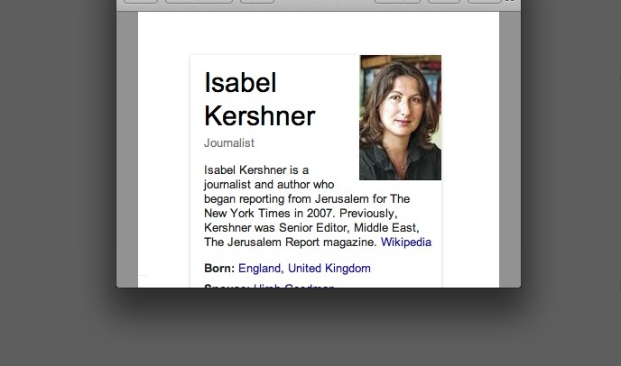
TAKE YOUR PICK: Isabel Kershner, a Jerusalem-based reporter for the New York Times, can’t seem to decide how to report Palestinian civilian casualty figures. Is it “most of them civilians” or “a majority of them probably civilians”? Meanwhile, colleague Anne Barnard is so certain it’s a “majority” that she doesn’t even see the need to cite attribution. (screenshot)
AL JAZEERA AMERICA:
July 29th: “Since the military offensive began on July 8, more than 1,216 Palestinians—most of them civilians—have died.”
Al JAZEERA ENGLISH:
July 29th: “At least 1,110 Palestinians, most of them civilians, have died in the ongoing Israeli offensive.” .
CNN:
July 13th (CNN’s Diana Magnay to CNN’s Wolf Blitzer): “…The death toll rising, 166 and more than 1,000 people injured—the majority of them civilians…”
[Magnay was subsequently transferred by CNN to Russia after a tweet referring to a group of Israelis in Sderot—where rockets have caused more damage than anywhere in Israel—as “scum.” She claims they made a threat to her. Even if true, a seasoned, professional journalist would never respond publically with such a slur. Such slurs are to be left for drinks with colleagues afterwards. If Magnay is tempted to repeat her bad judgment in the future, the word for scum in Russian is pronounced mraz]
July 25th (Chelsea J. Carter, Salma Abdelaziz and Karl Penhaul): “More than two weeks of violence that has claimed more than 800 lives, most of them civilians.”
July 26th (Elise Labott): “Israel and Hamas agreed to a 12-hour cease-fire starting Saturday morning, temporarily halting more than two weeks of bloodshed that has claimed more than 900 mostly civilian lives.”
July 27th (CNN’s Candy Crowley interviewing Palestinian official Mohammad Shtayyeh): MS: “Eighty percent of those who have been killed in Gaza are civilians, women, children, old men; 1,080 Palestinians have been killed in the last 18 days. Eighty percent of them are innocent people.” CC: “Mr. Shtayyeh – right.” [Why Crowley let's his claim slide is anyone's guess.]
July 28th (Hala Gorani): “Over 1,000 people are dead in the latest round. The vast majority Palestinian civilians. So will the humanitarian situation ever get so bad that world leaders have to step in rather than just urge the Israelis and Palestinians to cooperate with strongly worded statements?”
July 28th (CNN’s Carol Costello interviewing former Israeli ambassador Michael B. Oren): “So, I hear you. You want Israel to crush Hamas, now is the time still and we have to mention the civilians, more than 1,000 people have died. Most of them civilians. Is that worth the cost then?”
August 3rd (CNN’s Crowley interviewing Texas governor Rick Perry): “Governor, you have long been a staunch supporter of Israel. But I wonder, if you will, when you look at the pictures that we’re seeing, and we know that Netanyahu has expressed his regret for the civilian deaths, but when you look at the 1,700-plus Palestinian deaths in Gaza, the large majority of which are civilians, we are told, what is your thought about that? What is your reaction to that?”
August 4th (Anderson Cooper 260): “The conflict is entering into its fourth week and already more than 1800 Palestinians have died in Gaza, mostly civilians, according to local health officials.”
August 7th (John Vause in Gaza, Reza Sayah in Cairo, Michael Pearson in Atlanta. Jethro Mullen, Claudia Rebaza, Samira Said and Karl Penhaul also contributed to this report. Total: Seven reporters.) “It’s unclear how many of the Palestinian dead were militants. The United Nations has estimated that at least 70% of the dead were civilians.” .
ASSOCIATED PRESS:
July 24th (Tia Goldenberg): “More than 30 have died, along with three civilians on the Israeli side and more than 700 Palestinians, most of them civilians.”
July 25th (Khalil Hamra): “The United Nations says civilians make up three-fourths of the dead…”
July 28th (Edith Lederer): “The war, now in its 21st day, has killed more than 1,030 Palestinians, mainly civilians, according to the Palestinian health ministry.”
August 4th: “The war has taken nearly 1,900 Palestinian lives, most of them civilians caught in fighting inside Gaza’s crowded urban landscape, according to Hamas medical officials”
August 13th (Mohammed Daraghmeh and Goldenberg): “The fighting has so far killed more than 1,900 Palestinians, the majority of them civilians, Palestinian and U.N. officials say.”
August 14th (Hamza Hendawi): “More than 1,900 Palestinians have been killed, mostly civilians…”
August 17th (Daraghmeh): “Nearly 2,000 Palestinians have been killed—mostly civilians—and more than 10,000 people have been wounded since the war began July 8, according to United Nations figures.”
August 18th (Karin Laub): “Israel has fired thousands of tank and artillery shells toward what it said were targets linked to militants during the war, though a majority of those killed were civilians, according to Gaza health officials.”
WALL STREET JOURNAL:
July 23rd (Nick Casey and Asa Fitch): “Palestinian health officials say nearly 700 Palestinians have been killed in the last 16 days, most of them civilians including 166 children and 67 women.”
July 28th (Josh Mitnick and Casey): “The Palestinian Health Ministry said 1,032 Palestinians, most of them civilians, have been killed in Gaza since Israel launched an aerial offensive on July 8.” .
NPR (Morning Edition)
August 6th (Alice Fordham): “Gaza officials say more than 1,800 died. The U.N. says that about 1,300 were civilians.” [This computes to 72%.]
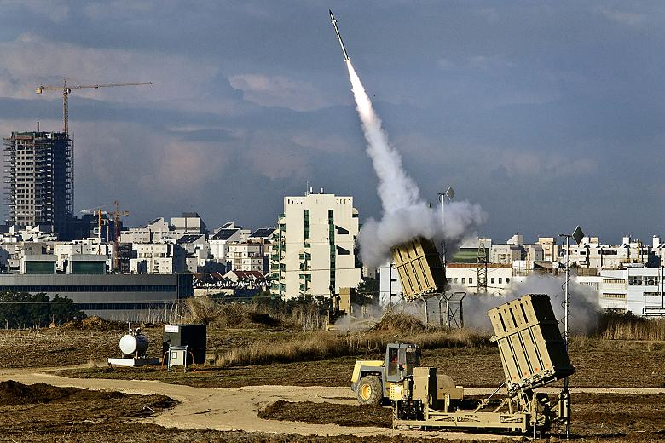
LONGSHOT: At a cost of as much as $100,000 per unit, Israel’s Iron Dome, seen here in action, has a rocket-interception rate of 85-90%. But it doesn’t cover the whole country—not by a longshot.
TIME MAGAZINE:
July 27th: “More than 1,050 Palestinians have been killed in the 20-day bombing and subsequent invasion, the vast majority of them civilians, according to Palestinian health officials.”
FOX NEWS:
July 27th (Chris Wallace): “..Gaza officials say now that more than 1,000 Palestinians, the vast majority of them civilians, have been killed….” .
WASHINGTON POST:
July 22nd (Sudarsan Raghavan, Anne Gearan and Ruth Eglash): “By Tuesday night, the Palestinian death toll had risen to more than 630 since the conflict erupted July 8, according to officials with the Gaza Health Ministry, with more than half the deaths occurring since Israel launched its ground incursion Thursday night. The United Nations says more than 70 percent of the casualties are civilians, including many children.”
July 28th (Raghavan and Eglash): “The current conflict has killed more than 1,035 Palestinians, more than 70 percent of them civilians, according to the United Nations.”
July 30th (Raghavan, William Booth and Eglash): “The Palestinian casualty toll rose to at least 1,340 killed and about 7,200 injured, Gaza health officials said. Many of the casualties have been civilians, including about a third who are children, according to the United Nations.”
August 4th (Griff Witte): “Well over half of those dead are civilians, including at least 354 children, according to a U.N. estimate released Sunday.”
CBS NEWS:
July 10th (Holly Williams): “So far this week at least 80 Palestinians, most of them civilians, have been killed.”
CBS MORNING NEWS:
July 29th (Susan McGinnis): “… Casualties on the Palestinian side are far greater with more than eleven hundred dead so far, most of them civilians.” .
USA TODAY:
August 1st (Jim Michaels): “The Palestinian Health Ministry said more than 1,400 Palestinians in Gaza have been killed, three-fourths of them civilians.” .
NBC NEWS:
July 29th (Alexander Smith): “The current push, Operation Protective Edge, has seen more than 1,150 Palestinians die, most of them civilians.”
NBC’s MEET THE PRESS:
August 3rd (Host David Gregory interviewing Riyad Mansour, Permanent Observer of Palestine to the UN): RM: “…We have a tragic humanitarian problem in Gaza, which you have indicated more than 1,700 Palestinians, most of them civilians, 80 percent or more, and more than 9,000 have been injured. 80 percent of them, according to you and statistics, have been injured.” DG: “Let me stop you on that point. [Note: He doesn’t stop him on the point of the casualty figures.] Your anger at Israel—certainly understandable, the loss of civilians horrific. There is agreement about that. I’m wondering though whether you’re outraged by the conduct of Hamas? Starting the conflict by firing rockets, building tunnels to kill and kidnap Israelis, being more than willing to sacrifice Palestinian lives by embedding them into their own kind of arsenal and using them, as Israel contends, as human shields. Do you have a level of outrage at Hamas itself?” DG: [Following RM’s response to those issues]: “Fair enough. Fair enough. And indeed, the reason I’m pressing this point is not to challenge you about how horrific the loss of civilians are.”
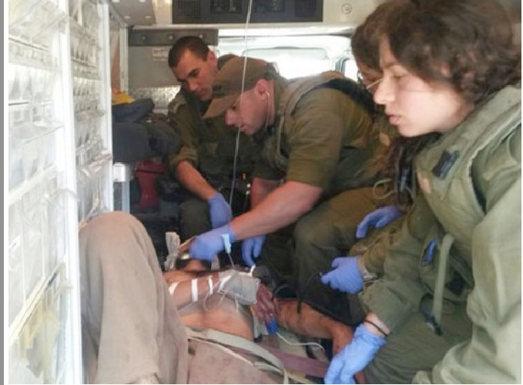
TREATING THE ENEMY: Israeli medics tend to an injured Palestinian fighter on July 18th in the Gaza Strip. It’s an image that one rarely, if ever, sees in wars, and not fit-to-print in the New York Times and other big Western media outlets. (photo: IDF spokesperson/Flash90)
.
BLOOMBERG:
July 29th (Elliott Gotkine and David Wainer): “The Israeli offensive against Gaza rocket operations and tunnels militants built to infiltrate Israel has killed more than 1,100 Palestinians, most of them civilians.”
BLOOMBERG-BUSINESS WEEK:
July 29th (Saud Abu Ramadan, Alisa Odenheimer and Jonathan Ferziger): “The third major military showdown in Hamas-ruled Gaza in less than six years has claimed the lives of more than 1,200 Palestinians, most of them civilians, and fifty-five Israelis, all but two of them soldiers, as well as a Thai citizen killed in Israel, according to officials.”
BBC:
July 29th: “More than 1,100 Palestinians, most of them civilians, have been killed in the fighting since 8 July.”
BBC MONITORING EUROPEAN (from Anatolia news agency, Turkey):
August 13th: “At least 1944 Palestinians have been killed and nearly 10,000 others injured—the vast majority of them civilians—in relentless Israeli attacks on the strip since July 7.”
BBC MONITORING MIDDLE EAST:
August 8th: “According to the latest count from the UN, Israel’s Operation Protective Edge against Hamas and other militants in Gaza has claimed the lives of more than 1,800 Palestinians, 72 per cent of whom were civilians.” .
LOS ANGELES TIMES:
July 29th (Paul Richter): “More than 1,050 Palestinians, most of them civilians, have been killed in three weeks, officials said Monday.”
August 9th (Laura King, Batsheva Sobelman and Maher Abukhater): “During four weeks of fighting, about 1,900 Palestinians have died—a large majority of them civilians, according to the United Nations—and 64 Israeli soldiers and three civilians were killed.” .
UPI:
July 17th: “Hamas agreed to the temporary truce after 220 of Gaza’s residents, the majority of them civilians, were killed in the nine-day confrontation.”
XINHAU [China news agency; distributed by BBC Monitoring Newsfile]:
August 4th: “During the almost 30 days of the Israeli offensive on the Gaza Strip, the death toll on the Palestinian side has reached 1,800, mostly civilians, plus 9,500 wounded.”
What may be happening here is yet another time-honored tradition in our field: copycat journalism. Given the deadlines, more fierce today than before, it’s too easy to simply pick up the wording from a rival media outlet—particular when numbers are involved.
That said, in the end, these media outlets may be right about the numbers. But today they are rolling the dice on it—unfair to their audiences—and the odds are against them.
The IDF will not release its own figures on civilian casualty rate in Gaza. This fact is almost never mentioned by major media outlets. “We are choosing not to get into a mudslinging war about the numbers at this point,” IDF spokesman Eytan Buchman explained to me on July 26th. On the issue of UN figures, Israeli Foreign Ministry spokesman Yigal Palmor said, “They’re not UN estimates: these figures are provided by Gaza health authorities (so: Hamas) and the UN merely redistributes these figures, for lack of the possibility to hold an independent survey. So these stats must be presented for what they are: Hamas processed figures.”
On August 9th, Palmor wrote me an update: “We had no access to primary info sources at first so we could not honestly present clear-cut figures. After Cast Lead [2009], it took a few months of investigations to ascertain the exact number of armed militants vs. civilians among the dead. We are now collecting more data from primary sources and the number of verified gunmen among the casualties is constantly and significantly rising.”
But it is regrettable, astounding really, that not one of these news outlets (again, except short shrift from the Times) reviewed and cited the work of the independent Amit Meir center. By not doing so, they’ve let down their viewers and readers, while helping Hamas in the war (if unwittingly or not) and fueling anti-Semitism globally.

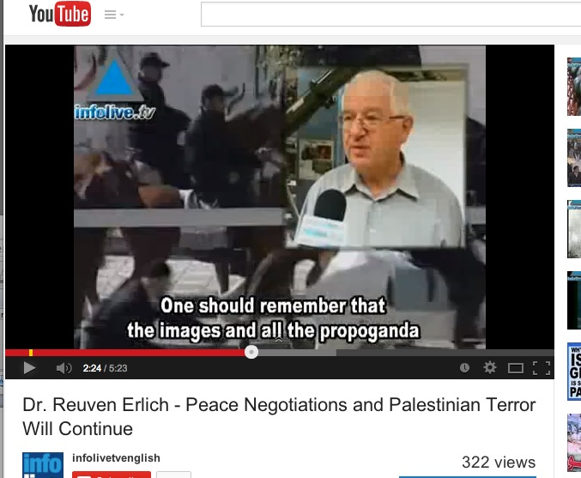
REUVEN’S WAR: “We are the only ones who are trying to check each name [Palestinian casualties], to examine every day,” he says of his Meir Amit Intelligence and Terrorism Information Center. So why isn’t Western media ringing his phone? [YouTube screenshot]
The man who runs the center, Reuven Erlich, served in the IDF Intelligence Corps, mainly as an analyst specializing Syrian, Lebanese and Palestinian affairs. He retired after 30 years in 1994 with the rank of colonel. Between 1985 and 2000 he worked in key government posts on Lebanese affairs and peace negotiations.
I first spoke with Erlich on August 5th. He was not a happy man. For one thing, the New York Times had just posted its Page-One story that finally raised questions about the casualty figures—but it didn’t go far enough (and the newspaper has since reverted to form with a lack of skepticism about the numbers.) “It’s propaganda,” he said about Western media’s reporting that the ‘majority’ or ‘vast majority’ of Palestinian deaths are civilians. “First, it’s based on Hamas control of officials. They are controlling all the results and all the lies so they can control the results. It’s not based on examination of each name. We are the only ones who are trying to check, to examine every day.”
Second point, he says: “The impression is that in all their figures, there are no terrorists, no operatives, only civilians. Only Palestinian ‘martyrs.’ Nobody tried to make the association between terrorist operatives and civilians. So the inference is that Israel is killing many, many hundreds who are not terrorists. So it is a big lie that is spreading all over the world, and I am frustrated because everybody who is quoting the numbers—1,000 or 1,500, 2,000—nobody is mentioning terrorists. There are no terrorists. It’s deliberate. This is the system, it’s a system based on lies, unfortunately. The same methods were used in the past. It’s not something new. But it’s a lost battle, believe me. I’m frustrated. There’s nothing we can do.”
Erlich says the center has a small staff of experienced researchers, all of whom know Arabic and are familiar with Palestinian issues. “The basis of our study is our own work, and we are also gathering information about the names [of the dead] from security sources. We take everything into consideration, like journalists. We can also verify terrorists by photographs.” As for Gazan children who have been killed, he says, “I don’t know, I don’t believe them [Hamas]. We found some examples of children, we checked their names and we saw a youngster with a rifle. Nobody can really control the figures—they can write as many children as they want—only an examination like we are making.”
When we spoke on the 5th, his center had already studied 150 names and concluded that only about 50% were true civilians. He said he was preparing the next day to release the next 150, which he said showed essentially the same results. [This didn't make the August 6th print edition version of the Times story, although it should have.] “All other lists, including the [Gaza] Ministry of Health are guesses,” he said. “Nobody tried to check even 50 names. We are the only ones. That’s why it’s a huge task to check and fight against Hamas deception. But this is the only way, and it takes time. All other figures are not reliable. I would like the New York Times to find somebody who tried to check the list, name by name. That’s all. And believe me, it’s a media war. I have a name for this war: The Casualty War…Hamas did the same in [Operation] Cast Lead.”
Last Wednesday, I spoke again with Erlich. He was in a better mood. “Five hours after we published (including in Arabic) the second batch of 150 names [August 6th], the Hamas Interior Ministry published an announcement, calling on Palestinians to be very careful about publishing information and photos of their ‘martyrs’ because Israel is collecting and publishing sensitive information and using it for ‘justification of its crimes’ and to ‘damage our positions.’” Such is the effect that his center’s work apparently has on Hamas.
Four days ago, the Meir Amit center released its third installment of its analysis of the Palestinians killed in the war. Of the 450 names now studied, reports Erlich’s team, terrorist operatives constitute approximately 46% of the names, while non-involved civilians constitute approximately 54%. (The identities of 44 of the 450 are still unknown at this stage.) The ratio may vary as the center continues its work, and it’s anticipated—based on prior conflicts in Gaza—that the final result will likely show that most of the dead are terrorist operatives.
Long-term, perhaps the biggest problem with media outlets serving the civilian-casualty soup before it’s ready is that phony numbers help inflame the world against Israel—and Jews generally. And that damage can’t be undone, even if big media outlets suddenly woke up and started doing their jobs.
Anti-Jewish riots have taken place throughout Europe and elsewhere. Jewish kids have been attacked; rabbis threatened, one beaten.
In Ireland on August 11th, shoppers—many chanting “Free Palestine”—stormed a Belfast supermarket to remove what they said were products that had ties to Israel. Watching the scene is like taking a horrific trip back to 1930s Europe. (It should be said that if boycotters of Israeli goods want to be consistent, they should also dispose of their iPhones, their computers with Intel chips, and a slew of medical devices that Israeli entrepreneurs have invented.)
HATE IN AISLE 5: Belfast shoppers teaching their kids how to single out Israel, the Jew among nations. (Don’t forget to dispose of your iPhones, your computers made from Intel chips, and the vast amount of medical devices invented in Israel.)
. In California, hundreds of protesters blocked an Israeli ship for several days from unloading cargo.
In Rome on August 9th, posters citing the “massacre” of Palestinians urge locals not to buy from a whole list of shops allegedly owned by Italian Jews. Spanish playwright Antonio Gala wrote that it wasn’t surprising that Jews have been expelled so many times in their history, while a city councilman in Ireland urges the UN to bomb Israel.
A riot by Gazan sympathizers outside a synagogue in central Paris trapped nearly 200 terrified worshippers inside the building. It sparked a street brawl between the rioters and dozens of Jewish men who arrived to defend the temple.
In Austria, an Israeli soccer team was attacked on a field by pro-Hamas fans.
In Belgium, a doctor refused to treat a 90-year-old Jewish woman—instead suggesting she go to Gaza for a few hours to “get rid of the pain.”
The list goes on and on.
Politicians like the UK’s John Prescott, a former deputy prime minister, parrots the media stats, jacks them up, and inflames the Israel-hatred to greater heights. “Of the 1,000-plus to die, more than 80 per cent were civilians, mostly women and children,” he wrote in a late July op-ed in the Daily Mirror. “But who is to say some of the other 20 per cent weren’t innocent too? Israel brands them terrorists but it is acting as judge, jury and executioner in the concentration camp that is Gaza.”
Little surprise that Britain is now reviewing all arms export licenses to Israel. Little surprise that France’s Foreign Minister, Laurent Fabius, wants the world powers to impose from outside a political solution.
“For all the formerly fascist and colonial regimes of Europe, Israel is a godsend,” says journalist Weiss.
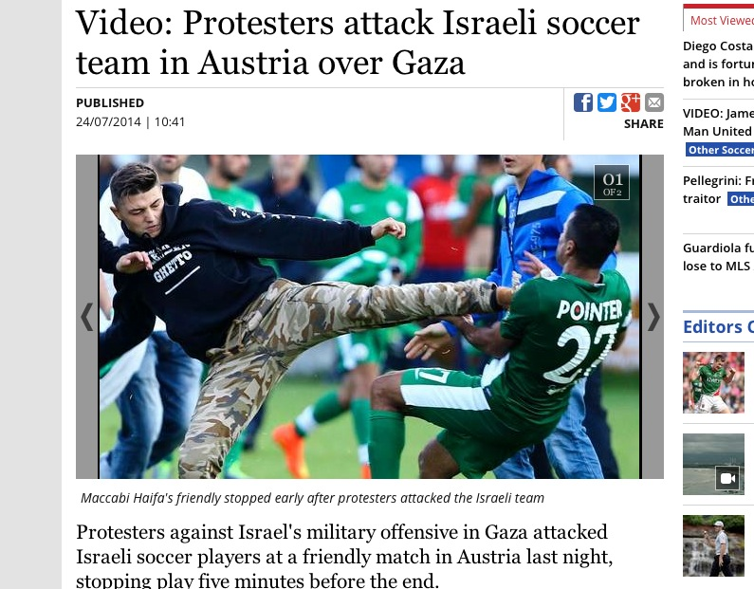
WELCOME TO BISCHOFSHOFEN: Anti-Israeli protesters stormed a soccer field recently in the Austrian town of Bischofshofen to attack Israeli players—one of whom was kicked in the chest. (screenshot: Irish Independent)
. NEW YORK TIMES REPORTERS IN GAZA
So what is going on at the New York Times? Why is the “paper of record” leaving out so much of consequence, and failing to cover in any adequate way—indeed, seems to be avoiding like the plague—the aspect of the story to which it is closest, the media role in the war? We can’t read the minds of the reporters the Times has in Gaza, but we can what they’ve put in the social media for all to see.
New York Times reporter Fares Akram was recently described by the Jerusalem bureau chief Rudoren as “brave, committed, talented…indefatigable.” I published that screenshot (taken by me in November 2012) of his Facebook homepage, with Arafat as his profile photo, for several reasons. First, I think it’s reasonable to ask what would happen if a current Times reporter had used as his profile picture, not his own face, but the face of Menachem Begin, who—decades before becoming Israel’s Prime Minister—was the leader of an underground Jewish group that ordered the 1946 bombing of the King David Hotel in Jerusalem, killing 91 Brits, Jews and Arabs? I think there would be an uproar in the media world, way beyond Facebook. The reporter might even be dismissed, or dispatched to another region.
Without getting deep into Arafat’s long and illustrious career as a terror leader, let’s just focus on a statement he made in 2002 that’s highly relevant for today’s Gaza conflict. Asked on official Palestinian TV what message he would like to send to “the Palestinian people in general, and the Palestinian children in particular,” he spoke of the value of dead children to the cause: “This child, who is grasping the stone, facing the tank, is it not the greatest message to the world when that hero becomes a Shahid [martyr]? We are proud of them.”
In September of last year, Akram posted a photo of a king-sized painting of Arafat being lifted onto an airplane. The caption he placed with it is a line from Longfellow: “The heights by great men reached and kept were not attained by sudden flight, but they, while their companions slept, were toiling upward in the night.”
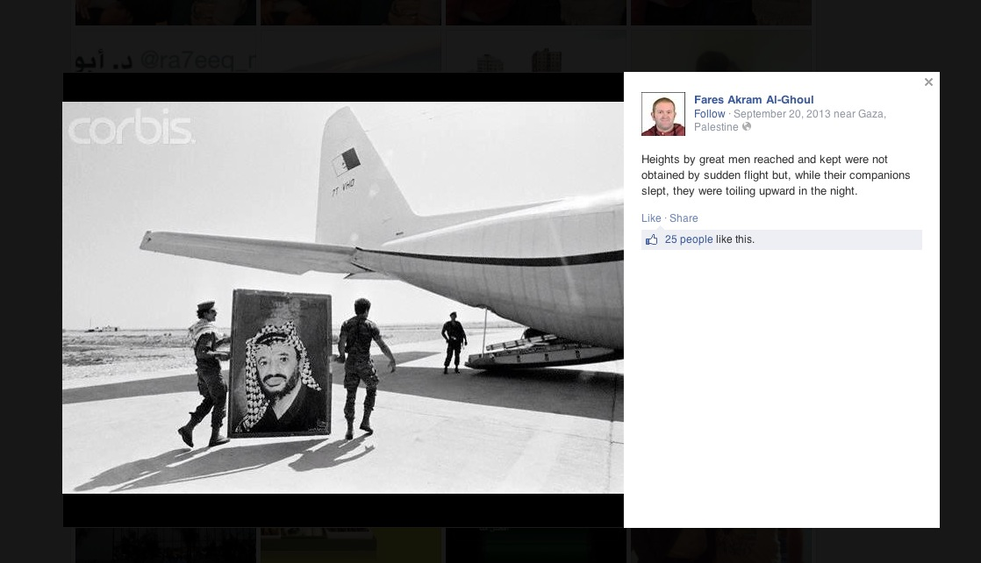
TAKING SIDES: New York Times reporter Fares Akram has lofty words to say about the “heights of great men” like the PLO’s Yasser Arafat (whose portrait here is being carried onto a plane.) Arafat knew plenty about the glory of heights, as his terrorists hijacked planes belonging to Pan-Am, Swissair and others. (Facebook screenshot)
.
Is it thus reasonable to ask whether Akram supports what his idol said in 2002 about how wonderful dead children are?
Finally, it’s worth remembering that when a peace offer was made to Arafat in 2000 that would give the Palestinians 95% of the West Bank, all of the Gaza Strip, East Jerusalem as their capital, plus a $30 billion compensation package for the 1948 refugees—fewer than 50,000 of whom are still alive today— Arafat rejected it and initiated the Second Intifada instead. At the time, Saudi Prince Bandar characterized that rejection as “a crime against the Palestinians—in fact, against the entire region.” And he held Arafat responsible for all the ensuing deaths of Israelis and Palestinians.
Akram’s Linked-In page reveals that he worked as a consultant for Human Rights Watch from 2007 to 2010, overlapping briefly with his Times gig. HRW is a group so vicious to Israel that its own founder, Robert L. Bernstein, severed ties with it long ago. While at the NGO, Akram contributed to three publications alleging Israeli war crimes during the 2008-9 Israel-Hamas war.
Tragically, his father, a judge in the Palestinian Authority, was killed in an Israeli air strike during that war. Is it unreasonable to ask if this tragedy presents at least the appearance of a conflict of interest? Readers may wonder how impartial Akram, or anyone in his shoes, could be after such a tragedy.
Consider the case of Michael Brown, the unarmed black teenager in Missouri who was shot and killed by a white police officer on August 9th, after allegedly robbing a convenience store. The incident has led to riots. Today the New York Times editorialized that, in order for there to be a fair inquiry, the prosecuting attorney in the case “needs to step aside or be replaced.” Why? In part because the prosecutor’s father was killed by a black suspect in 1964 while assisting a fellow officer.
Shouldn’t the same standard be applied to Akram, who wrote in 2009: “My grief carries no desire for revenge, which I know to be always in vain. But, in truth, as a grieving son, I am finding it hard to distinguish between what the Israelis call terrorists and the Israeli pilots and tank crews who are invading Gaza. What is the difference between the pilot who blew my father to pieces and the militant who fires a small rocket? I have no answers but, just as I am to become a father, I have lost my father.
Putting aside Akram’s past work, let’s look at his accomplishments for Al Jazeera, a gig that he enjoys alongside his Times position, which the newspaper’s editors apparently are fine with. Frankly, his recent articles for Al Jazeera read like pretty much what you would expect from the Qatari news site that never met a Palestinian terrorist it didn’t admire. His pieces show a stark blood-soaked landscape of burned Palestinian corpses and suffering Palestinian civilians—with not a single Hamas fighter to be found. His articles sometimes verge into self-parody but they are actually only slightly worse than the Hamas propaganda that has been generated by the Gaza press corps, as it has completed its transmogrification into tools of the terrorist group.
“The smell of death was everywhere” was the headline of one typical piece, which tossed at Al Jazeera readers the kind of anti-Israel red meat that they eagerly consume. The article was a description of Shujayea, the eastern Gaza City neighborhood in which the Israelis discovered a rabbit warren of tunnels and Hamas command centers, its tentacles extending well into Israeli territory. In Akram’s reporting of the neighborhood’s devastation the word “Hamas” appears but once in a quote, but nowhere does he even suggest that Hamas bears any responsibility for what happened here. There is simply suffering, and for no reason—just bloodthirsty Israelis, killing perhaps for the sheer joy of it.
Reading his articles, one can see why he is so popular from an Al Jazeera standpoint. After all, AJ is a Hamas cheerleader. Its Qatari funders are Hamas’s chief bankroll. But it’s harder to see what the Times sees in a reporter who can’t find Hamas people in the middle of what was, for all intents and purposes, the Pentagon of Hamas.
Akram continues in the same vein in an August 3rd article. In this one, Hamas is present only as a spokesman parroting propaganda. A typical paragraph:
“Israel’s offensive on the Gaza Strip has killed at least 1,762 Palestinians and injured over 9,200 others. Sixty-four Israeli soldiers have also been killed, along with two Israeli civilians and a Thai worker.”
The “offensive” killed 1,762 Palestinians. But against whom was that offensive? In describing Israeli casualties, Akram conveniently lapses into the passive voice.
Same Hamas-less landscape is portrayed in this August 1st article on the short ceasefire between Israel and Party or Parties Unknown.
In his July 30th dispatch, again Akram presents a Hamas-less portrait. The Gaza power plant is down because of an Israeli bombardment. The Israelis deny they hit the plant but not to worry, there’s no mention of that. What there is, as usual, is a detailed micro-recitation of Gaza misery and repeated descriptions of casualties of Israeli actions, with the word “Hamas” never used. In the fairyland of Akram’s reporting, there is only aggressive Israel, firing for no reason, against an enemy that does not exist.
His Twitter feed is very much like his reporting: “See no [Hamas] evil.” Where are the Hamas combatants? That to me is the major flaw in the reporting out of Gaza. Hamas combatants are never mentioned. They only have cameo roles, not the starring roles they should have. And their absence is never explained or mentioned only in passing.
Given this portfolio of stories, the New York Times (nor Al Jazeera) should have no fear that Hamas will intimidate Akram anytime soon. Nor for that matter, its Jerusalem bureau chief Rudoren, for when she skips in and out of Gaza.
As for Rudoren’s attack on the Foreign Press Association, in which she was dismissive of the claim that foreign reporters have been intimidated by Hamas, one only hopes she has seen the video last Thursday of a Hamas official conceding that the terrorist group has strong-armed journalists. The official, Isra Al-Mudallal, the head of foreign relations in Hamas’s Information Ministry, also admitted that some reporters were kept under surveillance—and some booted out of Gaza after they tried to film the launching of rockets against Israel, which the official called “collaborating with the occupation.”
Unfortunately, we cannot be certain whether Rudoren or her staff in Jerusalem or Gaza has seen it. There’s still no mention of the video in the newspaper. Not fit to print, apparently.
Let’s move to Abeer Ayyoub, who Rudoren also praised (in November 2012, during Israel’s Operation Pillar of Defense in Gaza) as her “wonderful fixer/journalist.” At that time, Ayyoub was getting reporting credit on stories written by Rudoren, even as she (like Akram) served as a consultant at the Israel-viperous Human Rights Watch.
Ayyoub no longer reports for the Times, but earlier this year she stated publicly that she has been boycotting all Israeli products for three years, which would cover her period at the Times.
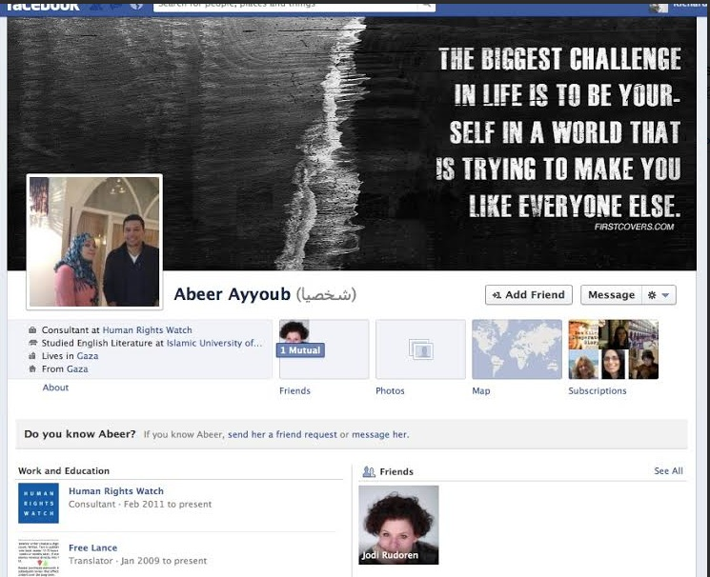
FIT TO BOYCOTT: Abeer Ayyoub was reporting for the New York Times from Gaza at the same time she was working for Israel-hostile Human Rights Watch—and boycotting all Israeli products. [Facebook screenshot, November 2012]
In a Facebook post on July 29th, Ayyoub parroted the Hamas line. She said she was asked in an interview “why Palestinians in Gaza are not feeling angry because of Hamas using the building materials for their tunnels and not for building houses and schools.” Her response was straight-up Hamas propaganda. “My answer was: why people in Israel [sic] won’t feel angry about Israeli government spending more money on enhancing its army instead of raising the level of education and health there? More importantly, why the U.S. wouldn’t save the money it supports the Israeli army with for sheltering its [America's] thousands of homeless there in the U.S.” It went on like this. She never really answered the question, but it was plain: Hamas diverting cement from kindergartens to terror tunnels was fine with her.
It gets worse.
In a particularly vile Facebook post on August 3rd, she attacked “so-called journalists” who “posted stuff and gave interviews that they left because they were threatened by Hamas to be kicked outta [sic] country if they don’t report what Hamas wants.” While excoriating those brave journalists, she defended Hamas. But she went beyond that. Using the term “we,” she actually implied that she was complicit in the cover-up of Hamas launching sites:
“…since the war began, Hamas has totally, and even more than enuf, facilitated the entrance of foreign journalists, no visa, no security clearance, nothing! they got the security support, decent hotels, friendly people. and, when it comes to the concern, WE THE LOCALS, tell the foreign journalists what can’t be reported, such as the places where rockets are fired from. Hamas never made a formal statement saying these thing shouldn’t be reported HOWEVER IT TOTALLY HAS THE RIGHT TO.” [Boldface added]
In a Facebook post in Arabic on April 6th, Ayyoub thanked Hamas for the great job it was doing educating the kids of Gaza.
Why was this Hamas apologist and defender ever representing the New York Times in Gaza?
Back in January of 2013, after I published a story that was critical of the Times and other major outlets for having ignored then-Egypt president Morsi calling Jews “apes and pigs,” I spoke with the paper’s foreign editor, Joseph Kahn. He told me that the Times didn’t feel it needed a permanent full-time reporter in Gaza. But I disagree. Given the importance of the conflict and the Times’ obsession with it at the expense of other global conflicts where far more civilians are dying, I don’t see how anyone can argue that such a position isn’t warranted. Especially right now.
It has long been said at the New York Times that if both sides of the Israeli-Palestinian divide complain about their coverage, then that’s proof they are doing a good job. In fact, a year or so ago, a former Times reporter commented on Rudoren’s Facebook page that this was what she herself was told when she arrived at the paper. Indeed, when the Times responds to criticism about its anti-Israel bias, it’s spokesperson Eileen Murphy likes to call attention to the enormous criticism they get from both sides. The truth is that upsetting both sides of a conflict does not mean you’re doing your job. It can often mean you’re just lazy. There are facts, there is history, and there is reporting that can get to the bottom of much.
It’s also an absurd excuse. If Nazis and Fascists both complained about Times coverage of Germany before World War II, does this mean that the coverage was flawless? The assumption is that criticism from both sides “cancels each other out.” But it’s possible that one side may have well-warranted complaints while the other might be totally frivolous—and might be complaining just to create the “two sides are complaining” effect.
Al Jazeera, the Qatar-based parent of Al Jazeera America, has long been venomous towards Israel. That’s no secret to anybody with eyes and ears—or a passport from Israel, whose citizens are prevented by the Emir of Qatar from visiting the country where the network is based.
A confidential State Department cable from February 2006 describes former Qatari Emir Hamad bin Khalifa Al-Thani, who founded Al-Jazeera by a royal decree in 1996, as a “a big friend of Hamas.” He pledged $400 million to Hamas during a visit to Gaza in 2012. Two months ago, Qatar’s prime minister, Abdullah bin Naser bin Khalifa Al Thani, announced that Qatar would give Hamas $60 million to pay the salaries of its civil servants in Gaza. And just last weekend, Qatar announced it would give funds to every Palestinian whose home was destroyed in the current war. (We can assume that the Emir will include the homes where terrorists stored or launched rockets from.)
Qatar is also comfortably housing Hamas leaders in Doha while Palestinian fighters and civilians in Gaza die. However, the Jerusalem Post reported yesterday that the Qatari government may have threatened to boot Hamas’s political bureau chief, Khaled Meshaal, from his sanctuary if he agreed to an Egyptian ceasefire proposal. (Egypt refuses to allow Qatar, a virulent supporter of the terrorist Muslim Brotherhood group, a seat at the table.)
Government officials in Iraq and Germany claim that Qatar has also funded ISIS, the new terrorist “state” where U.S. journalist James Foley was recently beheaded.
As for Al Jazeera, a State Department cable from December 2009 stated that Qatar was using the network as “an informal tool … of foreign policy.”
Israel’s Kobi Michael, the former national security official, points out that Al Jazeera does criticize certain corrupted regimes, “but nobody at Al Jazeera can say something about the Qatari corruption. Qatar is a tiny state with less than 250,000 citizens and more than 1.8 million slaves [migrants] with no dignity and human rights.”
While polls suggest that the majority of Gazans still seem to support Hamas, I’ve long wondered why moderate Gazans don’t form an underground to take on the terror group. Michael says Hamas’s terrorizing of the population is still too widespread to allow that to happen. “Since 2007 they have established an infrastructure and atmosphere of incitement—and those who refuse to collaborate with these efforts are forced to do it or just executed. Therefore citizens in Gaza cannot resist.”
He adds: “It is even worst than that due to the direct support for Hamas mainly by Qatar and the indirect support by international politics and media that collaborate with Hamas propaganda and the fabrication of figures and facts and pictures. The people of Gaza look at the international community’s approach and reaction towards other bloody arenas like Syria, Nigeria, Yemen and Libya, and understands that there will be no backing and support and they will be left alone. Think about it.”
And what of the Qatari government’s subsidiary, Al Jazeera America? I posed the matter to Steven Emerson, who has studied the network extensively. He is a longtime expert on Islamist terror who runs the Investigative Project in Terrorism (IPT), and he worked prior to that as an former investigative journalist for CNN and U.S. News and World Report.
“AJ America does very good reporting, but it was set up to provide cover as a propaganda outlet for its unabashed pro-Islamist, pro-Muslim Brotherhood, pro-Hamas owners,” says Emerson. “Qatar is the Number One financial supporter of the Brotherhood and Hamas today. Its coverage of the Israel-Hamas war has been scurrilously one-sided even though they pretend to be “evenhanded” by interviewing official Israeli spokesmen.”
On July 30, Al Jazeera’s coverage of the war was slammed by Rep. Brad Sherman (D-Calif), who sits on the House Foreign Affairs Committee. “Every one of those rockets [fired by Hamas into Israel] is a war crime, almost every one,” Sherman said, noting that Hamas seeks to hit civilian targets. “Of course it’s a war crime committed by Hamas. And of course the owners of this TV network help fund Hamas.”
A story on Al Jazeera America on July 31st focused on the long-term psychological and physical affects that Gazan children will suffer because of “Israel’s onslaught.” Reporter Hashem Said interviewed various medical experts on the subject. Not once was the word Hamas even mentioned, let alone the long-term effects on the kids of having such a ruthless government in power.
And, as I wrote earlier, the video of AJ America’s Nick Schifrin showing viewers how Hamas launches rockets from civilian areas has been removed by his employer.
Israeli Foreign Minister Avigdor Lieberman says Israel is re-evaluating whether to boot Al Jazeera out of the country. “Just as Great Britain would not permit Der Stürmer to establish a television channel to broadcast from London, and the United States would not permit an Al Qaeda channel to broadcast from New York,” the foreign minister said.
On Monday, Israel’s Ambassador to the UN, Ron Prosor, held a press conference—in part to wake reporters up to what Qatar is doing. “Ladies and gentlemen,” he said, “Hamas has been able to get away with its crimes thanks to the support and sponsorship it receives from Qatar. The Emir wants to appear to be progressive. After all, he and his family have gone on an international shopping spree buying the campuses of six American universities…” [One of those colleges is a virtual clone of New York University, my alma mater, which was established in Doha. Meanwhile, NYU's New York campus serves as a de facto U.S. headquarters for an attempted academic boycott of Israel—a subject I've explored.
"It [Qatar] can buy, bribe or bully its way to owning anything,” the Israeli ambassador added. “Now Qatar is spending its way to becoming the world’s biggest sponsor of terrorism, second only to Iran.”
If Qatar is aiding Hamas in various ways—financial, media, diplomatic, harboring war criminal—at what point is Qatar violating U.S. law against supplying material support to a designated terror group? “If Hamas were ever to be convicted of war crimes by the International Criminal Court, as it may well be, any individual who was an accessory to such crimes would be guilty as well,” writes former Harvard Law professor Alan Dershowitz. “It is entirely fair, therefore, to describe Qatar as a criminal regime, guilty of accessory to mass murder.”
An old friend and talented colleague of mine went to Al Jazeera America. (We worked together once on the Al Qaeda terrorism trail.) So did the highly-regarded veteran reporter Ed Pound, who runs AJ America’s investigative unit, as well as Marcy McGinnis—the accomplished former CBS News executive who is now AJ America’s vice president of newsgathering. When I think of them, I reflect back at what former ABC Nightline correspondent David Marash said publicly after he quit Al Jazeera English in 2008 because of anti-American bias. Today, I wonder if any of the dozen or so talented Western journos will quit AJ America in light of the Qatar-Hamas connection coming into sharper focus.
Terrorism expert Emerson puts it bluntly: “The journalists who joined AJ America have sold their souls, I’m sure for a very good price. Some of them went over to AJ America because it perfectly suited their ideological agendas.” .
THE BIG LIE: A RACIST STATE
Thanks in good measure to what investigative reporter Weiss calls “the media intifada”—the trans-Atlantic epidemic of lazy, incomplete, sometimes mendacious journalism and imitations thereof that has plagued the conflict—the cries of Israel as a racist-colonial state are being vomited forth from San Francisco to Spain.
So goes the monotonously screamed lie, despite the presence on the Israeli side of Arab Israelis, Bedouin tribesmen, Druze and black African soldiers—as well as Mizrahi (Middle Eastern) Jewish youngsters—comprising much of the Israel Defense Forces.
Israel’s diversity is a subject almost never covered in the West. The Times contributes to the racism label, adding to the nonfeasance in its news pages, by printing on its famously predictable op-ed page, cookie-cutter, paint-by-numbers tracts by Palestinian officials and Israel-hating academics that label Israel a racist state—a tedious litany of drivel repeated dozens of times before.
Case in point: ‘Israel’s Colonialism Must End,” an August 4th op-ed by Ali Jarbawi, a professor and former Palestinian Authority minister, which is chock full of variants of the words racism and colonialism that he uses to smack Israel with. But it’s all nonsense, and it’s high time that the newspaper’s editorial board stopped inflaming anti-Semitism with this stuff.
Two weeks ago, I had the pleasure of dining with Dumisani Washington, the head of a group called the Institute for Black Solidarity with Israel. “The claim that Israel is a racist/colonial/apartheid state is a blatant, bald-faced lie,” he says. “Further, those false accusations cheapen the experiences of South Africans, Black Americans and others who experienced those horrors—like my parents and grandparents. Israel is diverse in virtually every facet of society. It is intellectual dishonesty to affix those gross labels on a liberal democracy.”
Washington, a California-based author, pastor and music teacher, will be publishing a book next month called “Zionism and the Black Church.” His institute educates young people and college students about what Israel really is. Among other things, he focuses on Martin Luther King Jr’s strong support of Zionism. Born in the segregated south (Little Rock), he knows a thing or two about what racism is.
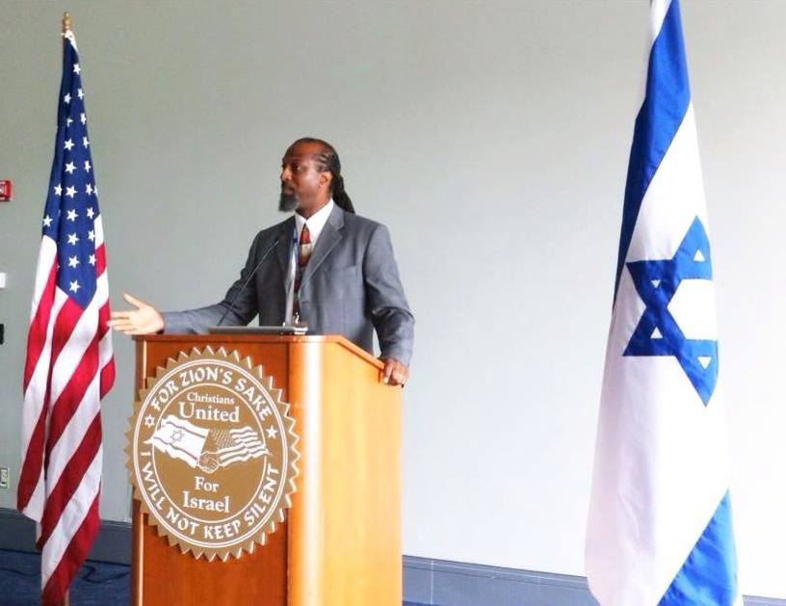
A LIBEL’S RESURGENCE: Dumisani Washington, of the Institute for Black Solidarity with Israel, tours the U.S. to teach students some truths. “The claim that Israel is a racist/colonial/apartheid state is a blatant, bald-faced lie.”
. While discrimination certainly exists in Israel (although not in its laws), as it does in most countries, the situation is improving and the Israeli-Palestinian struggle has nothing to do with race. For starters, Judaism is not a race, and anybody can choose to become a Jew. The late senator and U.S. Ambassador to the United Nations, Daniel Patrick Moynihan, made that clear enough in 1975, when he rose to the rostrum to condemn the UN’s labeling Zionism as “a form of racism and racial discrimination” (a designation the UN reversed). Moynihan called it “a lie” and “this obscenity.” (And he warned that corrupting the language of human rights in this way would cause irreparable harm to the UN and to actual racism.)
Nor is Zionism a colonial enterprise, as Jews immigrated in large numbers to escape persecution, not to plant the flags of other nations.
Nor is Israel engaged in “genocide” and “ethnic cleansing” of Palestinians, another farcical slander. Since 1948, the Palestinian population has increased eightfold.
But for those who insist on brainwashing themselves into believing it’s a racist conflict, they might want to see a photo posted on Twitter by Gutiérrez—the Spanish journalist who exposed Hamas’ firing a battery of rockets from the press hotel in Gaza. It’s a picture of an Arab IDF soldier kissing his mother, who is wearing a hijab, on the cheek. “I would be lying if I told you I saw signs of apartheid in Israel,” the journalist wrote next to the photo. “But I’m not going to lie.”
Or perhaps the brainwashed can meet Arab Israeli teenagers like Mohammad Zoabi, a proud Muslim Zionist. Or perhaps Israel haters can learn about the Druze IDF commander, Col. Ghassan Alian, who was injured in battle last month but insisted his doctors let him go back on the front because “I have many soldiers there. I need to return.”
Or perhaps they can meet people like Arab Israeli Anett Haskia, whose two sons and daughter serve in the IDF, and who encourages Israeli soldiers to “keep on fighting in Gaza until total victory.” As for those who don’t accept the state of Israel, she suggests they are “welcome to go to an Arab country.”
Where are their stories in the New York Times and elsewhere in Western media?
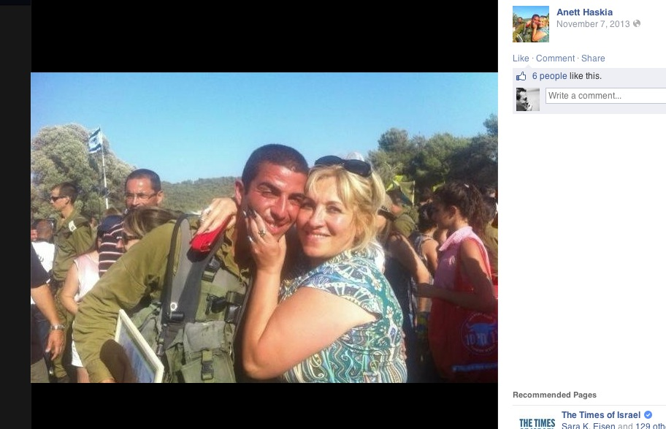
LOVE FOR SON, AND FOR COUNTRY: Arab Israeli mother Anett Haskia with son Hussam, one of her three children (including a daughter) who are serving in the IDF. All three are in the photo below. She encourages Israel’s soldiers to “keep fighting in Gaza until total victory.” (screenshots: Facebook)
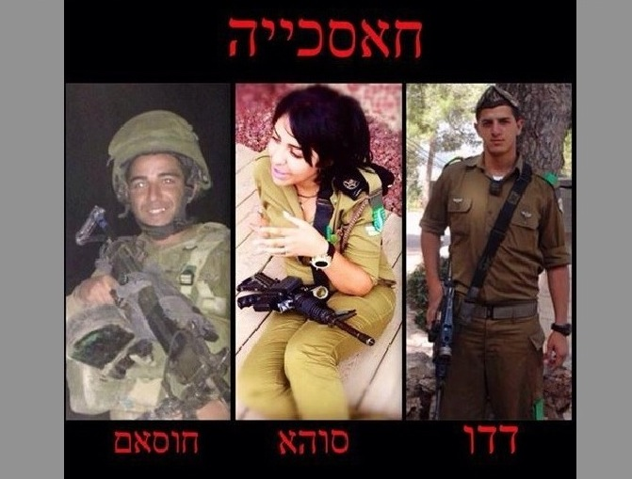
The three children of a proud Arab Israeli, Anett Haskia (pictured in photo above): Her son Hussam, daughter Suha, and son Dado.
. For that matter, where are the features of young, dead Israeli soldiers and their families? Or is it only the tragic deaths of Palestinian civilians that are worthy of ink?
There are 64 stories of fallen Israeli soldiers to choose from, and here is one, sent to me in late July by an Israeli cousin named Liraz:
“A week ago we celebrated our dear Nitsan’s 24th birthday. It was not easy to take a decision to celebrate during a war (this is absolutely not an operation)—but after all, these brave soldiers who are fighting there are doing it to protect us and allow us to celebrate life.
“Today [August 1st], I had to face Nitsan’s face, with heavy tears falling along her cheeks, and to realize how difficult it is to supply an answer to her question: ‘Why Mom, why is this world so unfair? So cruel? Why do they hate us so much?’
“Today, during a very hard battle, two soldiers were killed… One of them—Benaya Sarel—was the fiancée of Gali Nir, a very close friend of Nitsan’s, with whom she travelled to the Far East last year. Gali & Benaya, such a lovely young couple—met in the army, lived and loved, and were supposed to get married in ~3 weeks. Instead of dancing at their wedding, their family and friends will have to escort his coffin tomorrow on his last way. Benaya was a captain in Givati, one of our combat units. What a guy. You should have seen his pictures—taken in Gaza only a few days ago. He presented to the television camera ammunitions they found in a house. Great deal of ammunitions that it’s hard to believe.
“He was an admired officer, and, like our commanders, he was in front of his troops—killed by the suicide terrorist who came in front of the Israeli force, to distract them to [try and] take one of them into captivity.
“Nitsan and her girlfriends were trying to plan the party for Gali before the wedding. They knew she was in great tension, because Benaya is ‘inside.’ How tragic and awful it is now. No party, no wedding dress, a 24-year-old young fragile woman cannot start her life with her beloved man. Nitsan said she feels like she’s in a bad dream. And she wants to wake up, NOW.
“Honestly, I didn’t know what to tell my daughter. I know all the good reasons why I am growing up my children here, in this country. But to see them grow up and experience the unbearable pain—this is something that as a parent you are not prepared to do. Her sorrow, and the tragedy that her friend Gali will have to cope with now, just breaks my heart.
“I wish some of the [foreign] politicians who tell us what to do and how much to do and when to stop or how to handle this battle—I wish they would come to live here only for a short while. Realize who are our enemies and perhaps understand how wrong they [politicians] are not to support Israel all the way to the end, and not to assist us in any possible method to destroy this enormous evil called Hamas.”
Liraz told me that Nitsan was “devastated..crying all day” after the funeral to speak with me. A friend of hers permitted me to publish this photo (below) that she took of Benaya proposing to Gali.
A FALLEN SOLDIER, A GRIEVING FIANCÉE: Benaya Sarel (left) and Gali Nir were planning an August wedding, not a funeral with 10,000 in attendance. Western media outlets are all-but-uninterested in such stories. (photo courtesy of Talya Peled Keinan)
. Back in November 2012, during Israel’s Operation Pillar of Defense, I learned that another cousin was the commander of a patrol jeep that was hit by an anti-tank missile fired into Israel from Gaza. After an IDF spokesperson told me that the incident was “the immediate catalyst” for Israel’s operation that month, I wrote a piece about it. From time to time, I still think about the jeep’s driver, now blind in both eyes as a result of the attack. At the time I published, doctors were still trying to save one of his eyes. It could have made for a moving feature in the Times or any major American media outlet. Still would.
But since my colleagues in major media are all-but-uninterested in the stories of injured or fallen Israeli soldiers, I’ve compiled a few other pieces that they might consider:
** When Israel pulled every one of its citizens out of Gaza in 2005, it left behind an advanced infrastructure for agriculture that included roughly 3,000 greenhouses donated by American Jewish philanthropists. “Instead of building on the agricultural high-tech, the people of Gaza stole it all; they took it apart and destroyed it,” recalls historian Michael B. Oren, who served as Israel’s ambassador to the U.S. from 2009 until last September.
I spoke last month with Oren. He said that if world leaders would stand down and let Israel deal Hamas a decisive military defeat, followed by a demilitarization of the Gaza Strip, the population there could flourish—if they choose a different path than the one they selected in 2005. “Here’s a second chance,” he says, pointing out that Gaza could develop a booming tourism sector (thanks to beautiful beaches), lure international investment, and do joint ventures in high-tech with Israel just as Palestinian entrepreneurs on the West Bank are doing today.
I wrote a cover story in Forbes magazine a year ago about these promising high-tech co-ventures. Google the subject, and you’ll see that such a positive subject is still all-but-ignored by my colleagues. Why? Too positive?
** Another area rich for stronger coverage are the “terror tunnels”—32 of which the IDF says it has destroyed. Israel’s Hecht, an expert on underground warfare, points out that Egypt’s prior destruction of the Gazan smuggling operation—most of which has taken place since Egyptian President el-Sisi took power in June—is “one of the prime causes of the present war.” I didn’t know this until I spoke with him, and perhaps most American readers and viewers don’t know it either. Hecht has written extensively on tunnel warfare, and one of his papers (from July 27th) on the subject can be seen here.
Q: Has Israel destroyed any tunnels that are used for just moving food and other needed products into Gaza, as well as for trade outside Gaza? Or are there no such tunnels used exclusively for these purposes? Has Egypt been destroying any tunnels since Israel’s Operation Protective Edge began on July 8th?
Hecht: “The smuggling tunnels are all between Gaza and Egypt. They have in the past been targeted by Israel when specific intelligence provided the location of arms shipments moving through a specific tunnel. But it is a very inefficient and ineffective way to stop them. The bomb has to hit within a couple of meters at most in order to do any damage at all. Most of the tunnels are so deep that the only feasible target is the entrance and even if the bomb hits and blocks the entrance or a section of tunnel, the damage is so limited that it only takes a few days to dig a bypass. If, as has sometimes happened, there is a lot of explosive material in the tunnel when it is hit, then there might be a chain-reaction explosion that demolishes it along a considerable length, forcing it to be abandoned and then they have to dig a new one. This is the reason that the IDF had to go in on the ground against the offensive tunnels; to destroy them you need to climb in, place tons of explosive in a chain along the entire length and then explode it all at once.
“What really shut down the Gazan smuggling operation and can keep it shut in the future is the Egyptian army’s ground forces. They have shut down more than 1,630 smuggling tunnels—most of them since el-Sisi came to power [in June]. This is one of the prime causes of the present war: Taxation on the smuggling tunnels provided Hamas with 40% (some claim even 50%) of its revenues. They also were the only route of entrance of new weapons into Gaza, though these weapons were only a small percentage of the traffic, most of which was civilian.”
Q: You’ve written about the revolutionary work that the IDF has done in analyzing the location of tunnels and the techniques for destroying them. Is that knowledge of value for the U.S. military? How and why? And is there currently R&D work being done in Israel to learn more and further the technology?
Hecht: “This sort of knowledge is discussed and exchanged continuously between the two militaries. The problem is that, as yet, neither has found a solution that works well enough to make this specific problem easy. The U.S., led by Immigration and Customs Enforcement, has invested a lot of money into solving a similar problem on the Mexican border with similarly dismal results. For the time being the only working solution is intelligence culled from inside the rival organization that points to an area or the exact location of an entrance — and then to send patrols to find that entrance. R&D is being conducted, but the results are simply not good enough. All the existing technology can discover these tunnels only to a shallow depth that is less than half the depth they are being dug.”
On August 11th, Fox News editor-at-large George Russell (a former colleague of mine at Time magazine, who I later wrote a batch of investigative stories for at FoxNews.com) exposed an internal UN report revealing financial mismanagement at the agency that “adds a new level of potential credibility to Israeli accusations that internationally-managed relief supplies to Gaza were diverted into construction” of tunnels used by Hamas to organize rocket attacks and infiltrations into Israel.
In 2004, the NGO Human Rights Watch (where Times reporters Fares and Ayyoub once worked) published a lengthy, clearly-politicized “report” condemning Israel for actions designed to stop terror tunneling in Gaza. The report, an accompanying publication (“Razing Rafah”), and a big media campaign “repeated false allegations that Israel was violating international law,” says Gerald Steinberg, who runs NGO Monitor, a group that tracks the falsehoods of NGOs operating in the Middle East. “This was the only HRW ‘report’ on the Gaza tunnels, which have grown massively in the past decade.”
Steinberg says that during the past decade, Amnesty International and other such “political” NGOs, as well as UNRWA, ignored Hamas’s strategic [offensive] tunnel construction. “They also turned a blind eye to the abused Palestinian children who were forced to dig the tunnels, causing at least 160 deaths, and perhaps many more,” he says. “In obsessive posts on Twitter, in which most target Israel, HRW head Ken Roth continues to ignore these issues.”
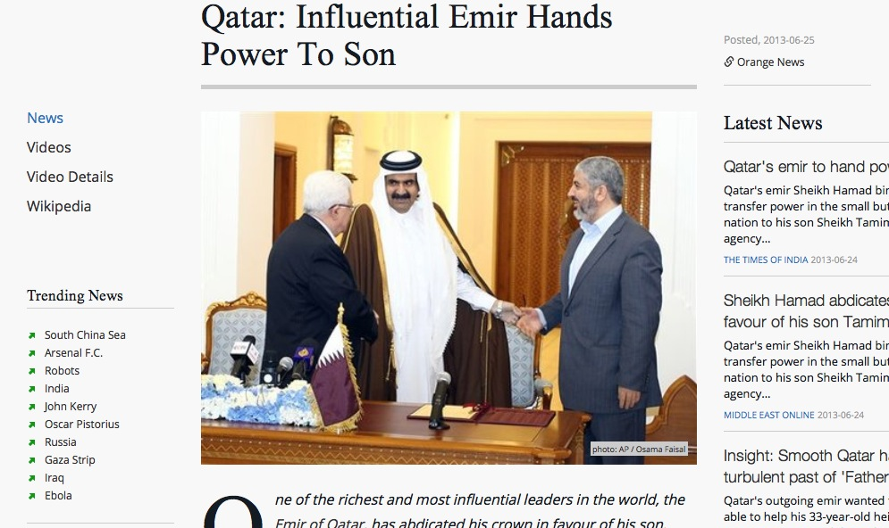
FUNDING AL JAZEERA AMERICA—AND TERROR: The Emir of Qatar in 2012 with the PA’s Mahmoud Abbas (left) and Hamas leader Khaled Meshaal. (screenshot: World News Network)
. Instead, HRW, Amnesty and UNRWA led the campaign demanding that Israel allow the import of cement into Gaza, where it was used to prepare the tunnels for deadly attacks on Israel. “Under the facade of human rights, the leaders of these organizations are morally complicit in the rampant child abuse, the deadly Hamas attacks through the tunnels, and the immeasurable cost to Gaza’s residents,” says Steinberg.
With media focused on Palestinian children, certainly the abuse of them during the construction of such tunnels should be a natural angle? But that might get foreign reporters booted from Gaza.
** Another idea for my colleagues might be to probe deeply into the Qatar-Hamas links. Poking around Al Jazeera’s home nation won’t be easy, as there’s no freedom of the press there. But it remains one of the most important stories of the entire war, and it’s sitting there waiting to be done.
** Finally, another investigative story worth pursuing, although it will also upset the press corps’ hosts in Gaza, is the sordid relationship between Hamas and UNRWA. While the UN has called for a probe of Israel for war crimes, the agency itself has been caught red-handed three times storing Hamas rockets—and has publicly admitted handing rockets back to Hamas. UNRWA has also admitted to hiring Hamas teachers at the schools, which are sometimes used as recruitment centers for child soldiers. The curriculum brainwashes the kids into working for the elimination of Israel. . SNOWING HIS VIEWERS IN THE UK
Of the dozen big-circulation newspapers in the UK, the Guardian stands alone in its virulent hatred of Israel. (even worse: the Independent, although it’s circulation is far lower.) This is clear to anyone who can stand to follow it, and one need only read Middle East commentator Tom Gross’s account of Guardian editor-in-chief Alan Rusbridger’s first visit to Israel in 2001 to see who is steering the paper’s biased reportage.
Less well known to those outside the UK is the hostility of TV’s Jon Snow, long known as “the face of Channel 4 News” (since 1989). He reputedly enjoys the biggest Twitter ratings in the country of any TV news reporter, and his network is one of the most followed by viewers there.
I decided to explore Snow’s coverage because an old friend and extremely talented colleague of mine (we worked closely in Pakistan after 9-11 on the terrorism trail) posted a link to a Snow broadcast in mid-July, with the comment “Lord I miss Jon Snow.” The colleague, who was based until recently in London, now works for Al Jazeera America.
So how is Snow covering the Israel-Hamas war? The newsman has become obsessed with injured and dead children in Gaza, to the expense of everything else. I could locate no broadcasts, however, on the harm being done to Israeli children near the Gaza border—where studies show that nearly half of the kids suffer post-traumatic stress-related symptoms from years of rockets and countless hours spent in bomb shelters.
A review of many of Snow’s broadcasts and dispatches shows one bias, absurdity and falsity after another, in such a format that it resembles a satire. . Examples:
** Following a brief visit to Gaza in mid-July, he referred only twice to Israeli security guards at a checkpoint into and out of Gaza—and each time stated that they “barked” orders [like dogs?]
** He referred to “three half-hearted aerial sirens” in Israel, as if citizens rushing to bomb shelters there deserve little sympathy.
** He falsely stated that Israel’s Iron Dome catches all the rockets. “Israel, courtesy of American finance [he uses his hands to create a half globe effect], has invented the most brilliant shield, which is keeping absolutely everything out—and that’s a big difference.”
In fact, the Iron Dome’s success rate in this war is about 85%. Given that all of Israel cannot be protected by it (75% of Israelis live within range of Hamas missiles), the IDF focuses on those rockets that are falling over population centers. From the start of the war until July 26th—the day of Snow’s on-air claim—the IDF identified 2,478 launches into Israel. Of these, 488 were intercepted successfully and exploded in mid-air, while 1,790 landed in Israel in open areas. (Perhaps 200 landed inside Gaza. Of course, any damage they caused was falsely attributed to Israeli bombing or artillery.)
So much for “keeping absolutely everything out.” One must ask, given such falsities, are viewers watching Snow purely for entertainment value, or do they buy what he hawks?
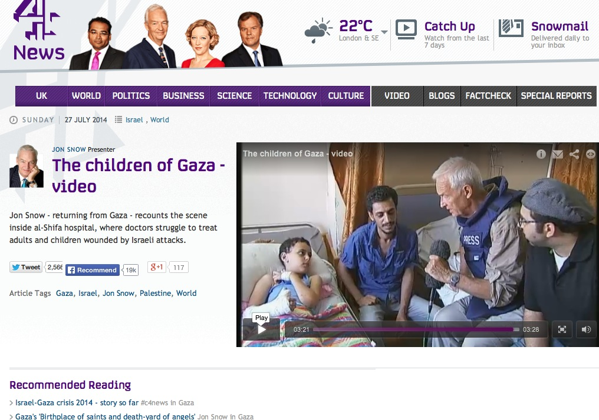
VISITING GAZA’S WOUNDED: UK newsman Jon Snow (right) says that Israeli officials “seem to be happy” when IDF strikes kill women and children. (screenshot: Channel 4 News)
. ** In the past Snow has referred to the Israel lobby in Washington as the “Jewish lobby”—despite the facts that Israel’s population is 75% Jewish, with the rest Muslim, Christian, Druze and other minorities. Does Snow have a problem with Jews, or is he simply ignorant?
** In a discussion inside Gaza’s Al Aksa Hospital with the institution’s medical director, the doctor told Snow: “These [children] are the declared target of the Israeli army. They are only killing children.” Snow doesn’t challenge him on that, not even slightly.
** In a clear broadside against Israel, he stated, “The world is witnessing what is happening in Gaza. There is bound to be judgment.”
** Snow told a Hamas spokesperson on air that, “If you stopped firing your rockets tonight, you would embarrass Israel into stopping fighting you.” Embarrass? Why use such a word? In fact, Israeli officials have said over and over that the missiles will stop when the rockets do—while Hamas has broken every ceasefire.
** He exaggerates ridiculously. In an interview with Israel’s former National Security Advisor, Yaakov Amidror, Snow called a rocket that landed near Israel’s Ben Gurion Airport, “clearly…a disaster…an enormous economic setback [due to a 24-hour flight ban by the U.S. and Europe.] “Please don’t exaggerate,” responds Amidror, adding sarcastically: “It’s Britain, I understand. So, it’s not a ‘disaster.’ It’s a problem. We will solve it, if not in the next 24 hours, in another 24 hours….This is not a disaster for Israel.”
Snow punches back: “How many 24 hours do you need to deal with the problem you describe as Hamas?” Amidror then educates the newsman on how Hamas is “the problem of Palestinians, not us, and Qatar money…[and running a] military machine instead of taking care of its own population.”
Amidror then lands the knockout, even as Snow tried to cut him off. “Remember—you are from Britain—what happened the last time someone decided to launch rockets and missiles into your own cities, so we will have to deal with it.”
Snow keeps trying. He complains that the IDF is “having to kill civilians on behalf of the political classes who will not talk to Hamas. That position simply cannot be sustained. I would argue, and I think there are many in the West who would support this, many would argue that you’re losing the propaganda war thereby.”
Amidror then educates Snow on something that most of the media does not seem to ever grasp. “You know, we are not fighting for propaganda,” he said. “We are fighting for our life. When Hamas decided to launch more than 1,500 missiles and rockets into Israel [now up to nearly 3,500], the problem is not propaganda, with all due respect to the propaganda. And what we are doing now, we are defending our ability to live in Israel. And what our pilots and our commanders on the ground are doing is to try to convince the civilians to leave the areas in which Hamas put its launchers and is fighting for within populated areas behind the shield of children of its own people. What we try to do is to defend our civilians. What they are doing is to use their civilians.”
** Snow began an interview with Mark Regev, the spokesperson for Israeli Prime Minister Netanyahu, by stating: “Mark Regev, the operation that you’re engaged in is Protective Edge, and its stated purpose is to protect Israeli civilians. Uhh, how does killing children on a beach contribute to that purpose?” After a discussion of the nature of war as he thinks Israel views it, Snow then states: “You seem to be happy for it to, frankly, well if it results in dead children, dead women, that’s it.”
Indeed, in a tragedy that was well-reported by media in the US and elsewhere, four Palestinian kids playing on beach in Gaza were killed by Israeli fire. As far as I could tell, what wasn’t asked by my mainstream colleagues was what they were even doing on a beach with Israeli naval forces stationed right off it Did not one of the four sets of parents think of keeping a tight eye on them? At what stage are parents responsible for their children?
** In that interview with Regev, Snow asked why Israel doesn’t talk to Hamas directly—as if this could somehow lead to a duet of Kumbaya. “Let me ask a final question,” said Snow, before sounding like a child himself. “You’ve tried three wars. You’ve tried virtually everything…You’ve besieged it [Gaza] for seven years. People live an intolerable and ghastly life, and you know that better than anybody. Why don’t you try one other thing: Talking. Why not talk? Why not be brave and talk directly with them? Why not?”
I’ll let Israeli military expert Hecht and Kobi address that absurdity.
Hecht: “I guess we should have negotiated with the Nazis too—just as Churchill did, oh wait—he didn’t. Or perhaps the way Britain and the U.S.A. negotiated with Saddam Hussein and are negotiating very effectively with the Taliban.”
Kobi: “Has this Brit asked himself why the UK or U.S. doesn’t negotiate with Al Qaeda or ISIS? Israel has negotiated with Hamas, but indirectly. There is not any cause to negotiate with them [directly] because any negotiation with them legitimizes them, strengthens their political position and weakens the moderates.
“[Second] Israel has no interest in having two Palestinian states competing against each other on its back. The PLO is the only and sole legitimate representative of the Palestinian people; why does Israel have to undermine it?
“[Third] Hamas is a terror organization that seeks eliminating and destroying not only the state of Israel but the Jews as a whole.”
Not surprisingly, Snow doesn’t mention the inconvenient fact of Hamas’ charter, which calls for the killing of Jews everywhere.
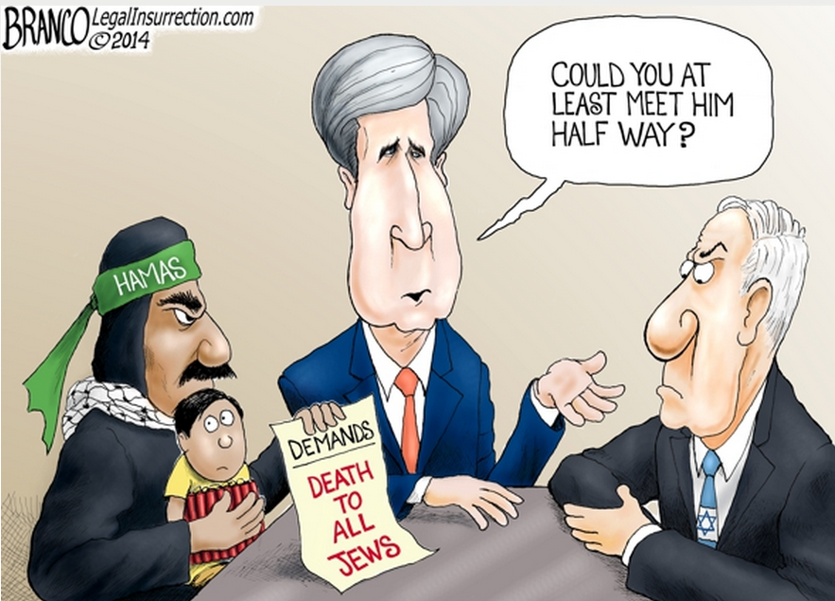
SNOWING HIS VIEWERS: Top UK newsman Jon Snow calls on Israel to negotiate directly with Hamas, but apparently has never read its charter. (Cartoon courtesy of Legal Insurrection.)
. What is one to do when watching and reading Jon Snow? Perhaps simply laugh. But what Snow doesn’t seem to understand is that, to those who actually know the facts, his falsities and bias actually undermine the lives and deaths of the Palestinian children that he obsesses over.
And that applies to Western media generally, on both sides of the Atlantic.
As for the New York Times, having failed to do any serious enterprise reporting since the war began, here’s the big crumb the newspaper tossed out to its readers after the last ceasefire went into effect:
On Saturday, a Page One story about a 91-year-old man named Henk Zanoli who rescued Jews during the Holocaust but who has now decided to return a medal he received because he’s upset about the numbers of Palestinian civilians who have died in the warfare. According to Times’ reporters Christopher F. Schuete and Anne Barnard, “his act crystalized the moral debate over Israel’s military air and ground assault…in which about 2,000 people, a majority of them civilians, have been killed.”
Of course, it “crystalized” nothing of the sort. The man is a genuine hero who genuinely rescued Jews, and he’s a genuine anti-Zionist going back many decades, as his letter to the Israeli ambassador to the Netherlands points out. He obviously went to the trouble of publicizing the letter, probably sending it out widely to the media [the story appeared first in Israel’s Haaretz]. A publicity stunt, and one eagerly utilized.
Zanoli’s wartime exploits are not to be minimized. His actions today, falling in line with European Israel-hatred, are anything but heroic. (He refers to the deaths in Gaza as “murder carried out by the State of Israel.”) A nonbiased article—remember, this is a lengthy front-page story—would have explored his views on European anti-Semitism, the spread of Islamist beliefs, and his callous disregard of the perils facing Jews today.
Also, note how the two Times reporters state emphatically and without attribution that a majority of those killed are civilians. A day earlier, at least Times reporter Kershner began using the word “probably” on that point. Knock, knock, New York Times, any editors home?
That Times piece made me reflect on the newspaper’s coverage during the Holocaust. In 2001, just two months after 9-11, the paper’s former executive editor, Max Frankel, wrote a scathing come-to-Jesus op-ed on what he called “the staggering, staining failure of the New York Times to depict Hitler’s methodical extermination of the Jews of Europe as a horror beyond all other horrors in World War II—a Nazi war within the war crying out for illumination.”
While the Times today is, to some degree, following down the same path with Hamas, we fortunately live in a 24/7 global online-media world, where we don’t need to depend on such an important newspaper for its coverage.
Not content with its ‘morally-crystalizing’ Page One story about the Holocaust hero, the Times struck again the following day with yet another Page One story that was malevolent towards Israel. This one, odd enough just for its timing during the current war, focused on how three Israeli men are allegedly among the central operators in Israel’s underground kidney market (i.e. the trafficking of kidneys to save lives.) The reporter—Kevin Sack—concluded that while the trade is extremely active in China, Egypt, India, Pakistan, Turkey, Eastern Europe and elsewhere, Israelis have played “a disproportionate role.” It’s a word the Times has used a great deal this summer to describe the ratio of Israeli-to-Palestinian fatalities.
Students of the New York Times may conclude that, given the space allotted to the piece (it included two full pages inside), this is the kind of ”exposé” the editors may be submitting for journalism awards next year.
I realize that kidneys are off-point for an article about the current war, but it’s not off-point for a critique of how the Times covers Israel. Therefore, I reached out yesterday to Dr. Asif Efrat, one of Israel’s leading experts on the country’s role in the global kidney trade. I asked Asif, who teaches at IDC Herzliya, one of Israel’s most prestigious colleges, what he thought of this Times triumph. His response, in full:
“The main problem with the article is that it does not mention the changes in Israel’s regulation of transplantation since 2008. The reporter says that an analysis of ‘trafficking cases since 2000 suggests that Israelis have played a disproportionate role.’ This was certainly true before 2008: from the mid 1990s to 2008, the HMOs reimbursed Israeli patients for transplants done abroad, and this was a strong incentive to pursue those transplants. Yet in 2008 Israel enacted an Organ Transplantation Law that made organ brokering a criminal offence and prohibited the HMOs from paying for commercial transplants abroad. The law also includes a set of measures to encourage altruistic organ donations in Israel in order to reduce the organ shortage.
“As a result of this law, the number of Israelis who buy organs abroad has significantly decreased. Indeed, the trade has not completely disappeared, as the Times article documents, but there has been a significant decline. Prior to 2008, Israel was denounced by the international transplant community for sponsoring the organ trade through the HMO reimbursement; but leaders of the transplant community—those behind the Declaration of Istanbul—have praised the Israeli law. I believe this should have been mentioned. And to put things into perspective, it could have been noted that patients who buy organs come not only from Israel, but from a variety of countries in Asia, the Arab world, and Europe.”
There you have it: Two questionably-important Page One distractions from the kind of enterprise pieces about Israel that the Times should be doing this month— while the Israel-Hamas war continues. Media watchdogs such as the Committee for Accuracy in Middle East Reporting in America (CAMERA) and HonestReporting have been tracking the paper’s record in the war. It took just one day for the Times to start the crooked ball rolling with a front-page headline flipping reality itself on its head: ”Israel presses air barrage and Hamas strikes back.”
One thing I wish the Times had deemed worthy of sharing with its readers is an electrifying speech delivered by Florida Senator Marco Rubio on the Senate floor in late July. It was about as strong a statement in support of Israel as anything I’ve heard presented in that great body since the war began. Rubio places all the blame for the deaths of Palestinian civilians where it belongs: at the door of Hamas.
“Please don’t tell me that this was caused by Israel,” Rubio implored a Palestinian official in Washington who had sent him a blistering letter. “In my time here in the Senate, I’ve had the opportunity to visit multiple countries. I have never met a people more desirous of peace than the people in Israel. But peace cannot mean your destruction. And that’s what they’re facing here… They [Hamas] are willing to sacrifice their own people to win a PR war. And I think it is absolutely outrageous that some in the press corps domestically, and most of the press corps internationally, is falling for this game. So please don’t tell me that both sides are to blame here.”
Comedian and political commentator Bill Maher has noted the absurdity of constantly blaming Israel for its efforts to exist. ”What I find so ironic is that after World War II, everybody said, ‘I don’t understand the Jews. How could they have just gone to their slaughter like that?’” he told the Los Angeles-based Jewish Journal in 2012. “OK, and then when they fight back: ‘I don’t understand the Jews. Why can’t they just go to their slaughter?’ It’s like, ‘You know what? We did that once. It’s not gonna happen again. You’re just gonna have to get used to the fact that Jews now defend themselves…”
I recently attended a benefit dinner held by OneFamily, a charity that helps Israeli victims of terrorism. (It was launched in 2001, following a suicide bombing at a Sbarro restaurant in downtown Jerusalem that killed 15 and injured 130). On the night of the dinner, the group was raising funds to help move Israeli families from the south of the country, where they’ve been cooped up in bomb shelters, to the north.
The keynote speaker that night, Eric Mandel, has briefed members of Congress on Israel since the 1980s, and he speaks frequently to students. “Media bias against Israel will never end,” he told the audience. “However, the American people are enigmatically both sympathetic to Israel while at the same time ill-informed of the facts of the Israeli-Palestinian conflict. This makes Americans particularly vulnerable to distortions and lies about Israel…In this war, the mainstream media is not challenging Hamas’ defenders. You would never know that the ‘siege against Gaza is of Hamas’ own making. The borders were open for trade and commerce until Hamas decided to continually fire missiles into Israeli civilian areas.”
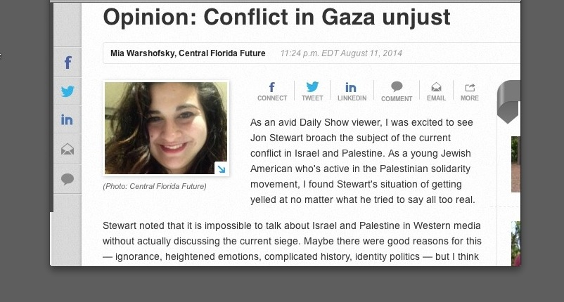
BRAINWASH VICTIM: Mia Warshofsky, a 19-year-old Jewish college student in Florida who is organizing boycotts of Israel, has never been there. Why bother, when she can rely on Western media outlets for her knowledge. (screenshot: Central Florida Future)
Speakers like Mandel and Dumisani Washington (of the Institute for Black Solidarity With Israel) are going to have their work cut out for them this autumn, as the boycott-Israel movement (BDS) on college campuses will likely be rocketing as never before. On Sunday, Haaretz focused on a few of those students who are desperately in need of history lessons and accurate media reports.
Among them: a Jewish sophomore in Florida named Mia Warshofsky. In a column she wrote on August 11th for her school paper, the 19-year-old teaches us that “an operation with a 76 percent civilian casualty rate is ineffective and disproportionate in scope. Targeting hospitals, schools, civilians and civilian infrastructure is not self-defense.” As she “cannot be complacent in the Israeli occupation,” she is planning to launch chapters of the Israel-hating Jewish Voice for Peace, and Students for Justice in Palestine, at her 60,000-student campus, the University of Central Florida.
Mia has never been to Israel.
Reading through her tedious repetition of the Hamas narrative, it’s hard not to wonder about the role played in molding her thinking by biased coverage of the Gaza conflict in the media. It’s as if an entire mythology of Israeli aggression and Hamas innocence has been foisted on the public by a media that is too feckless, too lazy, too prejudiced, and sometimes too just plain dumb to know any better. Regrettably, as history has taught us, bad journalism has made truth the first casualty of war.
A memorable line from the 1962 John Ford film “The Man Who Shot Liberty Valance” comes to mind. The main character, played by Jimmy Stewart, has just spent hours explaining to a frontier journalist why he did not in fact kill Liberty Valance, the notorious outlaw, but the myth nonetheless had propelled the Stewart character into a successful career in politics.
The journalist throws his notes into a fire and refuses to print the truth. The Stewart character asks why. The journalist replies: “This is the West, sir. When the legend becomes fact, print the legend.”
Substitute “Gaza” for “West” and the problem can be summarized in that one sentence.

