UNESCO NGO Forum 2017

May 3-4, 2017

http://unescongoforum2017.com/faqs/

FAQs

VISAS

WHAT YOU NEED TO KNOW
- For the purpose of the UNESCO NGOs Forum 2017, you will need to apply for a Business Visa.
- The passport MUST contain two blank visa pages side by side in order for the visa to be issued.
- A passport valid for at least six months. Final exit or exit/reentry visas are required to leave Saudi Arabia, and you will need six months’ validity to request such a visa. You should have at least two months’ validity left when you depart.
- For more detailed information, please reach out to the nearest Saudi Arabia Consulate or Embassy near you or visit the Saudi Arabia’s Ministry of Foreign Affairs website or other visa service provider.

TRAVEL AND TRANSPORTATION
To and/or from King Khalid International Airport

FOR PARTICIPANTS
- All arriving from outside Saudi Arabia should plan to arrive on Tuesday, 2 May 2017. Taxis from the airport to the forum venue, Four Seasons Hotel Riyadh at Kingdom Center, should not exceed SAR 70 or around USD 20. Uber service is also available.

WHERE TO STAY
The UNESCO NGOs Forum 2017 will be held at Four Seasons Hotel Riyadh at Kingdom Center.
Participants can stay in hotels nearby the UNESCO NGOs Forum 2017 venue including:

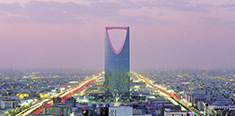

Four Seasons Hotel Riyadh at Kingdom Center
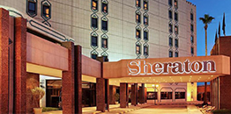

Sheraton Riyadh Hotel & Towers
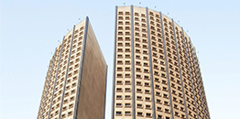

Four Points by Sheraton Riyadh Khaldia
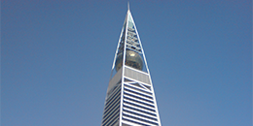

Al Faisaliah Hotel
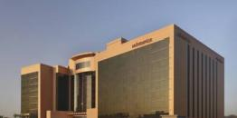

Mövenpick Hotel Riyadh
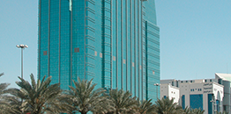

Novotel Riyadh Al Anoud
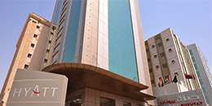

Hyatt Buyutat
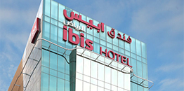

Hotel ibis Riyadh Olaya Street

CULTURAL AND LOCAL SPECIFICITIES

Dress Etiquette
Due to the conservative nature of the Islamic religion and practice in Saudi Arabia, travelers are advised to observe the following dress code when in public places:
- Men should wear long pants and shirts not open above the collar bone. For business meetings, a conservative suit is expected.
- Women are expected to dress conservatively. It is required to wear an Abaya, which is a long robe, usually black, that cover most of their body. Make sure to select clothes that cover arms and shoulders, and opt for long trousers in place of shorts.

Meeting & Greeting
- A handshake is generally accepted form of meet and greet.
- Due to the conservative nature of the Saudi society, men and women are reserved in their interaction in public.
- It is common for a Saudi to greet each person individually with a handshake while standing. Close male counterparts kiss on each cheek.
- It is uncommon for men to shake hands with women, unless women offer their hand first.
- Always use the right hand when engaging in a handshake, as the left hand is considered impolite.
- In conversations with a Saudi, it is considered polite to engage in small talk; learning a few Arabic greetings would be well received.

Arabic Greetings
Classical Arabic is the language of the Koran. A number of local Arabic dialects are used for spoken conversation in Saudi Arabia such as Hijazi (Western Province), Najdi (Central Province), and Khaliji (Eastern Province).
Useful Arabic words and phrases:
- God willing – Inshallah
- Welcome – Ahlan wa sahlan
- Hello – Marhaba
- How are you? – Kaif halak?
- Well – Tayyib; kuwais
- Please – Min fadlack
- Thanks – Shukran
- Yes – Naam
- No – La
- Sorry, excuse me – Mut-assif
- Good morning – Sabah ilkhair
- (reply) – Sabah ilnur
- Good evening – Masa’ ilkhair
- Goodbye – Ma’asalama
- Do you speak English? – Tatakallam inglizi?
- I don’t speak Arabic – Ma’ atakallam Arabi
- I do not know – Ma a’arif
- You honored us with your visit – Sharraftuna

Weather
Riyadh
38
May 9, 2017 Today
05:12 - 18:27
WindNE 3.6 km/h
Humidity13 %
Pressure1011 hPa
Cloudiness40 %
Precipitation0 mm
Wednesday
0 mm
21
39
Thursday
0.23 mm
22
32
Friday
0 mm
18
33
Saturday
0 mm
20
38
Sunday
0 mm
19
38
Monday
0 mm
19
40

Currency and Exchange Rates
From:
To:
Amount:

CHECKLIST

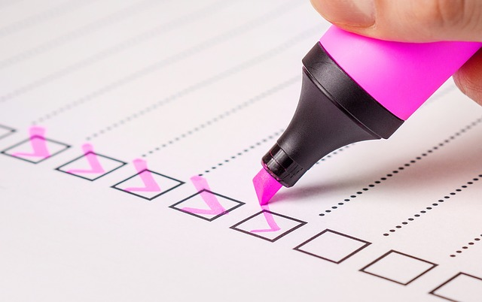
For speakers, moderators and invited delegates -You have received and printed your confirmation email and QR Code.
Your passport is valid and meets the visa requirements.
You have a printed copy of your airline ticket.
You have your hotel booking confirmation.

THINGS TO DO IN RIYADH
Riyadh is the capital of the Kingdom of Saudi Arabia. November to March is a popular time to visit, when temperatures are mild and there’s occasional rain.
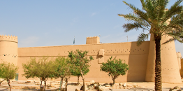
Al Masmak Fort
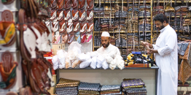
Deira Souk
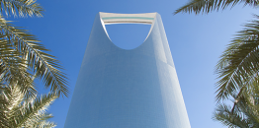
Sky Bridge at the Kingdom Center
Quad Biking at the Red Sand Dunes
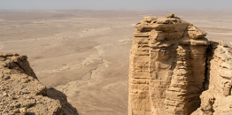
Edge of the World
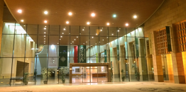
The National Museum
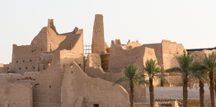
A Walk in the Past at the Historical Diriyah
Explore Riyadh Culinary Scenes

