Hamas Fires from Populated Area, Prevents Civilian Evacuation
IDF Blog
July 24, 2014
http://web.archive.org/web/20141012022246/http://www.idfblog.com/blog/2014/07/24/hamas/

In recent days, Hamas has fired rockets from an area of Beit Hanoun where an UNRWA shelter is located. Last night, the Israel Defense Forces told the Red Cross to evacuate civilians from UNRWA’s shelter in Beit Hanoun between the hours of 10 a.m. and 2 p.m. today. UNRWA and the Red Cross received the message.
Hamas prevented civilians from evacuating the area during the window that the IDF gave them.
Today, July 24, Hamas continued firing from Beit Hanoun. The IDF responded by targeting the source of the fire. Also today, several rockets launched from Gaza toward Israel fell short and hit Beit Hanoun.
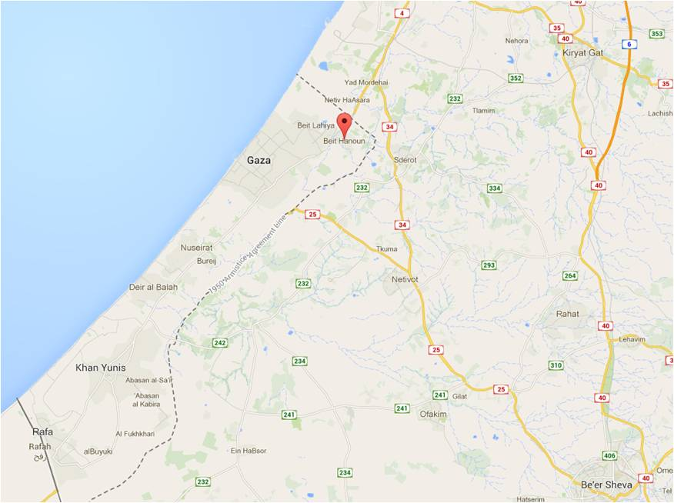
beit hanoun

