Hamas Indoctrinates Palestinian Youth after Kidnapping
IDF Blog
June 22, 2014
https://web.archive.org/web/20140806022329/http://www.idfblog.com/blog/2014/06/22/hamas-indoctrinates-palestinian-youth-kidnapping/

A short time after its attack against three Israelis, Hamas encouraged Palestinian youth to embrace its ideology of hatred and terrorism.
Pro-Hamas students glorified the kidnapping of three teenagers last week during two graduation ceremonies in Judea and Samaria. Just days later, the terrorist organization showcased a Hamas summer camp [EDITOR’S NOTE: LINK GOES TO A JUNE 13, 2013 IDF BLOG ARTICLE ENTITLED “Training Children for Terror: Hamas Summer Camps Aim to Indoctrinate Youth”] that provides military training to Palestinian children in Gaza.
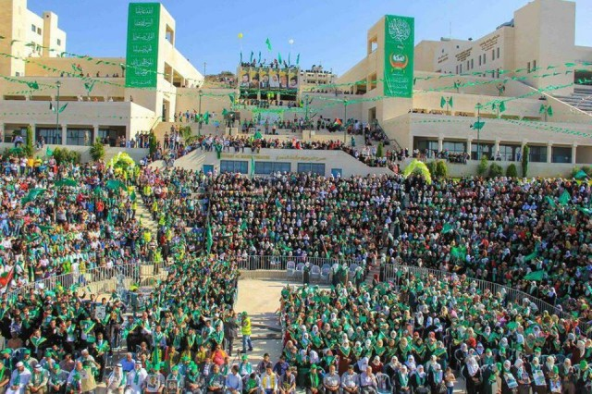
Last week’s events highlight Hamas’ extensive efforts to involve Palestinian youth in its terrorist activities. The organization uses Palestinian universities [EDITOR’S NOTE: LINK GOES TO A MARCH 26, 2014 IDF BLOG ARTICLE ENTITLED “Hamas Uses University as Bedrock for Propaganda”], summer camps and schools to spread its ideology of terror. The educational institutions are part of the ‘Dawa’ network, a social-welfare system that fuels support for Hamas violence.

Celebrating terror at Palestinian universities
During a graduation ceremony last Monday at An-Najah National University, thousands of attendees waved green Hamas flags in support of the terrorist organization. Dozens of graduates posed for a picture at the ceremony, holding up three fingers to represent three Israeli teens kidnapped by Hamas. The symbol has spread quickly throughout Palestinian communities as a sign of pride for the recent terror attack.
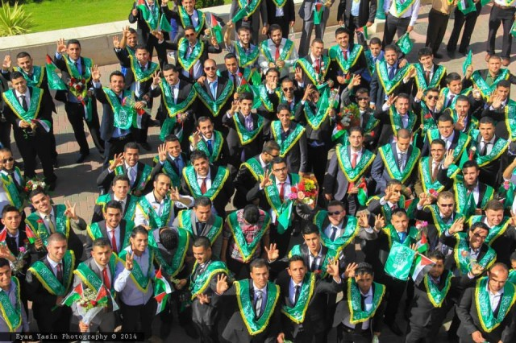
Massive banners at the ceremony paid tribute to terrorists including Ahmed Jabri, the former Hamas military chief who directed hundreds of terror attacks against Israel. In a second ceremony at Al-Quds university in Abu Dis, engineering graduates marched with signs reading “the Engineering Brigade of Al-Qassam,” a reference to the Hamas military wing. Like students at An-Najah, families of convicted terrorists held up three fingers in support of last week’s kidnapping.
In recent months, the university has hosted several events celebrating terrorist acts against Israel. Last March, Hamas held a major rally at Al-Quds glorifying violence. In November 2013, students marched in black military gear while holding mock weapons. They also offered the traditional Nazi salute as they trampled the Israeli flag.
Hamas students held a similar demonstration last month at Birzeit University. The students marched through campus carrying Hamas-made M-75 rockets, [EDITOR’S NOTE: LINK GOES TO A MARCH 11, 2014 IDF BLOG ARTICLE ENTITLED “Hamas Dedicates Gaza Square to Terrorist Rockets”] which terrorists fired at major Israeli cities in October 2012.

Summer camps and military schools
Just days after the graduation ceremonies, Hamas invited journalists to photograph its annual summer camp [EDITOR’S NOTE: LINK GOES TO A JULY 23, 2012 IDF BLOG ARTICLE ENTITLED “Hamas’ Summer Camps: Teaching Children to Hate”] for Palestinian children in Gaza. Nearly 100,000 children attend the camp, where they dress in military fatigues and take orders from Hamas terrorists.
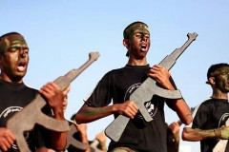
Children learn terror techniques at Hamas summer camp (Photo credit: AP)
Children learn terror techniques at Hamas summer camp (Photo credit: AP)
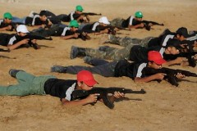
Children learn terror techniques at Hamas summer camp (Photo credit: AP)

Since its violent rise to power in the Gaza Strip in 2007, Hamas has been running these camps for the children of Gaza. The experience aims to promote Hamas’ ideology, teaching children the techniques behind kidnapping and terror attacks. Participants learn how to use weapons, and Hamas terrorists encourage them to participate in actual military operations.
“(You are) the generation of rocks, the generation of rockets, the generation of tunnels, the generation of the suicide bombings!” Hamas Prime Minister Ismail Haniyeh declared at a graduation ceremony for one camp in January 2014. “These summer camps emphasize that the Islamic enterprise, the Palestinian enterprise and the human Arabic enterprise are on the rise,” he said during an appearance on Hamas Al-Aqsa TV.
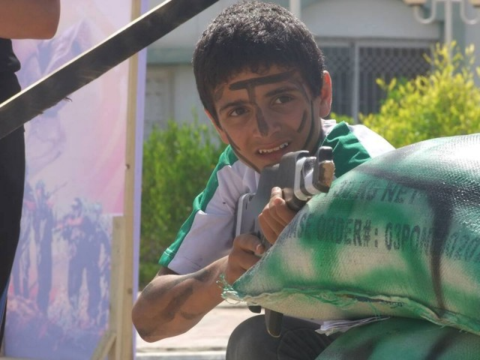
Hamas also operates training programs in Gazan schools, where for one hour a week terrorists from the Izz al-Din al-Qassam Brigades – Hamas’ military wing – train school boys to use Kalashnikov assault rifles and other forms of weaponry. This training makes use of the school’s facilities and takes place on school grounds.
In November 2013, Hamas introduced new textbooks [EDITOR’S NOTE: LINK GOES TO A NOVEMBER 7, 2013 IDF BLOG ARTICLE ENTITLED “New Hamas School Textbook Denies Israel’s Existence, Calls Jewish Holy Books ‘Fabricated’”] for 55,000 high-school students in the Gaza Strip. The textbooks deny the existence of Israel, do not mention the Oslo Peace Accords of the 1990′s, and describe Zionism as a racist movement which aims to drive all Arabs out of the area between Egypt and Iraq. This propaganda shows Hamas’ true face: as a terrorist organization which celebrates death and seeks to destroy Israel.

