Hamas Terrorists Behind Abduction of Israeli Teens
IDF Blog
June 13, 2014
https://web.archive.org/web/20140806024924/http://www.idfblog.com/blog/2014/06/13/three-israeli-teenagers-missing/

Hamas terrorists are responsible for the abduction of three Israeli teenagers last Thursday. Israeli forces arrested 80 Palestinian suspects last night in connection with the operation.
Palestinian terrorists kidnapped three Israeli teenagers late Thursday night in the Judea and Samaria region. On Sunday morning, the IDF confirmed that Hamas terrorists were behind the abduction.
IDF and Israeli security forces have been conducting a widespread operation for more than two days in an effort to find the Israelis and capture their kidnappers. The three teenagers – Eyal Yifrah, 19, Gilad Shaar, 16, and Naftali Frenkel, 16 – were last seen on Thursday night near Gush Etzion before being kidnapped by the Palestinian terrorists.
Following the abduction, IDF and Israeli security forces in Judea and Samaria began a search to find the kidnappers. Late Saturday night, security forces in Hebron arrested 80 Palestinian suspects in connection with the operation. 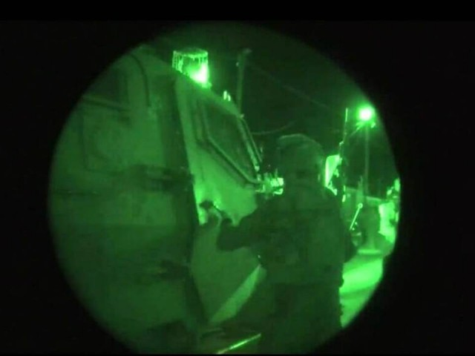
IDF Spokesman Brig. Gen. Moti Almoz said the IDF’s mission is to bring the three Israeli teenagers home safely and as soon as possible. “We are concentrating all of our intelligence efforts on trying to track down the missing individuals.”
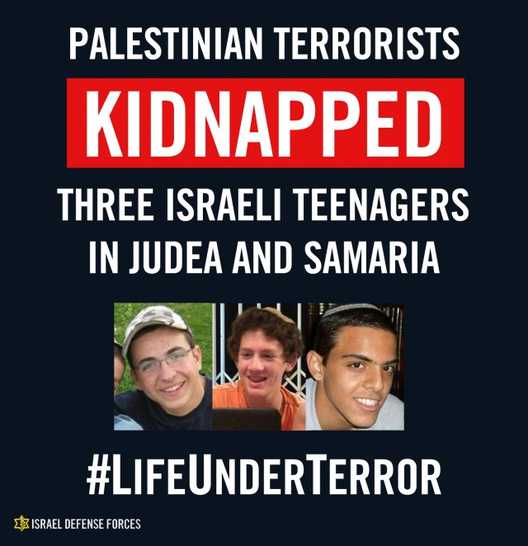

OFFICIAL ANNOUNCEMENT OF THE IDF CHIEF OF STAFF
IDF Chief of Staff Lt. Gen. Benny Gantz discussed the kidnapping publicly at a press conference Saturday night. “All of the IDF’s units have operated in close cooperation with Israel’s security organizations: the ISA (Shin Bet Security Service), the Israel Police and the Border Police,” the Chief of Staff said. “Under the guidance of Israel’s political leadership, the government, and the Defense Minister, we have operated for two days in growing scope and wherever needed.”
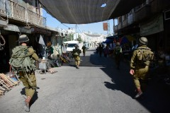
IDF Searches for Missing Teens in Hebron
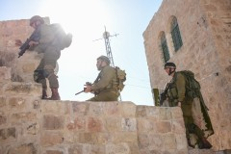
IDF Searches for Missing Teens in Hebron
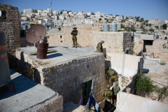
IDF Searches for Missing Teens in Hebron

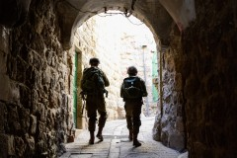
IDF Searches for Missing Teens in Hebron
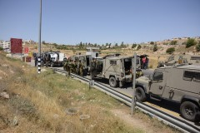
IDF Searches for Missing Teens in Judea and Samaria

“We will continue to do what’s necessary to bring this incident to an end as quickly as possible,” Lt. Gen. Gantz stressed. “We will keep a close eye on events in Israel’s various sectors — whether in Gaza or in the North — even as these events unfold. We remain determined to achieve our operational objectives, and will act with responsibility, poise and determination to accomplish whatever may be required of us.”

Kidnapping as a Tool of Terror
During the past two years alone, terrorists have attempted dozens of kidnapping attacks [EDITOR’S NOTE: LINK GOES TO A DECEMBER 4, 2013 IDF BLOG ARTICLE ENTITLED “Palestinian Terrorists Determined to Kidnap Israeli Soldiers”], and their motivation to abduct Israelis remains high. In many cases, their goal is to trade civilians or IDF soldiers for the release of Palestinian prisoners.
Hamas, the terrorist organization that rules the Gaza Strip, has put considerable effort into kidnapping attempts [EDITOR’S NOTE: LINK GOES TO A JUNE 13, 2013 IDF BLOG ARTICLE ENTITLED “Training Children for Terror: Hamas Summer Camps Aim to Indoctrinate Youth”] through its large network. With a heavy emphasis on preparations for abductions, the terrorist organization shares its knowledge, guidance and funds with its counterparts in Judea and Samaria.
In 2006, Hamas terrorists captured SFC Shalit, an Israeli soldier, and held him in captivity for five years. Terrorists viewed the kidnapping as a key accomplishment, increasing their determination to abduct Israelis and trade them for Palestinian prisoners.
In September 2013, a Palestinian terrorist kidnapped Sgt. Tomer Hazan [EDITOR’S NOTE: LINK GOES TO A SEPTEMBER 21, 2013 IDF BLOG ARTICLE ENTITLED “Joint IDF and ISA Operation Exposes Murder of an IDF Soldier”]. The terrorist lured Sgt. Hazan to the village of Siniria in central Judea and Samaria, where he murdered the soldier and concealed his body in a water well.
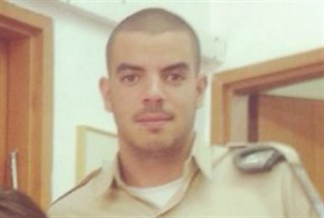
Sgt. Tomer Hazan, who was kidnapped and murdered by a Palestinian terrorist
During an Israeli interrogation, the murderer confessed that he had planned to use the soldier’s body to bargain for the release of his brother, imprisoned for involvement in multiple terror attacks.
Since 2013, the IDF and ISA have foiled over 64 kidnapping attempts. Hamas prisoners held in Israeli jails planned and directed the majority of these efforts.

A constant terror threat
In recent months, other terror attacks not involving kidnapping have led to the deaths of Israelis. Just one day after the murder of Sgt. Hazan, Palestinian sniper fire killed Sergeant Gabriel Kobi, age 20, in the city of Hebron.

Eden Atias, was stabbed by a Palestinian terrorist while he slept on an Israeli bus in the northern city of Afula.
In November 2013, a Palestinian terrorist stabbed Eden Atias, [EDITOR’S NOTE: LINK GOES TO A NOVEMBER 13, 2013 IDF BLOG ARTICLE ENTITLED “Terrorist Stabs IDF Soldier to Death on Israeli Bus”] an IDF soldier, while he slept on an Israeli bus in the northern city of Afula. Months later, on the eve of Passover, a Palestinian terrorist killed an Israeli civilian by opening fire on his vehicle on a main road in the area surrounding Hebron.
The safety of Israeli civilians is under constant threat: whether by way of rocket attacks, [EDITOR’S NOTE: LINK GOES TO A MARCH 12, 2014 IDF BLOG ARTICLE ENTITLED “In Response to Massive Rocket Attack, IDF Targets Terror Infrastructure in Gaza”] attempted kidnappings, [EDITOR’S NOTE, LINK GOES TO A JUNE 25, 2013 IDF BLOG ARTICLE ENTITLED “Seven Years Since Shalit Kidnapping: Motivation to Kidnap Still High”] suicide bombings [EDITOR’S NOTE: LINK GOES TO A DECEMBER 19, 2012 IDF BLOG ARTICLE ENTITLED “ISA: Terror Cell Responsible for Tel-Aviv Bus Bombing Arrested”] and even the slaughtering of children in their sleep [EDITOR’S NOTE: LINK GOES TO A MARCH 11, 2014 IDF BLOG ARTICLE ENTITLED “Today We Remember: The Fogel Family Massacre”]. The IDF’s soldiers remain on alert to prevent attacks, and will respond as necessary to protect Israelis from terrorists.
