Israel Accepts Ceasefires, Hamas Rejects Them
IDF Blog
August 1, 2014
http://web.archive.org/web/20140822080710/http://www.idfblog.com/blog/2014/08/01/israel-accepts-ceasefires-hamas-rejects/

Since the beginning of Operation Protective Edge, the IDF has agreed to five ceasefires. This morning, Hamas violated a ceasefire with Israel for the fifth time when it fired rockets and mortars into Israel and opened fire at IDF troops in the Gaza Strip. The IDF suspects that an IDF soldier was kidnapped during the confrontation.

A list of Hamas’ ceasefire violations:

15 July
The IDF suspended strikes for a period of 6 hours. During this time, Hamas fired 47 rockets into Israel.

17 July
Despite an agreement by Israel to observe a humanitarian ceasefire with Gaza at the request of the UN, Hamas fired three mortar shells and wounded an IDF soldier following the detonation of an explosive device on Israel’s border with Gaza. The IDF responded.

20 July
The IDF agreed to observe a humanitarian ceasefire in Shuja’iya at the request of the Red Cross. Hamas violated the ceasefire by continuing to fire at Israel from a rocket launching site located near the Wafa hospital in Shuja’yia.

26 July
For the fourth time, the IDF accepted a humanitarian ceasefire with Gaza. Hamas violated the ceasefire by firing more than six rockets into Israel.

1 August
The IDF agreed to a 72 hour ceasefire. Hamas used this opportunity to fire rockets into Israel and attack IDF forces in Gaza. During these clashes, a soldier may have been kidnapped by the terrorist organization.
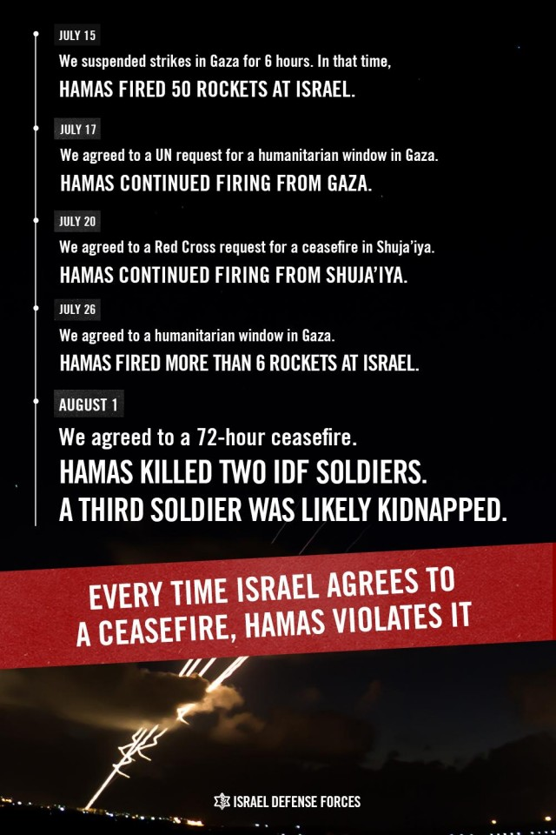
The IDF launched Operation Protective Edge in order to restore security to Israel and weaken Hamas.
Throughout the Operation, Hamas has prioritized terrorism over the needs of Gaza’s civilian population. Hamas’ violation of today’s ceasefire once again reveals the true face of the terrorist organization. Hamas’ goal is clear: to harm Israel, its soldiers and its civilians.
IDF forces in Gaza are making every effort to find the soldier who was kidnapped this morning. The IDF will do everything in its power to stop Hamas’ terrorism.

