Israel minimizes civilian casualties
Israel Ministry of Foreign Affairs
July 24, 2014
https://mfa.gov.il/MFA/ForeignPolicy/Issues/Pages/Israel-minimizes-civilian-casualties.aspx

The IDF strictly abides by the principles of international law, including the law of armed conflict, which calls inter alia to distinguish at all times between civilians and military forces.
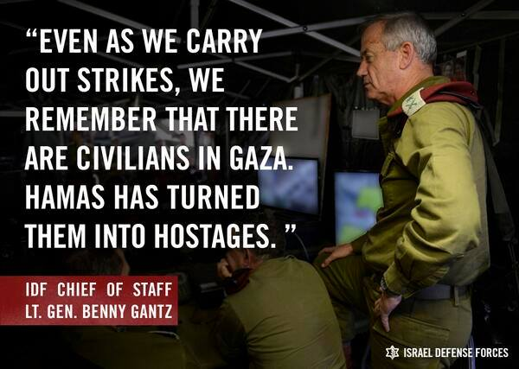
IDF Chief of Staff: Hamas turns civilians into hostages
Copyright: IDF Spokesperson
The Israel Defense Forces (IDF) has been doing its utmost to minimize harm to non-combatant civilians. The IDF strictly abides by the principles of international law, including the law of armed conflict, which calls inter alia to distinguish at all times between civilians and military forces, to take precautions to minimize civilian casualties, and to carefully consider the expected military gain of any action, weighed against potential collateral damage (the principle of proportionality).
Among the measures taken by the IDF to minimize the risk to Palestinian civilians are announcements about impending attacks in the form of phone calls, pamphlets and warning shots. In many cases missions have been aborted because civilians were identified dangerously close to the targets.
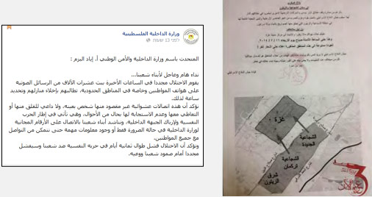
Flyer distributed by the IDF to warn the civilian population of Shuja'iya before an operation
Moreover, Israel’s commitment to international law is guaranteed by its strong democratic institutions, including an active and responsive legislature, efficient law enforcement mechanisms and an independent judiciary.
Phone Calls and Text Messages
As part of its efforts to minimize civilian casualties in Gaza, the IDF makes phone calls and sends text messages to civilians residing in buildings designated for attack. In the following video, you can hear a recording of an IDF soldier calling a Gazan to warn him of an impending airstrike in his vicinity.
​

[EMBEDDED VIDEO: https://youtu.be/7yvQz3SQxGI]

Leaflets
The Israel Air Force has dropped leaflets over Gaza that warn civilians to avoid being present in the vicinity of Hamas operatives. These leaflets urge civilians to move away from Hamas targets, making clear Israel’s intention to minimize civilian casualties. Since the operation began, Hamas has repeatedly instructed Palestinians to ignore these warnings.

Abandoning Air Strikes
The IDF has aborted aerial strikes seconds before they were to be carried out, due to civilians being present at the site of the target. The following video shows how IAF airstrikes were called off when civilians were identified in the area.
​
[EMBEDDED VIDEO: https://youtu.be/yE7ykidY7FA]

On July 9, Palestinians fled a Hamas target after the IAF fired a warning shot. Moments later, people in the surrounding area flocked to the roof of the target, acting as human shields. The IAF called off the strike to avoid civilian casualties.
​

[EMBEDDED VIDEO: https://youtu.be/VTArVIHDelg]

