Some of the NGOs contributing to the UNDAF report
(prepared by Human Rights Voices)
Al-Haq:
- “So I think a question that I would like to see answered or a general opinion is, is the Jewish religion being exploited for economic gains by a key elite segment within Israeli society? And are they the ones that are driving this conflict...”

(Excerpt from “Oral Statement by Al-Haq, UN Forum to Mark Fifty Years of Occupation,” June 29, 2017, Al-Haq, Accredited by ECOSOC and by CEIRPP, last accessed on October 15, 2017)

- “Much of the Israeli economy is controlled by a select number of holding companies, or groups, or families. And these issues, I think, allow us to look at this issue of the economic interests...The Jewish community as a whole when this issue of economics playing a role in perpetuating the conflict leads to the question...[I]s this conflict continuing in order to line the pockets of key individuals? And is the Jewish faith being used and exploited in the same way that the natural resources of Palestine are being exploited to achieve these ends?”

(Excerpt from “Oral Statement by Al-Haq, UN Forum to Mark Fifty Years of Occupation,” June 30, 2017, Al-Haq, Accredited by ECOSOC and by CEIRPP, last accessed on October 15, 2017)

- “[T]he time has come for a call for sanctions against Israel at the UN Security Council - including … divestments from Israel, the suspension of the EU/Israel association agreement and a halt on all military trade and cooperation with Israel.”

(Excerpt from “Urgent resolution on Palestine Presented by Al-Haq for the 39th FIDH Congress,” 23- 27 August 2016, International Federation for Human Rights, Accredited by CEIRPP, last accessed October 15, 2017)

- “Israel’s colonizing ideology remains the same as it was in 1948: to fragment and control as much of historic Palestine as possible while exploiting its natural resources, and to remove the indigenous Palestinian people from their lands.”

(Excerpt from “Oral statement by Al-Haq, Law in the Service of Man, Agenda Item 7, 35th Session, UN Human Rights Council,” June 19, 2017, Al-Haq, Law in the Service of Man, Accredited by ECOSOC and by CEIRPP, last accessed on October 15, 2017)

- “The deliberate targeting of Palestinian children has become a notable feature of the Israeli occupation in the OPT...the Israeli Occupation Forces (IOF) have long killed, beaten, tortured, arrested and arbitrarily detained Palestinian children.”

(Excerpt from “Special Focus on Palestinian Children: Targeting Palestine Through Its Future,” Al- Haq, Law in the Service of Man, Accredited with Special Consultative Status by ECOSOC, last accessed on August 25, 2016)

- “Israel’s conduct represents a series of measures designed to establish and maintain the domination of one racial group over another. Such domination by the Jewish group is associated with transferring control over land and natural resources, including water, to exclusively Jewish use...This reveals the true nature of this occupation as one that enables Israel to maintain a regime of apartheid.”

(Excerpt from “Statement at the UN Committee on the Elimination of Racial Discrimination, 80th Session,” Al-Haq, Law in the Service of Man, Accredited with Special Consultative Status by ECOSOC, last accessed on August 25, 2016)

- “Each year, on 15 May, ‘Nakba Day’ commemorates the anguish of those who were expelled from their homes...While the term Nakba is seen as a reference to the murder, exile and devastation of the 1948 war, in reality, it could just as easily be used to describe the current belligerent occupation...Palestinians in 2012 still experience ‘the catastrophe’...an uninterrupted stream of violations of international law that began more than sixty years ago.”

(Excerpt from “The Nakba: The Perpetuation of an Unwanted Legacy,” Al-Haq, Law in the Service of Man, Accredited with Special Consultative Status by ECOSOC, last accessed August 25, 2016)

- “…[W]e refer Member States of the UN to the following remedial actions that could and should be undertaken... 3. Freezing the assets of legal and natural persons responsible for violation in international law; 4. Downgrading diplomatic relations with States committing and abetting these offenses; 5. Ending cooperation with Israel’s parastatal institutions involved in funding or maintaining Israel’s illegal settlement enterprises (including the World Zionist Organisation, the Jewish Agency, the Jewish National Fund, the United Israel Appeal, Mekorot and its affiliates) and revoking their privileged charitable status; 6. Imposing international and domestic sanctions on institutions supporting, or benefitting from settler colonies and/or natural-resource extraction in Palestine; 7. Withholding weapons, building materials, equipment and services that maintain the settler colony regime... 9. Reviewing any assistance to, or cooperation with, the State Israeli [sic], which may directly or indirectly aid the settler colony regime.”

(Excerpt from “Joint written statement by Al-Haq, BADIL, Al Mezan and Habitat International Coalition to the UN Human Rights Council, Agenda Item 7, May 31, 2013,” Al-Haq, Law in the Service of Man, BADIL Resource Center for Palestinian Residency and Refugee Rights, Al Mezan Centre for Human Rights, and Habitat International Coalition, Accredited with Special Consultative Status by ECOSOC, last accessed on August 25, 2016)

- "The deliberate targeting of Palestinian children has become a notable feature of the Israeli occupation in the OPT... the Israeli Occupation Forces (IOF) have long killed, beaten, tortured, arrested and arbitrarily detained Palestinian children."
(Excerpt from "Special Focus on Palestinian Children: Targeting Palestine Through Its Future," Al-Haq, Special Consultative Status ECOSOC)
- "The rioting of Palestinian youth against the Israeli occupation is a sign of deep frustration...The current unrest should, therefore, be viewed in the broader context of Israel's colonial occupation and its harmful policies."
(Excerpt from "Special Focus on Palestinian Children: Targeting Palestine Through Its Future," Al-Haq, Special Consultative Status ECOSOC)
Al Mezan Centre for Human Rights:

- “To mark the 69th anniversary of the Nabka … [t]he Global Palestinian Refugee and IDP Network released a statement … and Al Mezan called on the international community to support the right to self-determination of the Palestinian people.” (NGO Action News, UNISPAL (a UN) website)

Editor’s note: The words “Al Mezan” on the UNISPAL website are a direct link to the following: “Monday, 15 May 2017, marks the 69th year since the Nakba, or the Catastrophe – one of the largest ethnic cleansings in modern history…”

(Excerpt from “NGO Action News, May 26, 2017,” BADIL Resource Center for Palestinian Residency and Refugee Rights, Accredited by ECOSOC, and Al Mezan, Accredited by ECOSOC and by CEIRPP, last accessed on October 15, 2017)

- “The Palestinian people’s heroic resilience and resistance to Israel’s denial of the Right of Return...”

(Excerpt from “66 years of ongoing Nakba – Back to Basics: The Right of Return is a national and inalienable right,” Al Mezan Centre for Human Rights, Accredited with Special Consultative Status by ECOSOC, last accessed on August 25, 2016)

Palestinian Centre for Human Rights:
- “The Palestinian Centre for Human Rights released its annual report on 20 June.” (NGO Action News, UNISPAL (a UN) website)

Editor’s note: The words “Palestinian Centre for Human Rights” on the UNISPAL website is a direct link to the following:
“Israel has aimed at seizing more lands from the oPt for years to create a Jewish majority through ethnic cleansing of its indigenous people… Israel also continued to create a Jewish majority in occupied Jerusalem… Israel tightened the noose on the city’s indigenous people…in order to implement a full ethnic cleansing project… Moreover, the Israeli systematic practices have created a new pattern of apartheid…”

(Excerpt from “NGO Action News, June 23, 2017,” Palestinian Centre for Human Rights, Accredited with Special Consultative Status by ECOSOC and accredited by CEIRPP, last accessed on October 15, 2017)

- “…the reality of the Israeli apartheid policy against Palestinians that has started since its establishment in 1948.”

(Excerpt from “Position Paper: Palestinian Human Rights Organizations Council (PHROC) Withdrawing ESCAW Report is Complicity: Rima Khalaf, Richard Falk and Virginia Tilley and the New Approach to End Occupation,” March 22, 2017, Palestinian Centre for Human Rights, Accredited with Special Consultative Status by ECOSOC and accredited by CEIRPP, last accessed on October 15, 2017)

- “…Raji Sourani, human rights lawyer and founder of PCHR [Palestinian Centre for Human Rights], gave an interview published on 16 July 2014.” (NGO Action News, UNISPAL (a UN) website)

Editor’s note: The word “interview” on the UNISPAL website is a direct link to the following: “The most important feeling is when you feel your soul and the souls of the people you love are so cheap, and your suffering and your blood so cheap, and there is only one blood and soul that is holy, which is Israeli Jews, you just lose your mind.”

(Excerpt from “NGO Action News, July 18, 2014,” Palestinian Centre for Human Rights, Accredited with Special Consultative Status by ECOSOC and accredited by CEIRPP, last accessed on August 25, 2016)

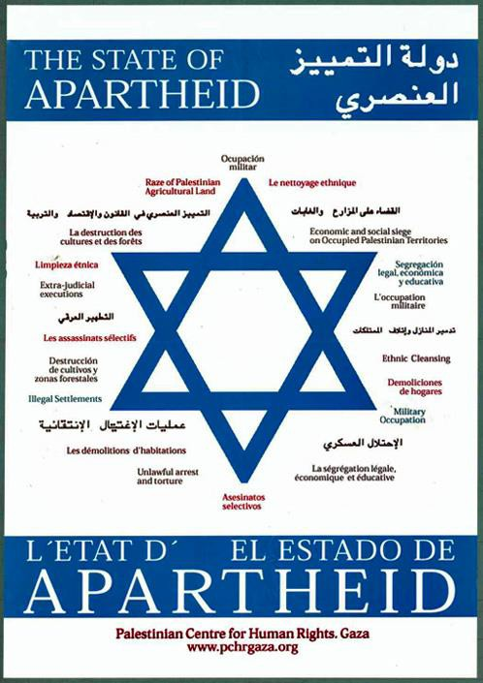

(Excerpt from “Palestinian Centre for Human Rights Poster, The State of Apartheid,” Palestinian Centre for Human Rights, Accredited with Special Consultative Status by ECOSOC and accredited by CEIRPP, last accessed on August 25, 2016)

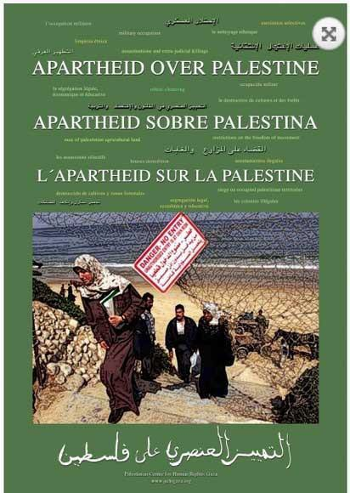

(Excerpt from "Apartheid Over Palestine," Palestinian Centre for Human Rights, Accredited with Special Consultative Status by ECOSOC and accredited by CEIRPP, last accessed on August 15, 2016)

Palestinian NGO Network (PNGO):
- “Palestinians, like any other people, have the right to resist foreign domination, exploitation, oppression and occupation ‘…by all available means including armed struggle.’”
(Excerpt from “PNGO calls upon the international community: Don't use aid to undermine legitimate Palestinian resistance,” April 5, 2017, Palestinian NGO Network, Accredited by CEIRPP, last accessed on October 15, 2017)

- “…Israel’s active policy of ethnic cleansing of Palestinians from their homeland...Since September 2000, Israel, whether through their military or through settler violence has systematically murdered 6876 Palestinian civilians, of which a quarter of them were children.”

(Excerpt from “PNGO urges international community to end Israel’s endemic impunity with regards to their ethnic cleansing policies,” Palestinian NGO Network, Accredited by CEIRPP, last accessed on August 25, 2016)

