Photo: Summer camp in a bomb shelter
IDF Blog
July 9, 2014
http://web.archive.org/web/20151117201323/https://www.idfblog.com/blog/2014/07/09/israel-fire-life-comes-halt/kids/

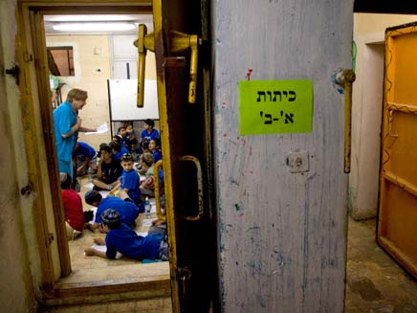
Summer camp in a bomb shelter

