Report: Hamas Terror Activity in Gaza
IDF Blog
July 22, 2014
https://web.archive.org/web/20140806022347/http://www.idfblog.com/blog/2014/07/22/report-hamas-terror-activity-in-gaza/

As the IDF continues its operation to dismantle terrorist infrastructure in Gaza, Hamas continues to implement inhumane measures against Israeli and Palestinian civilians. On a daily basis, Hamas commits war crimes and ignores threats to human life in Gaza.
Hamas routinely violates international law. The terrorist organization doesn’t stop at targeting Israel civilians with rockets, it also puts Gaza’s civilians in the line of fire and uses them as human shields.
The IDF launched Operation Protective Edge to combat Hamas’ rocket fire and its use of tunnels to attack Israelis. Throughout the operation, Hamas has shown its true face, committing war crimes against Israel and endangering its own people. Here are just a few examples:

Firing rockets at the civilian population
Since July 8, Hamas and other Palestinian terrorist organizations have fired over 1,840 rockets at Israel. This rocket fire is aimed at civilians. It targets Israeli cities and communities, with the objective of killing civilians.
Hamas has fired rockets at Israel’s largest cities, including Tel Aviv, Jerusalem and Haifa. The organization does not distinguish between military targets and civilians. It sees the entire Israeli population as a legitimate target.
[EMBEDDED VIDEO: http://humanrightsvoices.org/site/documents/?d=21968]

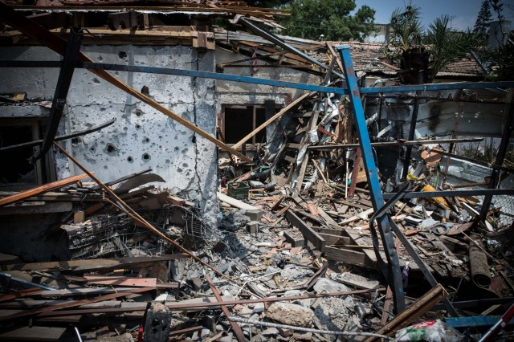
A rocket fired by Hamas destroyed this house in Yehud, Israel 22/7/2014

Directing civilians to act as human shields
Hamas officials urge civilians in Gaza to act as human shields. Palestinians are ordered to stand on the roofs of houses used for terror. This tactic endangers human lives for the sake of protecting terrorists from IDF strikes.

[EMBEDDED VIDEO: http://humanrightsvoices.org/site/documents/?d=21962]

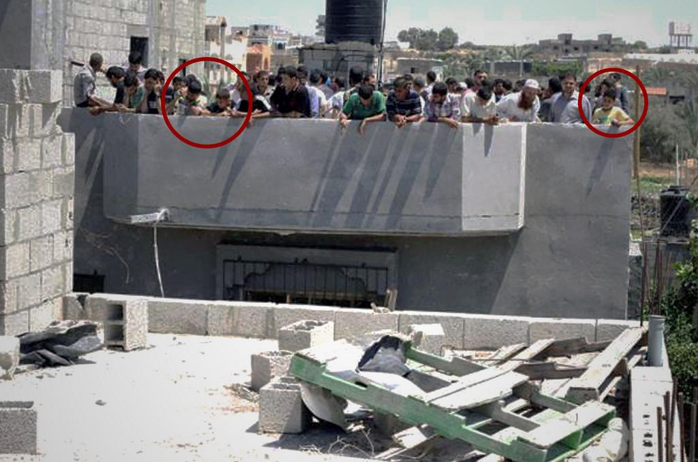
Hamas urges civilians, including children, to stand on the roof of a target where the IDF has warned of an impending strike.
When the IDF warns residents of an impending airstrike, Hamas urges Palestinians to stay where they are, despite the danger to their lives.

Hamas instructs Palestinians in Gaza not to follow the IDF’s instructions to evacuate their homes pic.twitter.com/Znh42xMLK8
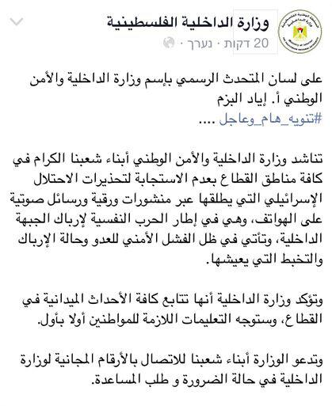
— IDF (@IDFSpokesperson) יולי 12, 2014

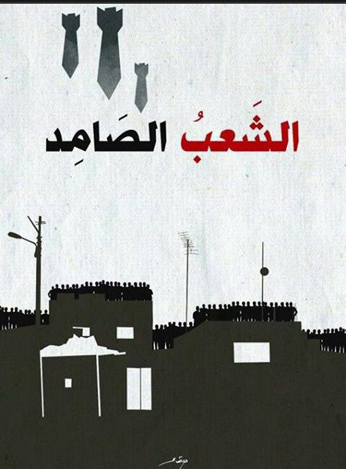
“A strong people” written in Arabic–word play on the name Hebrew name of Operation Protective Edge–encouraging Palestinians in Gaza to stand on the roofs of their homes to act as human shields.

[EMBEDDED VIDEO: http://humanrightsvoices.org/site/documents/?d=21838]

Attempted massacres in Israeli communities
On Saturday, July 19, a squad of Hamas terrorists climbed out of a tunnel near the Israeli community of Sufa, a few kilometers from the Gaza border. The terrorists, who were heavily armed, planned to enter a Kibbutz and carry out a massacre. IDF forces stopped the infiltrators and prevented the terror attack.

[EMBEDDED VIDEO: http://humanrightsvoices.org/site/documents/?d=21817]

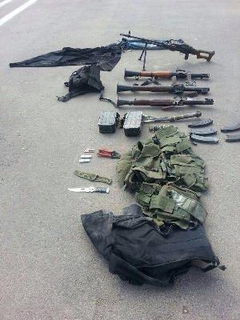
Weapons Found in Sufa Massacre Attempt
On Monday, July 21, Hamas terrorists infiltrated Israel through a second tunnel. They entered Israeli territory one kilometer away from the city of Sderot. Their plan was to kill Israeli civilians, but IDF forces stopped their attack.
[EMBEDDED VIDEO: http://humanrightsvoices.org/site/documents/?d=21922]

Using ambulances for terror activity
On Thursday, July 17, a Hamas terrorist in Gaza ran into an ambulance when an IDF aircraft targeted him. The IDF called off the strike so as to not hit the ambulance. The terrorist was using the ambulance and its staff to protect himself.

[EMBEDDED VIDEO: http://humanrightsvoices.org/site/documents/?d=21934]

Rigging civilian homes with explosives
On Saturday, July 19, IDF soldiers found a civilian home in Gaza rigged with Hamas explosives.
[EMBEDDED VIDEO: http://humanrightsvoices.org/site/documents/?d=21929]

Hiding weapons near civilians
Hamas hides its weapons close to civilians. The objective is to shield its weapons from IDF strikes, making them much more difficult for the IDF to target. Hamas places weapons storage facilities, rocket launchers, and rocket manufacturing centers in the middle of Palestinian neighborhoods. Many of its assets are located inside homes, schools and mosques.
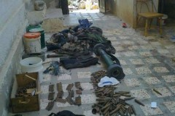
Weapons and Ammunition Found in Gaza Tunnel
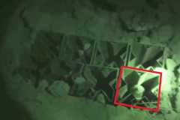
Grad rocket launcher found in a Gazan school
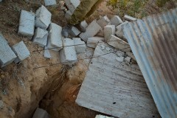
Terror tunnel near a house in Gaza

On Thursday, July 17, twenty Hamas rockets were found in a school belonging to UNRWA in Gaza. “(The incident) endangered civilians including staff and put at risk UNRWA’s vital mission to assist and protect Palestinian refugees in Gaza,” the UN commented.
On July 10, the IDF targeted a rocket launching site located in the middle of a Gaza neighborhood. The strike caused a large secondary explosion, proving that rockets and explosives were being held near civilian institutions.
[EMBEDDED VIDEO: http://humanrightsvoices.org/site/documents/?d=21955]

Firing from within the civilian population
Hamas fires rockets at Israel from within populated areas. This strategy is meant to prevent the IDF from striking Hamas terrorists and infrastructure. The terrorist organization also fires at IDF forces from civilian areas using short-range arms.

[EMBEDDED VIDEO: http://humanrightsvoices.org/site/documents/?d=21841]

