The UN has blood on its hands: Denying Israel’s right of self-defense must stop
OCT 15, 2023, 5:43 PM
By Anne Bayefsky
The Times of Israel
https://blogs.timesofisrael.com/the-un-has-blood-on-its-hands-denying-israels-right-of-self-defense-must-stop/

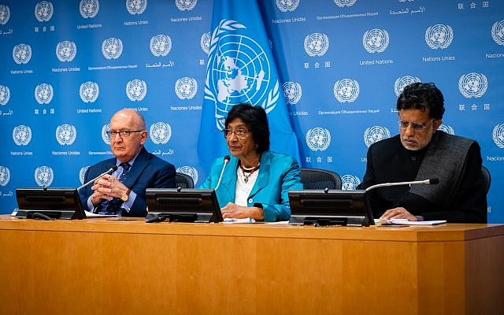
UN Commission of Inquiry. Chris Sidoti (left), Chair Navi Pillay (center), Miloon Kothari (right)
The butchery of 1,300 Israelis in a single day and the UN response to the atrocity have made one fact crystal clear: the United Nations has Jewish blood on its hands. Its role as an enabler of Palestinian terrorism must be front and center in the days ahead as its agents seek to deny the Jewish state the existential right of self-defense and fuel a global antisemitic pogrom.
On November 29, 1947, when the Jewish population had been decimated through unimaginable horrors by the Nazis, and the remnants of the Jewish people sought refuge and self-determination in their ancestral homeland, the UN General Assembly adopted a resolution to establish a Jewish state and another Arab state in the Middle East. On November 28, 1947, the Pakistani UN Ambassador railed against the decision, vowing “the Arabs of Palestine will not cooperate in setting up the Arab state…If the Arabs will not co-operate, as they will not, even the Jewish State will not be viable.” Seventy-five years later, the playbook hasn’t changed.
On October 9, 2023, two days after a slaughter of Jews unprecedented since the Holocaust, the Pakistani Ambassador to the UN in Geneva – speaking on behalf of all 56 Islamic states and the Palestinians – objected to “seven decades of foreign occupation.” He made the endgame very plain: the destruction of the Jewish state. He asked the states sitting in attendance at a UN Human Rights Council meeting to stand and join him in a minute of silence for “the victims of decades of foreign occupation in the Occupied Palestinian Territory.” And they did.
Jewish bodies were still unidentified and unburied. The dead were still being found and counted. The hospitals were still full of the injured. The accounts from survivors and first-responders of rape, beheadings, torture, mass murder, abduction of babies, families, the elderly and the disabled were still pouring in.
And the United Nations – a global powerhouse with an annual budget from all sources of fifty-billion dollars a year – immediately lined up to demonize the state of Israel.
It is vital to understand that war for Palestinian Arabs, and Arab and Islamic states that reject coexistence with Jews, has long had two phases. The first is the murder of Jews. The second is commandeering the United Nations to deny the Jewish state a right to defend itself, and to enable a repeat of the first phase until their goal is accomplished. Phase two includes hijacking and perverting international “law” and the principles of universal human rights to serve as tools of warfare and antisemitism.
United Nations forces are already coalescing around phase two – in effect, doing the political dirty work of Hamas and its partners. The incoming deluge of charges of human rights violations will confuse and disorient. Hence, set out below is a timeline of the reaction of the United Nations, its top actors and bodies, to events in the initial days of the war, October 7 to October 10. In those terrible and terrifying moments, when Israel was attacked and desperately seeking to eliminate the enemies operating inside its territory – while under rocket fire and facing two other active fronts – the character and agenda of the United Nations was laid bare.
From the outset, UN actors refused to acknowledge or support Israel’s right of self-defense. This fundamental right of every UN member state was never mentioned even once by the Security Council, the General Assembly, the Human Rights Council, the Secretary-General, or the UN High Commissioner for Human Rights.
Instead, UN officials reacted immediately by condemning Israel and finding ways to excuse and diminish the actions of its mortal enemies. The United Nations has revealed both a deep moral turpitude and its identity as an instrument of modern antisemitism. The demonization and attempted elimination of Israel may come from the barrel of a microphone, but make no mistake: it aims to be deadly.
The UN is not a neutral party in this war. Its actors are partisans, and their dishonest campaigns of unrelenting Israel-bashing and disinformation will only get louder and more frenzied in the days and weeks ahead. The noise should not obscure some basic features of every UN/Palestinian–Israeli war.
One: UN statistic-gatherers rely heavily on Hamas sources, who lie. Palestinian terrorists seek to inflate casualty numbers, and the UN has repeatedly obliged. Over the last few days, the UN has been continuously announcing alleged numbers of dead and injured in Gaza without disaggregating casualties into terrorists and civilians. And yet killing the armed combatants of the enemy during a time of war is not illegal.
Two: UN sources constantly misrepresent international law, claiming that any civilian casualty is a war crime. In fact, the rules prohibit targeting civilians, and they recognize that within limits, civilian collateral damage or indirect harm is an unfortunate, but legal, cost. Hamas’ use of the Palestinian civilian population of Gaza as its human shield is both a war crime, and a win-win for Hamas precisely because of the UN’s falsification of legal standards.
Three: UN players continually paint a picture of hundreds of thousands, even million(s) of Palestinians in Gaza negatively impacted by Israel and small numbers of Israelis harmed by comparison. Even the unimaginable number of 1,300 Israelis butchered almost one-by-one and at point-blank range is a blip to be overcome by numbers of suffering Palestinians. These scales are totally skewed. Not only does the UN ignore Hamas’ responsibility for the negative consequences of their actions for the local civilian population, they ignore the massive effect of the unprecedented butchery on Israelis.
Three to four million Israelis forced in and out of bomb shelters for days. Thousands of people and their thousands of friends and relatives burying the dead and observing the periods of mourning. Schools closed. Parents unable to go to work. Airline services cut. Entire communities laid waster. The over 300,000 people called to serve in the Israel Defense Forces (IDF) in order to protect themselves and their families from the homicidal fanatics next door.
Also not counted in UN “statistics”: the suffering of millions of Israelis (and Jews around the world) – today’s remnant of the Jewish people still traumatized by the Holocaust. Their pain comes both from the events themselves, and from the enormous stress and fear of the sacrifices they know are to come against an enemy without a shred of human decency.
None of it counts for the UN.
The failure of the United Nations to recognize and acknowledge the colossal human resources, both tangible and intangible, physical and emotional, required from a society that is forced to wage war in order to survive, is inexcusable. It is egregious discrimination against the self-determination of the Jewish people.
It’s called “double-discrimination.” First, the perpetrator belittles or minimizes the initial suffering of the attack itself. Second, the perpetrator does everything possible to gut the right of self-defense.
Four: Another feature of UN/Palestinian–Israeli wars relates to the fact that the UN has no definition of terrorism. This is because Islamic states refuse to include targeting Israelis within any definition. The UN is content to have the meaning of “terrorism” be fluid and ambiguous, which suits Palestinian terrorists just fine. As then Ambassador Nikki Haley said: “the United Nations has never once passed a resolution condemning Hamas. Never.”
Five: There’s the “good cop” routine of the Palestinian Authority (PA). On October 8, 2023, prior to the UN Security Council’s closed session, Riyad Mansour met the press. His statement – less than 48 hours after mass atrocities by Palestinians against Israels – is further evidence of a Palestinian violence-UN exculpatory two-step. He had a familiar agenda:
- Prevent the Council from issuing a statement supporting Israel’s right of self-defense: “We know only too well that the messages about Israel’s right to defend itself will be interpreted by Israel as license to kill.”
- Switch perpetrator and victim: “Where is the international protection the Palestinian people is entitled to?…We are not subhumans. We will never accept a rhetoric that denigrates our humanity and reneges our rights,”
- Issue threats of violence: “If this is about vengeance, then many Palestinians will feel they have much to avenge… Israel cannot wage a full-scale war on a nation, its people, its land, its holy sites, and expect peace in exchange.”
- Repeat the reference to 1948 and the creation of the Jewish state as the original problem: “Israel has announced dozens of times that it had handled the Palestinian problem by war against our people or peace with others since 1948.”
Hamas couldn’t have said it any better. The Security Council stayed silent.
We can understand UN actions going forward – and give them the disrespect they deserve – by recognizing, firstly, that they are rooted in an effort to hogtie Israel from the very start. And secondly, that they are part of a deliberate failure to acknowledge the real root cause of this war, and every other Arab attempt to annihilate the Jewish state: antisemitism.
What this timeline of Palestinian aggression and UN responses proves, therefore, is that regardless of what pours forth from the gigantic UN apparatus from this point on, UN words and actions will line up on the Palestinian side. The barrage of UN attacks will not stem from some authoritative or superior insight into the true meaning of this or that rule of international humanitarian or human rights law, but from the mind of a hired gun. In fact, the former UN “rapporteur” on Israel did such a splendid job trashing Israel that the Palestinian Authority announced last month that he’s joined their legal team.
The timeline below is in Eastern Time (ET), and the times of events in Israel are approximate. The sources of information on events as they unfolded were deliberately chosen to be those that were easily available to anyone. Online IDF sources and online CNN news updates. The timeline generously assumes that UN actors learned of the facts at the same time as everyone else and not before. It therefore tells us: “What the UN knew and when they knew it.”
Timeline
Friday, October 6 and Saturday, October 7, 2023
What the world knows between the hours of 11:35 p.m. on Friday night and 5:00 a.m. on Saturday morning, is that an unprecedented attack on the State of Israel has begun. Thousands of rockets directed at Israel’s civilian population, others indiscriminate, fired in a very short timeframe. A sizeable infiltration of Hamas and other Palestinian terrorists from Gaza into Israel. Hostages taken. People around Israel forced into shelters, including in its most populous cities. An invasion into Israel by Hamas and other Palestinian terrorists from land, sea and air (using paragliders and drones), fighting within Israel in multiple locations including at the official crossing between Gaza and Israel, and in civilian communities and army bases. Reports have already begun to emerge of horrific scenes of violence and many Israeli fatalities and injuries.
First on the scene: At 5:00 a.m. UN Special Coordinator for the Middle East Peace Process, Tor Wennesland:
“I am in close contact with all concerned to urge maximum restraint and call on all sides to protect civilians.”
He is unable to distinguish victim and aggressor. Analogizes the people of Israel to the terror organization Hamas and other Palestinian terror organizations. And in his pathetic effort to appear even-handed, he calls on the genocidal Islamic Resistance Movement (Hamas) to restrain itself.
Between 5:21 and 6:47 a.m., the world knows that 2,200 rockets have been fired into Israel in only six hours, 22 dead and 250 casualties have been reported, Israeli first responders in the Magen David Adom have suffered casualties, there are 21 active fronts within Israel itself, and videos are emerging of Hamas atrocities directed at civilians, families, women and children.
In comes Volker Türk, UN High Commissioner for Human Rights at 6:51 a.m. He says:
“I call for an immediate stop to the violence, and appeal to all sides and key countries in the region to de-escalate to avoid further bloodshed.”
The unprecedented attack on Israel is only 8 hours old, and Israel is already being told to stop doing anything “violent” and calm down. Telling Israel to avoid further bloodshed, is in effect, advice to drop dead. The appeal to “all sides” from the UN’s top human rights official is moral bankruptcy.
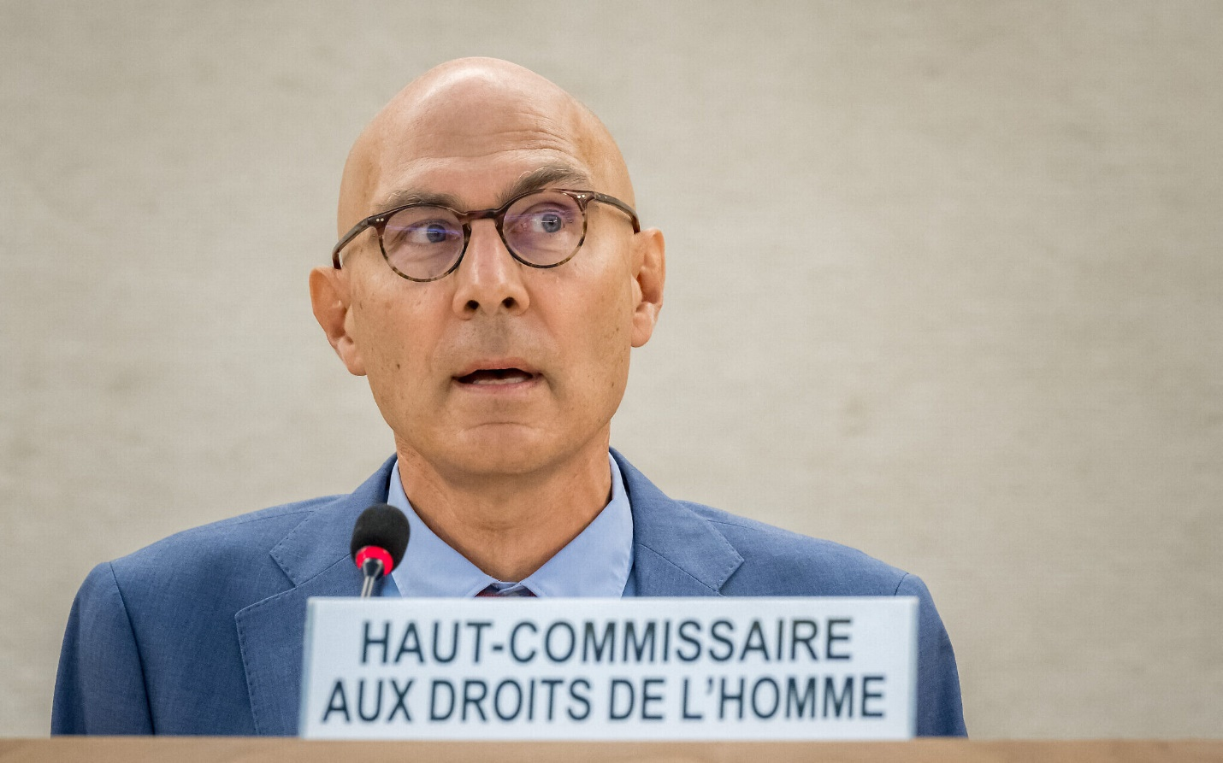
UN High Commissioner for Human Rights Volker Turk, 54th UN Human Rights Council in Geneva, on September 11, 2023. (Fabrice COFFRINI/AFP)
New reports within ten hours of the start put the death toll at 40 with 779 wounded in Israel and Israel now suffering a mass infiltration by Hamas terrorists in multiple locations.
At 9:46 a.m. here comes the UN “Special Rapporteur for the Situation of Human Rights in the Occupied Palestinian Territories” Francesca Albanese. She says:
“Today’s violence must be put in context. Almost six decades of hostile military rule over an entire civilian population…are in themselves an aggression.”
She is a cheerleader for Hamas. Her UN job description gives her a global platform to serve as the political front for terrorists who are dedicated to killing Jews. That’s her context.
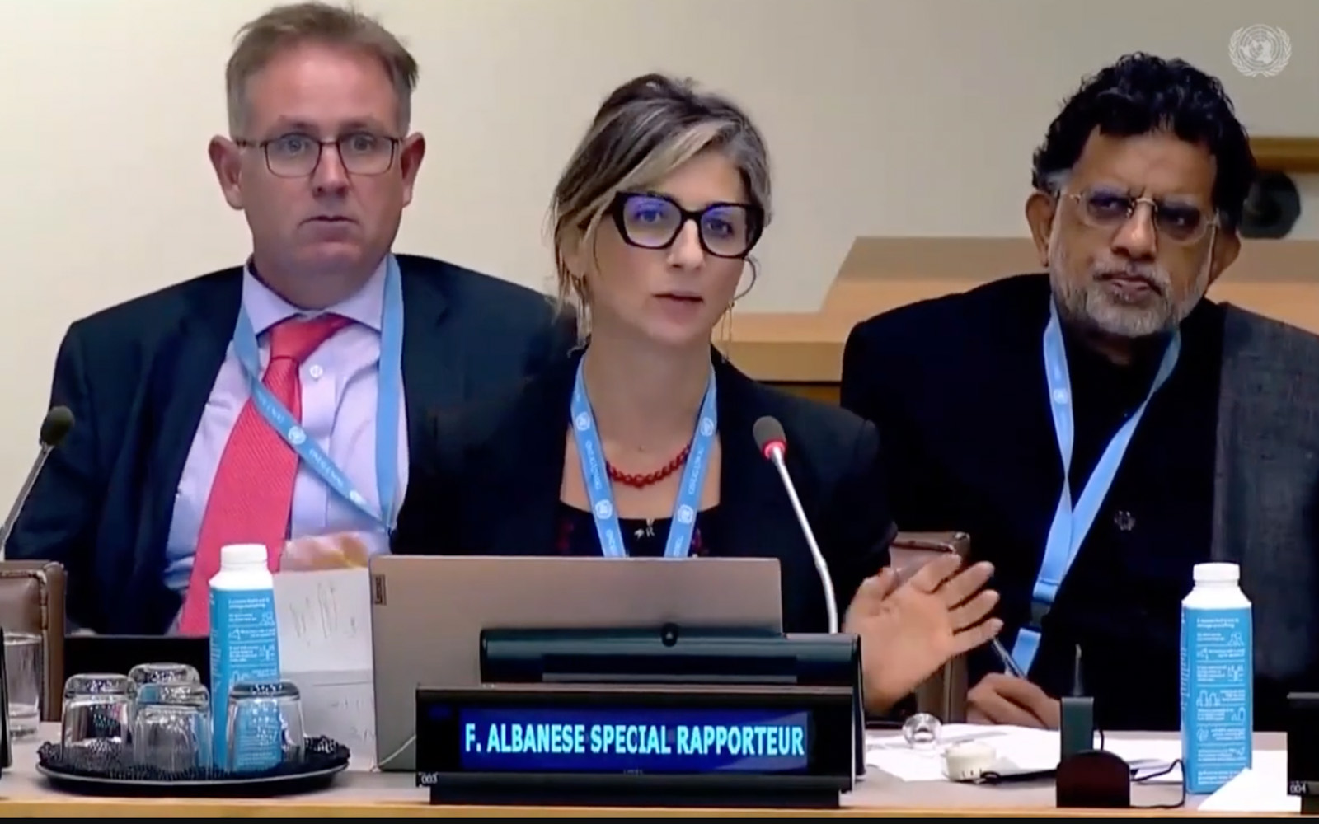
UN Special Rapporteur Francesca Albanese addresses the UN, October 2022. (Screenshot/ YouTube, used in accordance with Clause 27a of the Copyright Law)
Right behind her at 9:48 a.m. is UN General Assembly President Dennis Francis (from Trinidad and Tobago). He says:
“I urge all parties to refrain from further violence & to seek an immediate path to peace.”
An immediate call for Israelis to do nothing, and imagine peaceful coexistence with those in the middle of butchering your population.
Between 10:31 and 10:56 a.m. the injured within Israel are 908 and there are more reports of attempted infiltration of genocidal terrorists by sea.
In comes UN Secretary-General Antonio Guterres (through his spokesman) at 11:05 a.m.
He “urges maximum restraint.”
A call on Israel to take a chill pill while Jews are being slaughtered.
Between 11:30 a.m. and 5:07 p.m., casualty reports are now 200 killed and 1,452 wounded in Israel. Rocket fire from Gaza into Israel continues including direct hits on Tel Aviv, more Palestinian terrorists are attempting to infiltrate Israel and hostage-taking evidence grows. Palestinian terrorists are circulating gut-wrenching videos. One is a video in Gaza, taken by the captors, of a brutalized woman, hands cable-tied behind her back, with her pants covered in blood, indications she had been raped. Hamas’ official social media accounts have released other videos of lifeless bodies, people having their heads stomped on, bloodied faces, human beings repeatedly kicked and terrified. Reports continue that Palestinians are attempting to further infiltrate Israel by sea and through the border fence.
At 6:07 p.m. the UN Committee on the Exercise of the Inalienable Rights of the Palestinian People weighs in. It is the Committee created back in 1975 to implement the General Assembly resolution declaring Zionism to be a form of racism. The 1991 resolution rescinding that idea left the enforcement body intact. This committee:
“expresses concern by the alarming security situation prevailing in Israel & the Occupied Palestinian Territory.”
Security situation? In the “Occupied Palestinian Territories”? This is the inverse of “Jewish lives matter.”
Also at 6:07 p.m. the Chair of the Committee, the Ambassador of Senegal to the UN, Cheikh Niang, adds:
“Attacks against civilians, including retaliations, are contrary to international law under any circumstances. I also join the Secretary-General’s call for restraint from all parties to avoid further loss of life.”
It is less than 24 hours since this hideous attack on civilians in Israel began and the UN has inverted the situation to suggest that Israel is attacking civilians.
The UN is telling the bald-faced lie that international law says a country in these circumstances should restrain itself. Actual international law says Israel has a right and duty to prevent further loss of Israeli lives.
In the remaining six hours of Saturday, reports tell us: Palestinian terrorists are making further attempts to infiltrate Israel, the number of kidnapped has reached dozens, 3,000 rockets have been fired from Gaza headed for civilian targets in Israel, the death toll in Israel is known to be at least 300, with 1,864 injured, Israeli forces are engaged in fierce combat with Palestinian terrorists within Israeli civilian communities, and additionally at a police station that the terrorists have taken. Videos have emerged showing the kidnapping of a mother and her young children, loaded onto a pickup truck with the men around her yelling “Allahu Akbar” just like ISIS.
It’s been 24 hours and it is very clear that atrocities are being committed against Jews – in the here and now – that haven’t occurred since the Holocaust. It is also clear that antisemitism is not some meaningless drivel unrelated to the Jewish state. And yet, here is what the United Nations has not done. Not one of these senior UN officials has reconfirmed and supported Israel’s right of self-defense. There is no sign of an emergency session of the General Assembly. No call for a special session of the UN Human Rights Council – or an “urgent session” during a Council meeting, which could have been easily arranged since the Council happened to be in session. The UN Security Council, for its part, decided – mañana. It planned to meet on Sunday.
Sunday, October 8, 2023
On Sunday, October 8 from 12:08 a.m. to 6:10 a.m. reports indicate that the death toll has risen to 350; as many as 1,000 Hamas terrorists have infiltrated Israel; Israeli forces are engaged in combat with terrorists in Israeli communities; more Palestinian terrorists have attempted to infiltrate Israel by sea, with drones, and by air but are being thwarted; significant rocket fire from Gaza into Israel continues to cause casualties; and Hezbollah has opened a second front in the north with missile and artillery strikes from Lebanon into Israel.
Highly disturbing videos taking credit for what are horrifying atrocities continue to be circulated by Hamas. One shows an unconscious or lifeless body of a German-Israeli woman, almost naked, one leg misshapen, with a gunman carrying a rocket propelled grenade, his leg over her waist, another holding a clump of her hair, others spitting on her and shouting “Allahu Akbar.” Her mother identified her daughter by watching the video and recognizing the tattoos. Others show the kidnappings of young women and men, pleading for help as couples are separated and dragged away. Israelis are also relaying personal experiences to the media: a mother was on the phone with her children who are hiding in a safe room that doesn’t lock. She hears the door to their home break open and the children’s cries as the phone goes dead.
And in comes UN Rapporteur Albanese at 6:15 a.m. on Sunday, retweeting a tweet from an anti-Israel NGO based in Israel advocating that everybody
“focus on how our Jewish-supremacist govt brought us to this point.”
Business as usual for antisemites: blame the victims of antisemitism.
From 6:30 a.m. to 9:00 a.m. on Sunday the world hears of more kidnappings. It learns the identities of 74 Israeli IDF personnel and security officers killed by Palestinian terrorists. It hears of more attempted Palestinian infiltrations by sea. It sees more videos of the attack at the music festival and of women and children being dragged off, and it learns the horrific count of 260 bodies recovered inside Israel at the scene of the festival.
And Tor Wennesland, UN Special Coordinator for the Middle East Peace Process, makes an appearance at 9:49 a.m. to say:
“Priority now is to avoid further loss of civilian life & deliver much needed humanitarian aid to the Strip.”
Israel is still preventing more dead in ongoing warfare on the ground inside Israel, under rocket attack on civilian centers, still counting the bodies, and the world is learning of mind-blowing atrocities against Jews in the 21st century. And the UN “priority” is humanitarian aid to non-Jews, to others, specifically to those in places where the guys in charge are committing the atrocities, who sickeningly calculate that any collateral damage suffered by their own people, when Israel attempts to protect itself, is a win-win. This calculus includes the very predictability of the UN response.
Meantime, the UN is still at a loss to mouth support for Israel’s right of self-defense.
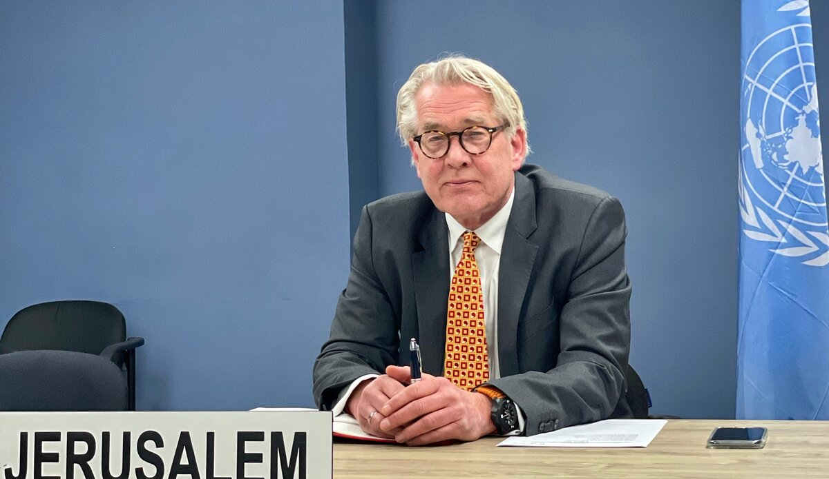
UN Special Coordinator for the Middle East Peace Process Tor Wennesland briefs, over video conference, the Security Council on the ‘Situation in the Middle East,’ including the Palestinian question, on January 26, 2021. (Daniela Penkova/UNSCO/File)
At 1:46 p.m. the UN refugee agency only for Palestinians, UNRWA, had something to say. UNRWA defines a refugee differently than the refugee definition for anybody else on earth. Ensuring the longevity of the agency and the perpetuation of the problem, Palestinian refugee status is acquired by birth instead of persecution. UNRWA issued a press release saying:
“UNRWA supports calls to reach an immediate ceasefire and a halt to the violence everywhere.”
In other words, from a humanitarian agency comes a belief in moral relativism between butchering Jewish civilians and preventing more. Israel should stop fighting back against the violence because it’s violent. Evidently, UNRWA would prefer the reader to forget that the facilities of UNRWA have been repeatedly used by Hamas terrorists for military purposes, as staging grounds, weapons depots, and hideouts, and as shields to provide cover to nearby military assets. And there are UNRWA teachers and officials who continue to be exposed as members and supporters of Hamas.
Prior to closed-door UN Security Council consultations at 3:00 p.m., the known death toll in Israel rises to 700, and the injured to 2,100. Reports indicate Israel is still fighting Palestinian terrorists on Israeli territory in several communities. Videos are emerging of badly-burned bodies bound by cable ties among Israeli festival attendees and Hamas terrorists putting the kidnapped in restraints.
At 3:00 p.m. the UN Security Council met. And did absolutely nothing. They needed unanimity to issue a statement and couldn’t muster it. Every one of the veto-holding members of the Council – the United States, the United Kingdom, France, China and Russia – had citizens that were victims of Palestinian terrorist atrocities, both dead and missing/presumed kidnapped. 36 UN member states had nationals murdered by Palestinian terrorists. And the Council could not condemn Hamas and other Palestinian terrorists for the atrocities perpetrated on civilians or issue a statement in support of the UN member state of Israel’s right of self-defense.
It was reminiscent of Rwanda, where the UN had information about genocidal intentions and refused to act. The Islamic Resistance Movement (Hamas) and Palestinian Islamic Jihad don’t hide their genocidal intentions. Now they were making good on their vile promise. In this case, Israel didn’t ask for UN forces or materiel, only for moral clarity and a recognition of the fundamental right of the Jewish state to self-defense as any other UN member would have. Fortunately, Israel didn’t wait for a sign of life from the Security Council. On the contrary, it is forced to gird itself against a Security Council bent on re-tying the hands of the Jews behind their backs.
From 4:32 p.m. to 9:31 p.m. rocket attacks from Gaza into Israel both targeting Israeli civilians or indiscriminate continue, and make a direct hit. The number of rockets fired at Israel within 48 hours has increased to more than 4,000. Israeli forces are still fighting Palestinian terrorists within Israel. Israelis are still sheltering inside homes, safe rooms and bomb shelters. Major international airline carriers from multiple countries are continuing to cancel flights in and out of Israel. Hamas and Palestinian Islamic Jihad (PIJ) are publicly boasting that they kidnapped and are holding over 100 civilian hostages, and the PIJ openly admits they intend to use the kidnapped as bargaining chips. Videos of Israelis including young women, mothers, grandmothers, and children, brutalized and dragged away by Palestinian terrorists are being seen by family members. Their stories, identities and terrifying ordeals are being broadcast around the world. Hamas itself releases video proof that they have executed hostages, with videos showing people first taken away and then showing their dead bodies.
Monday, October 9, 2023
On Monday, October 9, from 12:18 a.m. until 8:42 a.m. Israeli forces are still fighting Palestinian terrorists on the ground in Israel in seven or eight places, with possible further terrorist penetrations from Gaza; rocket fire targeting Israeli civilians from Gaza continues; the number of injured in Israel rises to more than 2,500. At 8:14 a.m. the world learns that terrorists have infiltrated Israel from Lebanon, the highly lethal Iranian proxy Hezbollah posing a very real threat. Israeli forces catch some and are searching for others. And the evidence of massive human rights violations piles up, like the dead. Videos emerge from the music festival showing Palestinian terrorists executing civilians, shooting wounded who were still moving to make certain they died, looting belongings from dead bodies, and grabbing women left alive (their fates unknown). Media interviews include an American university professor who was on the phone with his daughter while she and her husband were shot to death, the mother using her body to shield their child; the bullet pierced her son, but he managed to survive by remaining hidden for some time under his mother’s dead body.
And then came the UN Human Rights Council. At 9:00 a.m. Pakistan, speaking on behalf of the 57 members of the Organization of Islamic Cooperation (OIC) at the UN Human Rights Council, made a statement ironically blowing the cover off the whole operation. He said:
“this whole huge loss of lives and unabated violence is a sad reminder of more than seven decades of illegal foreign occupation, aggression and disrespect for the international law.”
Seven decades. Back to 1948, the founding of the modern State of Israel. This was never about grievances about this or that piece of land or policy. This is about the existence of the Jewish state and the ongoing refusal to recognize Israel’s right to exist, period.
Pakistan continued: “occupation is breeding violence.” The victims brought the atrocities they were suffering upon themselves. Hitler said the same. So did his partner, and Palestinian hero, the Grand Mufti of Jerusalem Amin al-Husseini. That’s how antisemitism works.
The Islamic states’ representative ended his statement with an appeal:
“to remember victims of decades of foreign occupation in the occupied Palestinian Territory. I request you all to stand for one minute to honor those victims.”
Shockingly, the representatives of Germany and France were among those who stood up.
The UN’s top human rights body – the UN Human Rights Council – didn’t issue a call for a special or urgent session aimed at stopping the massacres perpetrated by Palestinian terrorists. Instead, it delivered exactly what Palestinian terrorists wanted and expected from the United Nations. A justification. Solidarity with their goals. And the same greenlight for terror and carnage against the Jewish people to which their enemies have been dedicated before, during and after the Holocaust.
Minutes later, there was shelling from Lebanon into Israel. At the time, Israeli forces were still engaged in intense door-to-door fighting to retake control of Israeli territory, which they did. Rocket fire from Gaza directed at Israeli citizens and resulting casualties continued.
At 11:41 a.m. UN General Assembly President Francis had something else to say:
“I call for an immediate cessation of violence, for all parties to exercise maximum restraint, and for all stakeholders to engage in diplomatic discussions to de-escalate the situation…”
It’s the same UN manual making the rounds. Handcuff Israel in her hour of need. Put a genocidal Palestinian terrorist organization on the same moral level as the Jewish democratic state. Take a moment to imagine “diplomatic discussions” with one side brandishing instruments of torture and yelling “Allahu Akbar” and the other side saying what exactly? “Let me consider that point”?
At 12:31 p.m. UN Secretary-General Guterres weighs in with this abomination:
“I recognize the legitimate grievances of the Palestinian people…I am deeply alarmed by reports of over 500 Palestinians — including women and children — killed in Gaza and over 3,000 injured…While I recognize Israel’s legitimate security concerns, I also remind Israel that military operations must be conducted in strict accordance with international humanitarian law…This most recent violence does not come in a vacuum. The reality is that it grows out of a long-standing conflict, with a 56-year long occupation and no political end in sight. It’s time to end this vicious circle of bloodshed, hatred and polarization. Israel must see its legitimate needs for security materialized – and Palestinians must see a clear perspective for the establishment of their own state realized.”
It is hard to fathom the moral depravity of this statement. It is as if Guterres just got off the phone with Hamas leaders, and the Supreme leader of Iran Ali Khamenei while he was at it, and asked for talking points. Justification, sympathy, understanding – for the butchers. Inversion of victim and perpetrator. Reference to “circles” as if there isn’t an unmistakable villain. Worst of all: Providing both the political win desired by the terrorists and encouraging more of the same. More of violent pathological antisemitism, not just from Hamas, but from the enemies of the Jewish state and the Jewish people around the world.
Half an hour after the Secretary-General’s statement, Hamas threatened to start executing the hostages unless its demands, whatever they might be, are met. Fifteen minutes later at 1:17 p.m., Israel reports that the death toll in Israel has reached 900.
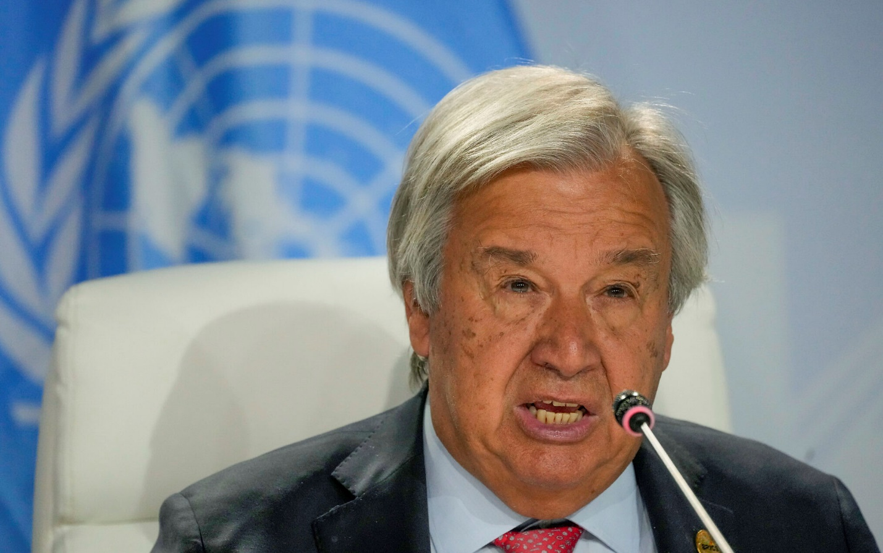
United Nations Secretary-General António Guterres, BRICS summit in Johannesburg, South Africa, August 24, 2023. (AP Photo/Themba Hadebe)
At 1:28 p.m. Guterres weighed in again, saying:
“It’s time to end the vicious circle of bloodshed, hatred & polarization in the Middle East.”
The UN Secretary-General has blood on his hands.
From 2:00 – 3:16 p.m. the world learns that an attack has occurred from Lebanon into Israel. The IDF indicates that at least 85 of those killed in the infiltration were soldiers. A terrible video is published by Hamas of the bloodied face of a female Israeli soldier. The men around her are shouting “this is nothing, we are just starting.” Her Jewish family identified their 19-year-old daughter from the video.
The world now knows that Palestinian terrorists are using rape as a weapon of war – and proud of it.
Minutes later at 3:27 p.m. UN Secretary-General Guterres lectures Israel:
“While I recognize Israel’s legitimate security concerns, I also remind Israel that…civilians must be respected & protected at all times.”
As if it’s Israel that is doing the disrespecting.
Responding to the brutalization and degradation of women is one of the UN’s top stated priorities. Neither the Secretary-General or any of these other UN leaders mentions this top priority atrocity – when the victims are in Israel and Jewish women and girls.
On the contrary, using her global UN platform, a day later on October 12 at 6:57 a.m. Albanese, the UN Human Rights Council’s Special Rapporteur on Israel, goes so far in defense of the Butchers of Gaza, as to tell the world not to believe their own eyes and ears.
“Caution! Numerous claims are circulating, repeated by US officials & amplified by mainstream media re Hamas’ crimes including beheadings/rape. ISR military did not confirm such claims. Divulging unverified information risks to escalate tensions & endanger lives in a volative [sic] context.”
Double-discrimination, politely put. Rape a Jew and then spread the lie that it didn’t and isn’t happening.
The remainder of Monday saw an IDF officer dying as a result of the encounter with terrorists from Lebanon, estimates of the number of hostages reaching up to 150, and video and other evidence of incredibly disturbing atrocities. The abduction of more whole families, three generations – an 80-year old woman, an adult child and son-in-law and the grandchildren ages 12, 13 and 16. A video of Palestinian terrorists opening fire on people in cars killing them at point-blank range. Terrorists throwing grenades into a bomb shelter and shooting dead a person who emerged and tried to run away. A person being repeatedly kicked on the ground by a group of terrorists. A daughter calling her father while under attack and showing him a photo of her brother who was with her and died in her arms; the daughter is now missing.
Tuesday, October 10, 2023
Early on Tuesday morning, at 5:08 a.m. (ET), UN High Commissioner for Human Rights Volker Türk issues a press release. It’s just over three days since the collective nightmare of Israel and the Jewish people began. The press release reads:
“‘We know how this plays out, time and time again – the loss of Israeli and Palestinian lives and incalculable suffering inflicted on both communities,’ said Türk. ‘All parties must respect international humanitarian law…’ Türk stressed that it is vitally important that everyone deprived of their liberty in the Occupied Palestinian Territory and Israel is treated humanely…Information gathered by the UN Human Rights Office indicates that Israeli air operations have also hit large residential towers in Gaza City and other residential buildings across Gaza, schools and premises of the UN relief and works agency, UNRWA, resulting in civilian casualties. ‘International humanitarian law is clear: the obligation to take constant care to spare the civilian population and civilian objects remains applicable throughout the attacks,” Türk said. The principles of distinction and the prohibition of indiscriminate or disproportionate attacks are paramount…’”
The UN’s top “human rights” authority figure has just analogized the brutalized kidnap victims from Israel being held in Gaza with prisoners justifiably held in Israeli jails. In his words: “everyone deprived of their liberty in the Occupied Palestinian Territory and Israel.” He then goes on to concoct an imaginary international law, implying that civilian casualties are of themselves a violation of the international law of armed conflict. That is false, for a very good reason: such a rule would encourage bad actors to make greater use of human shields. He hasn’t got a clue of whether Israel’s actions are “indiscriminate” or “disproportionate,” since he has no knowledge of the precise military target, the military advantage gained by hitting it, the identity or terrorist connection of the Gazans killed, and the proportionality calculation of the reasonable commander who – in Israel’s case – is making those careful decisions with legal advice and the best possible knowledge of civilian whereabouts in the face of an enemy that uses them as human fodder for PR purposes. The PR purposes that the UN is only too happy to provide.
Türk’s statement adds:
“The Human Rights Chief expressed deep concern at how hate speech and incitement to violence have surged since Saturday, fuelling anti-Semitism and Islamophobia in the region and globally.”
The Islamic Resistance Movement (Hamas) – bankrolled, weaponized and trained by the Islamic Republic of Iran – has a Charter that begins “Israel will exist and will continue to exist until Islam will obliterate it.” Hamas engages in a slaughter of Jews and others in the Jewish state because they are in a Jewish state. The slaughter of Jews is unprecedented since the Holocaust. Yet within three days the UN says the events are about “Islamophobia.” A distortion of reality and “whataboutism” at its worst.
The immediate spin that antisemitism has surged after the massacres is an intentional UN method to avoid identifying the massacres themselves, and their widespread celebration by Palestinians and supporters, as antisemitism. Parenthetically, UN actors have recently been waging a massive campaign to rebuff the definition of antisemitism that includes discrimination and demonization of Israel. The Butchers of Gaza have given these folks an inconvenient problem. They have made it painfully obvious that antisemitism is irrevocably and intrinsically tied to the equal and just treatment of the state of Israel (as spelled out in the “IHRA” definition of antisemitism).
From 5:44 a.m. to 6:36 a.m. the world learns that 123 Israeli soldiers have been killed in the attacks which means the vast majority of those targeted and slain by Palestinian terrorists were civilian. Details of massacres emerge. Over 100 bodies are found in the single tiny farming community of Be’eri. The terrorists went door to door, breaking into homes and slaughtering the civilians inside. Reminiscent of 9/11, when the hospital beds prepared in New York City were never needed, the spokesman for the Israeli forces first on the scene said: “We thought we would need more rooms (to house the evacuees). We didn’t need all the rooms.”
The atrocities at another small community, Kfar Aza, also come to light. IDF soldiers who were first on the scene relay to reporters what they saw – decapitated victims. Evidence of how the Palestinian terrorists, dressed for combat and armed with knives, guns and grenades, entered civilian homes and killed their Jewish prey: “They killed babies in front of their parents and then killed the parents. They killed parents and we found babies between the dogs and the family that [was] killed before him,” that is, before his eyes.
As these devastating facts came to light for the whole world, at 7:10 a.m. UN Humanitarian Coordinator for the Occupied Palestinian Territory, Lynn Hastings has this to say:
“…all parties must comply with their obligations under international humanitarian law. All military and armed groups must abide by the principles of distinction, proportionality, and precaution when conducting their operations.”
The UN Office for the Coordination of Humanitarian Affairs (OCHA) has been operating in the area for a long time and such a statement does not come from naïvete. It is deliberate misinformation to pretend that the Israeli military and the “armed groups” that are designated foreign terrorist organizations are equals and could both use a lecture on the laws of armed conflict. Palestinian “armed groups” are dedicated to the violation of the laws of armed conflict. They brag about raping soldiers and about deliberately targeting civilians. They don’t need a speech. They need to be militarily destroyed and politically rejected from civilized societies everywhere. So why the ruse? Because the demonization and bias against the state of Israel is the bread and butter of UN operations – dressed up as human rights and humanitarian concerns and international law. Hamas may have made this project more difficult, but UN actors refuse to adapt their go-to lingo for the occasion.
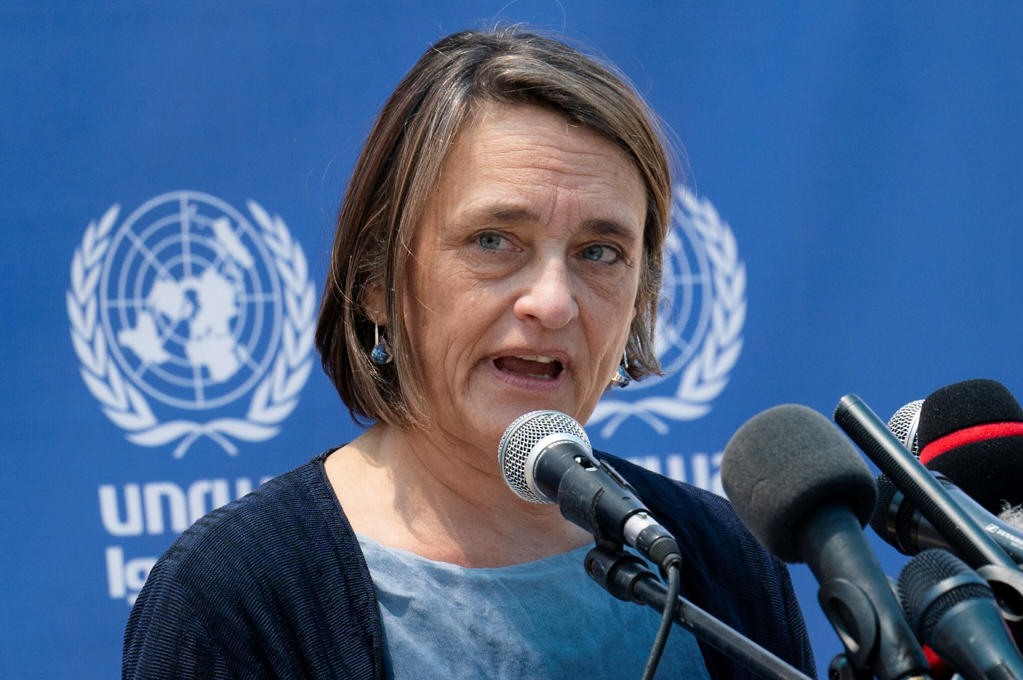
Lynn Hastings, United Nations Deputy Special Coordinator for the Middle East Peace Process and Resident Coordinator and Humanitarian Coordinator for the West Bank and Gaza, May 23, 2021, in Gaza City. (AP Photo/John Minchillo)
Lining up after Hastings at 7:18 a.m. was the UN “Commission of Inquiry on the Occupied Palestinian Territory, including East Jerusalem, and Israel.” Known as the COI, it is comprised of three members notorious for their anti-Israel biases and yet appointed in 2021 to conduct an inquisition directed at Israel as “impartial” and “objective” experts. The Chair of the “inquiry” is Navi Pillay, who was UN High Commissioner for Human Rights during both the 2008/9 and 2014 Gaza conflicts. On those occasions, she championed the lie that Israel deliberately targeted Palestinian civilians.
Racing for center stage, on October 10th, a mere 72 hours after the slaughter of Israelis begins, Pillay’s COI puts out the following:
“There is already clear evidence that war crimes may have been committed in the latest explosion of violence in Israel and Gaza, and all those who have violated international law and targeted civilians must be held accountable for their crimes…The Commission has been collecting and preserving evidence of war crimes committed by all sides since 7 October 2023, when Hamas launched a complex attack on Israel and Israeli forces responded with airstrikes in Gaza.”
It is hard to know where to begin with this obscenity. Her description of what happened here was twisted from the very start. This was an invasion of a UN member state and slaughter of its civilians, not an “explosion of violence in Israel and Gaza.”
At the very moment that Israelis civilians were being targeted, raped, maimed, blown up by grenades, burned alive, and beheaded, and 260 young concert-goers are running for their lives, being gunned down in their cars and slaughtered or dragged off to Gaza when their hiding places are discovered, Navi Pillay is collecting “evidence” of Israeli war crimes.
After just three days, with bodies from the massacre still yet to be identified and Israelis still burying their dead, Pillay has already found Israel guilty – “clear evidence” of war crimes in Gaza.
The adjective best describing Hamas’ attack for Navi Pillay is “complex.” By the variety of Jew-killing methodology employed?
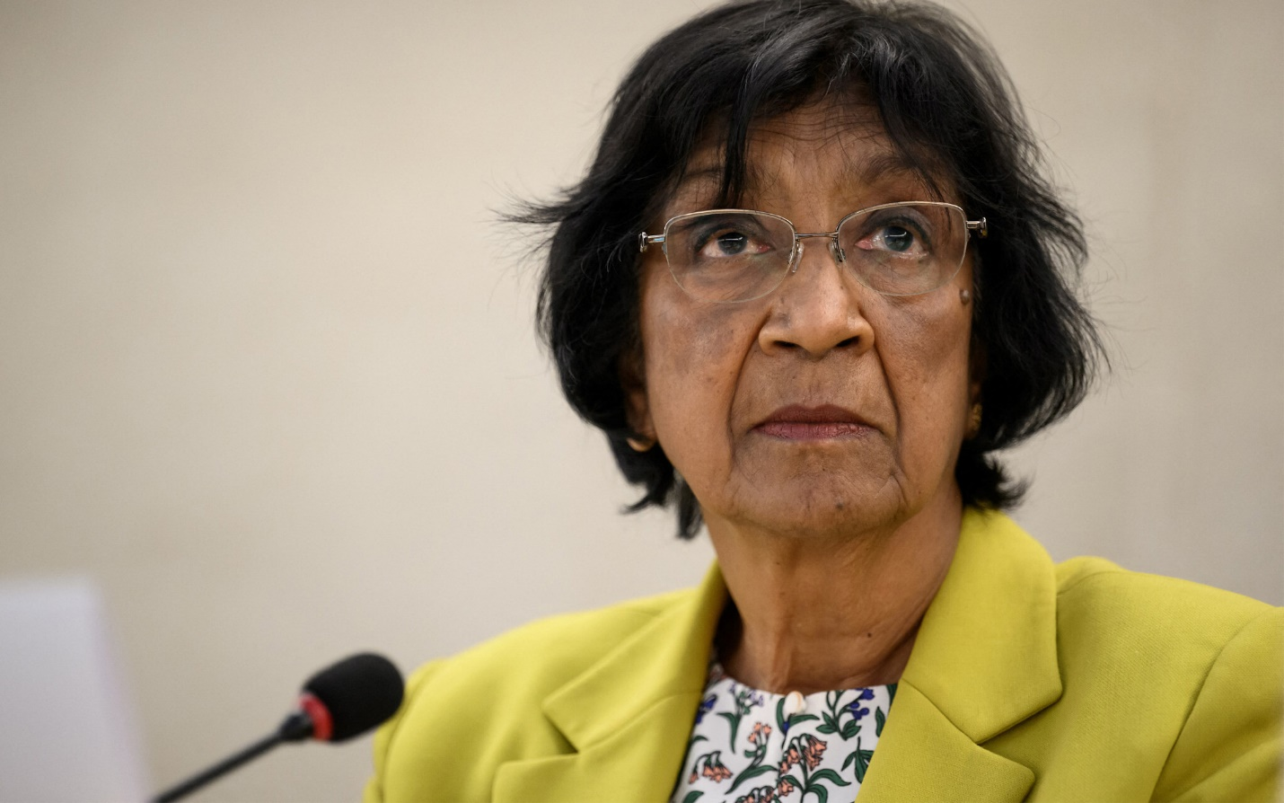
Former United Nations human rights chief Navi Pillay, the 50th session of the UN Human Rights Council, in Geneva on June 13, 2022. (Fabrice Coffrini/AFP)
In another UN moral equation between Israel and a terrorist organization, Pillay’s COI statement also included:
“The Commission is gravely concerned with Israel’s latest attack on Gaza… the Commission is committed to investigating current events and identifying those responsible for violations of international law on all sides… It will continue sharing information collected with the relevant judicial authorities, especially with the International Criminal Court… The Commission is deeply distressed by the mounting violence, and spiralling death toll and underscores the urgency for the parties involved to cease all forms of violence…The Commission urges Israeli security forces and Palestinian armed groups to adhere strictly to international humanitarian law and international human rights law…. [T]he only path towards ending violence and achieving sustainable peace is through addressing the root causes of the conflict including through ending the illegal occupation.”
It is early on October 10th. Israel is under rocket fire. Israel is still fighting off attempts to further infiltrate its borders. Israel is responding to a highly dangerous second front, from which it has already taken casualties, in the north. The full extent of the horror is still being determined, and the country has barely begun to be able to take the existential fight beyond its borders. And this UN attack dog is “gravely concerned with Israel’s latest attack on Gaza.” Telling the world from the COI perch in Geneva or South Africa, or wherever Pillay’s armchair might be, that she’s collecting “evidence” to prosecute Israel for crimes.
The usual UN formula for Jew-hatred – even-handedness between good and evil – is off to a running start. The reference to “all sides” and “the parties.” The call to “adhere strictly to international law” made to a democratic state and to a genocidal terror organization whose raison d’etre is to kill Jews.
Stop fighting back, screams Pillay! “Cease all forms of violence.”
And then the punch line: the slaughter of Jews was the fault of the Jewish state. The victims are to blame. “The root cause of the conflict” is Israel’s “illegal occupation.” There hasn’t been a Jew living in Gaza in almost two decades. On the other hand, there has been an unrepentant unremitting effort by Hamas and other Palestinian terror organizations from Gaza to kill Jews and eradicate their neighbor. But Navi Pillay told the General Assembly last fall that antisemitism is “always raised as a diversion.” Now that the “diversion” was killing Jews en masse, Navi Pillay was calling the plays for Team Genocide.
Forty-five minutes later at 7:56 a.m., there are reports of further attempts by Palestinian terrorists to infiltrate Israel, attempts that have been thwarted.
On 8:19 a.m. Director of the New York Office of the High Commissioner for Human Rights Craig Mokhiber – the highest ranking UN “human rights” official at UN Headquarters – gets involved and tells the world:
“The unbroken wall of propaganda, bias, racism, disinformation, incitement & blood-thirst in western corporate #media covering #Palestine & Israel is disgraceful, but not surprising. But that wall is as futile as the #apartheid wall & both will eventually crumble. #HumanRights”
His words are blood-curling. The Hamas media enterprise has been putting out video evidence of their own atrocities deliberately. The families of victims are finding out the true horror of what has happened to their loved ones from those videos and on social media. They are coming forward under agonizing, heartbreaking circumstances to testify before the cameras in the hopes that they might contribute to their safe return or at least to their legacies. Hamas officials are broadcasting on non-“Western” media the demands of the kidnappers. And this UN official is turning the screws on Israel. What’s going on here is a UN “human rights” fraud that can’t handle the truth, whose own propaganda machine has been dealt a blow by the facts.
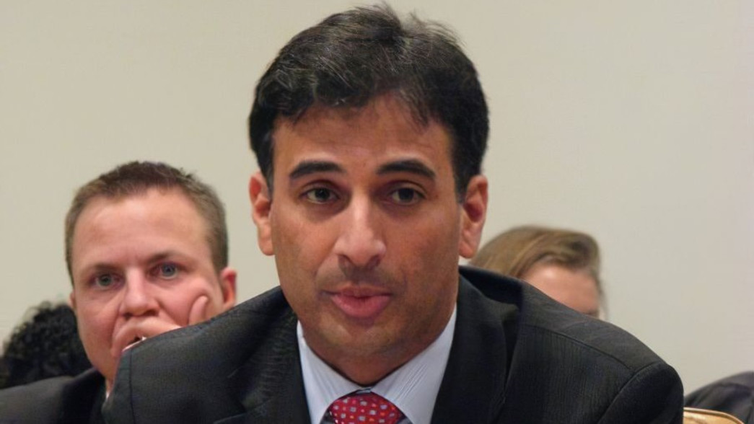
Outspoken: The UN’s Craig Mokhiber (Facebook)
The remainder of October 10th saw death tolls in Israel rise to 1,000 and then 1,200. Information that Israel had been invaded by thousands of Palestinian terrorists (though the number is still unclear). More of the terrorists were still being discovered inside Israel. A third front opened in the war against the Jewish state as missiles were fired from Syria into Israel.
And the UN-Hamas tag team was just clearing its throat.

