Examination of the Names of 17 Journalists and Media Personnel Whom the Palestinians Claim Were Killed in Operation Protective Edge

February 17, 2015
The Meir Amit Intelligence and Terrorism Information Center http://www.terrorism-info.org.il/en/article/20771

Overview of the Examination's Findings
1. About a week after the end of Operation Protective Edge the Palestinian Journalists Syndicate issued a list of 17 names, allegedly of journalists who had been killed in the operation. The list was published by the PA's Wafa News Agency, which received it from the Hamas-controlled Gaza office of the ministry of information.^{[1]} As part of the ITIC's ongoing project concerning Palestinians killed in Operation Protective Edge, the 17 names were examined.
2. The examination revealed that almost half (eight out of 17) were names of Hamas and Palestinian Islamic Jihad (PIJ) terrorist operatives, or were journalists who worked for the Hamas media. The Palestinian Journalists Syndicate and the Gaza office of the ministry of information tried to hide their military-terrorist identity, representing them only as journalists and media personnel. The examination revealed three levels of affiliation between the journalists and media personnel and the terrorist organizations (Hamas and the PIJ):
1) The high level: Two military-terrorist operatives armed and in uniform carried out propaganda missions in Hamas and PIJ military-terrorist units. One, whose picture appears at the beginning of this report, also recorded a will before he went into battle. It was uploaded to YouTube by the Izz al-Din al-Qassam Brigades, Hamas' military-terrorist wing, after his death.
2) The middle level: Three Izz al-Din al-Qassam Brigades operatives and one PIJ operative also worked for media affiliated with Hamas and the PIJ and/or local Gazan media.
3) The low level: Two of the names on the list belonged to civilian media personnel who were not military operatives in the terrorist organizations, but worked for Hamas' Al-Aqsa TV, and its publication Al-Resala.
3. Two additional conclusions were drawn from the examination:
1) More than one third (six) of the media personnel on the list were killed while reporting from the battlefield. Most or all of the others were killed during the battles in the Gaza Strip while they were in their houses or driving on the road under circumstances not connected to their media work. They were killed because they lived in densely populated areas where the IDF was fighting the terrorist organizations, which used the civilian population as human shields.
2) At least two of the media personnel on the list were not killed by the IDF. They were an Italian AP photojournalist and his translator, who were killed during one of the ceasefires while covering Gaza police engineers defusing unexploded ordnance in a location where there were no IDF soldiers (and Israel was not held responsible for their deaths). It is possible that others on the list were not killed by the IDF but the ITIC cannot prove it (that would necessitate thorough examinations of the events on the ground and comparisons with Palestinian reports in each case).
4. The findings of the examination indicate that the Palestinian list of 17 journalists killed during Operation Protective Edge was manipulative: it integrated names of civilians with names of terrorist operatives who served in information and media capacities. It incorporated the names of those who did in fact cover the fighting as correspondents and those who were killed randomly and were not serving as correspondents. It integrated those who were killed by the IDF in error with those in whose deaths the IDF had no involvement whatsoever. The objective was to give credence to the false claim that Israel deliberately killed a large number of media personnel and therefore was guilty of "crimes" for which the Palestinians demand the "murderers" be tried in international criminal courts. Manipulating the list of Palestinian journalists killed in Operation Protective Edge is another example of Hamas-led Palestinian tactics of deceit and fraud (as proved by the ITIC's findings of the examination of the lists of Palestinian fatalities). Thus, distorting the truth about the Palestinians killed in Operation Protective Edge has become a propaganda weapon in the Palestinian political, propaganda and legal war being waged against the State of Israel.
The Palestinian Institutions Issuing the List of the 17 Journalists
5. On September 2, 2014, the Palestinian Journalists Syndicate issued a list of 17 Palestinian journalists who were killed in Operation Protective Edge (See Appendix 5 for the original list in Arabic). A week previously, on August 26, 2014, the list was issued by the Hamas-controlled Gaza office of the ministry of information. It was then disseminated by the Palestinian Authority (PA)'s Wafa News Agency and received much media coverage (according to the Wafa website, it had received 5,846,812 hits as of January 26, 2015). It was quoted and referred to on websites and by the international media, and exploited for anti-Israeli propaganda.
6. The Palestinian Journalists Syndicate is a trade union established in 1979, originally located in Jerusalem. Today its main offices are in Ramallah and it has a branch in the Gaza Strip controlled, in ITIC assessment, by Hamas. Its chairman is Abd al-Nasser al-Najar, who has two deputies, Nasser Abu Bakr in Judea and Samaria and Tahsin al-Astal in the Gaza Strip (Website of the Palestinian Journalists Syndicate, February 4, 2015).
7. The list of 17 journalists and media personnel killed in Operation Protective Edge and short biographies were also issued by the Gaza office of the ministry of information. Published in Arabic and English, it was called "Heroes of Truth." The same office also issued a poster with pictures of the 17 journalists. The document about those who "paid a precious price, which is their souls," was written by a public relations team headed by Ihab al-Ghussin, who was formerly spokesman for the interior ministry in the de-facto Hamas administration in the Gaza Strip and today is deputy minister of information and head of the Gaza office of the ministry of information. He is also head of Al-Ra'i, a Hamas newspaper published in Gaza. The Gaza office of the ministry of information served the de-facto Hamas administration and continues to function, even after the establishment of the Palestinian national consensus government in June 2014.
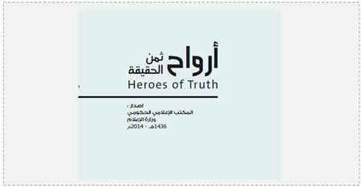‬ The title page of the Gaza office of the ministry of information's publication about the 17 journalists killed in Operation Protective Edge ("Heroes of Truth").‬
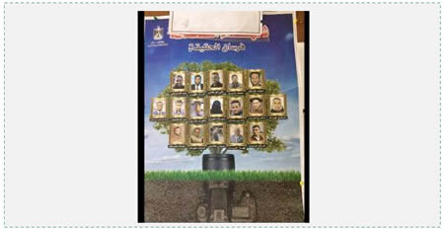 The commemorative poster issued by the Gaza office of the ministry of information for the 17 journalists. Their names are identical with the names on the list issued by the Palestinian Journalists Syndicate (Twitter account of DANCOHEN, January 27, 2015).‬
The Findings of the Examination
8. The list of 17 journalists and media personnel includes names of terrorist operatives as well as civilians who practiced a wide variety of media professions. They were journalists, photographers, editors, media crewmen (a driver and a translator) and a social network activist (whose status as a journalist is doubtful).
9. Of the 17 names, eight (almost half) had varying degrees of affiliation with the terrorist organizations in the Gaza Strip, as follows: two were military-terrorist operatives, who wore uniforms and were armed. They belonged to Hamas and PIJ military units and had propaganda missions (numbers 11 and 12 on the table in Appendix 1). Four were Izz al-Din al-Qassam Brigades and Jerusalem Brigades (the PIJ's military-terrorist wing) operatives who also served as journalists or personnel for the Hamas- and PIJ-affiliated media or for local Gazan media (numbers 4, 5, 9 and 10). Two were civilian journalists who worked for Hamas' media (numbers 6 and 15). Pictures of some of those affiliated with the terrorist organizations follow.
Ezat Salameh Doheir, PIJ terrorist operative (Number 12)
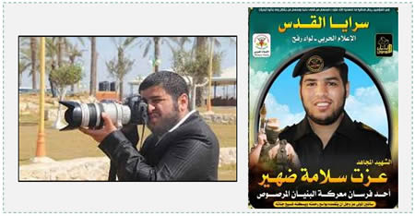 Left: Ezat Salameh Doheir carries a camera (Hamas forum, July 30 2014). Right: Death notice issued by the PIJ/Jerusalem Brigades for Ezat Salameh Doheir. He belonged to the "military media" unit of the Rafah brigade. The document issued by the Palestinian ministry of information made no mention of his identity as a military-terrorist operative and said only that he was killed in a "barbaric" Israeli attack.‬
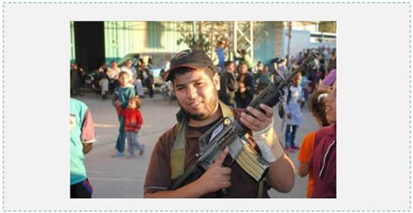 "Journalist" Ezat Salameh Doheir, wearing a PIJ/Jerusalem Brigades cap and armed with an M-16 rifle (Ardh Knaan website, December 25 2014).‬
Abdallah Fadel Mortaja, Izz al-Din al-Qassam Brigades terrorist operative (Number 11)
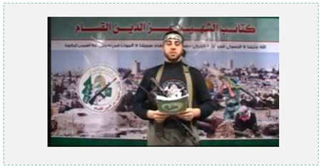 Abdallah Mortaja belonged to the Izz al-Din al-Qassam Brigades' military propaganda department. In the video he reads his will. He bids goodbye to his mother, wife and children, and says he belongs to the Al-Shejaiya battalion (the Gaza City battalion) of the Izz al-Din al-Qassam Brigades (YouTube, October 30, 2014) (click for video https://www.youtube.com/watch?v=X9_FvBCaYeU). The document issued by the Palestinian ministry of information makes no mention of his identity as a military operative, claiming he was a "journalist" who worked for civilian communications companies.
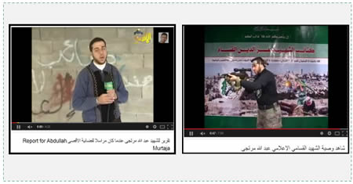 Left: Abdallah Mortaja photographed as correspondent for Hamas' Al-Aqsa TV (YouTube, December 12, 2013). Right: Abdallah Mortaja calls himself "an information shaheed of the Izz al-Din al-Qassam Brigades" in his videotaped will (YouTube, October 30, 2014).
Abdullah Naser Khalil Fahjan, Izz al-Din al-Qassam Brigades terrorist operative (Number 10)
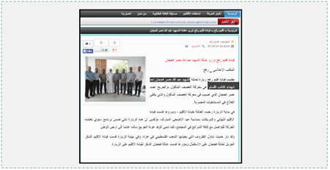 Abdullah Naser Khalil Fahjan, an Izz al-Din al-Qassam Brigades terrorist operative who also apparently worked as a reporter for Hamas' Voice of Al-Aqsa Radio. The picture shows the Rafah regional leadership of the "Al-Ahrar Movement" (an organization that split from Fatah and is today affiliated with Hamas) paying a condolence call to Abdullah Naser Khalil Fahjan's family. It was said of him (highlighted in black in the text) that he was "one of the shaheeds of the [Izz al-Din] al-Qassam Brigades" (Alahrar.ps, October 7, 2014).‬
Khaled Riyad Muhammad Hamad, Izz al-Din al-Qassam Brigades terrorist operative (Number 5)
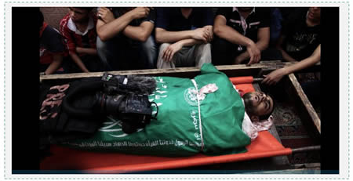‬ Khaled Riyad Muhammad Hamad, Izz al-Din al-Qassam Brigades terrorist operative, apparently also worked for Hamas' civilian media network. He was described as a "jihad fighter" journalist who was killed covering the fighting in Shejaiya. In the picture his body is wrapped in a green Izz al-Din al-Qassam Brigades flag. His Press vest and camera rest on the body (Hamas' Felesteen.ps, July 27, 2014).‬
Hamada Khaled Muqat, PIJ terrorist operative, killed with three other PIJ operatives (Number 4)
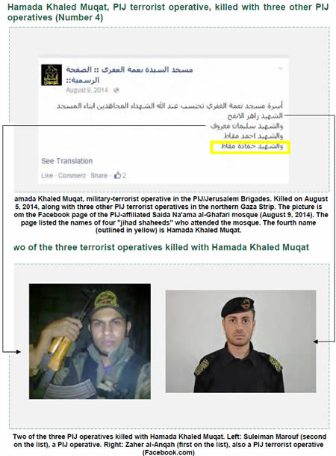
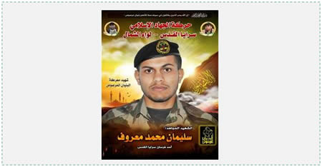 Death notice issued by the PIJ / Jerusalem Brigades / Northern [Gaza Strip] Brigade for the death of "jihad fighter shaheed" Suleiman Muhammad Marouf. He was one of the PIJ operatives killed with Hamada Khaled Muqat (Saraya.ps, October 15, 2014). His parents wrote an article in which they said he was an operative in the PIJ/Jerusalem Brigades in the northern Gaza Strip. They claimed he was killed at midnight on October 4, 2014, in an Israeli Air Force attack near the Al-Tawhid mosque in Jabaliya. His "jihad fighter shaheed" comrade Zaher al-Anqah and his "shaheed" brothers Hamada and Ahmed Muqat were killed with him, according to the family report. Suleiman Marouf's mission on the night he was killed was to check the Jabaliya region and make sure no activity was being carried out by collaborators (Saraya.ps, October 15, 2014).‬
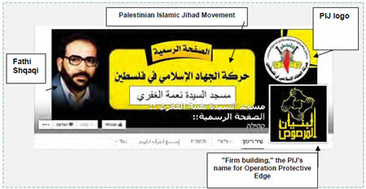 The main post on the Facebook page of the Saida Na'ama al-Ghafari mosque, four of whose frequenters were PIJ operatives who were killed. The mosque is clearly affiliated with the PIJ, as shown by the PIJ logo at the upper right, the PIJ inscription in the center and the picture of late PIJ leader Fathi Shqaqi at the left (Facebook page of the Saida Na'ama al-Ghafari mosque, February 3, 2015).‬
10. Other findings revealed by an examination of the 17 names:
1) Circumstances of death: About one third of the list (six of the 17 journalists) were killed while covering the hostilities in the Gaza Strip. Four were not affiliated with terrorist organizations and two were: three journalists (two unaffiliated and one affiliated) were killed in error on July 30, 2014 while covering Gazans stocking up on food in the market in Shejaiya (numbers 1, 6 and 14). Two others, both unaffiliated, (numbers 13 and 17), were killed (not by the IDF) while covering Gaza police engineers defusing unexploded ordnance. One terrorist operative, who might have been affiliated with a civilian media outlet, was killed while covering the fighting in the Shejaiya neighborhood (number 5). Apparently the others on the list (or most of them) were killed during Operation Protective Edge in circumstances not connected with their media professions (according to the document issued by the Gaza office of the ministry of information, "Some of these heroes were killed while they were holding their cameras… others were killed along with their family members on [sic] the Israeli bombing to [sic] their homes...").
2) Nationality: The journalists and media personnel killed were Palestinians with one exception, an Italian photojournalist working for AP (killed while covering Gaza police engineers defusing unexploded ordnance). The reasons for the relatively small number of foreign media personnel killed among the hundreds of foreign correspondents and photographers in the Gaza Strip during Operation Protective Edge were, in ITIC assessment the following: most importantly, Hamas' policy of deliberate concealment, which prevented foreign correspondents from reaching the combat zones, and Hamas' desire to ensure that its own military information operatives and the personnel affiliated with its media were those reporting on the hostilities (thus enabling Hamas to control the information that would be quoted by the international media).^{[2]}
3) Inclusion of journalists and media personnel not killed by the IDF on the Palestinian list: The list mixes (apparently deliberately) journalists and media personnel whose deaths were caused by the IDF in error with those in whose deaths the IDF was not involved. The most blatant example is the Italian AP photojournalist and his translator who were killed while unexploded ordnance was being defused by Gaza police engineers.They were killed in an area where there were no IDF soldiers present, and Israel was not accused of being either responsible for or involved in their deaths.^{[3]} It can be assumed that the list includes the names of other journalists and media personnel not killed by the IDF, although the ITIC cannot prove it (that would necessitate thorough examinations of the events on the ground and comparisons with Palestinian reports in each case).
The Policy of Fraud and Concealment: Abdallah Mortaja as a Case Study
11. In their publications (in ITIC assessment obeying deliberate Hamas policy), the Palestinian Journalists Syndicate and the Hamas-controlled Gaza office of the ministry of information concealed the true identities of the terrorist operatives who at the same time had media missions or were media personnel. One such individual was Abdallah Fadel Mortaja, a terrorist operative in the Izz al-Din al-Qassam Brigades' Shejaiya battalion in the Gaza City brigade (See picture above). The document issued by the Gaza office of the ministry of information represented him as a journalist and made no mention of his identity as a military operative, giving details only of his civilian record. Hamas' Alresala website called him "fellow journalist" Abdallah Mortaja, and avoided mentioning his military-terrorist activities. It described him as a graduate of the department of journalism and communications at the Islamic University in Gaza who was a correspondent for Hamas' Al-Aqsa TV and married to the daughter of Fawzi Barhoum, Hamas spokesman in the Gaza Strip (Alresala.net, October 25, 2015).
12. Based on the [biased] information disseminated from the Gaza Strip, on August 29, 2014 the director-general of UNESCO, Irina Bokova, issued a notice for the death of "journalist" Abdallah Mortaja, in line with "UNESCO's mandate to defend freedom of expression and press freedom" (UNESCO website, August 29, 2014). However, during the first half of November 2014 Mortaja's true identity as a Hamas terrorist operative was brought to UNESCO's attention by Perspectiva, an Israeli NGO. In consequence Abdallah Mortaja's name was stricken from the UNESCO list of journalists who died in Gaza in the line of duty and the condemnation of Israel was revoked. UNESCO's director-general added the following explanation on the UNESCO website (November 14, 2014): "I deplore attempts to instrumentalize the profession of journalists by combatants... The civilian status of journalists is critical, especially in situations of conflict, to ensure the free flow of information and ideas that are essential to the wider public and the restoration of stability and peace" (ITIC emphasis).
Campaign to Defame Israel
13. The report issued by the Palestinian Journalists Syndicate and quoted, partially or in its entirety, by various groups and individuals served as a platform for a campaign to defame Israel. The campaign used the report to substantiate two main claims: first, that Israel killed more journalists during the fighting in the Gaza Strip than the number of those killed around the globe in 2014; and second, that Israel deliberately killed them to keep them from performing their duty. The first claim is based on the false data about the number of media personnel killed in Operation Protective Edge, and the second claim is simply a fabrication.
14. The ITIC's examination of the names on the list indicated that the Palestinian Journalists Syndicate and the Hamas-controlled Gaza office of the ministry of information used various methods to inflate the number of civilian media personnel killed covering the hostilities. Two blatant methods were adding the names of Hamas and PIJ military operatives to the list of civilian media personnel and including the names of those whose deaths did not occur within the framework of their media duties.
15. Israel was also falsely accused of deliberately killing journalists (Union of Palestinian radio and television stations, summary report for 2014, according to Maannews.net, December 29, 2014). Based on the claim, the Gaza branch of PA's ministry of information demanded "to bring journalist killer to the international criminal courts" (Document of the Gaza branch of the Palestinian ministry of information). The following should be taken into account:
1) The deaths of approximately one third of the journalists and media personnel whose names appear on the list were caused in error while they were reporting on the fighting. Deaths of correspondents reporting from battle zones are considered an occupational hazard voluntarily accepted by correspondents and Israel cannot be blamed for them.
2) The deaths of two thirds of the media personnel on the list were the result of their residence in densely populated battle zones, full of terrorist operatives fighting against the IDF, and were unrelated to their mission as correspondents.
3) Two of those killed were uniformed, armed terrorist operatives, and including them on a list of journalists is pure manipulation. Four others were terrorist operatives who also had roles as media personnel. Two were civilians who worked for the Hamas media.
4) The Italian photojournalist working for AP and his translator were not killed by the IDF (the number of media personnel not killed by the IDF may be greater and requires a thorough examination).
The Military Media Networks of Hamas and the PIJ
16. Of the 17 names on the list, two were identified with certainty as armed, uniformed terrorist operatives who served in media roles in the PIJ and Hamas' combat units. They were Abdallah Fadel Mortaja, from the Shejaiya battalion of the Gaza City brigade of Hamas' Izz al-Din al-Qassam Brigades, and Ezat Salameh Doheir, from the Rafah brigade of the PIJ/Jerusalem Brigades. Both belonged to the military media networks of Hamas ("the information office") and the PIJ ("military media") and were terrorist operatives in every respect.
17. The following is a short description of the military media networks of Hamas and the PIJ:
1) Hamas considers the battle for hearts and minds very important and it maintains a military propaganda network called "the information office" within the Izz al-Din al-Qassam Brigades. It is staffed by terrorist operatives trained for media missions on the ground. They are deployed in accordance with Izz al-Din al-Qassam Brigades deployment, are not professional journalists but are rather terrorist operatives in every respect. Sometimes they are also military commanders who were trained to carry out media missions on the ground or to direct media networks throughout the Gaza Strip. That is because of Hamas' awareness that nowadays the camera is as much of a weapon as an assault rifle, a mortar shell or a missile (See Appendix 2).
2) The PIJ/Jerusalem Brigades also have a network called "military media." Its operatives deploy according to Jerusalem Brigades deployment. They are military-terrorist operatives or commanders, not professional journalists. "Military media" operatives are distributed throughout five regions in the Gaza Strip among the operatives of the organization's military-terrorist infrastructure (See Appendix 3).
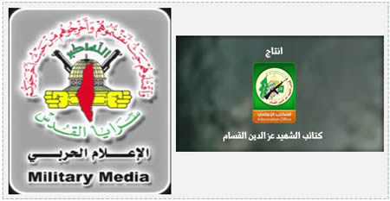 Left: The logo of the PIJ/Jerusalem Brigades' "military media." Right: The logo of the Izz al-Din al-Qassam Brigades' "information office.‬
18. The two military-terrorist operatives who appear on the list of the 17 journalists are not the only military-terrorist operatives in the ranks of Hamas and the PIJ's military information networks who were killed in Operation Protective Edge. At least three others were killed, one of them a senior commander. However, the Palestinian Journalists Syndicate avoided putting their names on the list (for their pictures and information, see Appendix 4).
Appendices
19. This report has five appendices:
1) Appendix 1 – Findings of the examination of the names of the 17 media personnel killed in Operation Protective Edge, as reported by the Palestinian Journalists Syndicate and the Gaza office of the ministry of information.
2) Appendix 2 – The "information office" network of Hamas' Izz al-Din al-Qassam Brigades.
3) Appendix 3 – The "military media" network the PIJ/Jerusalem Brigades.
4) Appendix 4 – Portraits of three Hamas and PIJ terrorist operatives who belonged to the organizations' military information networks and were killed in Operation Protective Edge.
5) Appendix 5 – The original list of 17 names issued by the Palestinian Journalists Syndicate and published by the Wafa News Agency.

