UPDATE: An Iranian Connection to the Cordoba Initiative?
The Ground Zero mosque website just removed a photo of Mohammad Javad Larijani: secretary-general of Iran's High Council for Human Rights, brother of Ali Larijani, top negotiator for Iran's nuke program.

Anne Bayefsky
August 13, 2010
PajamasMedia.com
http://pajamasmedia.com/blog/an-iranian-connection-to-the-cordoba-house-ground-zero-mosque/
UPDATE:
Several commenters have questioned the veracity of the story that the Cordoba Initiative has just deleted a photo of a high-placed Iranian operative from its website. What follows is the proof that the photo was originally on the Cordoba Initiative website, and its Shariah Index project page.
A screen shot below is from a cached copy of the original page, from http://gigablast.com/get?q=cordobainitiative.org+sharia&c=main&d=134956785546&cnsp=0.

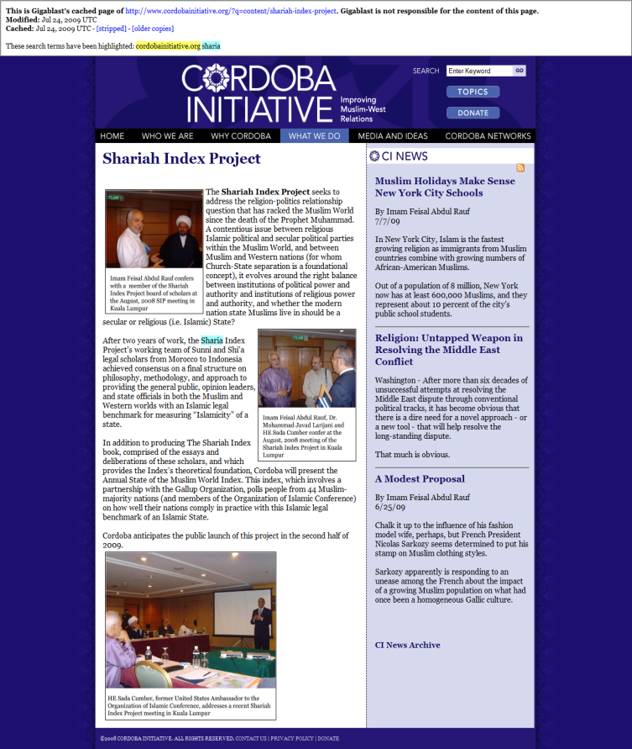

In fact, the photo which was removed still has the following specific internet address, as the Cordoba Initiative has — as of now — forgotten to delete the photo from their server: http://www.cordobainitiative.org/SIP2.jpg.

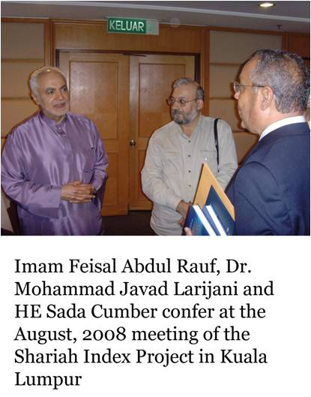

Here is how the page appears now, with the photo removed: http://www.cordobainitiative.org/?q=content/shariah-index-project.

