Tweet by Israel Mission to the UN in Geneva
July 27, 2022
https://twitter.com/IsraelinGeneva/status/1552399286276886528

Israel in UN/Geneva

@IsraelinGeneva

This is antisemitism. Miloon Kothari said “We are very disheartened by the social media that is controlled largely by – whether it is the Jewish lobby or specific NGOs,” Antisemitism has no place in today's society & should be condemned whenever it raises its ugly head.
Quote Tweet
Israel in UN/Geneva
@IsraelinGeneva
· 16h
“I would go as far as to raise the question of why Israel is even a member of the UN." Outrageous comments by a member of the CoI targeting Israel. To the CoI and its members, the very existence of Israel is the root cause of the conflict. Our reaction https://bit.ly/3Bmmepg

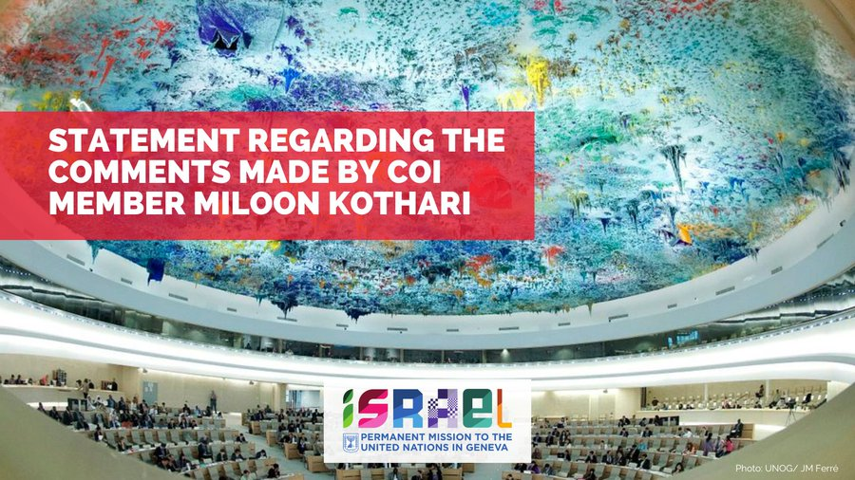

2:03 PM · Jul 27, 2022·Twitter for Android

