Twitter Thread by Mission of Israel to the United Nations in Geneva Regarding the U.N. “Commission of Inquiry” on Israel
July 29, 2022
https://twitter.com/IsraelinGeneva/status/1552916382626582560

Israel in UN/Geneva

@IsraelinGeneva

Unroll Mentioning a "Jewish lobby", is bad...
12:18 AM · Jul 29, 2022·Twitter Web App

24
Retweets

2
Quote Tweets

50
Likes

Tweet your reply

Reply

Israel in UN/Geneva

@IsraelinGeneva

·
11h
Replying to
@IsraelinGeneva
Mentioning a "Jewish lobby" and that "A lot of money is being thrown into trying to discredit us", is worse...
2
6
25

Israel in UN/Geneva

@IsraelinGeneva

·
11h
Mentioning that "Social media is largely controlled by the Jewish lobby" and that "A lot of money is being thrown into trying to discredit us", is terrible...
2
5
26

Israel in UN/Geneva

@IsraelinGeneva

·
11h
Navi Pillay, no matter the context, that is blunt antisemitism. If you can't see it, resign now!

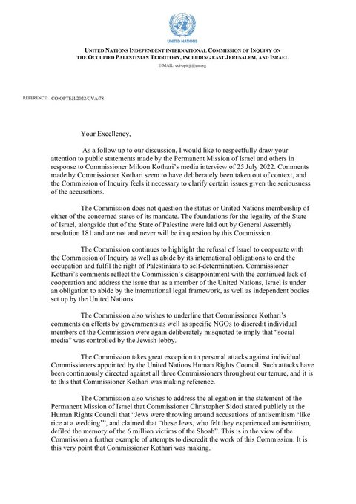

ALT

