Amendment #1: S/2023/775
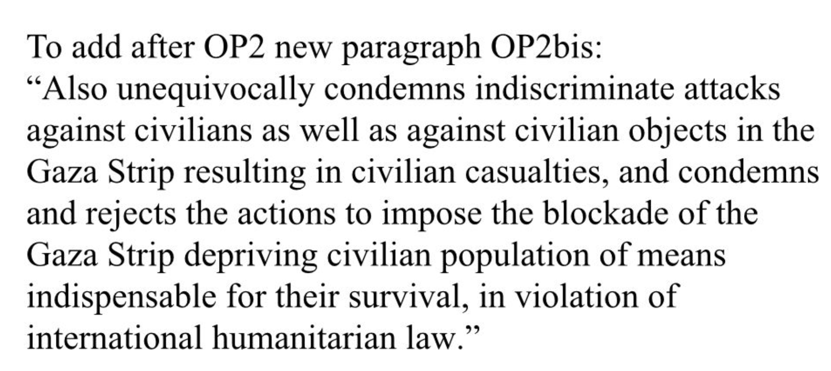

Amendment #2: S/2023/776
