17 Captivating Photos from Operation Protective Edge
IDF Blog
August 16, 2014
http://web.archive.org/web/20140819090447/http://www.idfblog.com/blog/2014/08/16/top-17-photos-operation-protective-edge/

The IDF launched Operation Protective Edge on July 8 in response Hamas’ incessant terror attacks against Israel. These photos show the daily reality of Israeli civilians living under rocket fire and the IDF’s soldiers on the field.
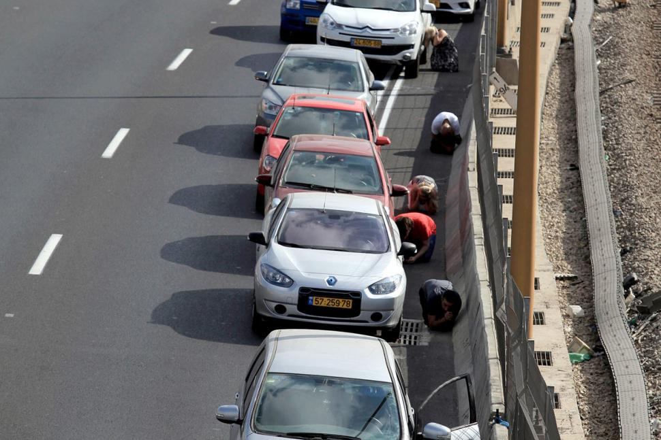
Israelis take cover upon hearing rocket sirens on a highway. Photo credit: Reuters
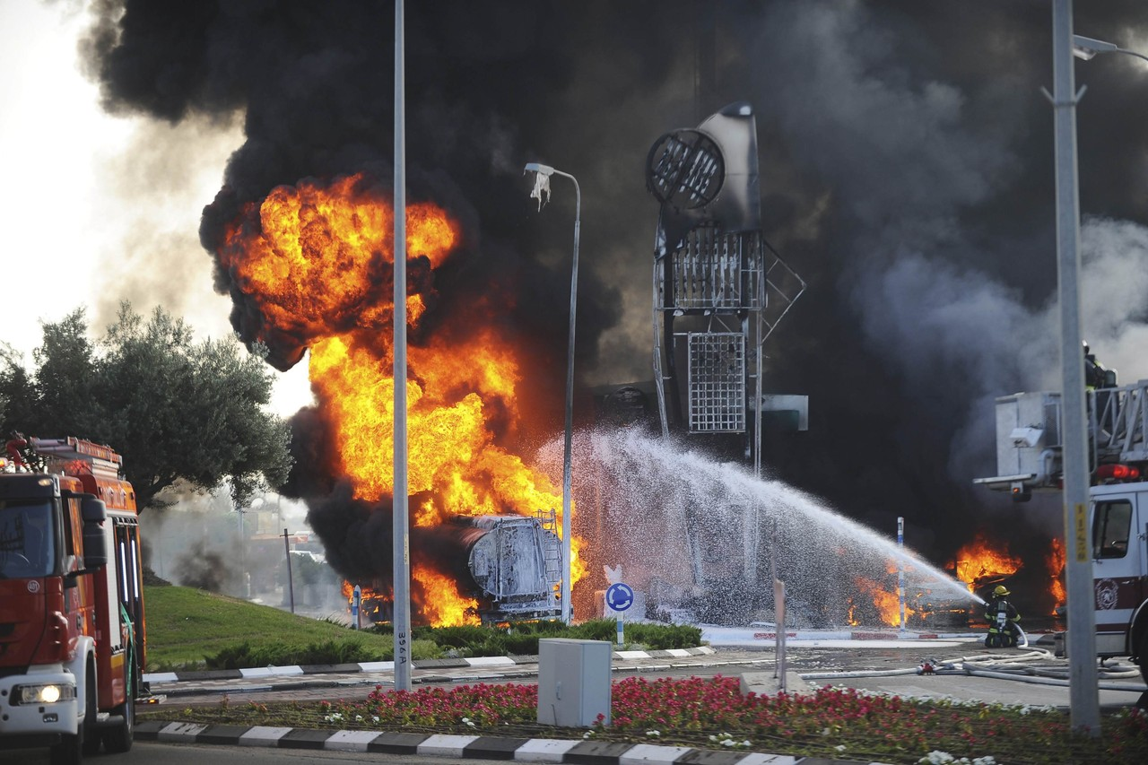
A rocket fired by Hamas hits a gas station in southern Israel. Photo credit: Avi Roccah
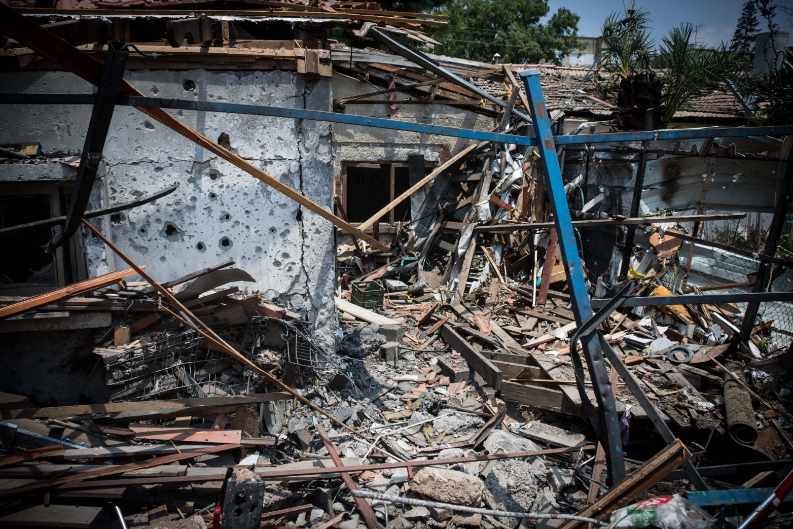
A house in Yehud is destroyed after being hit by a rocket fired from Gaza
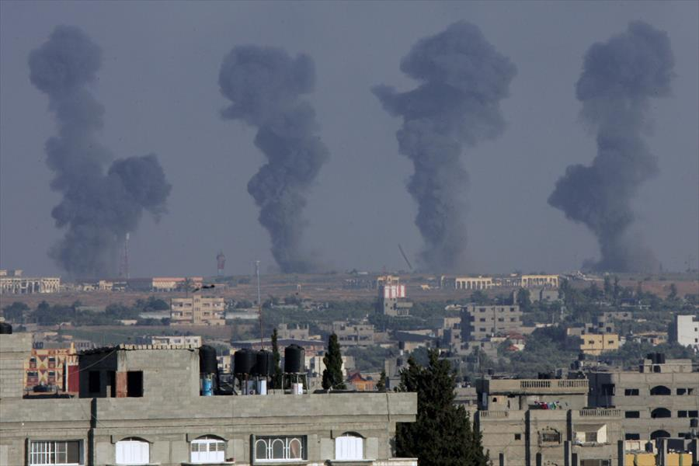
In response to incessant attacks, the IAF targets terror sites in Gaza. Photo credit: Flash90
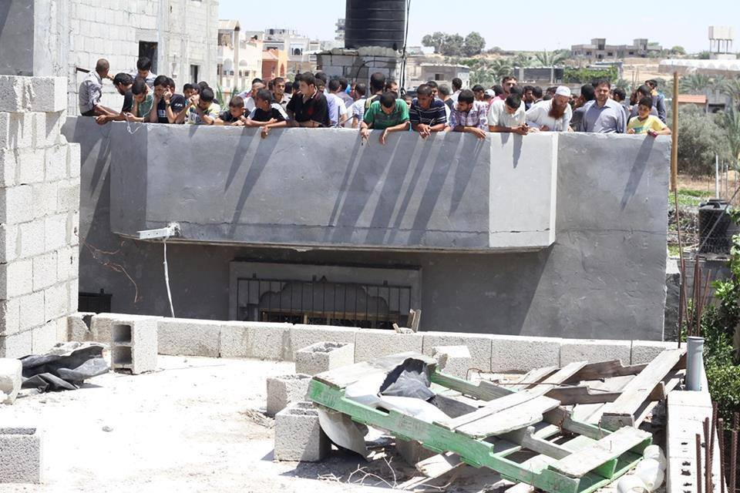
Gazan civilians run to the roof of a building used for terrorist activity after Hamas encourages them to serve as human shields.
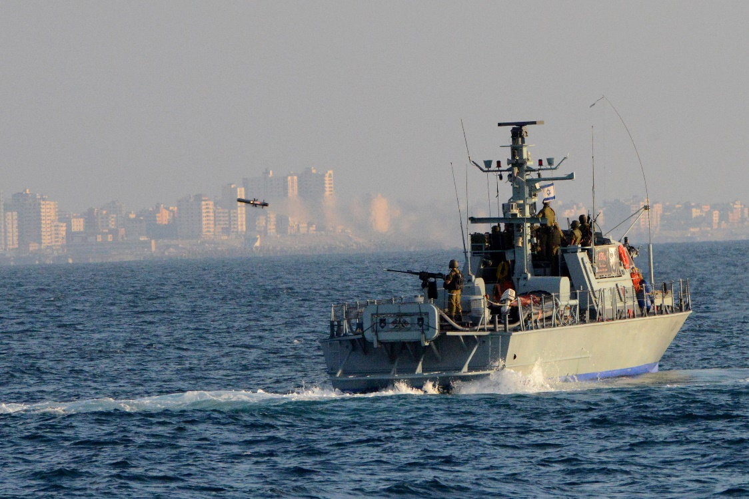
IDF Naval Forces strike Hamas terror infrastructure located near the Gaza Coast
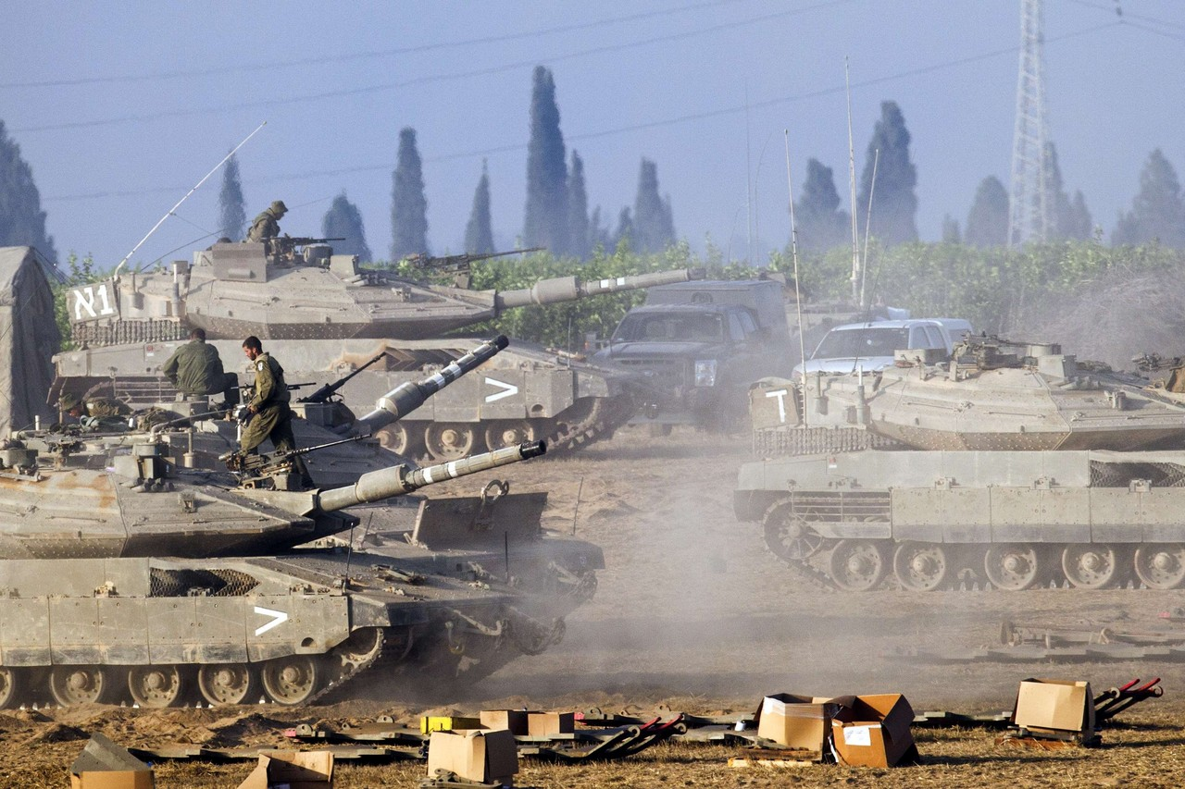
Forces from the Armored Corps prepare for the ground operation. Photo credit: AFP/GettyImages
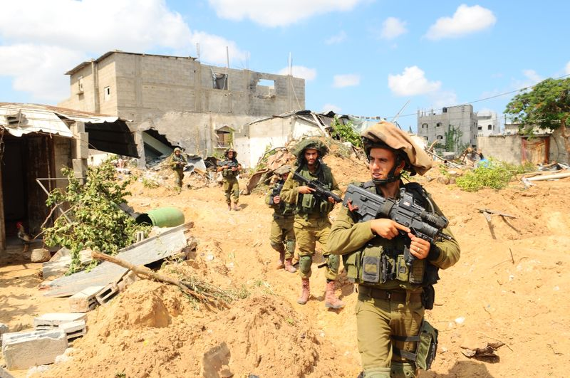
IDF soldiers complete a mission in the Gaza Strip
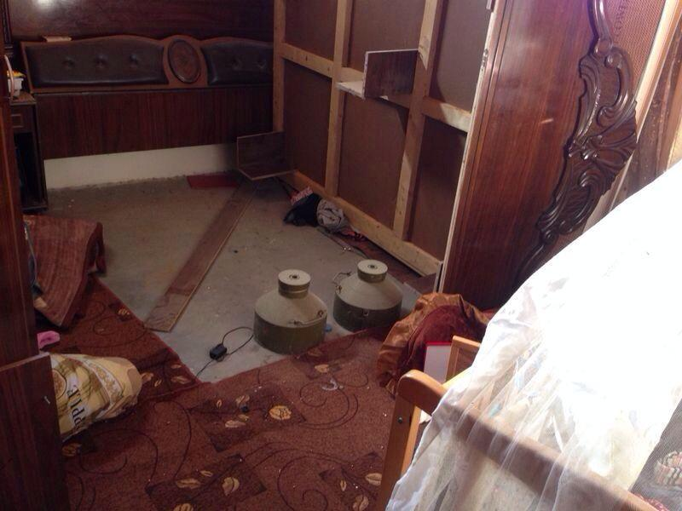
Two explosive devices discovered next to a baby’s crib in the Gaza Strip
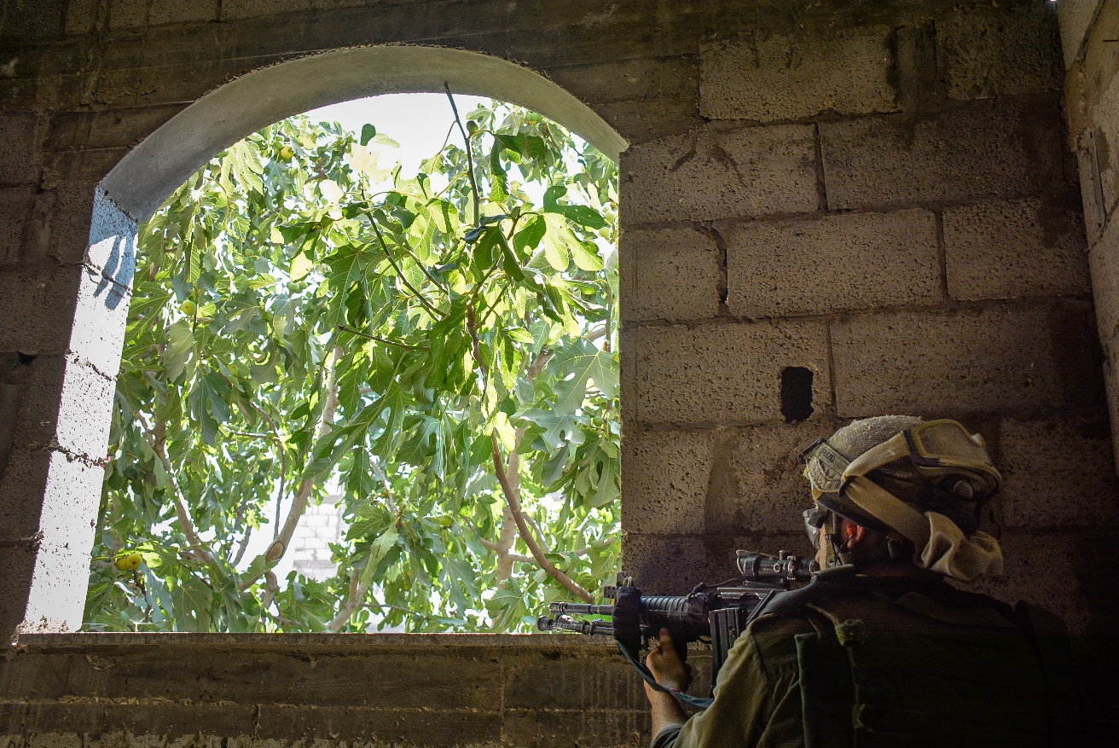
An IDF soldier in urban combat
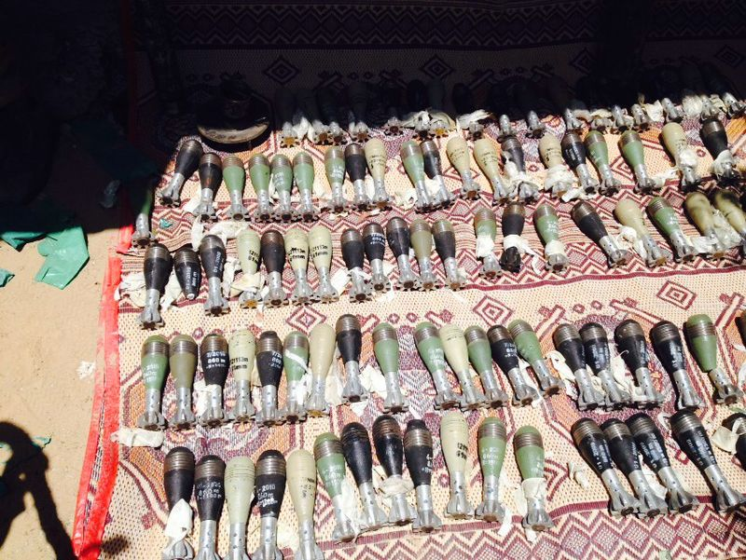
An arsenal of mortar shells uncovered in a tunnel by IDF forces operating in Gaza
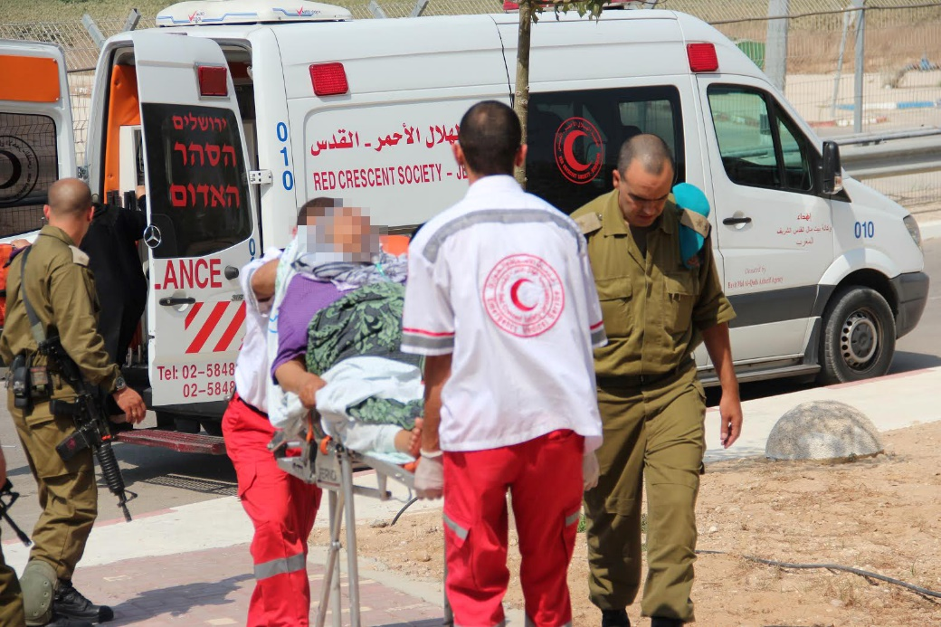
The IDF field hospital receives Palestinians patients from Gaza
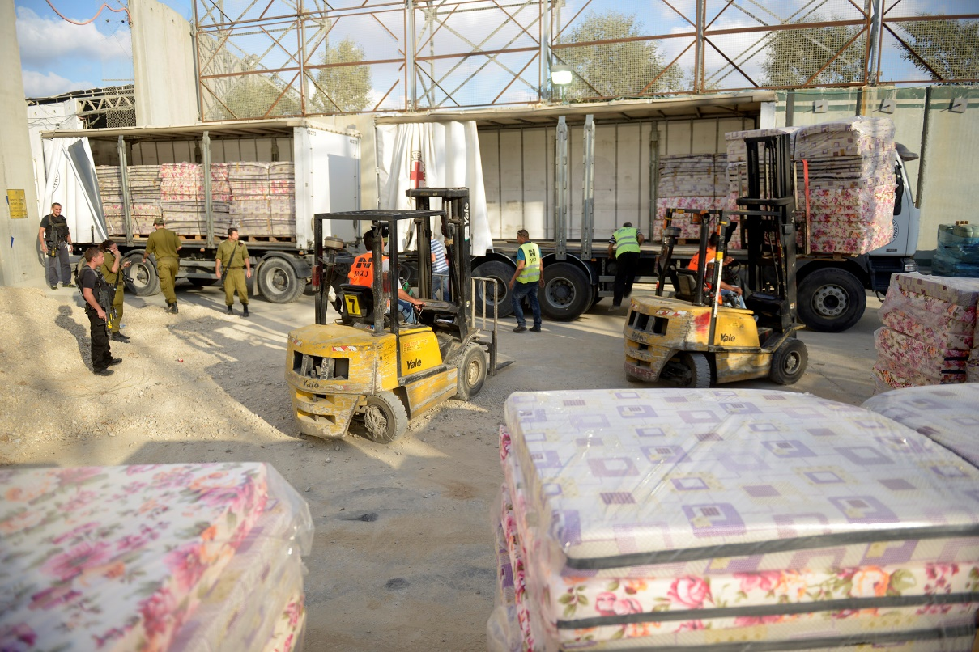
The IDF transfers goods and humanitarian aid from Israel into the Gaza Strip
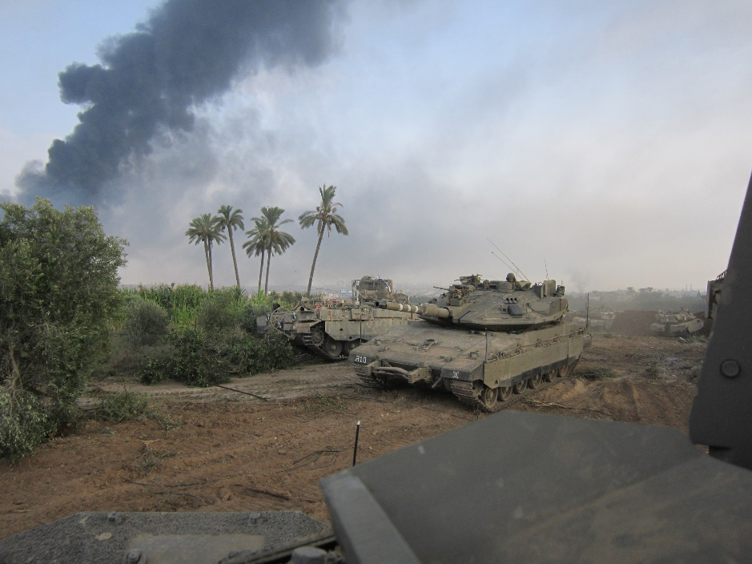
The 401 Armored Brigade supports Ground Forces near the Gaza border
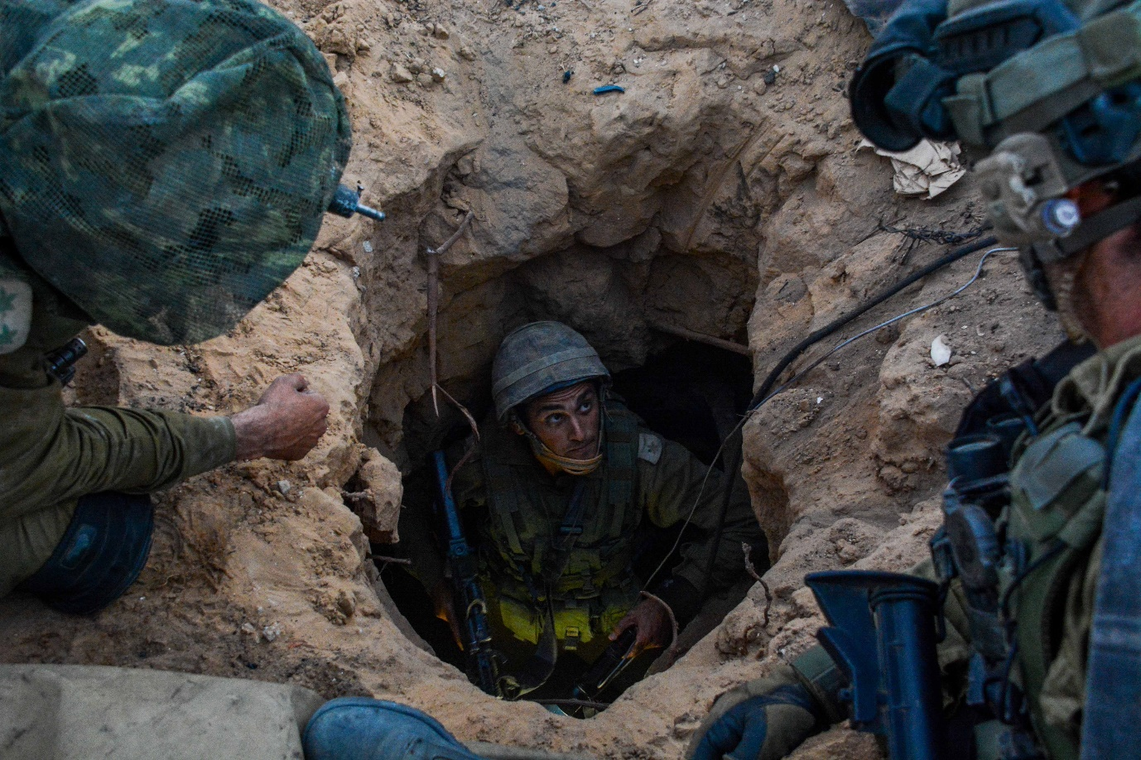
Soldiers prepare to dismantle a Hamas tunnel in the Gaza Strip
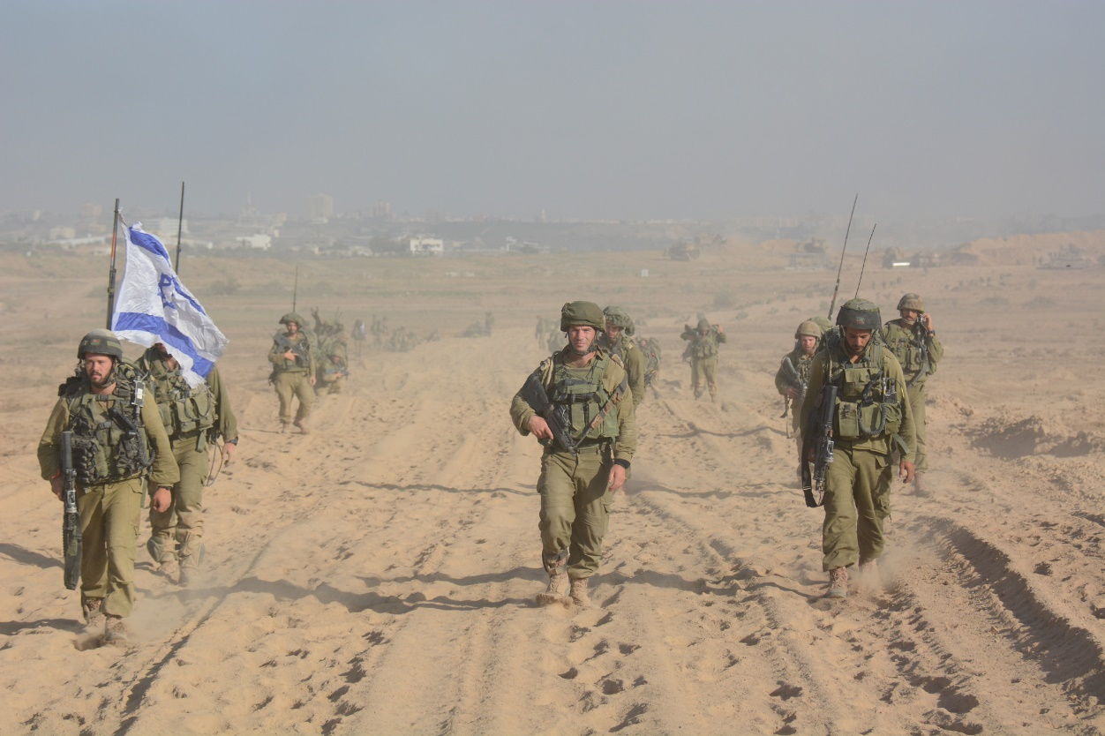
Infantry forces return to Israel
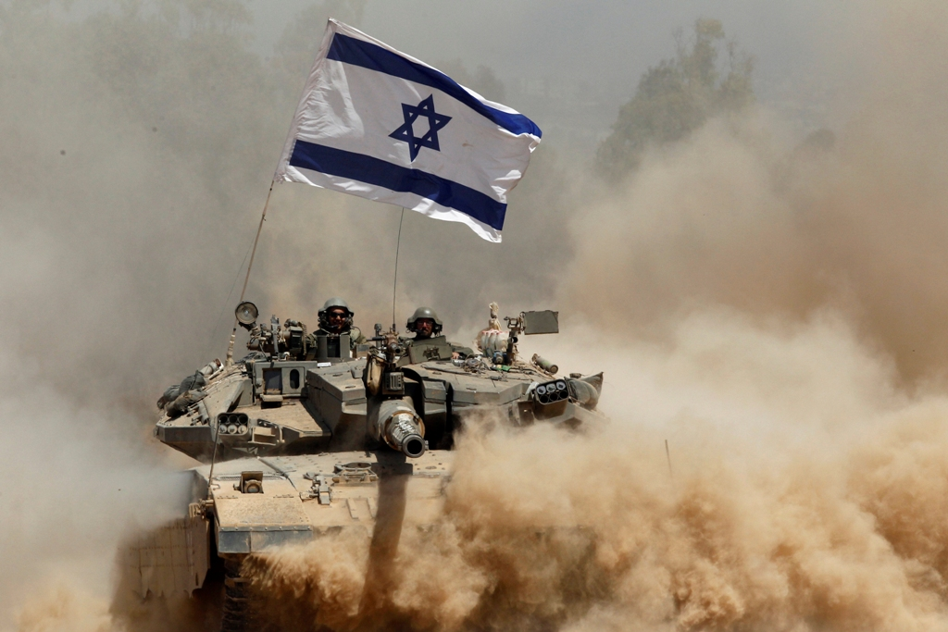
Israel withdraws its troops from the Gaza Strip. Photo credit: Reuters

