200 Hamas Terrorists Arrested in Connection with Kidnapping
IDF Blog
July 17, 2014
https://web.archive.org/web/20140806024955/http://www.idfblog.com/blog/2014/06/17/idf-searches-hamas-kidnappers/

After an operation in Judea and Samaria last night, Israeli forces have arrested about 280 Palestinian suspects in connection with the recent abduction of three Israeli teenagers.
IDF soldiers arrested 30 terror suspects Wednesday night in connection with Operation Brother’s Keeper, the mission to find Hamas operatives who abducted three Israeli teenagers last week.
Since the beginning of the operation, IDF forces have detained approximately 280 suspects, including 200 Hamas operatives. Fifty five of the arrested are Palestinians released in the Gilad Shalit prisoner exchange [EDITOR’S NOTE: LINK GOES TO A OCTOBER 18, 2011 IDF BLOG ARTICLE ENTITLED “Updating: Gilad Shalit Returns Home After 5 Years in Captivity] in 2011.
Forces detained the suspects in the Judea and Samaria region, where Hamas terrorists abducted the three teens last Thursday. Soldiers also searched about 900 locations and carried out operations against Dawa institutions, the civilian mechanism used by Hamas to recruit operatives, disseminate information and raise funds.
During an operation in Nablus earlier this week, the IDF uncovered hundreds of weapons and explosives hidden in Palestinian weapons caches. As forces left the city Wednesday night, Palestinians hurled rocks and an improvised explosive device at the soldiers, leading to several arrests in the area.
A violent riot also erupted Wednesday night in Jenin, where soldiers were operating as part of their mission to find the teens. Like in Jenin, Palestinians hurled explosives and opened fire at the forces. The soldiers responded with live fire, identifying hits.
On Sunday morning, the IDF confirmed that Hamas terrorists were responsible for last week’s abduction. The IDF’s soldiers are working around the clock, on all fronts, to find Gilad Shaar, Eyal Yifrach and Naftali Frenkel – the three Israeli teenagers abducted last Thursday.
[EMBEDDED VIDEO: http://humanrightsvoices.org/site/documents/?d=22003]

IDF Chief of Staff Lt. Gen. Benny Gantz briefed Israeli security officials during an assessment of the operation Sunday night.
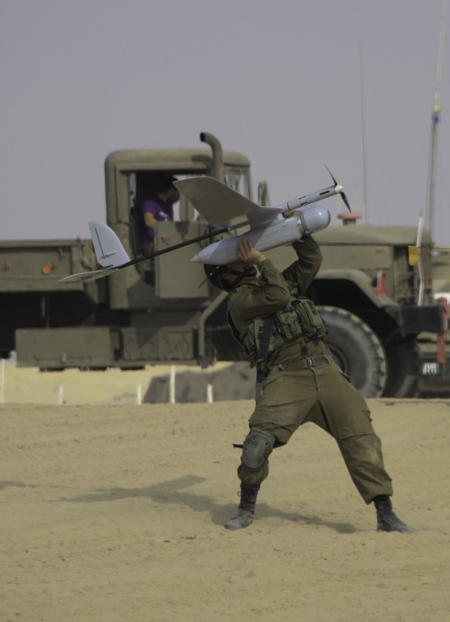
Soldier guides a drone during an IDF exercise
Soldiers controlling Skylark aerial drones are enhancing Israel’s operation. Their technology provides crucial intelligence to forces trying to find the kidnappers. [EDITOR’S NOTE: LINK GOES TO AN AUGUST 16, 2013 IDF BLOG ARTICLE ENTITLED “Leaving No Stone Unturned: How the IDF Locates Missing Soldiers”] “As soon as we identify [a target], we’ll be able to notify forces in the area,” said Captain Yochai Varso, an IDF company commander. “When they ask to see a house, we’ll be able to show them the structure and movement nearby.”
[EMBEDDED VIDEO: http://humanrightsvoices.org/site/documents/?d=22004]

During an overnight operation Saturday, IDF forces arrested about 80 Palestinian suspects connected to the terrorist kidnapping [EDITOR’S NOTE: LINK GOES TO A JUNE 25, 2013 IDF BLOG ARTICLE ENTITLED “Seven Years Since Shalit Kidnapping: Motivation to Kidnap Still High”]. “Palestinian terrorists will not feel safe,” IDF Spokesman Lt. Col. Peter Lerner stressed after the operation. “They will not be able to hide and will feel the heavy arm of Israel’s military capabilities.”
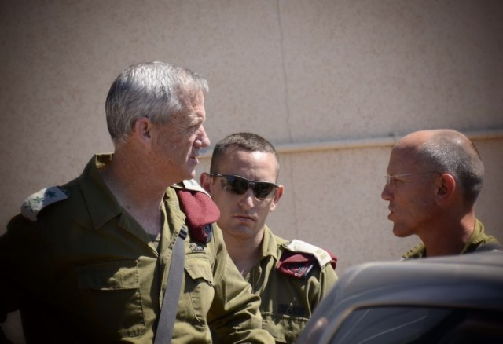
During a press conference on Saturday evening, IDF Chief of Staff Lt. Gen. Benny Gantz discussed the IDF’s broad search effort. “We are operating wherever needed and our efforts are growing,” Lt. Gen. Gantz stressed. “We remain determined to achieve our operational objectives, and will act with responsibility, poise and determination to accomplish whatever is required of us.”
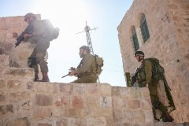
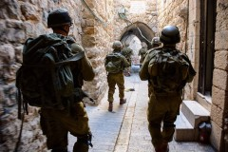

Israeli forces searched throughout Hebron [EDITOR’S NOTE: LINK GOES TO A MARCH 4, 2014 IDF BLOG ARTICLE ENTITLED “Three Years in Hebron: A First-Person Account From The Field”] for signs of the young Israelis. Their operation took them between alleys, on top of houses and through the city’s markets. Israeli forces performed similar operations across the Judea and Samaria [EDITOR’S NOTE: LINK GOES TO A DECEMBER 2, 2013 IDF BLOG ARTICLE ENTITLED “IDF Prepares to Combat Rising Terror Threats in Judea and Samaria”] region.
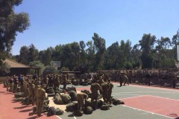
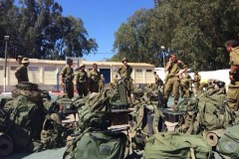
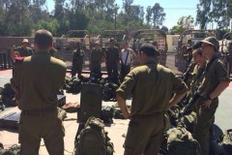

IDF Paratroopers joined the IDF mission on Saturday. Moments before setting out on their search, they gathered for a briefing in Judea and Samaria. Their participation expanded and strengthened Israel’s efforts to find the kidnapped Israelis.

[EMBEDDED VIDEO: http://humanrightsvoices.org/site/documents/?d=22005]

During an extensive part of the operation on Friday, IDF soldiers searched the streets and entered the houses of Judea and Samaria [EDITOR’S NOTE: LINK GOES TO A SEPTEMBER 10, 2013 IDF BLOG ARTICLE ENTITLED “Terrorism in Judea and Samaria Becoming More Sophisticated”]. The forces continued late into the night, working with determination to bring the teens home as quickly as possible.

[EMBEDDED VIDEO: http://humanrightsvoices.org/site/documents/?d=22006]

The Skylark Unit [EDITOR’S NOTE: LINK GOES TO A JANUARY 25, 2012 IDF BLOG ARTICLE ENTITLED “Maximum Efficiency at Minimum Risk- Showcasing IDF’s Skylark UAV”] uses UAVs to track troop movements on the ground in Judea and Samaria. The UAVs are optimal for surveillance and reconnaissance because they can be operated from remote locations and flown anonymously. Click to read more about the Skylark I-LE [EDITOR’S NOTE: LINK GOES TO A DECEMBER 26, 2011 IDF BLOG ARTICLE ENTITLED “8 Incredible Technologies Used by the IDF”].

