Hamas Caught Using Human Shields in Gaza

July 8, 2014
Israeli Defense Forces
http://www.idfblog.com/blog/2014/07/08/hamas-uses-human-shields/

The IDF is currently engaged in Operation Protective Edge against Hamas and other Palestinian terrorist groups in the Gaza Strip. Hamas places weapons and missile launchers in densely populated areas. They also send men, woman and children to act as human shields for terrorists.

(VIDEO: https://youtu.be/UXZEzbT0H1s)
Innocent bystanders can be killed as a result of Hamas’ abuse of its own civilians. Instead of keeping its citizens out of harm’s way, Hamas encourages and even forces Gazans to join its violent resistance against Israel.
During Operation Protective Edge, evidence of Hamas’ and other terror organizations’ use of human shields has surfaced.
This video published on July 8 on the Internet shows rockets being fired toward Israel. In the video, a civilian building can be seen next to the launching sites.
(VIDEO: https://www.youtube.com/watch?feature=player_embedded&v=5nyCFJkV6xE)

In this photo, taken on July 8 from live news footage, a rocket is seen being fired from within a civilian area.
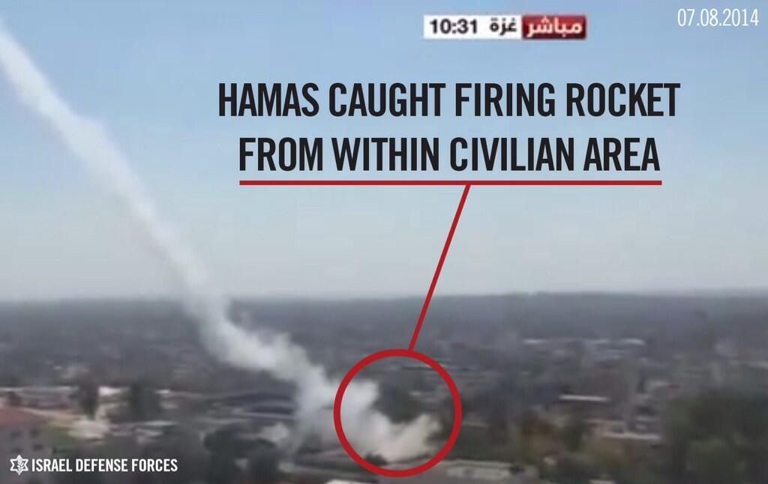
In this next photo, also from July 8, civilians gather on the roof of the home of a Hamas terrorist who was targeted by the IDF. They did so in order to act as human shields and deter an imminent IDF attack.
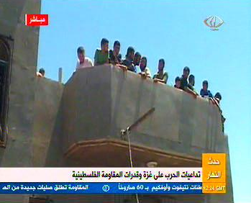
Civilians gather on the roof of the house of a Hamas terrorist
Hamas uses graphics such as the one below in order to assure Palestinians in Gaza that that they can become heroes by acting as human shields.
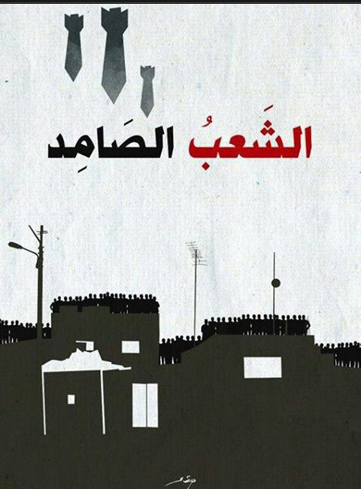
“A strong people” written in Arabic–word play on the name Hebrew name of Operation Protective Edge–encouraging Palestinians in Gaza to stand on the roofs of their homes to act as human shields.
Watch Hamas terrorists use civilians as human shields:

In the video below, which Hamas uploaded to the Internet, rockets are seen being fired from urban areas in the Gaza Strip. Hamas also uses such areas to store weapons.

