Hamas Fires Rockets from Everywhere in Gaza

August 4, 2014
Israeli Defense Forces
http://www.idfblog.com/blog/2014/08/04/hamas-fires-rockets-everywhere-gaza/

During Operation Protective Edge, Hamas has used populated areas of Gaza to launch attacks against Israel. The terrorist organization knows that rocket launching sites may be the targets of IDF counterstrikes. Nevertheless, Hamas has never stopped firing rockets from mosques, school, hospitals and other civilian areas.
(VIDEO: https://www.youtube.com/watch?v=IUrDAEgisXM)
Hamas is responsible for the destruction in civilian areas in Gaza. Not only did Hamas draw the IDF into a battle by refusing to cease its indiscriminate rocket fire on Israelis, Hamas also brought the battle right into the heart of Gaza’s civilian areas.

The IDF would not strike targets in civilian areas if Hamas had not embedded its terrorist infrastructure there. The IDF only intentionally attacks military targets. Unfortunately, Hamas never ceased to fire from populated civilian areas. Moreover, Hamas knows that even though the IDF does all it can to minimize civilian harm, including by providing effective advance warning where feasible, their rockets could eventually bring counterfire, in order to protect IDF forces and the Israeli civilian population.
Shuja’iya and Beit Hanoun
The IDF struck hundreds of terror targets in the areas of Shuja’iya and Beit Hanoun. Many of these targets were among the sites used to launch hundreds of rockets at Israel. Each red dot on the following intelligence map represents a location from where a rocket was launched at Israel.
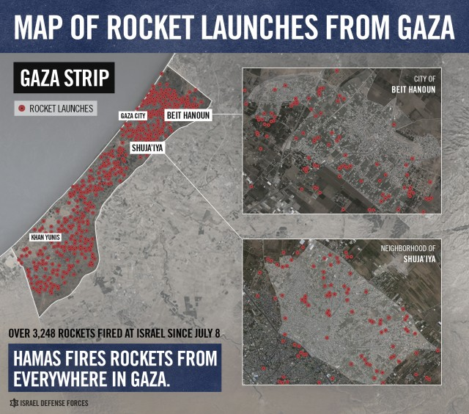
Places from which Hamas fired more rockets were more likely to be targets for IDF strikes.
Hamas Launched Attacks from UNRWA School
The IDF was clear: it would never intentionally strike an UNRWA facility merely because it is an UNRWA facility. Hamas was clear as well: terrorists continuously placed weapons in, and launched rockets and mortars from, the direct vicinity of UNRWA facilities, including schools.
The following map displays the area surrounding an UNRWA school in Zeitoun, Gaza.
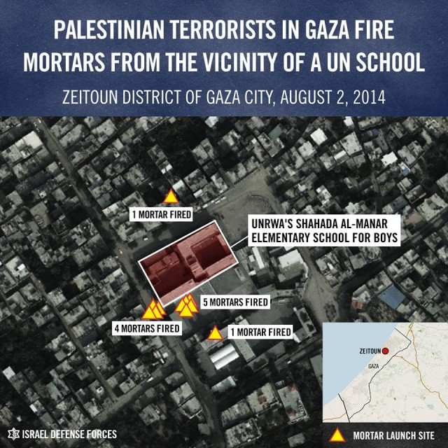
Hamas terrorists fired at least 11 mortar shells from the area surrounding the elementary school.
Hamas’ Cruel Calculus
Hamas is aware of the danger it poses to Gaza’s civilians by firing rockets at Israel from civilian areas and by turning civilian buildings into military targets.
Tragically, many of Hamas’ own rockets falling short into these neighborhoods contributed to much of the destruction there. Booby-trapped homes, intended to detonate on IDF forces, also caused damage (indeed, the IDF has warned civilians in Gaza of this danger when returning to their homes). Furthermore, Hamas used an enormous number of these civilian buildings for firing posts, intelligence gathering spots, command and control centers and cover for terror tunnel entrances. Hamas turned these neighborhoods into an intricate and vast military network.
Day after day, Hamas fired rockets from these areas and watched as the IDF responded – and Hamas continued to fire from those same areas. It is clear that Hamas was more than indifferent to civilian areas being struck, it actually hoped for it.

