William Schabas Lied, Repeatedly, On His Application Form To UNHRC

February 04, 2015
By Elder of Ziyon
Elder of Ziyon Blog
http://elderofziyon.blogspot.com/2015/02/william-schabas-lied-repeatedly-on-his.html#.VOpEcUt6gds

Israel's Channel 2 reported that William Schabas lied in his resignation letter - and on his application form to become the head of the commission to investigate the Gaza war..

In his letter, he wrote:
In early August 2014, when I was asked if I would accept a nomination to the Commission of Inquiry, I was not requested to provide any details on any of my past statements and other activities concerning Palestine and Israel. Of course, my views on Israel and Palestine as well as on many other issues were well known and very public. My curriculum vitae was readily available indicating public lectures and writings on the subject. My opinions were frequently aired on my blog. This work in defence of human rights appears to have made me a huge target for malicious attacks...

But his application did ask him about conflicts of interest. I found it online and it includes a series of three questions about conflict of interest,

Here's the first page:

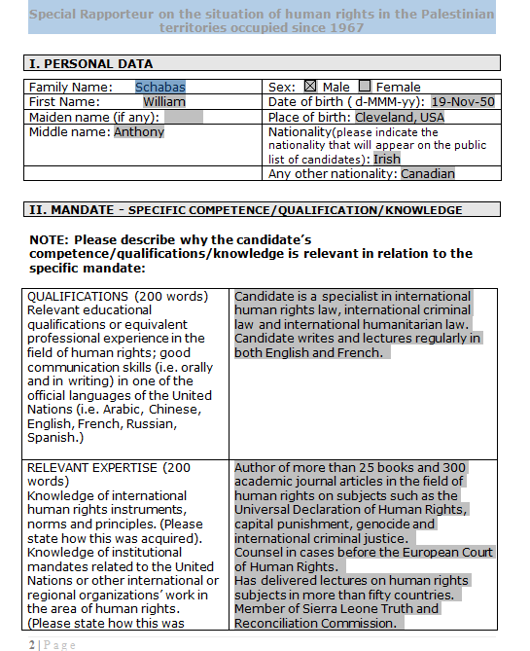

Here's where he answers, three times, that he has no conflicts of interest - and he lies on at least two of them, questions 1 and 3, based on his resignation letter alone:

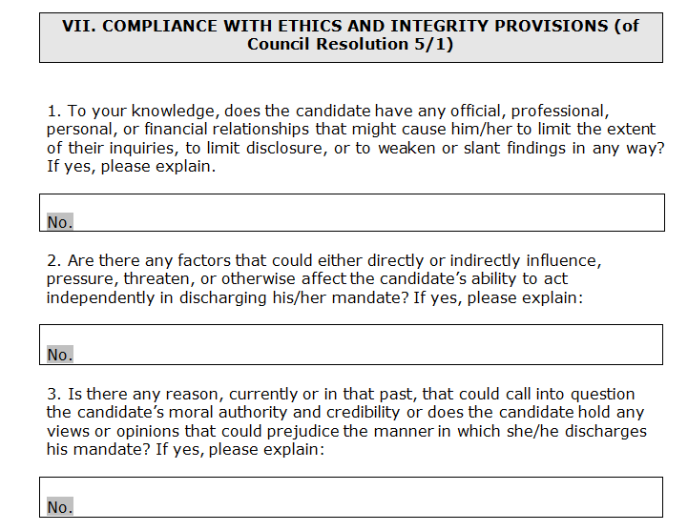
I would argue that his answer on question 2 was a lie as well, based on how he wrote his "motivation letter" elsewhere in the document:
The mandate of special rapporteur on the occupied Palestinian territories has proven to be one of the most sensitive and delicate of the special procedures. What I bring to the table is a level of expertise in the relevant legal sources, that is, international humanitarian law, international criminal law and international human rights. A very high standard of legal precision in these areas is important for the credibility of the mandate. Although controversy is inevitable, the 'stakeholders', States and international civil society must have a high level of confidence in the accuracy of the special rapporteur's observations, findings and legal qualifications.

The contribution that the special rapporteur can make in terms of the protection of the population in the occupied territories will be enhanced by an ability to interact in a constructive manner with the Occupying Power. Although a difficult task, especially in light of recent developments, efforts should continue in an attempt to create some level of communication and dialogue as the landscope continues to evolve, transformed by changes in the region and political developments within Palestine, Israel and beyond.
Even though to the media Schabas would emphasize that he would be looking at violations from all sides, here he only emphasizes protection of Gazans and potential actions by Israel. I think that shows that he could not act impartially. At any rate, having a financial relationship with the PLO should disqualify him based on that question anyway.

Are there any consequences for such a prestigious professor to being proven a liar by his own words?

(h/t Yair Rosenberg)

UPDATE: It has been pointed out to me that this was not the application for the specific position as leading the commission of inquiry; rather this was Schabas' application to become the "Special Rapporteur on the situation of human rights in the Palestinian territories since 1967" which was Rchard Falk's old job.

He still lied, but the last point I made about his interest in protecting Gazans is consistent with that job title. It is very interesting that he applied for Falk's job.

