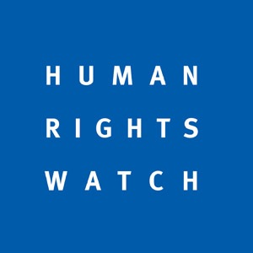
Expansion of Illegal Settlements, Deterioration in Gaza, Escalation in Repression by Palestinian Forces Warrant Council’s Attention
Item 7 General Debate, 25 September 2017

Thank you, Mr. President,
Recent months have seen several disturbing developments in the human rights situation in the Occupied Palestinian Territories.
First, Israeli authorities continue to expand its settlements in the West Bank, including East Jerusalem. Such transfers of civilians into occupied territory constitute war crimes. According to the Israeli group Peace Now, authorities approved plans for 85% more housing units in the first half of 2017 than during all of 2016. Last month, Israeli Prime Minister Benjamin Netanyahu said there “will be no more uprooting of settlements in the land of Israel” and that “we are here to stay, forever.” The Office of the High Commissioner for Human Rights should urgently establish the comprehensive database requested by this Council of businesses operating in illegal settlements to help states fulfill their obligations outlined in UN Security Council Resolution 2334.
Second, the humanitarian situation in Gaza remains dire. Israel’s decision in June to accede to a Palestinian Authority request to cut electricity to Gaza exacerbated the power crisis there, leaving households with roughly four hours of electricity a day. Power outages jeopardize water supply, inhibit processing of sewage and cripple operations of hospitals. The Council should call for Israel and the PA to increase the supply of electricity to Gaza—a dispute over payment should not be pretext to deprive Palestinians in Gaza of electricity.
Third, the PA and Hamas have continued crackdowns on dissent, arbitrarily arresting and prosecuting activists and abusing those in custody. Earlier this month, the PA detained human rights defender Issa Amro, apparently over a Facebook post. Amro, who addressed this body in June 2013, also faces charges in an Israeli military court for his role in a peaceful protest. The Council should condemn these restrictions on free expression by Palestinian authorities and renew its commitment to monitoring respect for human rights in the West Bank and Gaza by Israel, the PA and Hamas, as part of its mandate.
Continuing debates concerning the appropriate item number under which to address issues relating to the Occupied Palestinian Territories should not deter the Council from addressing, one way or the other, these pressing human rights concerns.

