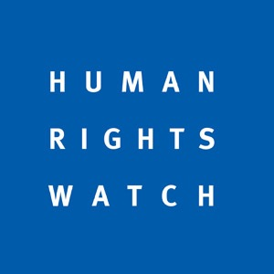
Gaza Killings, Unabated Settlement Activity Underscore Need for International Accountability, Action
Item 7 General Debate, 2 July 2018

Thank you, Mr. President,
Since the March session, Israeli forces have killed 124 Palestinians in demonstrations in Gaza and wounded more than 4,000 with live ammunition. Senior Israeli officials apparently approved orders to fire on demonstrators who posed no imminent threat to life, acts that may amount to war crimes. The Commission of Inquiry established by this body should identify those officials who sanctioned open fire regulations that violate international norms.
The Palestinian Authority and Hamas both violently dispersed peaceful demonstrations in recent weeks and continue to arbitrarily arrest critics and mistreat those in detention.
As Israeli authorities approved thousands of new housing units in Jewish settlements in the West Bank, the Israeli Supreme Court in May approved the government’s plan to demolish Khan Al-Ahmar Ab al-Hilu, a Palestinian village of 180 people east of Jerusalem, including its school, which educates 160 children from five surrounding villages, to facilitate settlement expansion. The transfer of civilians into occupied territory and forcible transfer of protected people in the occupied territory are war crimes.
We welcome the High Commissioner’s opening statement that his office will continue its work on the database of businesses operating in settlements, and publish an update, possibly before September. Businesses cannot operate in or with settlements without contributing to serious abuses.
Meanwhile, Israeli authorities continue to narrow the space for Palestinian, Israeli and international rights defenders. In May, Israel revoked the work permit for Human Rights Watch’s Israel and Palestine director and ordered him to leave the country. He challenged the order which is currently under review in the Israeli courts. This body should continue to raise concern about these growing restrictions.
We deplore the fact that Israel refused to participate in the adoption of its UPR report last week. This is but the latest example of a history of non-cooperation, illustrating that Israel is unwilling to submit to international scrutiny of its human rights record, irrespective of the Council agenda item under which this takes place.

