The Persistence of History

August 25, 2015
The Economist
http://www.economist.com/news/international/21661812-islamic-states-revival-slavery-extreme-though-it-finds-disquieting-echoes-across

“SPOILS of war,” snaps Dabiq, the English-language journal of Islamic State (IS). The reference is to thousands of Yazidi women the group forced into sex slavery after taking their mountain, Sinjar, in August last year. Far from being a perversion, it claims that forced concubinage is a religious practice sanctified by the Koran. In a chapter called “Women”, the Koran sanctions the marriage of up to four wives, or “those that your right hands possess”.

Literalists, like those behind the Dabiq article, have interpreted these words as meaning “captured in battle”. Its purported female author, Umm Sumayyah, celebrated the revival of Islam’s slave-markets and even proffered the hope that Michelle Obama, the wife of America’s president, might soon be sold there. “I and those with me at home prostrated to Allah in gratitude on the day the first slave-girl entered our home,” she wrote. Sympathisers have done the same, most notably the allied Nigerian militant group, Boko Haram, which last year kidnapped an entire girls’ school in Chibok (pictured above).

Religious preachers have responded with a chorus of protests. “The re-introduction of slavery is forbidden in Islam. It was abolished by universal consensus,” declared an open letter sent by 140 Muslim scholars to IS’s “caliph”, Abu Bakr al-Baghdadi, earlier this year. “You have taken women as concubines and thus revived…corruption and lewdness on the earth.”

But while IS’s embrace of outright slavery has been singled out for censure, religious and political leaders have been more circumspect about other “slave-like” conditions prevalent across the region. IS’s targeting of an entire sect for kidnapping, killing and sex trafficking, and its bragging, are exceptional; forced labour for sexual and other forms of exploitation is not. From Morocco, where thousands of children work as petites bonnes, or maids, to the Syrian refugee camps in Jordan where girls are forced into prostitution, to the unsanctioned rape and abuse of domestics in the Gulf, aid workers say servitude is rife.

Scholars are sharply divided over how much cultural mores are to blame.
Apologists say that, in a concession to the age, the Prophet Muhammad tolerated slavery, but—according to a prominent American theologian trained in Salifi seminaries, Yasir Qadhi—he did so grudgingly and advocated abolition.

Repeatedly in the Koran the Prophet calls for the manumission of slaves and release of captives, seeking to alleviate the slave systems run by the Greeks, Romans, Byzantines and Jewish Himyarite kings of Yemen. He freed one slave, a chief’s daughter, by marrying her, and chose Bilal, another slave he had freed, to recite the first call to prayer after his conquest of Mecca. His message was liberation from worldly oppression, says Mr Qadhi—enslavement to God, not man.

Other scholars insist, however, that IS’s treatment of Yazidis adheres to Islamic tradition. “They are in full compliance with Koranic understanding in its early stages,” says Professor Ehud Toledano, a leading authority on Islamic slavery at Tel Aviv University. Moreover, “what the Prophet has permitted, Muslims cannot forbid.” The Prophet’s calls to release slaves only spurred a search for fresh stock as the new empire spread, driven by commerce, from sub-Saharan Africa to the Persian Gulf.

To quash a black revolt in the salt mines of southern Iraq, the Abbasid caliphs in Baghdad conscripted Turkish slaves into their army. Within a few generations these formed a power base, and from 1250 to 1517 an entire slave caste, the Mamluks (Arabic for “chattel”), ruled Egypt.

Their successors, the Ottoman Turks, perfected the system. After conquering south-eastern Europe in the late 14th century, they imposed the devshirme, or tribute, enslaving the children of the rural poor, on the basis that they were more pagan than Christian, and therefore not subject to the protections Islam gave to People of the Book. Far from resisting this, many parents were happy to deliver their offspring into the white slave elite that ran the empire.

Under this system, enslaved boys climbed the ranks of the army and civil service. Girls entered the harem as concubines to bear sultans. All anticipated, and often earned, power and wealth. Unlike the feudal system of Christian Europe, this one was meritocratic and generated a diverse gene pool. Mehmet II, perhaps the greatest of the Ottoman sultans, who ruled in the 15th century, had the fair skin of his mother, a slave girl from the empire’s north-western reaches.

All this ended because of abolition in the West. After severing the trans-Atlantic slave trade in the 19th century, Western abolitionists turned on the Islamic world’s, and within decades had brought down a system that had administered not just the Ottoman empire but the Sherifian empire of Morocco, the Sultanate of Oman with its colonies on the Swahili-speaking coast and West Africa’s Sokoto Caliphate.

With Western encouragement, Serb and Greek rebels sloughed off devshirme. Fearful of French ambitions, the mufti of Tunis wooed the British by closing his slave-markets in 1846. A few years later, the sultan in Istanbul followed suit. Some tried to resist, including Morocco’s sultan and the cotton merchants of Egypt, who had imported African slaves to make up the shortages left by the ravages of America’s civil war. But colonial pressure proved unstoppable. Under Britain’s consul-general, Evelyn Baring, Earl of Cromer, Egypt’s legislative assembly dutifully abolished slavery at the end of the 19th century. The Ottoman register for 1906 still lists 194 eunuchs and 500 women in the imperial harem, but two years later they were gone.

For almost a century the Middle East, on paper at least, was free of slaves. “Human beings are born free, and no one has the right to enslave, humiliate, oppress or exploit them,” proclaimed the Cairo Declaration on Human Rights in Islam in 1990. Early jihadist groups followed the trend, characterising themselves as liberation movements and, as such, rejecting slavery.

But though slavery per se may be condemned, observers point to the persistence of servitude. The Global Slavery Index (GSI), whose estimates are computed by an Australian NGO working with Hull University, claims that of 14 states with over 1% of the population enslaved, more than half are Muslim. Prime offenders range from the region’s poorest state, Mauritania, to its richest per head, Qatar.
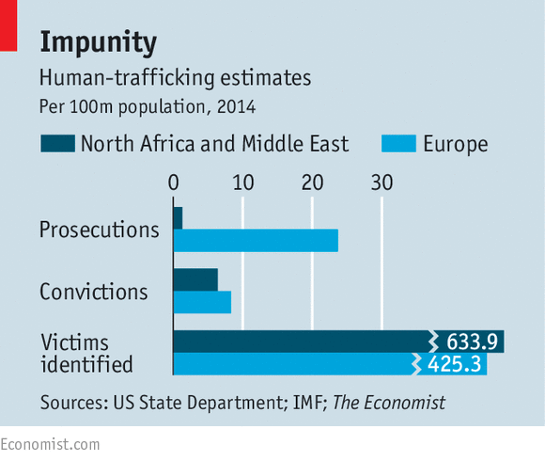
The criteria and data used by GSI have been criticised, but evidence supports the thrust of its findings. Many Arab states took far longer to criminalise slavery than to ban it. Mauritania, the world’s leading enslaver, did not do so until 2007. Where bans exist, they are rarely enforced. The year after Qatar abolished slavery in 1952, the emir took his slaves to the coronation of Queen Elizabeth II. Government inspections and prosecutions are rarities. “The security chiefs, the judges and the lawyers all belong to the class that historically owned slaves,” says Sarah Mathewson of London-based Anti-Slavery International. “They are part of the problem.”
No labour practice has drawn more international criticism than the kafala system, which ties migrant workers to their employers. This is not slavery as IS imposes it; migrants come voluntarily, drawn by the huge wealth gap between their own countries and the Gulf. But the system “facilitates slavery”, says Nicholas McGeehan, who reports for Human Rights Watch on conditions in the desert camps where most such workers live. The Gulf’s 2.4m domestic servants are even more vulnerable. Most do not enjoy the least protection under labour laws. Housed and, in some cases, locked in under their employer’s roof, they are prey to sexual exploitation.
Irons and red-hot bars
Again, these workers have come voluntarily; but disquieting echoes persist. Many Gulf nationals can be heard referring to their domestics as malikat (slaves). Since several Asian governments have suspended or banned their female nationals from domestic work in the Gulf out of concern for their welfare, recruitment agencies are turning to parts of Africa, such as Uganda, which once exported female slaves. Some domestic servants are abused with irons and red-hot bars: resonant, says Mr McGeehan, of slave-branding in the past.
Elsewhere in the region, the collapse of law and order provides further cover for a comeback of old practices. Syrian refugee camps in Jordan provide a supply of girls for both the capital’s brothels and for Gulf men trawling websites, which offer short-term marriages for brokerage fees of $140-270 each. Trafficking has soared in Libya’s Mediterranean ports, which under the Ottomans exported sub-Saharan labour to Europe. Long before Boko Haram kidnapped girls, Anti-Slavery International had warned that Nigerian businessmen were buying “fifth wives”—concubines alongside the four wives permitted by Islam—from neighbouring Niger.
Gulf states insist they are dealing with the problem. In June Kuwait’s parliament granted domestic servants labour rights, the first Gulf state to do so. It is also the only Gulf state to have opened a refuge for female migrants. Qatar, fearful that reported abuses might upset its hosting of the World Cup in 2022, has promised to improve migrant housing. And earlier this year Mauritania’s government ordered preachers at Friday prayers to publicise a fatwa by the country’s leading clerics declaring: “Slavery has no legal foundation in sharia law.” Observers fear, though, that this is window-dressing. And Kuwait’s emir has yet to ratify the new labour-rights law.
Rather than stop the abuse, Gulf officials prefer to round on their critics, accusing them of Islamophobia just as their forebears did. Oman and Saudi Arabia have long been closed to Western human-rights groups investigating the treatment of migrants. Now the UAE and Qatar, under pressure after a wave of fatalities among workers building venues for the 2022 World Cup, are keeping them out, too.
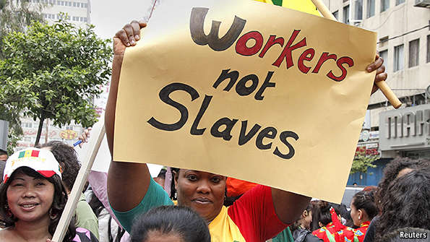
Internal protests are even riskier. Over the past two years hundreds of migrant labourers building Abu Dhabi’s Guggenheim and Louvre museums have been detained, roughed up and deported, says Human Rights Watch, after strikes over unpaid wages. Aminetou Mint Moctar, a rare Mauritanian Arab on the board of SOS Esclaves, a local association campaigning for the rights of haratin, or descendants of black slaves, has received death threats.
Is it too much to hope that the Islamic clerics denouncing slavery might also condemn other instances of forced and abusive labour? Activists and Gulf migrants are doubtful. Even migrants’ own embassies can be strangely mute, not wanting criticism to curb the vital flow of remittances. When Narendra Modi, India’s prime minister, visited the UAE this week, his nationals there complained that migrant rights were last on his list. Western governments generally have other priorities. One is simply to defeat IS, whose extreme revival of slavery owes at least something to the region’s persistent and pervasive tolerance of servitude.
This piece originally identified Mehmet II as caliph. He was a sultan. Sorry for the error.

