PETITION: Boycott HP, Technology of Israeli Apartheid!
U.S. Campaign to End the Israeli Occupation/ US Campaign for Palestinian Rights

https://org.salsalabs.com/o/641/p/dia/action3/common/public/?action_KEY=20604
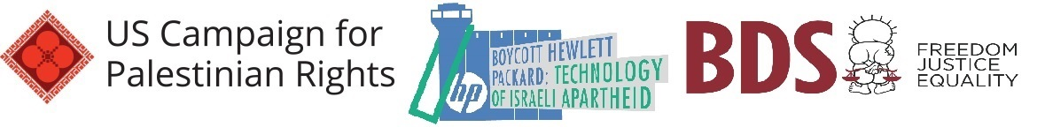Hewlett Packard (HP) companies provide Israel with key technology to enforce the deadly blockade of Gaza, to service illegal settlements and facilitate the ongoing colonization of Palestinian land, and to restrict the movement of Palestinians at Israel’s notorious checkpoints and through its racist ID card system. HP companies claim to be a beacon of social responsibility but in fact participate in brutal systems of oppression worldwide. Join people of conscience from around the world in signing the pledge below.
We call on Hewlett Packard companies -- including HP Inc., Hewlett Packard Enterprise, and all spin-offs -- to end all participation in the brutal oppression of the Palestinian people and other targeted communities worldwide. We pledge not to purchase products -- including printers, computers, and ink -- from complicit HP companies, and we call on retailers, universities, schools, faith communities, investment funds, municipalities, governments, trade unions, and other institutions to boycott and divest from HP companies until they cancel all contracts that supply Israel with technology, equipment, and information used in its ongoing violations of Palestinian rights and international law.

