Boycott, Divestment & Sanctions (BDS)

Palestine Solidarity Campaign

https://www.palestinecampaign.org/campaigns/bds/

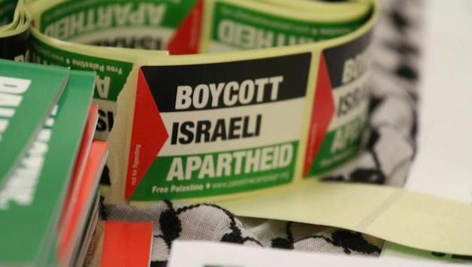
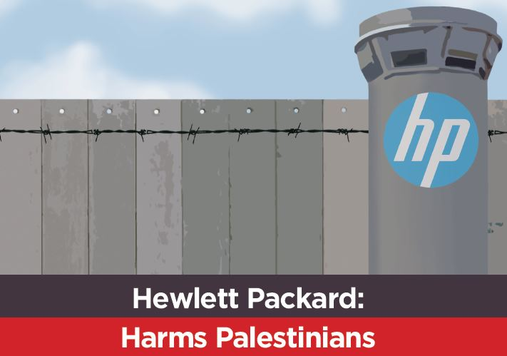

Sign the pledge
Hewlett Packard (HP) are the the technology behind the occupation and system of apartheid. Sign the pledge to boycott HP today.

Boycott Israeli Apartheid
BDS is people like you and me choosing not to do business with Israel until it respects Palestinians' human rights and upholds international law.
For decades, Palestinians have faced military occupation and been denied their fundamental rights. With BDS we are showing companies that profiting from occupation and discrimination is not acceptable. And we are holding Israel to account where our government has failed to act.
Boycott is a tool human rights defenders have used throughout history. It worked for Mahatma Gandhi, Martin Luther King Jr, and Nelson Mandela - and it's working for us.

