**Syria Protests Lead to at Least 22 Deaths**

By [Adam Smit](http://www.thirdage.com/authors)

April 9, 2011

Third Age  
*http://www.thirdage.com/news/syria-protests-lead-least-22-deaths_4-9-2011*

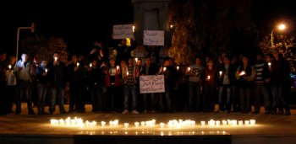Anti-government protesters hold the Syrian flags and candles at Shuhada or (Martyrs) Square in Swaeda in the southern pa... [Read More](javascript:void(0);)rt of Syria on March 28, 2011. The demonstration was for the victims who were apparently killed by the security forces in Daraa and other cities along in the country. UPI/Ali Bitar

[Click to Enlarge](http://www.thirdage.com/image/syrians-protest-against-their-government-7" \o "syrians protest against their government)

Syria protests on Friday resulted in the deaths of at least 22 protestors, though human rights organizations claim their numbers could be well over 100.

According to the Israeli newspaper Haaretz, 17 protestors were killed in a clash with security forces in the southern city of Daraa. Two more were reported dead in Homs, and three in Harsata.

Syrian state-controlled television reported that 19 policemen were also killed as “vandals” fired on them at the scene of the Daraa incident.

The protests, which occurred shortly after thousands of citizens marched out of a mosque in Daraa that has become the epicenter of the movement, were reportedly intended as recrimination for the brutal crackdown in recent weeks by Syrian government forces. Protestors object to the authoritarian Baath Party governance of President Bashar Assad.

"I saw pools of blood and three bodies in the street being picked up by relatives in the Mahatta area," a witness in Daraa said.

Reporters have had difficulty accurately portraying events on the ground as the Syrian government has tightly restricted any media access since the protests began.

Protests have occurred every Friday for the past three weeks, as called for by organizers of the movement. The demonstrations, which demand reform in this, one of the most authoritarian nations in the region, have challenged the 40-year rule of President Assad.