A Soldier’s Account from Gaza: How Hamas Used Human Shields
IDF Blog
August 25, 2014
http://web.archive.org/web/20150213181642/http://www.idfblog.com/blog/2014/08/25/soldiers-account-gaza-hamas-used-human-shields/

Lieutenant Adam Landau fought in the Gaza Strip during Operation Protective Edge. In a special on-camera interview, he told us what he saw and experienced on the battlefield.
When Operation Protective Edge began, Lt. Adam Landau and other soldiers from the 188th Armored Brigade were positioned along the northern border. During the operation’s ground phase, they were called to join the fighting in Gaza. “Once you enter enemy territory, something in your mind switches,” he recalled after returning safely to Israel. “We fought against a huge number of Hamas terrorists there.”
[EMBEDDED VIDEO: http://humanrightsvoices.org/site/documents/?d=21868]
On several occasions, Lt. Landau saw Hamas operatives using civilians as human shields. “Once, we started to look for a terrorist who we knew was in a specific house,” he said. “Suddenly, a small boy appeared, and the terrorist grabbed him and escaped with him.”
“They shot at us from mosques, schools, and of course from civilian houses,” Lt. Landau said. “In the end, if they shoot at you from a mosque, You see a family’s house and you see the clothes hanging outside…And behind all of this is a terrorist holding an AK-47, shooting at you.”

Fighting in Shuja’iya
Landau’s battalion was urgently called to reinforce Golani forces who had suffered losses in the battle of Shuja’iya. The forces, who were originally positioned far away from Gaza, travelled a long distance before crossing the border. “My tank drove more than 350 kilometers during the operation,” Lt. Landau said. “Hearing the first shots and mortar fire on the other side was frightening, but our soldiers kept a positive attitude and encouraged each other to complete the mission.”
Landau praised the collaboration between the infantry and armored forces during the operation. “We quickly understood where our forces were headed, which allowed us to act quickly and confidently,” he recalled. “Once we finished evacuating [injured troops], we remained on the field and joined the infantry’s mission to locate and neutralize Hamas’ tunnels. It was a combined effort: We had to secure the area from long-range fire while infantry troops entered houses” that were potentially rigged with explosives. “Combat engineers, meanwhile, took care of the tunnels.”
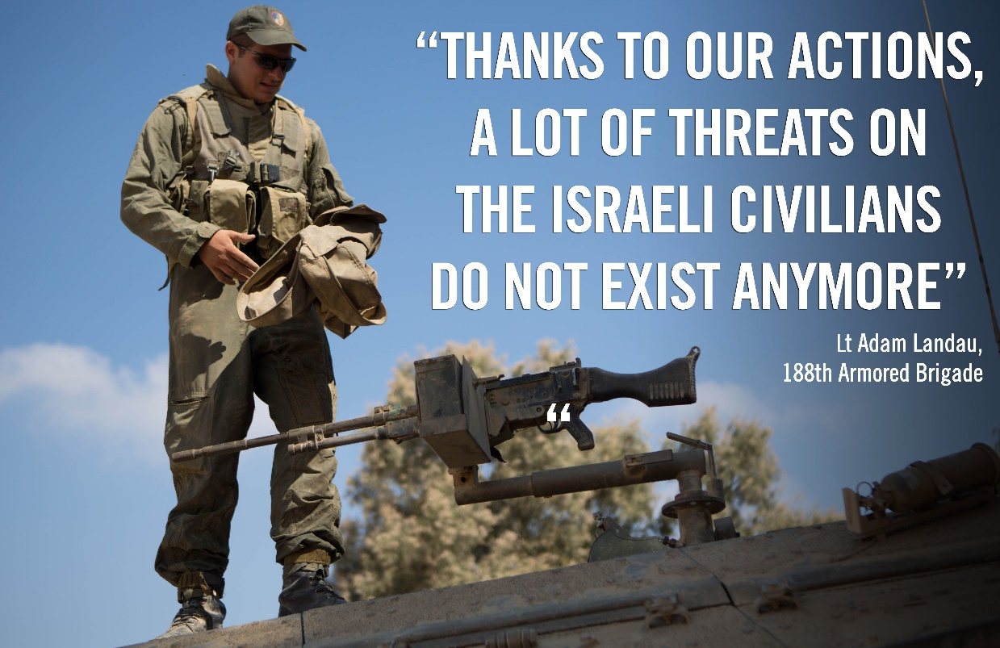
Lt. Landau’s battalion would sometimes wait up to 10 hours before confronting enemy fire. “It gives you the impression that you can relax, but that’s exactly what you can’t do,” he said. “The attack can come from any house, at any time.”
After a week of battle in Shuja’iya, the battalion briefly left Gaza to rest before the next round of battle. When they returned to the field, they were called to central Gaza where they continued dismantling Hamas’ tunnels.

With the entire nation behind them
Lt. Landau recalled how the troops received enormous support from the Israeli public throughout the operation. He said that thousands of Israelis sent gifts, sweets and letters of support to the soldiers on the front.
“It’s one thing to receive food, but when you receive a letter written by a child who supports you, it gives you the strength to keep going,” he said. “You understand who you’re fighting for, and you understand that there are people out there who rely on you.”
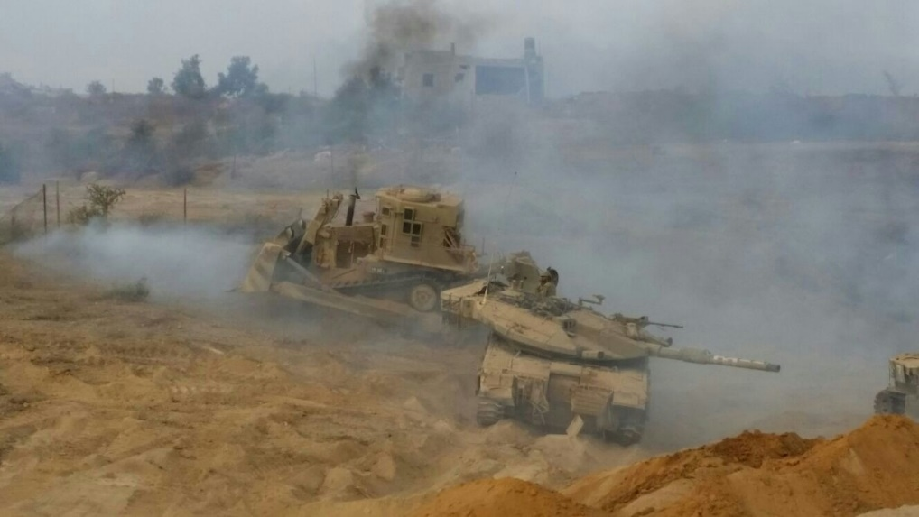
Armored vehicles of the 188th Brigade

