Twitter Thread, Agnes Callamard (@AgnesCallamard)
Twitter
January 2, 2020
https://twitter.com/AgnesCallamard/status/1212918159096864768

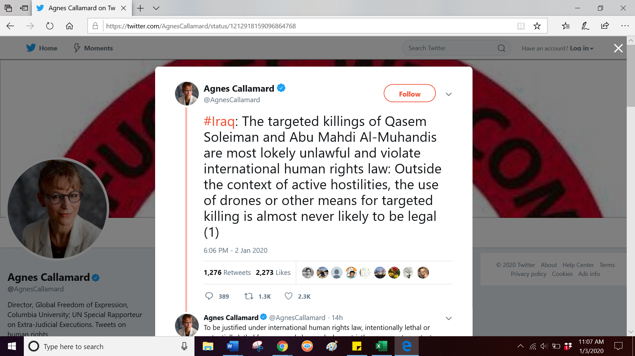
“#Iraq: The targeted killings of Qasem Soleiman and Abu Mahdi Al-Muhandis are most lokely unlawful and violate international human rights law: Outside the context of active hostilities, the use of drones or other means for targeted killing is almost never likely to be legal (1)” (https://twitter.com/AgnesCallamard/status/1212918159096864768)

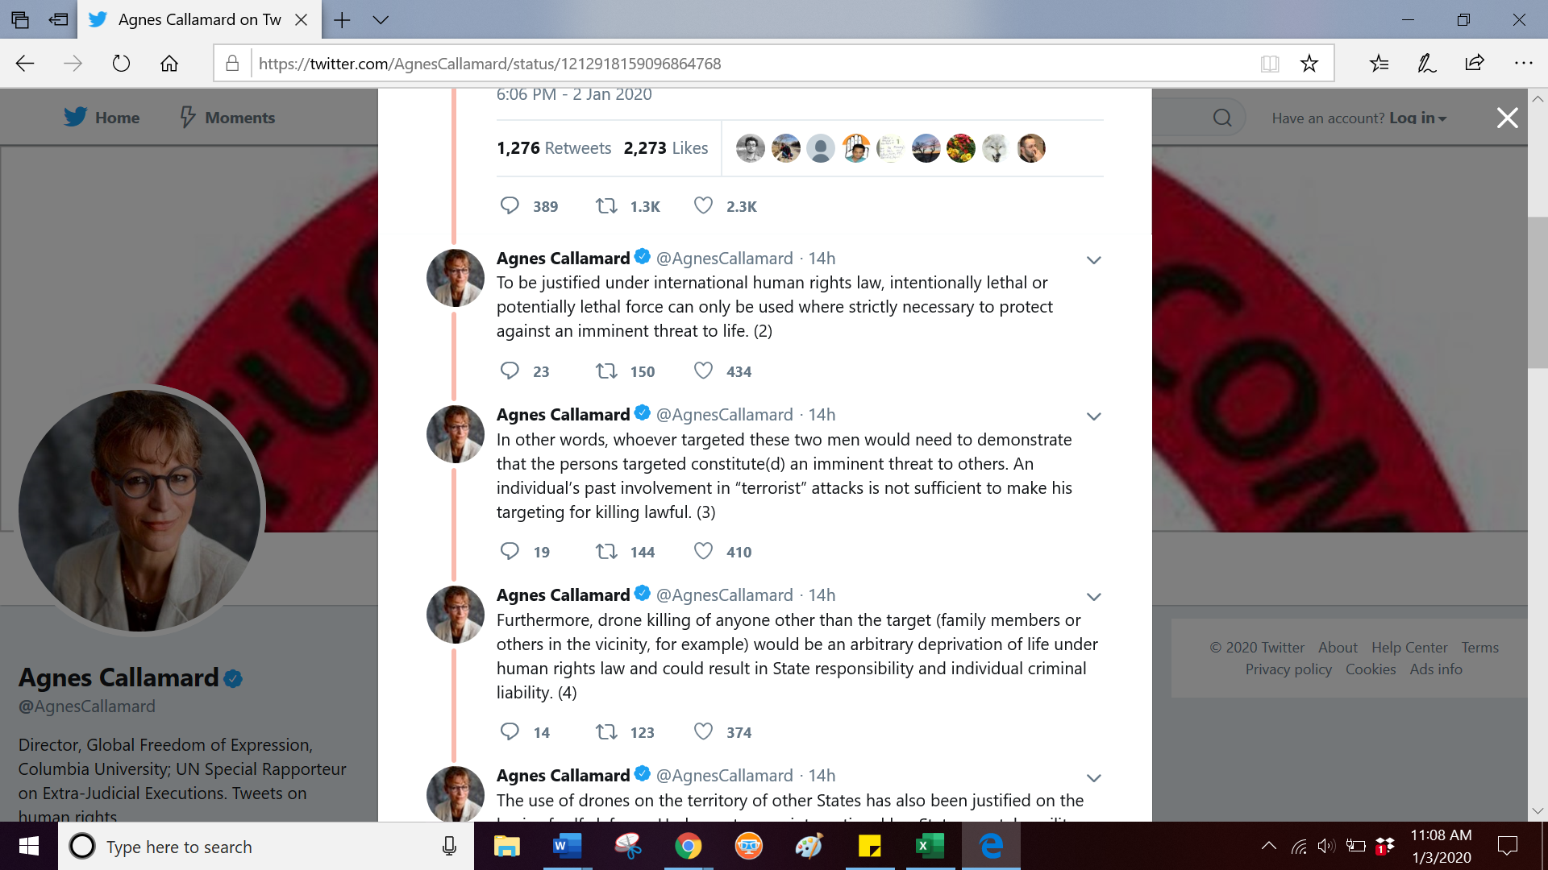
“To be justified under international human rights law, intentionally lethal or potentially lethal force can only be used where strictly necessary to protect against an imminent threat to life. (2)”
(https://twitter.com/AgnesCallamard/status/1212918160187371521)
“In other words, whoever targeted these two men would need to demonstrate that the persons targeted constitute(d) an imminent threat to others. An individual’s past involvement in “terrorist” attacks is not sufficient to make his targeting for killing lawful. (3)”
(https://twitter.com/AgnesCallamard/status/1212918161697394689)
“Furthermore, drone killing of anyone other than the target (family members or others in the vicinity, for example) would be an arbitrary deprivation of life under human rights law and could result in State responsibility and individual criminal liability. (4)”
(https://twitter.com/AgnesCallamard/status/1212918162720772096)

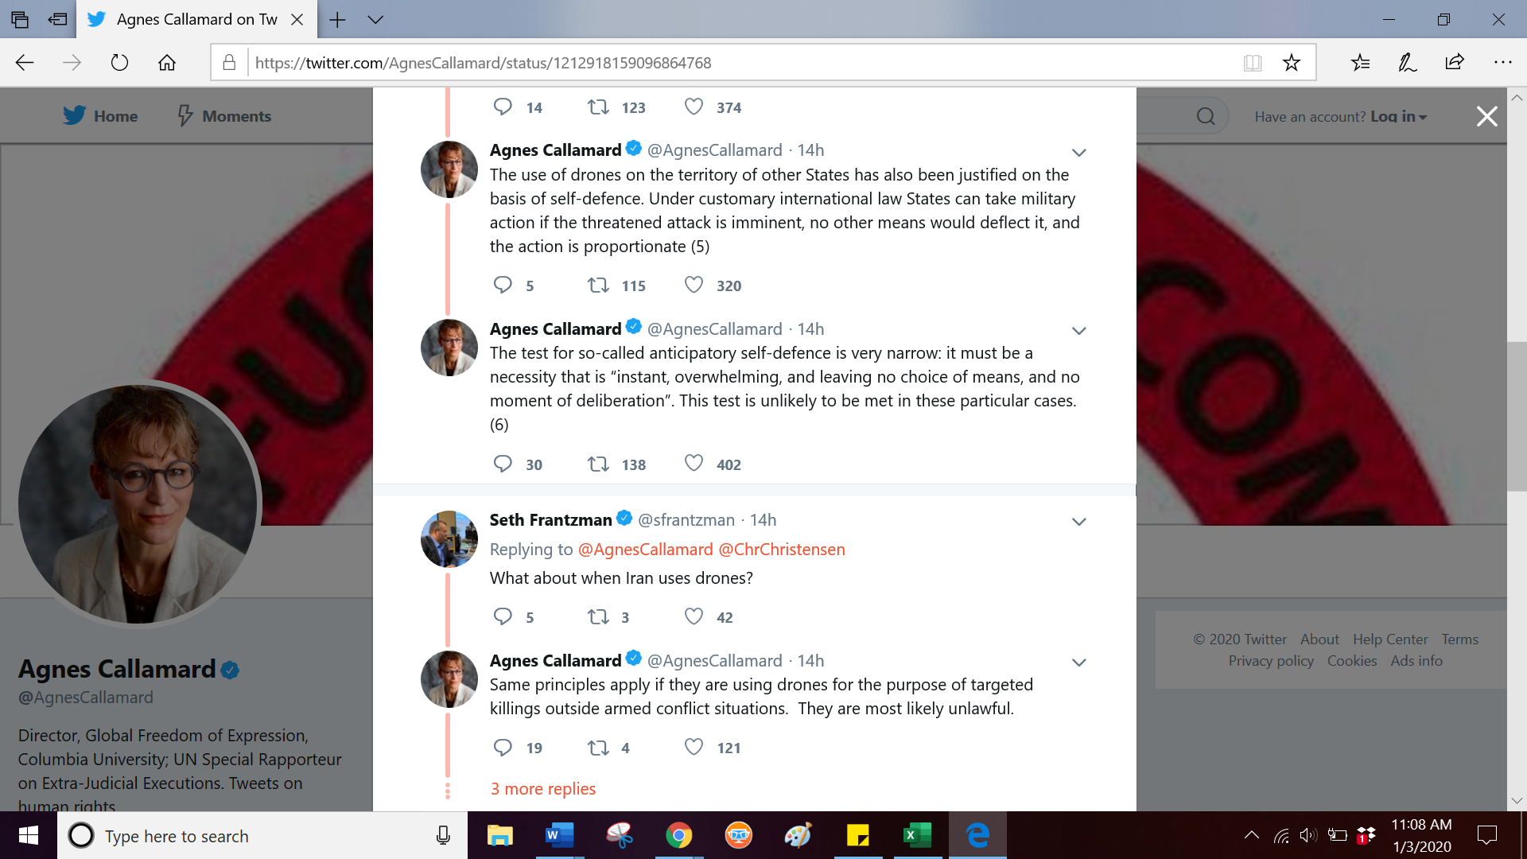
The use of drones on the territory of other States has also been justified on the basis of self-defence. Under customary international law States can take military action if the threatened attack is imminent, no other means would deﬂect it, and the action is proportionate (5)”
(https://twitter.com/AgnesCallamard/status/1212918163580608513)
“The test for so-called anticipatory self-defence is very narrow: it must be a necessity that is “instant, overwhelming, and leaving no choice of means, and no moment of deliberation”. This test is unlikely to be met in these particular cases. (6)”
(https://twitter.com/AgnesCallamard/status/1212918164453019648)
[Responding to a Tweet by Seth Frantzman (@sfrantzman) reading “What about when Iran uses drones?”]
“Same principles apply if they are using drones for the purpose of targeted killings outside armed conflict situations. They are most likely unlawful.”
(https://twitter.com/AgnesCallamard/status/1212921741770657793)

