Behind the Headlines: Hamas war crimes
Israel Ministry of Foreign Affairs
July 13, 2014
https://mfa.gov.il/MFA/ForeignPolicy/Issues/Pages/Behind-the-Headlines-Hamas-war-crimes-13-Jul-2014.aspx

Hamas - an internationally recognized terrorist organization - deliberately embeds its military operations deep in residential areas, and exploits its own civilian population as human shields. These actions are war crimes.
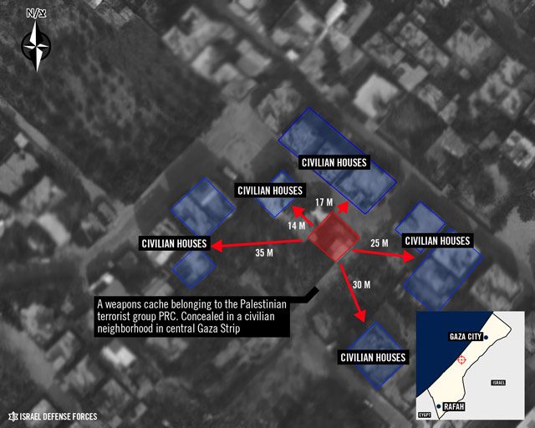
Weapons cache concealed in a civilian neighborhood in Gaza
Copyright: IDF Spokesperson
Hamas - an internationally recognized terrorist organization - deliberately embeds its military operations deep in residential areas, and exploits its own civilian population as human shields. These actions are war crimes.
Many of Hamas' commanders use their own homes for military purposes - including weapons storage, command and control centers and military communications. In videos uploaded to the IDF's YouTube channel, secondary explosions can be seen following IDF attacks on some of these houses - clearly indicating their military use. Under international law, when the exploitation of these residential houses makes an effective contribution to Hamas' military actions, these buildings clearly become legitimate military targets.
When attacking these lawful targets, the IDF makes every effort to ensure such attacks are proportionate and to minimize any unavoidable civilian harm. The IDF has no desire to harm civilians, and is acting solely to weaken Hamas terrorist infrastructure and safeguard our civilians.
The IDF conducts its operations in full accordance with international law. IDF commanders are trained in international law and legal advisors are embedded at the highest level of the chain of command. The IDF employs a range of tools - including distributing flyers, personalized phone calls and SMS - to warn people in the vicinity of an impending attack.
Instead of raising doubts regarding Israel's commitment to the rule of law, the international community should be questioning why Hamas deliberately embeds its military operations in residential homes and civilian areas. A terrorist organization that uses its civilian population as human shields, and deliberately fires at the Israeli civilian population, is conducting war crimes - and should be denounced for doing so.
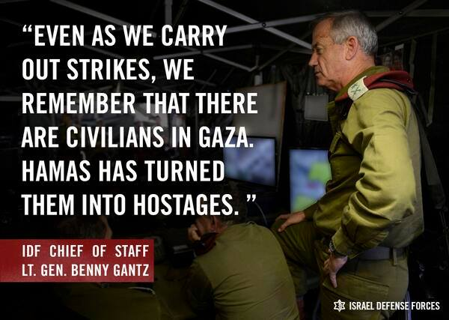

[EMBEDDED VIDEO: https://youtu.be/KUJpFSE4oH4]

Hamas' actions are in clear violation of the most fundamental principles of the laws of armed conflict, including the principle of distinction. This principle requires parties to an armed conflict to refrain from deliberately targeting civilian population or civilian objects. Likewise, it requires parties to distinguish its military operations and the civilian population, and to refrain from using the presence of the civilian population to shield military objectives.
Hamas violates this fundamental principle in two main ways –
• By deliberately attacking Israel's civilian population, including by conducting suicide, rocket and mortar attacks.
• By deliberately and systematically employing tactics which put the Palestinian civilian population in danger, including the launching of attacks from within densely populated areas, the use of human shields, deploying weapons storage sites and command centers in residential homes and in densely populated areas and commandeering sensitive sites (such as hospitals, private homes, schools and mosques) for terrorist use.
These actions clearly constitute war crimes, as defined by international law and may also amount to crimes against humanity.
The principle of distinction is anchored in customary international law. It has been reflected in treaties and other sources of international law, including in several articles of the Additional Protocol to Geneva Conventions, 1979.[1] For example:
• Article 48: “In order to ensure respect for and protection of the civilian population and civilian objects, the Parties to the conflict shall at all times distinguish between the civilian population and combatants and between civilian objects and military objectives and accordingly shall direct their operations only against military objectives.”
• Article 51(2): "The civilian population as such, as well as individual civilians, shall not be the object of attack. Acts or threats of violence the primary purpose of which is to spread terror among the civilian population are prohibited."
• Article 58: " The Parties to the conflict shall, to the maximum extent feasible: (a)…endeavor to remove the civilian population, individual civilians and civilian objects under their control from the vicinity of military objectives;
(b) Avoid locating military objectives within or near densely populated areas."
• Article 51(7): "… The Parties to the conflict shall not direct the movement of the civilian population or individual civilians in order to attempt to shield military objectives from attacks or to shield military operations."
• Article 12(4): "Under no circumstances shall medical units be used in an attempt to shield military objectives from attack. Whenever possible, the Parties to the conflict shall ensure that medical units are so sited that attacks against military objectives do not imperil their safety."
• Article 53: "It is prohibited (a) to commit any acts of hostility directed against the historic monuments, works of art or places of worship which constitute the cultural or spiritual heritage of peoples; (b) to use such objects in support of the military effort."

Targeting civilians - a crime against humanity
Palestinian Envoy to the UN Human Rights Council (UNHRC) Ibrahim Khreisheh was interviewed last week (July 9) on Palestinian Authority TV (interview translated into English by MEMRI,The Middle East Media Research Institute).
He said: "The missiles that are now being launched against Israel, each and every missile constitutes a crime against humanity, whether it hits or missed, because it is directed at civilian targets...Targeting civilians, be it one civilian or a thousand, is considered a crime against humanity."
Relating to Israel's mode of operation in Gaza during Operation Protective Edge he stated: "Please note that many of our people in Gaza appeared in TV and said that the Israeli army warned them to evacuate their homes before bombardment. In such a case, if someone is killed, the law considers it a mistake rather than intentional killing, because (the Israelis) followed the legal procedures."

