CHILDREN OF HATE

Jackie Hugi, Maariv - June 24, 2002

(Unofficial translation by Ester)
Original URL: http://images.maariv.co.il/cache/ART309971.html
Secondary source: http://www.factsofisrael.com/blog/archives/000123.html

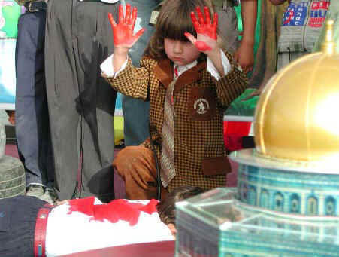

This is how the graduation ceremony goes at the kindergartens of the "Islamic Charitable Association" in Gaza

Kindergartens in Gaza teach children Jihad against Israel, justification of the Ramallah lynching [in Oct 2000], admiration of the Hizbullah, and the continuation of the Intifada. The children receive these lessons in Israel-hatred at the independently-run education network of the "Islamic Charitable Association", which is responsible for the education of some 5000 children.

At the graduation ceremony of one of the most recent kindergarten classes, the children burned the Israeli flag and cried: "In the name of the Shahid (martyr) Mohammed al-dura and the Shahida, the infant Iman al-Haju, we promise to continue with the Jihad, the resistance and the Intifada". One of the girls raised her hands high, hands dipped in red paint, in the manner of one of the perpetrators of the Ramallah lynching, whose hands were covered in blood. One boy, dressed as the secretary-general of the Hizballah, Hassan Nasrallah, made a speech in which he said: "The Palestinians will not be alone in their battle against Zionism. Hizbullah is with them, always" - which earned him much applause. Children carried toy rifles, and some had Keffiyehs over their faces.

An internal document of the (Israeli) Government Operations Coordinator in the territories, which came out recently, analyzed the expressions of hostility in the Association's kindergartens. The document determines that the Islamic Association's network of kindergartens serves as a firm base to incite young children against Israel. The document warns that these kindergartens constitute for the Hamas the ideological basis for future suicide bombers.

The Association's website documents the ceremony of the 11th class to graduate these kindergartens. Participating at the ceremony, which took place at the Shati refugee camp on the Gaza coast, were 1650 children and thousands of adults.

The children were dressed in army fatigues. Around the podium where the ceremony took place hung flags of Hizballah and the Islamic Association, pictures of martyred children, and slogan. One of the latter cried: "The blood of the children and the martyred of Palestine will be a curse to haunt to Zionist criminals".

The ceremony started with the reading out loud of passages from the Koran by one of the children. Afterwards, a platoon of five-year-olds staged a military parade, armed with plastic rifles. Two of the children carried a model of the Al-Aqsa mosque in Jerusalem. One of the marchers stopped and cried, "Do Sharon's tanks, missiles and mortars frighten you?". His friends answered in unison: "No, no". He continued: "The Zionist bombings do not frighten us. Our people will not bend". Later, the children burned the Israeli flag, and one child impersonated Hamas' leader, Sheikh Ahmed Yassin.

The Islamic Association of Gaza is the largest charitable organization in the Gaza Strip of the religious stream. It was founded 26 years ago, and at its head is Sheikh Ahmed Bahar, a member of Hamas. It operates tens of kindergartens in Gaza, helps needy families and orphans, and supports poor students and martyrs' children. Additionally, the Association facilitates blood donations, operates a medical clinic for a nominal fee, and also a sports club, best known for its successful volleyball team.

The Association subsists upon donations and the nominal dues of its members.

Last year, their institutions were visited by representatives of a Swedish NGO and of a South African Islamic delegation. Non-profit organizations in Italy and the US donated computers and VCRs.

Sheikh Bahar said at the ceremony that he places the responsibility on the shoulders of the Palestinian mothers to "Raise the children on the teachings of Islam, love of Jerusalem and Palestine, and love of Jihad and resistance"

