Captured Intel Reveals Hamas’ Explosive Plans
IDF Blog
July 27, 2014
http://web.archive.org/web/20140806022330/http://www.idfblog.com/blog/2014/07/27/captured-intel-reveals-hamas-explosive-plans/

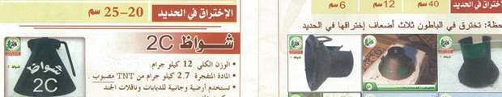
Our soldiers found a Hamas training manual in Gaza. The contents: instructions on how to make bombs at home.
Our soldiers on the ground in Gaza recently captured a training manual that gives step-by-step instructions on how to make homemade bombs. The manual amounts to a terrorism 101 handbook on concealing and detonating all kinds of explosives.
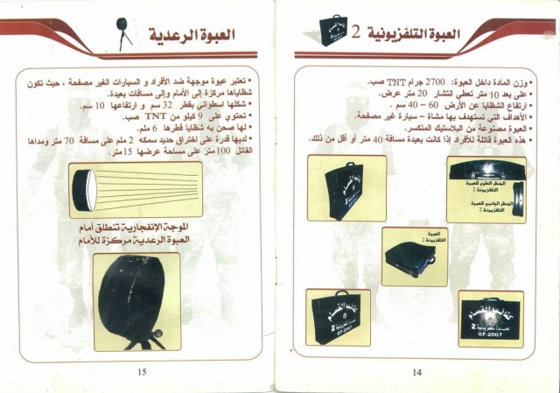
The training manual found by IDF soldiers contains instructions for handling and detonating different types of explosives. Page 14 explains how to fill a television-shaped bomb with shrapnel.
[EMBEDDED VIDEO: http://humanrightsvoices.org/site/documents/?d=21859&id=25143]
Hamas has experimented with many kinds of explosives during the course of its existence. In the 1990s and into the Second Intifada, Hamas suicide bombers blew themselves up in cafes, restaurants, hotels, shopping malls and buses. Hamas continues to use suicide belts today.
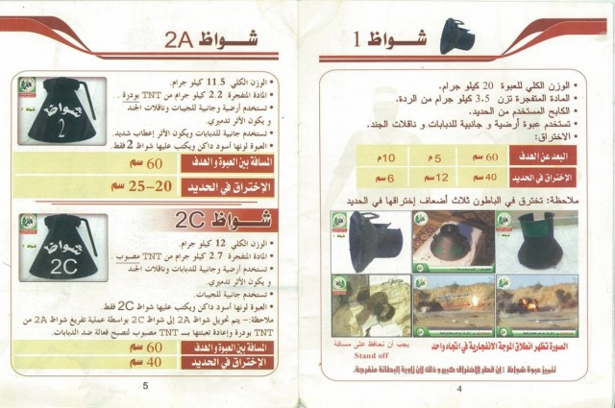

Rigging Civilian Homes to Blow
IDF soldiers operating on the ground in Gaza continue to come across civilian homes rigged by terrorists with explosives. All kinds of mines, remotely detonated bombs and other IED have been found throughout Gaza.
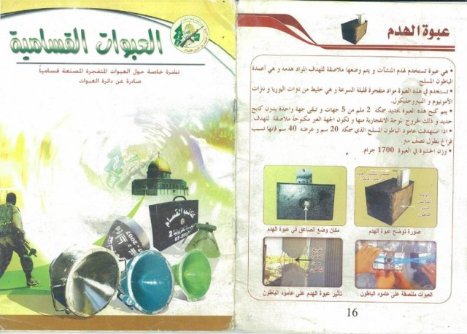
During Operation Protective Edge, soldiers from the Givati Brigade found explosives that are very similar to those detailed in the manual. Such explosives have been found in Palestinian homes in Gaza, endangering not only the residents of the house but also neighbors within range of a potential explosion.

