Behind the headlines: Events in Sejaiya, Hamas' terror stronghold
Israel Ministry of Foreign Affairs
July 20, 2014
https://mfa.gov.il/MFA/ForeignPolicy/Issues/Pages/Events-in-Sejaiya-Hamas-terror-stronghold.aspx

Hamas both embedded its missiles and other military targets among the civilians population of Sejaiya and then ordered the civilians to remain and act as human shields.
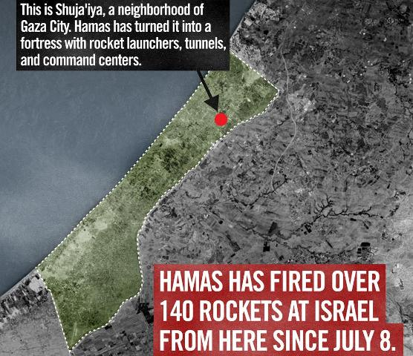
Sejaiya, Hamas' terror stronghold
Copyright: IDF Spokesperson
The area of Sejaiya (in the northern Gaza Strip) is one of Hamas' major terrorist strongholds which serves as a central launching point for rockets aimed at the civilian population in Israel.
In addition, this major terrorist stronghold includes a large rocket hide-out and weapons' manufacturing facilities. Also in the area are approximately ten terror tunnels leading to Israeli territory, constructed for the purpose of carrying out terrorist attacks against Israelis.
Hamas deliberately located its terrorist infrastructures in the midst of the civilian population of Sejaiya. Hamas' activities violate various rules of international law, including Article 58 of the Additional Protocol I of the Geneva Conventions, which prohibits locating legitimate military targets "within or near densely populated areas."
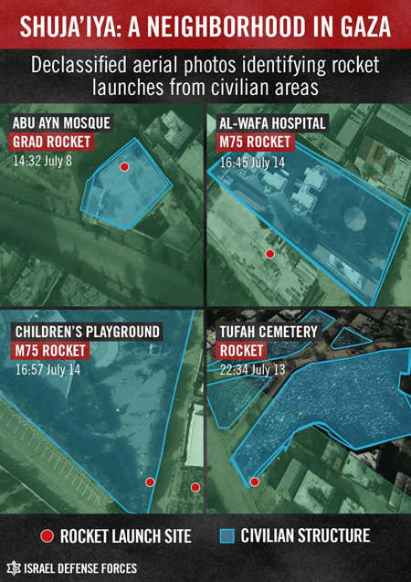
Prior to starting operations near Sejaiya, the IDF engaged in extensive efforts to warn uninvolved civilians in the neighborhood. It issued many warnings to the civilian population there during the past three days, through the use of flyers, phone calls and announcements in the Arabic media. Israel asked the civilians of Sejaiya to evacuate to specified safer areas for their own protection.
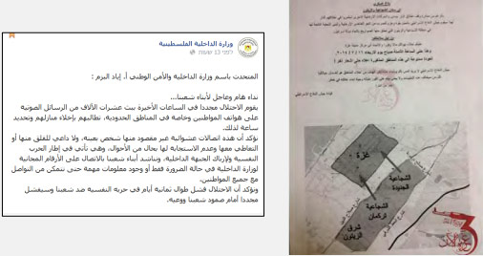
Left: Hamas Ministry of the Interior repeats the call to Gazan residents not to heed the IDF's telephone warnings to immediately evacuate their houses, describing the phone calls as psychological warfare against the Gazan population (Facebook page of the Gazan ministry of the interior, July 15, 2014).
Right: The IDF's flyer instructing the residents of Sejaiya and Zeitoun, east of Gaza City, to vacate their houses and move to the central part of the city.
Hamas is preventing the civilian population from evacuating the neighborhood. It is using the civilian population as human shields to protect Hamas terrorists and their illegal activities. Even now, Hamas continues to call upon civilians - from the mosques, the streets and through the media - not to evacuate.
These activities by Hamas clearly violate the laws of armed conflict which strictly forbid directing the movement of civilians to shield military targets from attack (Article 51(7) of the Additional Protocol I of the Geneva Conventions).
In order to meet the humanitarian needs of the population of Sejaiya, Israel approved a medical-humanitarian ceasefire today in the area between 13:30-15:30 Israel time (20 July). Israel then extended the ceasefire by two hours (until 17:30) for the benefit of the civilians there.
Israel again called on the population to evacuate the area within this timeframe for their own safety. Israel gave instructions to move westwards towards Gaza City, beyond the Salah a-Din route.
Hamas continued to fire, violating the humanitarian ceasefire again, clearly demonstrating its disregard for the lives of the civilians of Sejaiya.
Israel regrets any harm to uninvolved civilians, but it is Hamas that bears full responsibility for the damage to Sejaiya and the suffering of its residents. Hamas both embedded its missiles and other military targets among the civilians population and then ordered the civilians to remain and act as human shields. Its war crimes and violations of basic morality should be widely condemned by all persons of conscience.

Background
- Sejaiya is a neighborhood located to the southeast of Gaza City, which is in the northern Gaza Strip. The neighborhood, situated opposite Israel's Nahal Oz and the Karni crossings to Gaza, is one of the closest residential points to the fence that separates the Gaza Strip from Israel.
- This densely populated neighborhood is known to be one of the strongholds of terrorist activity against Israel and has been the scene of many confrontations with Israeli forces going back as far as the 1970s and continuing through the first and second Intifadas and Operation Cast Lead (December 2008).
- Following the Hamas takeover of the Gaza Strip in 2007, Sejaiya became a Hamas stronghold. This followed confrontations and harassment of members of the Hils clan, allied with Fatah, who were forced to leave the area (some of them fled for their lives and found sanctuary in Israel).
- Since the expulsion of Fatah from the neighborhood, there has been an ongoing rivalry between Hamas and Islamic Jihad. Each side tries to present itself as the leading force behind the "resistance" in the neighborhood by digging rocket-launching pits for attacking Israel and conducting other types of terrorist activity.
- Today, the area is heavily patrolled and monitored by Hamas. It contains attack tunnels and many mosques that serve as arms stores, next to which pits have been dug to use as rocket-launching sites against Israel.

