Gaza rocket hits Sderot factory, setting it ablaze
By: Mattan Tzuri
Ynet News
June 28, 2014
https://www.ynetnews.com/articles/0,7340,L-4535501,00.html

A rocket fired from Beit Hanoun in the Gaza Strip hit a factory in the Sderot industrial area on Saturday, causing it to catch on fire.

A second rocket fell in an open area near Sderot. In a second attack later in the evening, two additional rockets hit open areas in the Sdot Negev Regional Council.

No one was hurt from any of the rockets, but the factory was burned to the ground.

Four workers who were inside the factory when the rocket hit managed to escape. Two of them, 23 and 59 years old, were taken to the Barzilai Medical Center in Ashkelon suffering from light burns.

The fire in the factory led to smaller explosions inside the factory, caused by paint canisters that caught on fire.

Earlier, a Code Red siren was sounded in Sderot and in the Hof Ashkelon Regional Council. A 50-years-old man suffered blast injuries after tripping on his way to a safe room at the sound of the Code Red siren, and was taken to the Barzilai Medical Center in Ashkelon.

"The city's residents are not deterred by the heinous and cowardly actions of terrorists who are firing rockets from Gaza towards civilian populations," Sderot Mayor Alon Davidi said. "We stand strong in order to give the prime minister, defense minister and the IDF full backing in the operation to bring the boys back home and restore order."

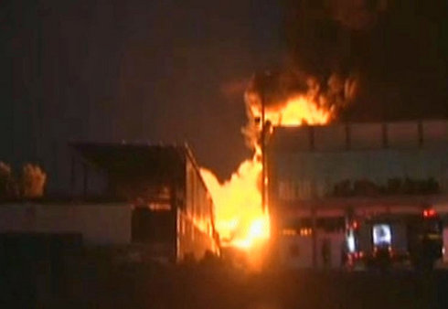
Sderot factory on fire after being hit by Gaza rocket (Photo: Roee Idan)

On Friday evening, six rockets were fired into from Gaza into Israeli territory and a mortar shell exploded near the border fence between Gaza and Israel. Two of the rockets fired were shot down by the Iron Dome anti missile system while the other four fell in open areas in the Eshkol Regional Council. No damage or injuries were reported as a result of the rockets or mortar fire.

