Hamas Kidnappings: A Constant Threat in Israel
IDF Blog
June 16, 2014
http://web.archive.org/web/20140618203748/http://www.idfblog.com/2014/06/16/hamas-kidnappings-constant-threat-israel/

Last week’s Hamas abduction followed dozens of attempts to kidnap innocent Israelis. Since the beginning of 2013, Israel has foiled 64 planned abductions, many of them at the hands of Hamas terrorists.
Hamas’ recent abduction of three Israeli teenagers hardly constitutes its first attempt to kidnap innocent Israelis. In the past two years alone, Palestinian terrorist organizations have planned 64 abductions. IDF and Israeli security forces have foiled all of these attempts, but kidnapping remains a central element of Hamas’ efforts to terrorize Israel.
Hamas terrorists [LINK GOES TO A JUNE 12, 2014 IDF BLOG ARTICLE ENTITLED “Israeli Interrogation Reveals: Palestinian Soccer Player Aided Hamas Terrorists”] prey on unsuspecting hitchhikers, luring them into cars before forcing them into captivity. The purpose of their efforts is often clear: to use civilians or soldiers as bargaining chips for the release of convicted Palestinian terrorists. In other cases, the terrorists seek to murder innocent civilians [EDITOR’S NOTE: LINK GOES TO A DECEMBER 24, 2013 IDF BLOG ARTICLE ENTITLED “Gazan Sniper Kills Israeli Civilian”] and instil fear in Israeli communities.
Since Thursday, Israeli forces have been searching extensively for Hamas terrorists who kidnapped [EDITOR’S NOTE: LINK GOES TO A DECEMBER 4, 2013 IDF BLOG ARTICLE ENTITLED “Palestinian Terrorists Determined to Kidnap Israeli Soldiers”] three teenagers near the community of Gush Etzion. The young Israeli civilians – Eyal Yifrach, 19, Gilad Shaar, 16, and Naftali Frenkel, 16 – were on their way home to their families when they were abducted. As part of their ongoing operation, IDF forces have arrested about 150 Palestinian suspects, many of them Hamas terrorists.

A history of Hamas abductions
Last week’s kidnapping [EDITOR’S NOTE: LINK GOES TO A JUNE 25, 2013 IDF BLOG ARTICLE: Seven Years Since Shalit Kidnapping: Motivation to Kidnap Still High] is the latest in series of Hamas abductions. In 2006, Hamas terrorists infiltrated Israel, killing two soldiers and kidnapping a third, SFC Gilad Shalit. [EDITOR’S NOTE: LINK GOES TO AN OCTOBER 18, 2012 IDF BLOG ARTICLE ENTITLED “Reliving History: The Day Gilad Shalit Returned Home] The organization held Shalit in captivity until in 2011, when Israel agreed to exchange [EDITOR’S NOTE: LINK GOES TO A DECEMBER 18, 2011 IDF BLOG ARTICLE ENTITLED Second Stage of Operation for the Return of SFC Gilad Shalit Completed] 1,027 convicted terrorists for his release.

[MISSING PLUGIN]

In 1994, Hamas abducted Sgt. Nachshon Wachsman with the intention of trading him for terrorists. The Hamas operatives murdered [EDITOR’S NOTE: LINK GOES TO A NO LONGER FUNCTIONING URL] Sgt. Wachsman while Israeli forces attempted to free him from captivity. Two years earlier, Hamas abducted Sgt. Maj. Nisim Toledano [EDITOR’S NOTE: LINK GOES TO A NO LONGER FUNCTIONING URL] , a border policeman, on his way to work. Sgt. Maj. Toledano’s captors eventually murdered him, and his body was found two days later.
Two Hamas terrorists dressed up as religious Jews and kidnapped [EDITOR’S NOTE: LINK GOES TO A SEPTEMBER 11, 1996 ISRAEL MFA ARTICLE ENTITLED “Kidnapppings of IDF soldiers”] Sgt. Avi Sasportas in September 1989. Israeli investigators assume that the operatives brutally murdered him just moments after he entered their car. In a similar event later that year, Hamas terrorists abducted Cpl. Ilan Saadon [EDITOR’S NOTE: LINK GOES TO A MAY 3, 2012 IDF BLOG ARTICLE ENTITLED “Today in History: Hamas Abducts Cpl. Ilan Saadon”]. Although he struggled to fight his abductors, they shot him to death and discarded his body at a scrap site.
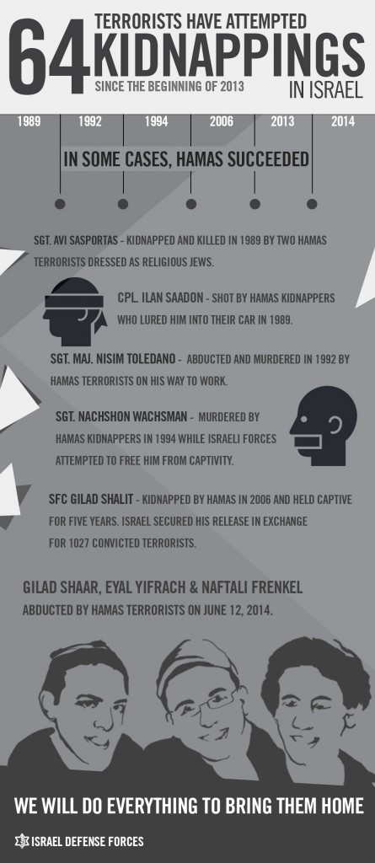

Frequent kidnapping attempts
Israeli security forces have prevented the vast majority of kidnapping attempts, but terrorists continue to invest considerable effort into abductions. In September 2013, a Palestinian terrorist lured Sgt. Tomer Hazan, [EDITOR’S NOTE: LINK GOES TO A SEPTEMBER 21, 2013 IDF BLOG ARTICLE ENTITLED “Joint IDF and ISA Operation Exposes Murder of an IDF Soldier “] an IDF soldier, to a village in central Judea and Samaria. The terrorist murdered Sgt. Hazan and confessed that he had planned to use the soldier’s body to bargain for the release of his brother, imprisoned for involvement in multiple terror attacks.
Sgt. Tomer Hazan
The Israel Secruity Agency (ISA or Shin Bet Security Sevice) prevented a major kidnapping last year when it arrested an Islamic Jihad cell [EDITOR’S NOTE: LINK GOES TO AN UNDATED SHIN BET ARTICLE ENTITLED “חשיפת התארגנות של גיהאד עולמי ממזרח ירושלים” (in English: “Unveiling World Jihad Organization from East Jerusalem“] operating inside Israel. After detaining the terrorists, the security forces found ski masks, adhesive tape, a box cutter and a handgun in their possession. The squad, which received funding and training from activists from Jenin, had clearly been preparing to carry out a kidnapping [EDITOR’S NOTE: LINK GOES TO AN UNDATED SHIN BET ARTICLE ENTITLED “סוכלה חוליית ג'יהאד איסלאמי שהתכוונה לבצע פיגוע חטיפה” (IN ENGLISH: “An Islamic Jihad squad was targeted that was intended to carry out a kidnapping attack”)]
Early last year, Hamas operatives from the Gaza Strip were in the midst of preparations to kidnap [EDITOR’S NOTE: LINK GOES TO A DECEMBER 4, 2013 IDF BLOG ARTICLE ENTITLED “Palestinian Terrorists Determined to Kidnap Israeli Soldiers “] an Israeli soldier. IDF forces arrested its members in February 2013, and discovered that its members planned to run over a soldier and then stow him away in a car.
Kidnapping is a constant threat to the safety of Israeli civilians. Eyal, Gilad, and Naftali are the three unfortunate victims of belligerent terrorism, but the IDF’s soldiers remain on alert to try and prevent these attacks.
[EMBEDDED VIDEO: http://humanrightsvoices.org/site/documents/?d=22024]
***This article does not include kidnapping attempts made by terrorist organizations other than Hamas, with the exception of Sgt. Tomer Hazan.

