Hamas Launches Rockets on Civilians in Gaza
IDF Blog
July 31, 2014
http://web.archive.org/web/20140822025714/http://www.idfblog.com/blog/2014/07/31/hamas-launches-rockets-civilians-gaza/

Hamas’ indiscriminate firing of rockets endangers millions of Israeli and Palestinian lives. While the IDF strikes terrorist targets in Gaza with precision, Hamas launches rockets with one aim: hitting civilians.
On the afternoon of July 28, a squad of Gaza terrorists fired a barrage of four rockets from a densely populated area, aiming to kill Israelis. Instead, one hit al-Shifa hospital and another the Shati refugee camp, both inside Gaza. A third was intercepted by the Iron Dome missile defense system above Ashdod. While Israel invests in keeping its citizens safe, Hamas invests in terrorist infrastructure. And the people of Gaza suffer.
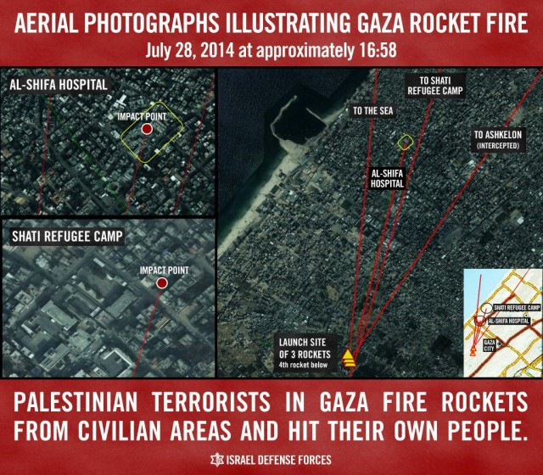
The Hamas rockets that hit Palestinian civilian structures on that day, weren’t the only ones. Of the thousands of rockets launched by terrorists at Israel since July 8, more than 280 have landed inside the Gaza Strip. This doesn’t include a rocket fired on July 13 that hit electricity infrastructure inside Israel, knocking out power for 70,000 Gaza residents. Despite the danger of further rocket fire, Israel Electric Corporation staff fixed the damage, restoring power to the residents of Gaza — victims of Hamas.
50 of the rockets fired from Gaza in the last 24 hours landed in Gaza.
— IDF (@IDFSpokesperson) July 30, 2014

A rocket fired from Gaza hit electricity infrastructure in Israel that supplied power to Gaza, cutting power to about 70,000 people in Gaza.
— IDF (@IDFSpokesperson) July 13, 2014
Of course, Hamas rockets landing on civilian areas inside Gaza are not the terrorist organization’s only crimes against the Palestinian people. Hamas has regularly and insistently called on Gaza’s civilians to ignore the IDF’s warnings about impending strikes on military targets, and instructed them to position themselves directly in the line of fire. This is part of Hamas’ human shield apparatus — the way it uses Gaza’s civilians to protect its terrorist infrastructure.
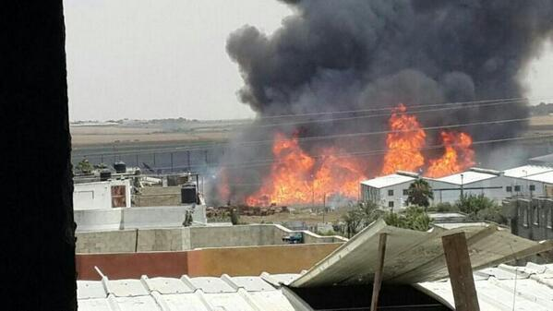
A rocket fired from Gaza on July 12 falls short and crashes into UNRWA warehouses.
