Hamas again uses Gazan civilians as human shields
Israel Ministry of Foreign Affairs
July 11, 2014
https://mfa.gov.il/MFA/ForeignPolicy/Terrorism/Pages/Hamas-again-uses-Gazan-civilians-as-human-shields-July-2014.aspx

Hamas again uses Gazan civilians as human shields to prevent the Israeli Air Force from attacking operatives' houses. Hamas will probably employ various tactics of using civilians as human shields as Operation Protective Edge continues and expands.

Source: ITIC

Overview

1. During confrontations with Israel, Hamas and the other terrorist organizations in the Gaza Strip have adopted various tactics of using civilians as human shields. One of them is encouraging civilians to gather on roofs to prevent operatives and their houses from being attacked by the Israeli Air Force (IAF). Such a tactic is aimed at deterring Israel from attacking and was used by the terrorist organizations in Operation Cast Lead, and now again in Operation Protective Edge (on July 8, 2014).

2. It can be expected that Hamas and the other terrorist organizations will use this and other tactics to encourage Palestinian civilians to protect their terrorist operatives and infrastructures. In ITIC assessment, the use of civilians as human shields is likely to increase as the IDF expands the scope of Operation Protective Edge. The organization's objectives are to make it difficult for the IDF to operate and to exploit civilian casualties for political, propaganda and legal purposes when it ends. (For examples of the tactic of using civilians as human shields, see Appendix B).

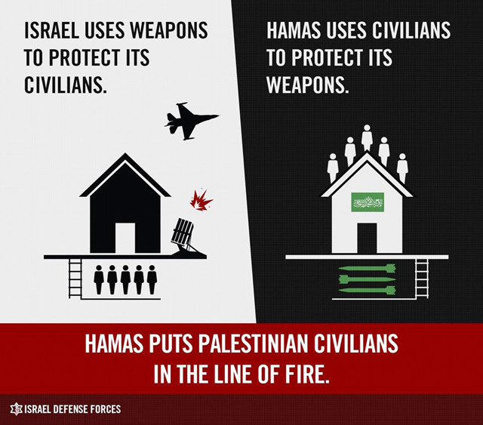

Using civilians as human shields to prevent air strikes:
Attacking a terrorist operative from the Kaware clan - Initial Update

3. On July 8, 2014, during Operation Protective Edge, the IAF attacked the house of Odeh Kaware, a senior Izz al-Din al-Qassam Brigades Hamas terrorist operative from the Kaware clan in Khan Yunis. After the attack an Egyptian media website reported that eye witnesses told the Turkish news agency Anadolu that the IDF had warned the members of the household of Odeh Kaware, a senior terrorist operative in the Izz al-Din al-Qassam Brigades, to vacate the house because it was going to be attacked (Masralarabia.com, July 9, 2014). According to the Israeli newspaper Haaretz (July 9, 2014), an IDF source had reported that the house was used as an operations room by a company commander in the Hamas brigade in Khan Yunis.

4. The Palestinian media reported that many civilians had gathered around the house and mounted the roof to serve as human shields for the Hamas operative and to prevent the IDF from attacking (Paltimes.net and Watan TV, July 8, 2014). According to the Palestinian media, seven Palestinians were killed in the attack and several others were wounded.

Hamas spokesman appeals to civilians to serve as human shields to prevent air strikes

5. On July 8, 2014, Hamas spokesman Sami Abu Zuhri called on civilians in the Gaza Strip to serve as human shields for operatives attacked by the IAF. Interviewed by Al-Aqsa TV, he mentioned the attack on the Kaware house, during which, he said, "bare-chested men" had gathered to face Israeli war planes "to defend their homes." He said the tactic had already proved itself and called on the Palestinian people to use it again (Video of the interview aired by Zvi Yehezkeli, Israel Channel 10 TV, July 8, 2014; MEMRI, July 9, 2014).

6. In the interview with Sami Abu Zuhri, the interviewer said that a large number of people had gathered [near the Karawe house] and were mounting the roof to prevent IAF planes from attacking it. He added that the tactic had proved highly successful in the past, in the case of the martyr Nizar Riyan, and asked Sami Abu Zuhri to comment. Sami Abu Zuhri replied that the jihad-fighting Palestinian people defended their homes and blood with "bare chests." The tactic had proved effective against the [so-called Israeli] "occupation" and Hamas, he said, called on the Palestinian people to use it to protect their homes. (For information about Sheikh Nizar Riyan, who developed the concept of using civilians as human shields for terrorist operatives in the Gaza Strip, see Appendix A).

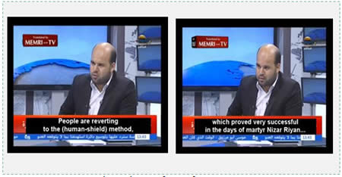
From the interview (MEMRI, July 9, 2014)

Sami Abu Zuhri calls on the Palestinian people to use the tactic to defend their homes: "We in the Hamas movement call on our people to adopt this procedure."

[Video: https://youtu.be/UXZEzbT0H1s]
[Video: https://youtu.be/uzFgIhFKII8]

7. Following the attack on Odeh Kaware's house in Khan Yunis, Sami Abu Zuhri issued a statement condemning it. He stressed that as a result all Israeli civilians had become legal targets (Zamnpress.com, July 8, 2014). (Note: In any case Hamas regards every Israeli civilian as a legitimate target and indiscriminately launches rockets at civilian population centers.)

Announcement from the Palestinian Ministry of the Interior in the Gaza Strip

8. After the interview with Sami Abu Zuhri, the ministry of the interior in the Gaza Strip issued "an important announcement" calling on civilians not to pay attention to IDF announcements about vacating their homes (July 10, 2014). It read as follows (Facebook page of the ministry of the interior in the Gaza Strip, July 10, 2014) (ITIC translation):

"The army of the occupation [i.e., the IDF] has recorded a telephone message and used it to call tens of thousands of residents in all areas of the Gaza Strip, calling on them to vacate their homes immediately. We hereby note that these recorded messages [have as their objective] to frighten the residents, to sow terror and weaken the internal front in the shadow of the enemy's failure. We call on our dear residents to reject these messages, not to vacate their homes and to conduct themselves calmly. Should the need arise, call the following toll free numbers: Central Operations 109, the Ministry of the Interior 1800131313..."

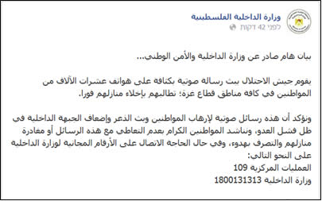

Announcement from the ministry of the interior to the residents of the Gaza Strip, telling them not to pay attention to IDF announcements about vacating their homes (Facebook page of the ministry of the interior in the Gaza Strip, July 10, 2014)

Appendix A
Sheikh Nizar Riyan, who shaped the concept of using civilians as human shields for Hamas operatives whose houses are attacked from the air

1. Sheikh Nizar Riyan, mentioned by Sami Abu Zuhri's interviewer, was a senior Hamas military-terrorist operative, killed by the IDF at the beginning of Operation Cast Lead. On December 31, 2008, the IDF warned him that it planned to attack his house in the Jabaliya refugee camp (northern Gaza Strip). The house served as a weapons storehouse, and there was a tunnel under the house that served as an escape route for Izz al-Din al-Qassam Brigades terrorist operatives. Despite the warning, Nizar Riyan refused to leave. He also did not evacuate his family. The IAF attacked his house, where many explosives were stored. Therefore, many secondary explosions were heard, the result of the detonation of the stored explosives. He and his family were killed, and extensive damage was done to neighboring houses.

2. Approximately two years before Operation Cast Lead, Nizar Riyan made headlines in the Palestinian media when he was joined the civilians serving as human shields for the house of Muhammad Baroud. Muhammad Baroud was a senior Popular Resistance Committees terrorist operative who lived in the Jabaliya refugee camp (November 18, 2006). After Muhammad Baroud received a telephone call from the IDF warning him, Palestinian civilians were called out to serve as human shields for the house. Ismail Haniya, head of the (former) de-facto Hamas administration in the Gaza Strip, visited the house the following day in a show of solidarity, and was warmly received by the civilians who had served as human shields. He said in a radio interview that "I feel that what happened last night will serve as a model...an example for out Palestinian people and [send] the message that aggression will not break our will..." (Radio Sawt al-Aqsa, November 19, 2006).

3. After the event at Muhammad Baroud's house, Nizar Riyan announced the beginning of an operation "to defend the homes of jihad fighters." He said that "from now on, jihad fighters will not permit Israel to attack their homes..." Elsewhere he said that the men and women who had gone to Muhammad Baroud's house had divided themselves into shifts and guarded the house day and night (Palestinian TV, November 19, 2014; Paltoday.ps, November 10 and 20, 2006).
Appendix B
Short summary of the tactics of human shields used by the terrorist organizations in the Gaza Strip

1. The human shield concept of Hamas and the other terrorist organizations operating in the Gaza Strip involves the extensive use of civilians as human shields for defending terrorist operatives from Israeli air and ground attacks. It was widely used during Operation Cast Lead and is being used again in Operation Protective Edge.

2. The following are past examples of how the terrorist organizations use Gazan civilians as human shields. In ITIC assessment Hamas and the other terrorist organizations will use similar tactics in Operation Protective Edge in addition to what has been done so far, especially if the operation evolves into a ground incursion into the Gaza Strip. They are motivated by a desire to make it difficult for the IDF to operate and to exploit civilian casualties for political, propaganda and legal purposes.

3. The main tactics used are:

1) The presence of terrorist operatives and storing weapons in civilian residences - Civilian residences in the Gaza Strip serve the terrorist operatives as safe houses, places to store weapons, surveillance posts and locations from which rockets are fired into Israel. The organizations have also constructed escape and attack tunnels under civilian residences (which were exposed in Operation Cast Lead).

2) Terrorist operatives are assimilated into civilian neighborhoods, which are turned into combat compounds - During Operation Cast Lead terrorist operatives were assimilated into residential neighborhoods and exchanged their uniforms for non-military clothing. During the operation, operational sketches were found proving that entire neighborhoods had been turned into Hamas combat zones. The military-terrorist infrastructures of the terrorist organizations were established near civilian residences and public institutions, from which the operatives fought against the IDF.

3) Rocket fire from populated areas and from the proximity of civilian houses - The terrorist organizations use this tactic to make it difficult for the IDF to attack and to increase the chances of their operatives' survival. In the past Israel exposed the tactic and for that reason Hamas is taking preventive measures to make difficulties for Israel in Operation Protective Edge.

4) Coercion of civilians not to leave their homes in battle zones - The tactic was used in both Operation Cast Lead and Operation Pillar of Defense following warnings from the IDF advising the civilian population to vacate combat zones where the IDF was operating or planning to operate. Hamas operatives coerced the civilians to remain in their homes and prevented them from leaving, even by force.

5) Extensive military use of mosques, hospitals and educational institutions - For example, during Operation Cast Lead Hamas made extensive use of hospitals and other medical facilities as shelters where its leadership and senior field operatives hid, and launched rockets at Israel in close proximity to such facilities. It located its military-terrorist infrastructures within and near hospitals and stored weapons in and near medical centers. Hamas also used mosques and schools for various military purposes (for which there is a great deal of factual evidence).

6) Military use of vehicles belonging to foreign institutions - Operational vehicles belonging to the terrorist operatives were repainted as belonging to foreign institutions (ambulances, press vehicles, commercial vehicles, etc.). For example, during Operation Pillar of Defense, on November 19, 2012, the IDF attacked a vehicle carrying Muhammad Riad Shamlakh, a senior Hamas terrorist operative, responsible for Hamas' forces in the southern Gaza Strip. The car had been marked as a media vehicle and bore the sign "TV."

