Hamas expel Russia Today’s Harry Fear from Gaza for tweeting about Hamas rocket fire from civilian area
Hurry Up Harry
July 30, 2014
http://hurryupharry.org/2014/07/30/hamas-expel-russia-todays-harry-fear-from-gaza-for-tweeting-about-hamas-rocket-fire-from-civilian-area/

Here is Harry Fear reporting for Russia Today:
[EMBEDDED VIDEO: https://youtu.be/9QtkzGrUZls]
Fear tweeted earlier:
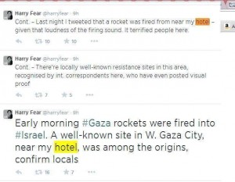
That tweet no longer appears on Fear’s feed.
Palestinian photo-journalist Fadi Arouri announces on Facebook:
#‎RT‬ Correspondent Harry Fear Asked officially to leave #‎Gaza‬ After a recent tweet that refers to the location of Fired rockets Towards Occupied Palestinian lands Which is Called “Israel”
مراسل روسيا اليوم هاري فير طلب منه رسمياً مغادرة غزة بعد تغريدة على تويتر أشارت لموقع إطلاق الصواريخ للأراضي المحتلة
The Jerusalem Post’s Lahav Harkov also tweets the news.
Doha Al Wazany comments on Facebook:
unfortunately mistakes are not allowed at this point of time! in addition that history gave us tough lessons about those who aggressively support us, are the ones who actually stab us in the very back!
@RanaGaza tweets:
Harry Fear is a pseudo-journalist who has been tweeting locations of rocket launchers, and lying a lot.
@Imnadz, a Palestinian blogger who writes for the Electronic Intifada, tweets:
“it’s unconfirmed yet but it’s happening: Harry Fear expelled from Gaza once Israelis open Erez. BEST NEWS EVER! i’m celebrating the news on the expelling of harry fear with ma3moul. hand made ma3moul. i’ve been preparing for such great news “
@miniestmini tweets:
Harry Fear is being expelled from #Gaza – YES! Go home. Stop using Palestinians to make a name for yourself. What a nerve Harry Fear had, to go to Gaza and use Palestinian suffering to boost popularity & then tweet location of resistance rockets!

