Submission to the UN Human Rights Council “Commission of Inquiry” on Israel
created May 27, 2021 by resolution A/HRC/RES/S-30/1

Issues to which submission applies:
- “Underlying root causes of recurrent tensions, instability and protraction of conflict in and between the Occupied Palestinian Territory, including East Jerusalem [sic], and Israel; as well as systematic discrimination and repression based on national, ethnic, racial or religious identity;”
- “Facts and circumstances regarding alleged violations of international humanitarian law and alleged violations and abuses of international human rights law leading up to and since 13 April 2021;”
- “Identification of those responsible;”
- "Recommendations on accountability measures, with a view to avoiding and ending impunity and ensuring legal accountability, including individual criminal and command responsibility;"

Submission: (This submission itself does not constitute an endorsement of the “Commission of Inquiry” or its mandate.)

Part A. Name of victim and description of the incident:

[original document inserted]

***************************************************************************
Part B. Root causes. Systematic discrimination and repression. Violations of international law. Those responsible. Criminal responsibility.

Amin al-Husseini

Palestinian national leader, Nazi collaborator and the voice of the Palestinian people

Amin al-Husseini (also Amin al-Hussayni, Hajj Amin al-Husseini) became the Grand Mufti of Jerusalem on May 8, 1921 (under the political authority of the British Mandate in Palestine). On January 9, 1922, he became the first president of the Supreme Muslim Council and Administrator of the waqf (funds for repair and improvement of religious sites and institutions). He carried overarching religious authority throughout Palestine. In 1936 al-Husseini became the first president of the Arab Higher Committee. In 1948 al-Husseini became the first president of the All Palestine Government.
Al-Husseini was described by Palestinian Edward Said and others as “Palestine’s national leader,” and the Arab Higher Committee, which he chaired, “represented the Palestinian Arab national consensus, had the backing of the Palestinian political parties that functioned in Palestine, and was recognized in some form by Arab governments as the voice of the Palestinian people.” The Nazis referred to him as “the religious leader of the Arabs in Palestine and simultaneously their highest judge and financial manager.”
Palestine’s national leader and the voice of the Palestinian people was also a vicious antisemite and Nazi collaborator.

The Facts:

- In 1920 al-Husseini instigated Arab riots in the Jewish quarter of Jerusalem that left hundreds of Jews injured or dead. A British military tribunal convicted him of incitement, in absentia, since he had fled to Syria.
- In 1929, with al-Husseini casting himself as the “spiritual leader defending the holy sites of Islam against Jewish incursion,” another wave of Arab violence took place in Hebron, Safed, Jerusalem, and elsewhere. It resulted in the slaughtering of rabbis, students and other Jews, as well as the razing of synagogues and burning of Torah scrolls. Jewish families had lived in Hebron and these other ancient Jewish cities for millennia.
- “[I]n the 1930’s Husseini’s efforts to make the Arab-Israeli clash also a Muslim-Jewish clash included a focus on supposed Zionist designs on the Al-Aqsa Mosque in Jerusalem.” Using his leadership positions, al-Husseini “exacerbated religious tension, infused the secular issues of Jewish immigration and land purchases with religious fervor, internationalized the political dispute by equating the Jewish presence in Palestine with an existential threat to the Muslim faith.” The strategy would become a Palestinian and other Arab template for attempting to achieve the ethnic cleansing of Jews from the Middle East throughout the 20th and 21st centuries.
- As Grand Mufti of Jerusalem, al-Husseini sought assistance from Nazi Germany from the moment Hitler rose to power in 1933. As early as 1936, Arab fighters were directly receiving funds and weapons from Nazi ally, Fascist Italy.
- Over the course of 1936 and 1937, al-Husseini’s Arab Higher Committee “demanded that the British halt Jewish immigration to Palestine, ban the transfer of Arab lands to Jews, and establish an Arab national government.” His Committee also declared “that the ‘Arab nation’ would ‘not agree…to the establishment of a National Home for the Jews in this Moslem Arab Holy Land.’” More waves of Arab violence ensued, leaving hundreds dead and injured.
- British authorities stripped al-Husseini of his positions as Grand Mufti of Jerusalem, president of the Supreme Muslim Council, and Administrator of the waqf in September 1937. In October 1937, al-Husseini fled to Lebanon.
- In 1940 al-Husseini moved from Lebanon to Iraq. With major cash infusions directly from the Nazis starting in 1941, al-Husseini issued a call over Baghdad radio for a Muslim Holy War. Within weeks there was a massacre of the Jews of Baghdad, murder, widespread rape and pillaging, and the destruction of Jewish homes and businesses (known as the Farhud).
- In the fall of 1941, al-Husseini moved to Germany. He spent the rest of the Second World War, living lavishly as Hitler’s guest, the Nazi regime paying him enormous sums. For his part, Al-Husseini served as a recruiter of tens of thousands of Arabs and Muslims for the SS and as a major propagandist for the Nazis.
- Just weeks after his arrival in Berlin, Al-Husseini met with Hitler himself on November 28, 1941.
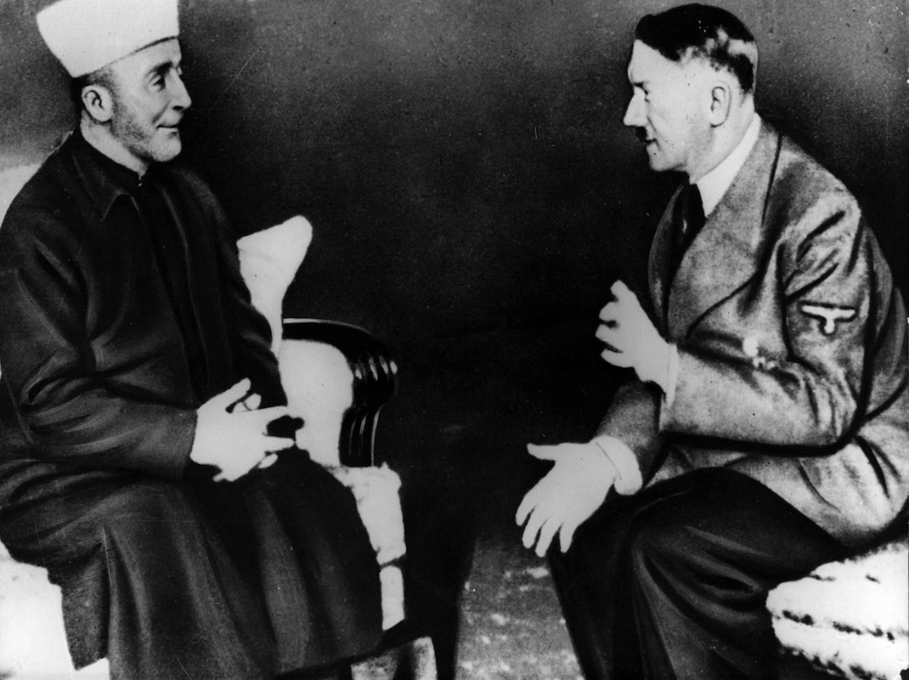

Amin al-Husseini (left), Adolf Hitler (right), Berlin, November 28, 1941

- There is an official German record of the meeting between al-Husseini and Hitler. It records their discussion of resolving the “Jewish problem.” And it records a genocidal pact made between the leader of the Palestinians and the leader of the Germans to bring Nazism – extermination, ethnic cleansing, genocide – to the Jews in Palestine. A Nazi propaganda video also recorded his entrance and the commencement of the visit – replete with al-Husseini’s ‘Heil Hitler’ salute.

“GRAND MUFTI:
The Grand Mufti began by thanking the Fuhrer for the great honor he had bestowed by receiving him. He wished to seize the opportunity to convey to the Fuhrer of the Greater German Reich, admired by the entire Arab world…The Arabs were Germany’s natural friends because they had the same enemies as had Germany, namely the English, the Jews and the Communists. Therefore they were prepared to cooperate with Germany with all their hearts and stood ready to participate in the war…by the commission of acts of sabotage and the instigation of revolutions…”

Al-Husseini asked for a public declaration of Germany’s support for “the elimination of the Jewish national home” because “a public declaration…would also ease the Mufti’s work of secretly organizing the Arabs against the moment when they could strike.”

HITLER:
The Fuhrer replied that Germany’s fundamental attitude on these questions, as the Mufti himself had already stated, was clear. Germany stood for uncompromising war against the Jews. That naturally included active opposition to the Jewish national home in Palestine…Germany was resolved, step by step, to ask one European nation after the other to solve its Jewish problem, and at the proper time to direct a similar appeal to non-European nations as well…This was the decisive struggle; on the political plane, it presented itself in the main as a conflict between Germany and England, but ideologically it was a battle between National Socialism and the Jews. It went without saying that Germany would furnish positive and practical aid to the Arabs involved in the same struggle…The Fuhrer then made the following statement to the Mufti, enjoining him to lock it in the uttermost depths of his heart: He (the Fuhrer) would carry on the battle to the total destruction of the Judeo-Communist empire in Europe…[T]he German armies would in the course of this struggle reach the southern exit from Caucasia…Germany’s objective would then be solely the destruction of the Jewish element residing in the Arab sphere…In that hour the Mufti would be the most authoritative spokesman for the Arab world. It would then be his task to set off the Arab operations, which he had secretly prepared.

GRAND MUFTI:
… He asked, however, whether it would not be possible, secretly at least, to enter into an agreement with Germany of the kind he had just outlined for the Fuhrer.

HITLER:
The Fuhrer replied that he had just now given the Grand Mufti precisely that confidential declaration.”

- Al-Husseini wrote in his own memoirs: “Our fundamental condition for cooperating with Germany was a free hand to eradicate every last Jew from Palestine and the Arab world. I asked Hitler for an explicit undertaking to allow us to solve the Jewish problem in a manner befitting our national and racial aspirations and according to the scientific methods innovated by Germany in the handling of its Jews.”
- In April 1942, Joachim von Ribbentrop, Nazi Foreign Minister, sent a letter to al-Husseini which again recorded the genocidal pact between the Palestinian leader and the Nazis. It said: “Germany is consequently ready to give all her support to the oppressed Arab countries in their fight against British domination, for the fulfillment of their national aim to independence and sovereignty and for the destruction of the Jewish National Home in Palestine.” Ribbentrop was found guilty of crimes against humanity at the Nuremberg Tribunals and executed.

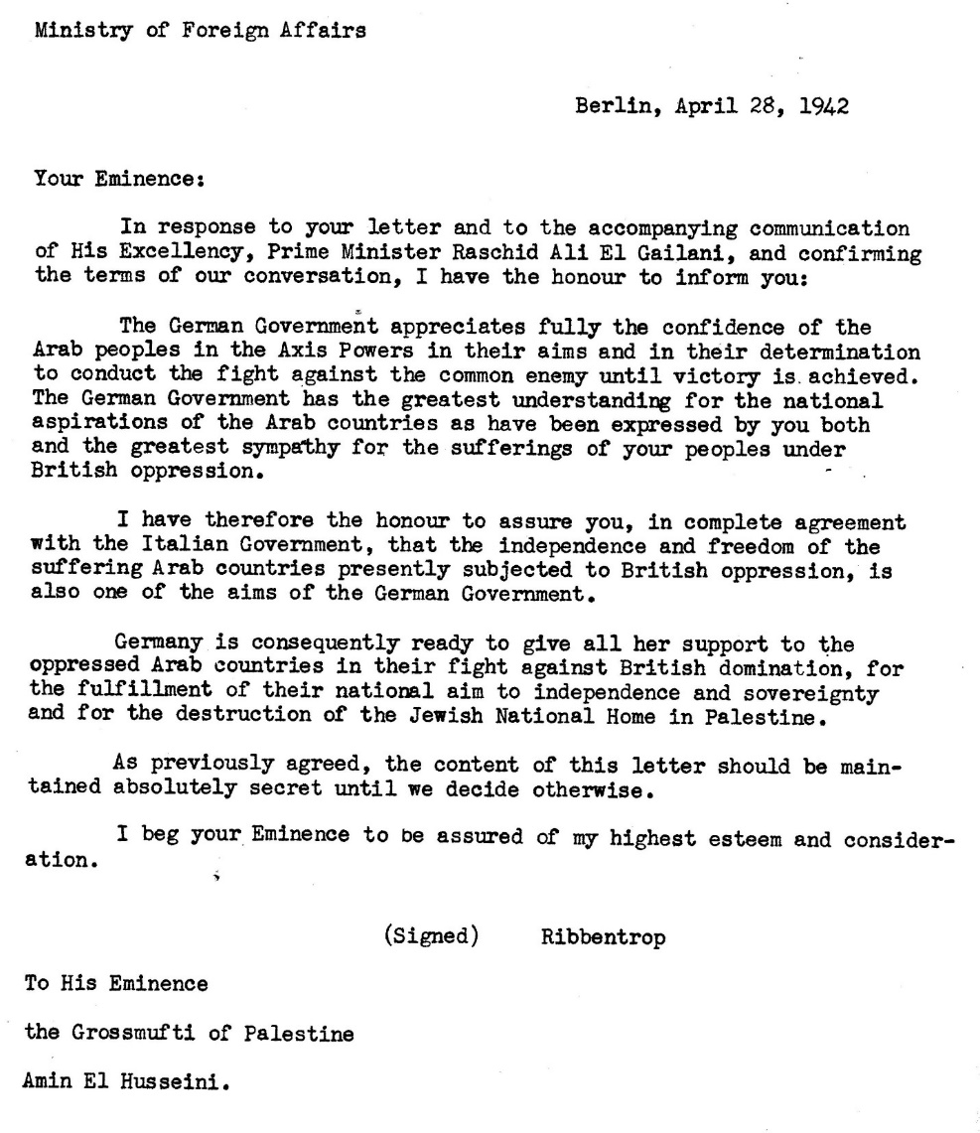
- Al-Husseini personally interacted with many of the Nazis top officials, including Heinrich Himmler (the SS Chief), Adolf Eichmann (pivotal actor in the implementation of the Holocaust), and Von Ribbentrop (Foreign Minister).

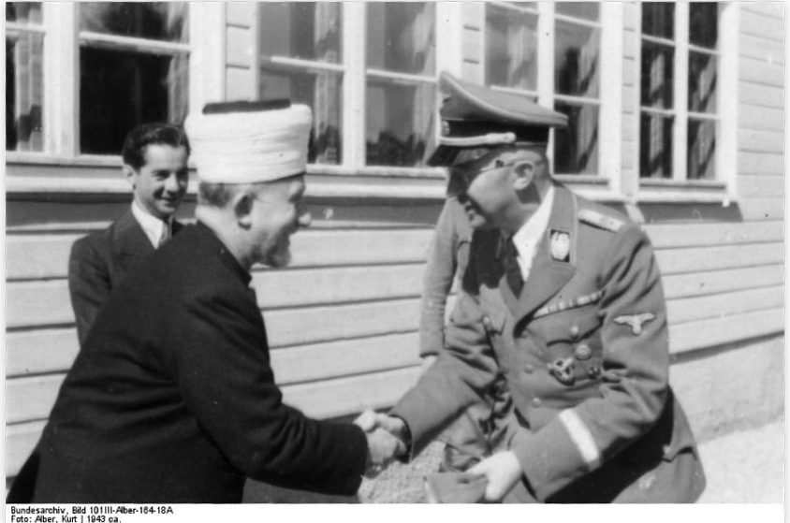

Amin al-Husseini (left), Heinrich Himmler, SS chief (right), 1943

- Al-Husseini was personally taken on tours of concentration camps by top Nazi officials, where he witnessed Jewish captives. “Among the prisoners were Jews from Hungary. Forced labor, terror and violence characterized their daily lives.”
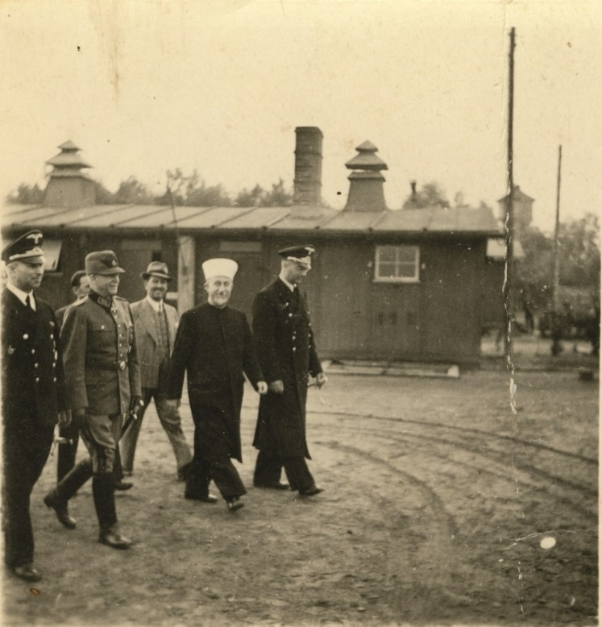

Al-Husseini visits the Trebbin concentration camp in 1942 with Nazi senior officials and government figures directly involved in genocide and the “Final Solution,” including Arthur Seyss-Inquart second from left, and Martin Luther far right.
- Husseini recorded in his memoirs his knowledge of the mass extermination of the Jews almost two years before the end of the war.
- As he had since the early days of the Nazi regime in 1933, al-Husseini repeatedly urged the Nazi leadership to prevent Jewish emigration to Palestine. Written letters in 1943 establish his preference for sending Jewish children to death camps in Poland.
- In his role as propagandist for the Nazis, al-Husseini conducted grotesquely antisemitic radio broadcasts inciting listeners to genocide. They included “kill the Jews” (summer of 1942), and “Arabs! Rise as one and fight for your sacred rights. Kill the Jews wherever you find them. This pleases God, history and religion. This serves your honor, God is with you.” (March 1944).
- The Nazis invited al-Husseini to deliver speeches which they then broadcast in German and Arabic across North Africa and the Middle East. These included: “the holy Qur’an and the life story of the Prophet are full of evidence of Jewish lack of character and their malicious, mendacious and treacherous behavior.” (December 1942) and “They [the Jews] lived like a sponge among peoples, sucked their blood, seized their property, undermined their morals…a Jewish state in Palestine…is a bloody stab in the heart of the Arab fatherland! The establishment of a Jewish commonwealth in Palestine would subject the Arab countries and all the countries of the Middle East to the danger of Jewish economic exploitation and to the Jewish world conspiracy.” (November 1943)
- The SS Main Office Chief referred to al-Husseini’s recruiting contribution as having “had an extraordinarily successful impact.”

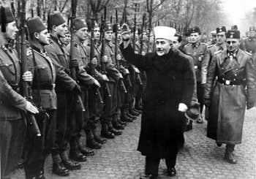

Amin al-Husseini greets Muslim Waffen-SS members with a Nazi salute, November 1943

- The SS Muslim division recruited by al-Husseini committed crimes against humanity.
- As he had promised Hitler himself, al-Husseini plotted sabotage operations in the Middle East, including “a 1944 mission for Palestinian Arabs and Germans to carry out sabotage and propaganda after German planes dropped them into Palestine by parachute.”
- When the war ended, Yugoslavia originally asked that al-Husseini be placed on the United Nations list of war criminals. Held in France in comfortable circumstances, and with British officials objecting to his prosecution, however, he was allowed to escape to Syria and lived another 30 years in Egypt and Lebanon.

After the war, al-Husseini peddled another lie: his innocence. He claimed he was a victim of “false accusations spread by the Jews about his alleged pro-Axis activities during the war.”
Palestine’s national leader, the voice of the Palestinian people and Nazi propagandist Amin al-Husseini was an antisemite, a racist, a bigot. He trafficked in hate speech against Jews. He pursued the goal of mass murder. His Jewish victims spanned continents, from the Middle East to Europe, from Palestine to Iraq to Nazi Germany. Individual Jewish men, women and children were tortured, raped, mutilated, and butchered because of Amin al-Husseini. He was a propagandist for evil incarnate and richly rewarded for his services.
In UN terminology, al-Husseini fostered and perpetuated a climate of systematic discrimination and repression based on national, ethnic, racial or religious identity – Jewish identity to be specific. He incited an environment of hatred and gross intolerance. He advanced a culture of inequality. He aided and abetted the mainstreaming of antisemitism and the normalization of genocide among masses of listeners. Employing the same words Navi Pillay applied to convict and sentence perpetrators in the case of Rwanda – when the victims of genocide were not Jews: “he was fully aware of the power of words, and he used the radio – the medium of communication with the widest public reach – to disseminate hatred and violence.”
“No temporal restrictions” and “all underlying root causes” – in the Commission’s words – therefore point directly to Amin al-Husseini. He personifies the root cause of conflict with the Jewish people and the Jewish state, namely, ugly, unrepentant antisemitism. Al-Husseini lashed Palestinian identity to the mast of antisemitism. And for that he was venerated and parroted by his Palestinian successors and offspring.

Al-Husseini’s Offspring: Yasser Arafat, Mahmoud Abbas, Ahmed Yassin, Abdel Aziz Rantissi, Khaled Mashaal, Ismail Haniyeh

Al-Husseini was the man that his successor, Yasser Arafat, “came to adore and emulate.” The man Arafat referred to as “our hero” and then boasted “I was one of his troops.” And Al-Husseini forged the path of Arafat’s successor, Mahmoud Abbas, namely, a shared antisemitism of Holocaust denial, of blaming Jews for their own plight, of charging the victims of the Nazis with Nazism and of aping their abusers. Thus we are burdened in the 21st century with a Palestinian Authority whose current appointed successor as Grand Mufti of Jerusalem laid a wreath at al-Husseini’s grave. And a Palestinian Authority instilling antisemitism in yet another generation at the “Amin Al-Husseini Elementary School” in El-Bireh.
When al-Husseini arrived in Egypt in June 1946, founder of the Muslim Brotherhood Hasan al-Banna declared “The Mufti is worth the people of a whole nation put together. The Mufti is Palestine and Palestine is the Mufti. Oh Amin!...Yes, this hero who challenged an empire and fought Zionism, with the help of Hitler and Germany. Germany and Hitler are gone, but Amin Al-Husseini will continue the struggle.” Indeed, the founding Covenant of the wing of the Muslim Brotherhood known as Hamas (Islamic Resistance Movement) is a transparent call to commit genocide against “the Jews.” In effect to this day, it invokes “almost precisely the same words used in al-Husaini’s wartime speeches and German propaganda.”

Never Again, Despite the UN “Commission of Inquiry”

Jewish survivors, their descendants, the remnant of the Jewish people left after the Holocaust will not allow the United Nations and its Commission of Inquiry to remove the “never” from “never again.” Or to demonize and deny the self-determination of the Jewish people embodied in the Jewish state – the birthplace of Judaism and the continuous homeland of this indigenous population for over 3,000 years.
The voices of the victims of Jew hatred advocated, promoted, and disseminated by “Palestine’s national leader” and its “hero” will not be silenced.

Hear my name.

Edward Said, Ibrahim Abu-Loghud, Janet L. Abu-Loghud, Mohammad Hallaj and Elia Zureik, “A Profile of the Palestinian People,” Edward Said and Christopher Hitchens, eds., Blaming the Victims: Spurious Scholarship and the Palestinian Question, 1988, p. 248
Video clip, translation from German: https://encyclopedia.ushmm.org/asset/a104f8cb-205a-47d1-8b24-5b4625aff487.mp4
“Hajj Amin Al-Husayni: Arab Nationalist and Muslim Leader,” United States Holocaust Museum Memorial Museum Holocaust Encyclopedia, https://encyclopedia.ushmm.org/content/en/article/hajj-amin-al-husayni-arab-nationalist-and-muslim-leader; Zvi Elpeleg, The Grand Mufti: Haj Amin al-Hussaini, Founder of the Palestinian National Movement (Routledge, 1993), p. 6
“Hajj Amin Al-Husayni: Key Dates,” United States Holocaust Museum Memorial Museum Holocaust Encyclopedia, https://encyclopedia.ushmm.org/content/en/article/hajj-amin-al-husayni-key-dates
Jeffrey Harf, “Haj Amin al-Husseini, the Nazis and the Holocaust: the Origins, Nature and Aftereffects of Collaboration,” Jewish Political Studies Review, Fall 2014, Vol. 26, No. 3/4, pp. 13-37, at p. 17
“Hajj Amin al-Husayni: Arab Nationalist and Muslim Leader,” United States Holocaust Memorial Museum, https://encyclopedia.ushmm.org/content/en/article/hajj-amin-al-husayni-arab-nationalist-and-muslim-leader
Report to the Auswärtiges Amt (Foreign Ministry) by Heinrich Wolff, head of the German Consulate in Jerusalem on a meeting with al-Husseini on March 31, 1933, two months after Hitler came to power. Wolff to Auswärtiges Amt (AA), Jerusalem (March 31,1933), Politisches Archiv des Auswärtiges Amt (PAAA) R78325III,1920–33, Bd.1, L318926
Nir Arielli, “Italian Involvement in the Arab Revolt in Palestine, 1936-1939,” British Journal of Middle Eastern Studies, Vol. 35, No. 2, 2008, pp. 187-204
“Hajj Amin al-Husayni: Arab Nationalist and Muslim Leader,” United States Holocaust Memorial Museum, https://encyclopedia.ushmm.org/content/en/article/hajj-amin-al-husayni-arab-nationalist-and-muslim-leader
“Hajj Amin al-Husayni: Arab Nationalist and Muslim Leader,” United States Holocaust Memorial Museum, https://encyclopedia.ushmm.org/content/en/article/hajj-amin-al-husayni-arab-nationalist-and-muslim-leader
A Survey of Palestine: Prepared in December 1945 and January 1946 for the information of the American-Anglo Committee of Inquiry, Vol. 1, April 1946, (Printed by the Government Printer, Palestine), pp. 38-49, https://www.bjpa.org/content/upload/bjpa/a_su/A%20SURVEY%20OF%20PALESTINE%20DEC%201945-JAN%201946%20VOL%20I.pdf
“Hajj Amin al-Husayni: Key Dates,” United States Holocaust Memorial Museum, https://encyclopedia.ushmm.org/content/en/article/hajj-amin-al-husayni-key-dates?parent=en%2F11104
Office of Chief Counsel for War Crimes, Doc. No. NG-5461-SS60, pp. 1-10, here p. 1, 4, Affidavit by finance officer Consul Carl Rekowski, Bremen. October 5, 1947 on payments to al-Husseini of the special funds of foreign minister Ribbentrop: 50,000 Reichsmark, 25,000 in foreign currency, all in all 75,000 plus other payments for housing, driver, Hotels Adlon, Zittau, and 150,000 for his 150 Syrians, all monthly. See also: Breitman and Norman Goda, Hitler’s Shadow: Nazi War Criminals, U.S. Intelligence, and the Cold War, National Archives and Records Administration, 2011, p. 19, https://www.archives.gov/iwg/reports/hitlers-shadow.pdf
Video clip of Al-Husseini meeting Hitler: November 28, 1941, https://encyclopedia.ushmm.org/asset/a104f8cb-205a-47d1-8b24-5b4625aff487.mp4; the video transcript (translated from German) says: “The Führer meets the Grand Mufti of Jerusalem, one of the most influential men of Arab nationalism. The Grand Mufti is the religious leader of the Arabs in Palestine and simultaneously their highest judge and financial manager. Because of his nationalism, the British have persecuted him bitterly and put a price of 25,000 pounds on his head. His adventurous voyage brought him over Italy to Germany.” Available at: https://encyclopedia.ushmm.org/content/en/film/hajj-amin-al-husayni-meets-hitler?parent=en%2F11105
Official German record of the meeting between Adolf Hitler and the Grand Mufti of Jerusalem, Haj Amin al-Husseini, on November 28, 1941, at the Reich Chancellory in Berlin. (Source: Documents on German Foreign Policy 1918-1945, Series D, Vol XIII, London, 1964), reproduced in https://www.timesofisrael.com/full-official-record-what-the-mufti-said-to-hitler/
Mudhakkirāt al-Ḥājj Muḥammad Amīn al-Ḥusaynī (Memoirs of Hajj Muhammad Amin Al-Husseini) Publisher: Dimashq : al-Ahālī, 1999, https://www.worldcat.org/title/mudhakkirat-al-hajj-muhammad-amin-al-husayni/oclc/43253452; see also as early as March 1941 “Déclaration officielle de l”Allemagne et de l”Italie concernant les Pays Arabes,” paragraph 7: “L’Allemagne et l’Italie reconaissent l’illegalité du ‘Jewish National Home’ en Palestine. Elles reconaissent à la Palestine et aux autres Pays Arabes le droit de résourdre la question des élément juifs en Palestine et dans les autres Pays Arabes selon l’intérêt nationale arabe de la même manière qu’était résolue cette question dans les pays de l’Axe. Il s’en suit aussi qu’aucune immigration juive ne sera premise dans les Pays Arabes.” (Berlin, March 1, 1941). USArchII, T120, R63, S71, F50682 ff., B255147, cited at p. 127 and footnote 30 in Barry Rubin and Wolfgang Schwanitz, Nazis, Islamists and the Making of the Modern Middle East, Yale University Press, c. 2014.
Letter from Ribbentrop to “His Eminence the Grossmufti of Palestine Amin El Husseini, Berlin, April 28, 1942, Ministry of Foreign Affairs” https://isgap.org/wp-content/uploads/2017/04/004-Ribbentrop-Mufti-Record-The-Nation-Associates-New-York-1947-28041942.jpg
Wolfgang G. Schwanitz, “Photographic Evidence Shows Palestinian Leader Amin al-Husseini at a Nazi Concentration Camp,” Tablet Magazine, April 6, 2021, https://www.tabletmag.com/sections/news/articles/amin-al-husseini-nazi-concentration-camp
Wolfgang G. Schwanitz, “Photographic Evidence Shows Palestinian Leader Amin al-Husseini at a Nazi Concentration Camp,” Tablet Magazine, April 6, 2021, https://www.tabletmag.com/sections/news/articles/amin-al-husseini-nazi-concentration-camp. Arthur Seyss-Inquart presided over Hitler’s Anschluss of Austria in 1938 and two years later served as commissioner for the occupied Netherlands where he oversaw the deportation of 100,000 Jews to death camps. Martin Luther was a senior official in the Foreign Office and one of 15 Nazis to attend the 1942 Wannsee Conference where the Nazis managed “the logistics of Jewish mass murder.” German diplomat Fritz Grobba (far left) served as Ambassador to multiple Arab countries, played a major role in Nazi operations in Iraq in 1941 and in urging the dissemination of an Arabic version of Hitler’s Mein Kampf.
Among other evidence, al-Husseini writes in his memoir of a meeting with Himmler on July 4, 1943 in Zhitomir: “Every time I heard of his deep hatred of the Jews…He said…we have decided in this war to make them suffer and to pay attention to their activities in advance. Thus, up to now we have liquidated about three million of them.” p. 185 translated from Arabic and available in Barry Rubin and Wolfgang Schwanitz, Nazis, Islamists and the Making of the Modern Middle East, Yale University Press, c. 2014.
The Attorney General v. Adolf Eichmann, Judgment of the District Court of Jerusalem, Criminal Case No. 40/61, p. 159, Memoranda sent by the Mufti to the German Foreign Ministry, Ribbentrop (T/1260, T/1261), and to the satellite governments of Romania and Bulgaria (T/1263, T/1264), https://www.asser.nl/upload/documents/DomCLIC/Docs/NLP/Israel/Eichmann_Judgement_11-12-1961.pdf
Matthias Küntzel, National Socialism and Anti-Semitism in the Arab World, Jewish Political Studies Review, 17:1-2 (Spring 2005) and citations: Nicholas Bethell, Das Palästina-Dreieck, Juden und Araber im Kampf um das britische Mandat 1935 bis 1948 (Frankfurt am Main: Propyläen-Verlag, 1979), p. 240 (German). According to Bethell, El-Husseini was the "Leiter" ("Director") of this station, while according to Hurewitz the Mufti was a director of the "Arab Bureau" in Berlin, which was responsible for preparing and transmitting the Arabic broadcasts, under the supervision of Goebbels's Propaganda Ministry. See J. C. Hurewitz, The Struggle for Palestine (New York: Norton, 1951), p. 154.
The original was emphasized in italics. Cited in Herf, “Nazi Propaganda for the Arab World,” 213, Original cite: “Weekly Review of Foreign Broadcasts, F.C.C. [Federal Communications Commission, No. 118/3/4/44, Near and Middle East,” United States National Archives, College Park, Record Group 165, MID, Regional File, 1922-44, Palestine, entry 77, Box 2719, folder 2930. See also: “Axis Broadcasts in Arabic,” weekly reports to Secretary of State Cordell Hull (from U.S. Amb. Alexander Kirk, in Cairo from 1941-1944, and from U.S. Amb. Pinckney Tuck from 1944-1945)
“Al-Husayni, Speech, 18 December 1942,” Berlin Politisches Archiv des Auswärtiges Amt, Berlin, R 27327, cited in Motadel, Islam and Nazi Germany’s War, pp. 46-47
Haj Amin al-Husseini, “The Protests of the Moslems of Europe against the Balfour Declaration,” November 5, 1943, cited in Herf, Nazi Propaganda for the Arab World, pp. 185-186
April 29, 1943, “Hajj Amin al-Husayni: Wartime Propagandist”, https://encyclopedia.ushmm.org/content/en/article/hajj-amin-al-husayni-wartime-propagandist?parent=en%2F11099
The Bosnian Muslims in the Second World War: A History, by Marko Attila Hoare, (Columbia University Press: 2013), pp. 53, 192; David Motadel, Islam and Nazi Germany's War, (Belknap Press: 2014), p. 68; Bernard Lewis, Semites and Anti-Semites: An Inquiry into Conflict and Prejudice (W.W. Norton, 1999), p. 154; Francine Friedman, "Contemporary Responses to the Holocaust in Bosnia and Herzegovina," Bringing the Dark Past to Light: The Reception of the Holocaust in Postcommunist Europe, John-Paul Himka and Joanna Beata Michlic (eds.). (University of Nebraska Press, 2013), pp. 86-87
Breitman and Norman Goda, Hitler’s Shadow: Nazi War Criminals, U.S. Intelligence, and the Cold War, National Archives and Records Administration, 2011, p. 20, https://www.archives.gov/iwg/reports/hitlers-shadow.pdf; Sean McMeekin, The Berlin-Baghdad Express: The Ottoman Empire and Germany's Bid for World Power, (Belknap Press of Harvard University Press, 010), p. 362; Rafael Medoff, “The Mufti's Nazi years re‐examined,” Journal of Israeli History, (September 1996), p. 327; "4 JULY 2001 RELEASE: KURT WIELAND," MI5 Security Service, available at https://web.archive.org/web/20110611043738/https://www.mi5.gov.uk/output/4-july-2001-releases-kurt-wieland.html; The Grand Mufti of Jerusalem Haj Amin al Hasanji (Husseini): “To the Reichsfuehrer SS and Minister of the interior H. Himmler,” July 17, 1944, available at: http://cojs.org/july-27-1944-2/
Cable from Sava Kosanovich, Minister of the Interior and Information in the Yugoslav Government, declaring that “Mufti Hadj Amin el-Husseini put by Yugoslavia on list of war criminals.” Cited in “Ex-mufti of Jerusalem Placed on War Criminals List; Indicted by Yugoslav Government,” Jewish Telegraphic Agency (JTA), July 20, 1945, http://pdfs.jta.org/1945/1945-07-20_165.pdf?_ga=2.18392250.242571651.1645300293-1015420726.1643945268 and https://www.jta.org/archive/ex-mufti-of-jerusalem-placed-on-war-criminals-list-indicted-by-yugoslav-government But see Jennie Lebel, The Mufti of Jerusalem: Hajj Amin al-Husaini and National Socialism, (Belgrade: Cˇigoja Stampa, 2007), pp. 260-264; Joseph B. Schechtman, The Mufti and the Fuehrer (New York: Yoseloff, 1965), p. 175; Barry Rubin and Wolfgang Schwanitz, Nazis, Islamists and the Making of the Modern Middle East, Yale University Press, c. 2014, pp. 196-197
Richard Breitman and Norman Goda, Hitler’s Shadow: Nazi War Criminals, U.S. Intelligence, and the Cold War, National Archives and Records Administration, 2011, https://www.archives.gov/iwg/reports/hitlers-shadow.pdf, pp. 21-22; Memo from Jane Burrell to Mr. Blum re: Mufti of Jerusalem, March 7, 1946, Haj Amin al-Husseini Name File, volume 1, file 92, Central Intelligence Agency, available at https://www.cia.gov/readingroom/document/51966ec7993294098d50a38e; Floyd A. Spencer, Asst. Military Attaché, Cairo Report, Background of Plan to Return … Husseini to Middle East, June 21, 1946, NARA, RG 165, Army G-2 3161.0503, MIS 279421; The Escape of the Grand Mufti of Jerusalem, August 2, 1946, NARA, RG 263, Grumbach Series 12, Finished Reports.
Memo dated June 10, 1947 regarding Views of the Mufti; Desire for British Neutrality, Haj Amin al-Husseini Name File, volume 2, file 55, Central Intelligence Agency, available at https://www.cia.gov/readingroom/document/51966ec7993294098d50a2b1
The Prosecutor v. Ferdinand Nahimana, Jean-Bosco Barayagwiza, Hassan Ngeze, International Criminal Tribunal for Rwanda, Navanethem Pillay presiding, Case No. ICTR-99-52-T, Judgement and Sentence, December 3, 2003, p. 358, para. 1099, and “Three Media Leaders convicted for Genocide,” Press release, International Criminal Tribunal for Rwanda, Dec. 3, 2003, https://unictr.irmct.org/en/news/three-media-leaders-convicted-genocide
Saïd K. Aburish, Arafat: From Defender to Dictator, Bloomsbury Pub., 1998, p. 15
Al Sharq al Awsat, a London Arabic daily, reprinted in the Palestinian daily Al Quds, Aug, 2, 2002, as translated in “Nazi ally, Hajj Amin Al Husseini, is Arafat's ‘hero,’” Palestinian Media Watch Bulletin, August 5, 2002, Itamar Marcus, available at https://freerepublic.com/focus/news/728053/posts
Mahmoud Abbas, “The Other Side: The Secret Relations between Nazism and the Leadership of the Zionist Movement,” translated by the Simon Wiesenthal Center, available at “Abbas: Story of 6 million cremated Jews is propaganda,” Palestinian Media Watch, https://palwatch.org/page/4; In 2018, in a broadcast on Palestinian Authority television, Abbas doubled-down on such obscene fictions: “I received a doctorate from Moscow from the Institute of Oriental Studies in a surprising subject…It is the secret connections between Nazi Germany and the Zionist movement…This is firm.” “Abbas maintains conclusion from controversial doctoral thesis, on the ‘secret connections between Nazi Germany and the Zionist movement’”, Palestinian Media Watch, Feb. 23, 2018, https://palwatch.org/page/13901; And again as recently as December 2021 – reported by Muwaffaq Matar (Fatah Revolutionary Council member and regular columnist for the official PA daily) writing about a meeting held by Abbas with various Palestinian intellectuals at the PA presidential headquarters in Ramallah on Dec. 23, 2021, Palestinian Media Watch, Dec. 30, 2021, https://palwatch.org/page/29835
Official PA TV, April 30, 2018, Itamar Marcus, “Mahmoud Abbas: Jews' ‘social role... usury; caused ‘massacres every 10 to 15 years’ and the Holocaust; Jews were hated because of their own behavior.” Palestinian Media Watch, May 2, 2018, https://palwatch.org/page/14181
Palestinian Media Watch database of original sources and excerpts at “Rewriting History » Holocaust Denial & Distortion,” at https://palwatch.org/database/43
Muhammad Ahmed Hussein, appointed by Mahmoud Abbas,“PA Mufti lays wreath on grave of Nazi collaborator Hajj Amin Al-Husseini,” WAFA (official Palestinian Authority news agency), May 19, 2015, translated by Palestinian Media Watch, https://palwatch.org/page/8160
“76 Palestinian Authority schools named after terrorists and Nazi collaborators and honoring Martyrs and Martyrdom,” Palestinian Media Watch, Sept. 17, 2018, https://palwatch.org/STORAGE/special%20reports/PA%20Ministry%20of%20Education%20schools%20named%20after%20terrorists%20-%202018.pdf#page=9
“Hassan Al-Banna and the Mufti of Palestine” in “Contents of Secret Bulletin of Al Ikhwan al-Muslimin dated 11 June 1946,” Cairo (July 23, 1946), NACP RG 226 (Ofﬁce of Strategic Services), Washington Registry SI Intelligence, Field Files, entry 108A, box 15, folder 2. (cited in Jeffrey Herf, Nazi Propaganda for the Arab World (New Haven, CT, Yale University Press, 2009), p. 244)
The Covenant of the Islamic Resistance Movement, adopted August 18, 1988, Article 2, https://avalon.law.yale.edu/20th_century/hamas.asp
Barry Rubin and Wolfgang Schwanitz, Nazis, Islamists and the Making of the Modern Middle East, Yale University Press, c. 2014, pp. 251-252

