How Hamas dug its Gaza ‘terror tunnel,’ and how the IDF found it
By: Mitch Ginsburg
Times of Israel
October 16, 2013
https://www.timesofisrael.com/how-the-tunnels-in-gaza-are-dug-and-detected/

The tunnel stretching from the outskirts of Khan Yunis to the fields of Kibbutz Ein Hashlosha was meant to facilitate a complex terror attack involving an assault on soldiers or civilians, with the intention of seizing a captive Israeli and holding him or her as a bargaining chip. Senior Hamas official Moussa Abu Marzouk confirmed as much on Tuesday, two days after Israeli authorities revealed their discovery.

“The tunnel which was revealed was extremely costly in terms of money, effort and blood,” Abu Marzouk wrote on his Facebook page. “All of this is meaningless when it comes to freeing our heroic prisoners.” He went on to detail the lucrative nature of the Gilad Shalit deal, in which 1,027 prisoners were released after the Israeli soldier was kidnapped in just such an attack.

Slightly less clear was the manner in which such an “extremely advanced and well prepared” tunnel, as the Gaza Division commander called it, was dug and, later, detected.

“They’d begin with a shaft, drilling straight down,” said a former Southern Command officer who served in the IDF’s geology unit. “Then they’d start to move horizontally.”

The earth in which the tunnelers began drilling, in the eastern Gaza Strip, he said, is characterized by calcium carbonate – a sort of sand that is fossilized with sea shells. Other parts of Gaza have simple sand layers – beneath dunes – and shallower water tables, and are thus, on both accounts, less conducive to tunneling.

In the Rafah region, for instance, he said the water table was perhaps 20 meters beneath the surface. In the Khan Yunis-Ein Hashlosha region, northeast of Rafah, the water table, which sits at around sea level, was roughly 60 meters beneath the surface.

The Ein Hashlosha tunnel, which was discovered on October 7 and revealed to the public on Sunday, was 20 meters at its deepest. Counterintuitively, the deeper one digs the more stable the tunnel.

“Tunneling is a question of stability of the rocks or soils surrounding the underground cavity,” said the IDF reserves officer. “In principle, the deeper the tunnel, the greater the stability.”

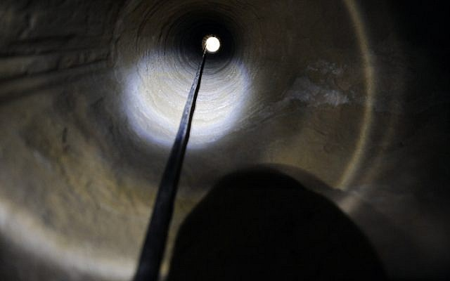
An air hole in the Ein Hashlosha tunnel, roughly 20 meters above the tunnel floor (Photo credit: David Buimovitch/ Flash 90)

To illustrate the difficulties of tunneling just beneath the surface in sand, he suggested recalling days at the beach as a child and the constant caving in of all holes “at the face of the excavation near the surface.”

Tunneling through uncemented sands, he said, “can be a nightmare in terms of stability.” The fossilized dunes are more difficult to dig through but are likely to be more stable. He said that the tunnelers in the Gaza Strip have “a very good knowledge” of the ground conditions and would likely have chosen the more stable soil as their surface of choice.

Nonetheless, the diggers, whom he deemed professionals, took the unusual precaution of supporting the tunnel with cement arches all through its length. “More often one sees wood used as a support structure,” he added.

Two likely contributors to Hamas’s decision to opt for the more costly and more labor-intensive model of cement supports are the nature of the planned attack – a powerful explosive blast could compromise the tunnel — and the fact that it was built for a future attack, at a time of the terror organization’s choosing, and therefore needed to remain intact until the strike was approved.

The actual digging was done by one person, likely rotating with an additional laborer. The reserves officer said that the diggers probably used electric or pneumatic jackhammers and could be expected to progress 4-5 meters a day, if all went well in excavating a two-meter-high and one-meter-wide tunnel. After every meter or yard of progress, he said, a concrete support might be inserted. The Ein Hashlosha tunnel ran for 1,700 meters.

All told, some 3,400 cubic meters of soil were excavated from the earth in carving the tunnel, the geologist estimated. A mountain of earth that size, even if carted away daily on trucks, leaves a traceable signature and is one way in which the IDF is able to spot the hallmarks of a tunnel. Other ways, according to an academic tunnel-detection expert, include devices that measure sub-surface sound, the strength and direction of a magnetic field, and the propagation or spread of radio and light waves.

The seismic method is the most intuitive and monitors the tremors created by people moving and digging underground. The downside of this method, the expert said, is that many actions create tremors, and in an agricultural area, where there is ample foot and vehicle traffic, the seismic method can often sound a false alarm.

A magnetometer can, among other things, detect electrical wires or other metal objects, if they are present in a tunnel.

Radio waves can also be used, for instance via two boreholes, in which a transmitter and a receiver are plunged into the earth. The way the radio waves propagate between these antennae could be used to detect cavities within the earth.

Finally, Israeli researchers Asaf Klar and Raphael Linker, both of the Technion Faculty of Civil and Environmental Engineering, developed a system based on fiber-optic cables that can detect a tunnel at a depth of more than 20 meters. The system forms an underground fence that could “analyze the tunneling-induced changes in the optical fiber,” according to the Technion’s literature, and, on the basis of computer software models, pinpoint the location of the tunnel.

The tunnel detection expert, who spoke on condition of anonymity, said that the Technion-developed system analyzes the shift in the wavelength of a laserbeam that travels through a fiberoptic cable and in that way detects tunneling activity.

And yet, he said, each technique has its drawbacks and “what usually works is a combination of all of these approaches.”

Gaza Division commander Brig. Gen. Michael Edelstein told reporters on Sunday that the effort spent in finding the 5,500-foot-long tunnel required “the sort of dedication I wish I could detail,” but he did not elaborate.

Elhanan Miller contributed to this report

