How is the IDF Minimizing Harm to Civilians in Gaza?
IDF Blog
July 16, 2014
http://web.archive.org/web/20140825042830/http://www.idfblog.com/blog/2014/07/16/idf-done-minimize-harm-civilians-gaza/

The IDF does everything possible to limit civilian casualties in Gaza. Hamas exploits these efforts by encouraging Palestinian civilians to ignore the IDF’s warnings.

Phone Calls and Text Messages
As part of its efforts to minimize civilian casualties in Gaza, the IDF makes phone calls and sends text messages to civilians residing in buildings designated for attack. In the following video, you can hear a recording of an IDF soldier calling a Gazan to warn him of an impending airstrike in his vicinity.
[EMBEDDED VIDEO: https://youtu.be/7yvQz3SQxGI]

Leaflets
The Israel Air Force has dropped leaflets over Gaza that warn civilians to avoid being present in the vicinity of Hamas operatives. These leaflets urge civilians to move away from Hamas targets, making clear Israel’s intention to minimize civilian casualties. Since the operation began, Hamas has repeatedly instructed Palestinians to ignore these warnings.
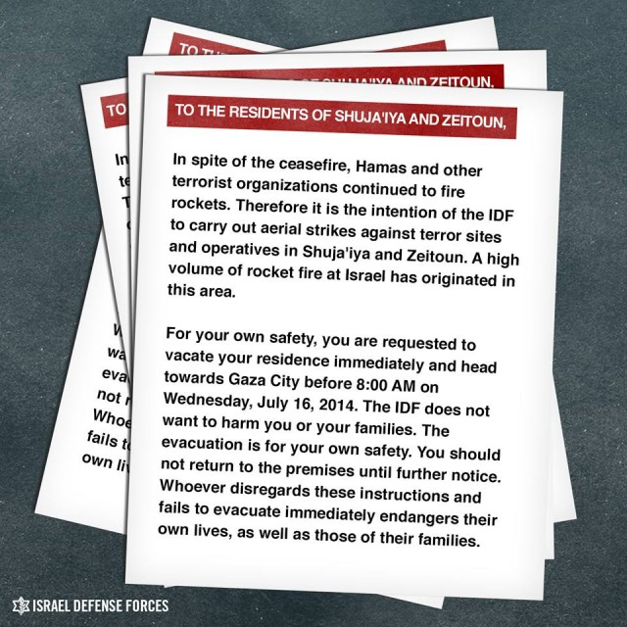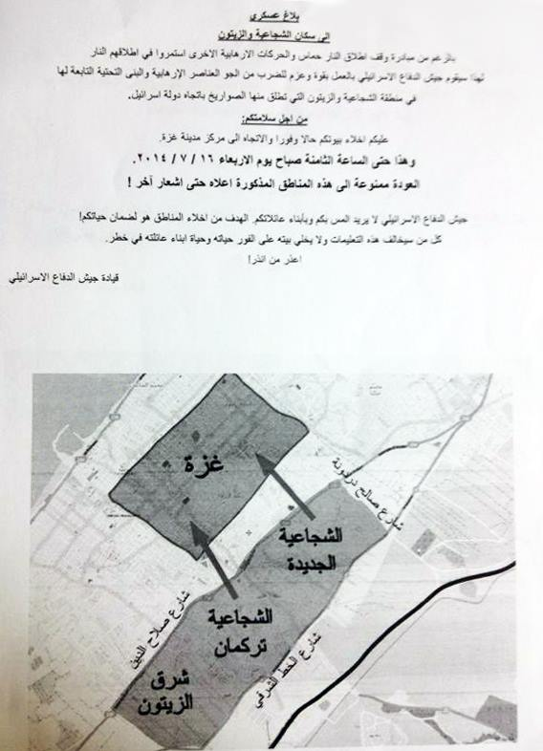
The IDF sent a voicemail with the same message to civilians in Gaza. Below you can listen to the original recording in Arabic.
00:00
00:00

[MISSING AUDIO FILE]

Roof-Knocking
“Roof knocking” is when the IAF targets a building with a loud but non-lethal bomb that warns civilians that they are in the vicinity of a weapons cache or other target. This method is used to allow all residents to leave the area before the IDF targets the site with live ammunition.
The following video demonstrates how Hamas exploits the IDF’s efforts to avoid civilian casualties. On July 9, Palestinians fled a Hamas target after the IAF fired a warning shot. Moments later, people in the surrounding area flocked to the roof of the target, acting as human shields. The IAF called off the strike to avoid civilian casualties.
[EMBEDDED VIDEO: https://youtu.be/VTArVIHDelg]
In contrast, Hamas places civilians in the line of fire. Just days ago, Hamas spokesperson Sami Abu Zuri encouraged Palestinian civilians to serve as human shields.
[EMBEDDED VIDEO: https://youtu.be/UXZEzbT0H1s]

Abandoning Air Strikes
The IDF has aborted aerial strikes seconds before they were to be carried out, due to civilians being present at the site of the target. The following video shows how IAF airstrikes were called off when civilians were identified in the area.
[EMBEDDED VIDEO: https://youtu.be/yE7ykidY7FA]
Despite the IDF’s efforts to avoid civilian casualties, Hamas continues to operate from within civilian areas, encouraging Gazans to avoid IDF warnings in a deliberate attempt to create civilian casualties.
