IDF Expands Operation Against Hamas Terrorists
IDF Blog
June 17, 2014
https://web.archive.org/web/20140806024623/http://www.idfblog.com/blog/2014/06/17/idf-expands-operation-hamas-terrorists/

In response to last week’s kidnappings and constant terrorism in Judea and Samaria, the IDF intensified its efforts to weaken Hamas.
IDF soldiers conducted a special operation Monday night in the city of Nablus, arresting dozens of terrorist suspects and uncovering hundreds of weapons in the area. The mission emphasized a key objective of the IDF operation: to weaken Hamas’ terrorist infrastructure inside Judea and Samaria.
The operation involved hundreds of forces from the Nahal Brigade, who uncovered guns, explosive devices, grenades and ammunition throughout the city. Soldiers arrested 41 terrorist suspects, bringing to 191 the number detained since the operation began. The IDF is determined to reduce constant acts of terrorism in the region, many of which involve Hamas.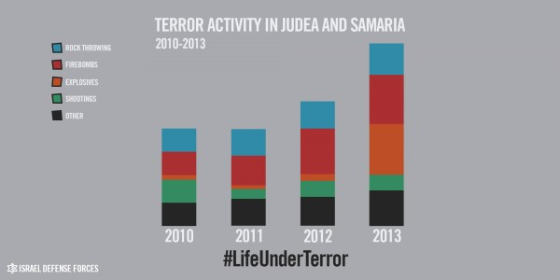
Even as Israeli security measures prevent Hamas violence, the organization’s members plan attacks as part of terror cells. For example, a Hamas-run cell from the region carried out the bombing of a Tel Aviv bus in November 2012 [EDITOR’S NOTE: LINK GOES TO A DECEMBER 19, 2012 IDF BLOG ARTICLE ENTITLED “ISA: Terror Cell Responsible for Tel-Aviv Bus Bombing Arrested”], wounding 26 innocent civilians in the attack. Each year, the Israel Security Agency (ISA or Shin Ben Security Service) exposes several of these cells and arrests their members.
On a regular basis, terrorists attempt to break through security fences and attack Israeli civilians in Judea and Samaria. In October 2013, a terrorist infiltrated an Israeli community and attacked a 9-year-old girl who ultimately survived her injuries. Two years earlier, Palestinian terrorists broke into a home in Ariel and brutally stabbed five members of the Fogel family [EDITOR’S NOTE: LINK GOES TO A MARCH 11, 2014 IDF BLOG ARTICLE ENTITLED “Today We Remember: The Fogel Family Massacre”] as they lay sleeping.
IDF soldiers are often the targets of attacks in the region. In September of last year, a Palestinian terrorist kidnapped Sgt. Tomer Hazan [EDITOR’S NOTE: LINK GOES TO A SEPTEMBER 21, 2013 IDF BLOG ARTICLE ENTITLED “Joint IDF and ISA Operation Exposes Murder of an IDF Soldier”] and murdered him in Judea and Samaria. Last November, a terrorist from the area stabbed Pvt. Eden Atias [EDITOR’S NOTE, LINK GOES TO A NOVEMBER 13, 2013 IDF BLOG ARTICLE ENTITLED “Terrorist Stabs IDF Soldier to Death on Israeli Bus”], a 19-year-old IDF soldier, while he slept on a bus.

Weapons in the hands of terrorists
Each month, IDF forces in the region report discoveries of weapons caches like the ones found Monday night. The soldiers perform frequent searches of Palestinian homes, where they uncover weapons [EDITOR’S NOTE: LINK GOES TO A MAY 7, 2014 IDF BLOG ARTICLE ENTITLED “IDF Soldiers Uncover Weapons in Terrorist’s Possession”] inside of walls and in other hiding places. Just a few weeks ago, Israeli security forces caught a Palestinian [EDITOR’S NOTE: LINK GOES TO A MAY 30, 2014 IDF BLOG ARTICLE ENTITLED “Suicide Bombing Thwarted by IDF This Morning”] man with 12 pipe bombs strapped to his body as he approached troops at Tapuah Junction.

[EMBEDDED VIDEO: http://humanrightsvoices.org/site/documents/?d=22012]

Firebombs
Terror attacks are especially common inside of Judea and Samaria. Every month, Palestinians hurl dozens of firebombs [EDITOR’S NOTE: LINK GOES TO A JULY 21, 2013 IDF BLOG ARTICLE ENTITLED “Suspected Firebomb Attacker Arrested”] at civilians and passing cars. The attacks instil fear in the region’s residents and risk lives on a daily basis. Just last month, forces reported nearly 100 firebomb incidents throughout the region.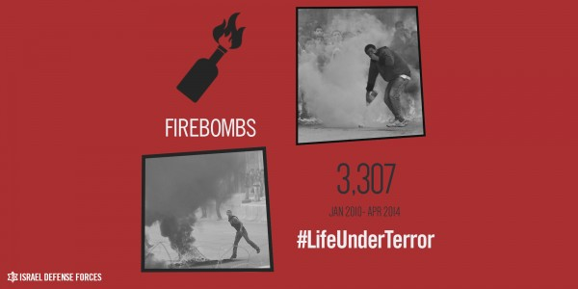

Rocks can kill
Other violence comes in the form of rock throwing, a terror act that threatens to injure and kill civilians. From 2010 to April of this year, the IDF recorded more than 19,000 incidents of rock throwing in Judea and Samaria. Thirty percent of these attacks were directed at civilian vehicles, and the incidents injured 116 people in total. Rocks may appear harmless, but they threaten lives. [EDITOR’S NOTE: LINK GOES TO AN APRIL 4, 2013 IDF BLOG ARTICLE ENTITLED “When Rocks Kill”]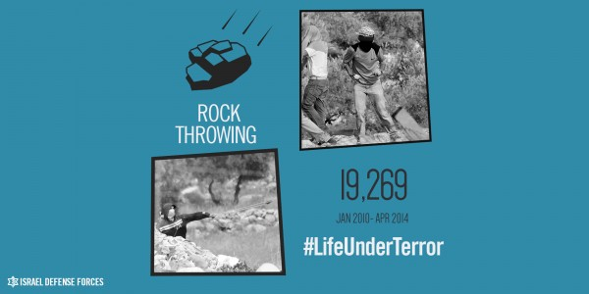

Explosives
Terrorists use sophisticated explosives to harm as many innocent people as possible. Explosive devices were especially common during the Second Intifada, when they killed hundreds of Israelis in attacks on buses and in other public places. Earlier this year, four IDF soldiers were injured when an explosive device detonated under their patrol jeep.
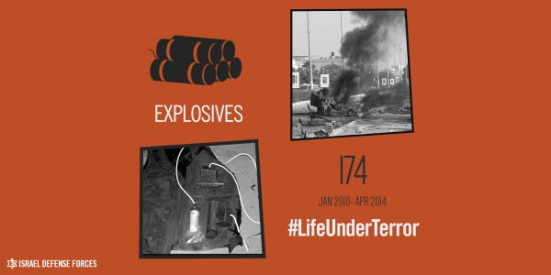

Shootings
Though not as common as other kinds of terror, shootings repeatedly occur in Judea and Samaria. In September 2013 Palestinian sniper fire killed Sgt. Gabriel Koby, [EDITOR’S NOTE: LINK GOES TO A SEPTEMBER 23, 2013 IDF BLOG ARTICLE ENTITLED “IDF Spokesperson: Forces Conduct Extensive Search in Hebron After Shooting of Soldier”] age 20, as he performed routine guard duty in the city of Hebron. [EDITOR’S NOTE: LINK GOES TO A MARCH 4, 2014 IDF BLOG ARTICLE ENTITLED “Three Years in Hebron: A First-Person Account From The Field”]
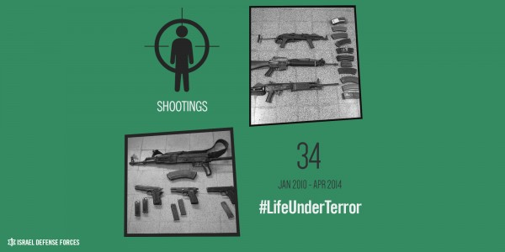
Israeli forces must contend with continuous violence emanating from the Judea and Samaria region. As Hamas calls for Israel’s annihilation, the safety of Israeli citizens is under constant threat. Operation Brother’s Keeper is meant to prevent further Hamas terror, including attacks like the abduction of the three teens Eyal Yifrach, Gilad Shaar and Naftali Frenkel.
