IDF Targets Senior Hamas Terrorists in Gaza
IDF Blog
August 21, 2014
http://web.archive.org/web/20151117074612/https://www.idfblog.com/blog/2014/08/21/idf-targets-senior-hamas-terrorists-gaza/

Mohammed Abu Shamlah and Raed Attar were responsible for dozens of terror attacks against Israelis.
In a combined overnight mission, IDF and Israeli security forces targeted senior Hamas terrorists in the Gazan city of Rafah. The operation killed Mohammed Abu Shamlah, Raed Attar and Muhamad Barhoum, three commanders in Hamas’ military wing.
Raed Attar, who oversaw Hamas forces in Rafah, planned major infiltrations and other attacks that killed Israeli civilians. He was directly involved in the 2006 kidnapping of SFC Gilad Shalit, [EDITOR’S NOTE: LINK GOES TO AN OCTOBER 18, 2012 IDF BLOG ARTICLE ENTITLED “Reliving History: The Day Gilad Shalit Returned Home”] as well as efforts to hold him captive in Gaza.
In addition to planning attacks, Attar oversaw the construction of tunnels used to attack Israel through the Sinai Peninsula. As a senior Hamas operative, his major responsibility was to smuggle weapons into Gaza and oversee efforts to train and arm terrorists.
Mohammed Abu Shamlah directed Hamas’ forces in Southern Gaza. During Operation Protective Edge, 13 terrorists under his command infiltrated Israel through a tunnel near the community of Sufa. He planned dozens of terror attacks that killed Israeli civilians and soldiers.
In 1994, Shamlah was involved in the murder of an IDF officer in Rafah. About a decade later, he took part in a vicious attack against an IDF soldiers. During the attack, terrorists detonated explosives near an IDF military position, killing 6 soldiers and injuring 10 others. He was directly involved in the 2006 terror attack that led to Gilad Shalit’s kidnapping and killed two soldiers.
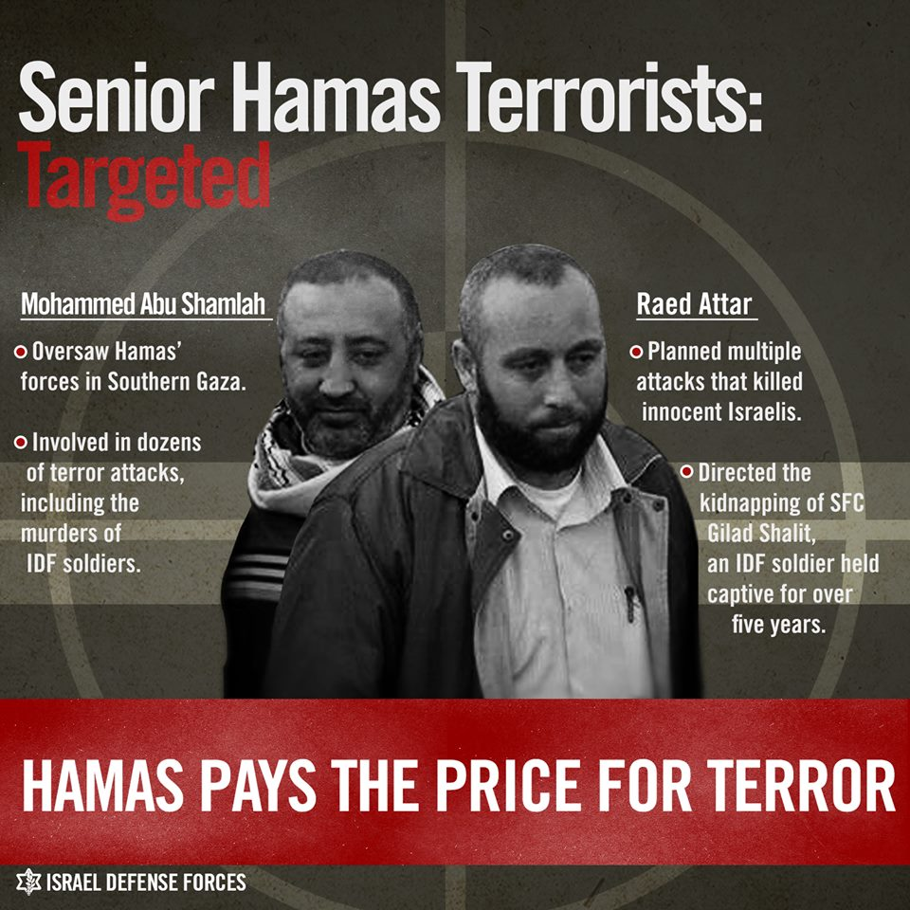
Muhamad Barhoun, whose death the IDF confirmed earlier today, was a senior Hamas operative in the Rafah area who smuggled weapons to terrorists. For several years, he lived in Libya and Syria, where he raised funds for the terrorist group and transferred them to Gaza.
“Hamas terrorists orchestrating attacks against Israel, launching rockets indiscriminately at our civilians and abducting our soldiers will not evade our intelligence and striking capabilities,” said IDF Spokesman Lt. Col. Peter Lerner. “This morning’s strike sends a clear message to those responsible for planning attacks: We will strike those who have terrorized our communities, towns and cities, and we will pursue the perpetrators of abduction of our soldiers and teenagers. We will succeed in restoring security to the State of Israel.”

