IDF Thwarts Hamas Infiltration and Terror Attack
IDF Blog
July 17, 2014
http://web.archive.org/web/20151117074603/https://www.idfblog.com/blog/2014/07/17/breaking-idf-thwarts-infiltration-attempt-hamas-terrorists/

Earlier Thursday morning (July 17), IDF forces thwarted an attack by Hamas terrorists attempting to infiltrate Israel through a terror tunnel.
This morning, IDF forces identified approximately 13 terrorists attempting to infiltrate Israel through a terror tunnel constructed by Hamas. The tunnel led underground from the southern Gaza Strip towards the southern Israeli community of Sufa. ​IDF forces thwarted an impending terror attack, preventing the terrorists from attacking an Israeli kibbutz. The foiled attack could have had deadly and devastating consequences if carried out. No injuries were reported to IDF soldiers.
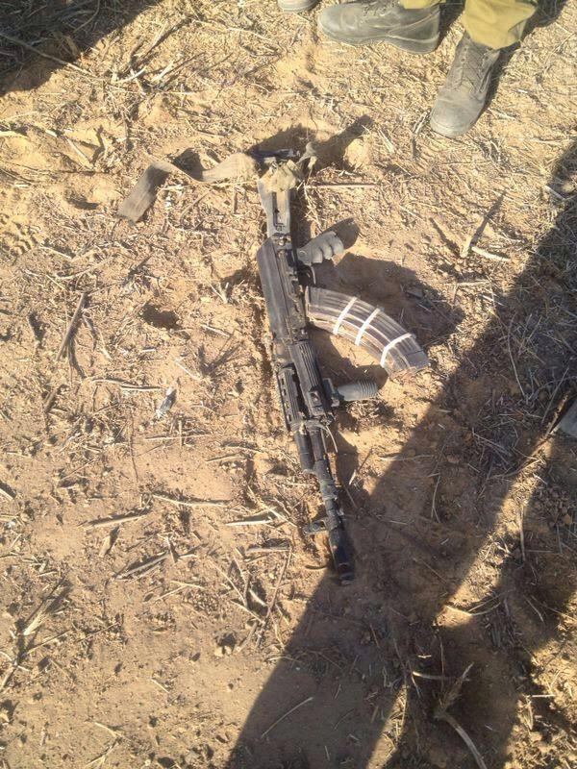
Weapons from the thwarted Hammas tunnel attack
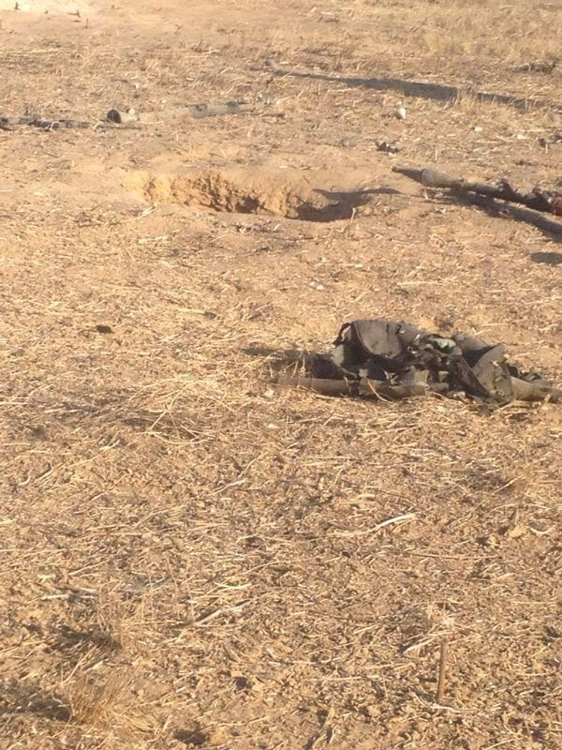
Weapons from the thwarted Hammas tunnel attack
Weapons from the thwarted Hammas tunnel attack
Weapons from the thwarted Hammas tunnel attack
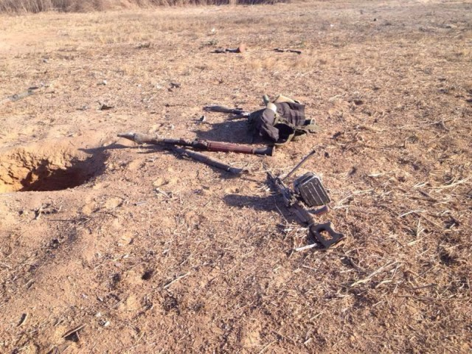
Weapons from the thwarted Hammas tunnel attack
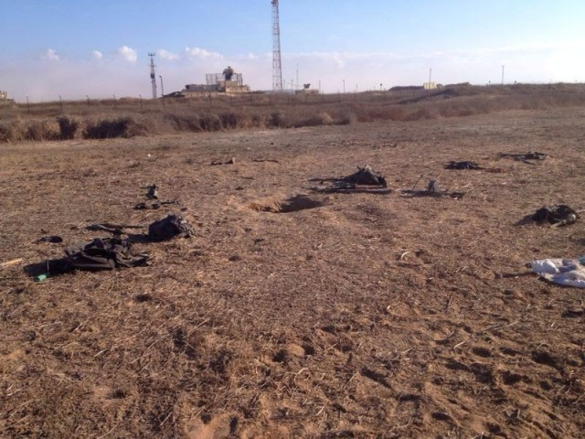
Weapons from the thwarted Hammas tunnel attack
Weapons from the thwarted Hammas tunnel attack
Terror tunnels are just one example of Hamas’ constant attempts to violate Israel’s sovereignty and security, by carrying out lethal attacks against Israeli civilians. As the IDF demonstrated in recent days, Hamas will not be able to launch strikes against Israel without consequences.
The IDF will continue to combat Hamas’ efforts to terrorize Israeli civilians.

