IDF report: Hamas illegally used civilian infrastructure during Operation Protective Edge
Israel Ministry of Foreign Affairs
August 21, 2014
https://mfa.gov.il/MFA/ForeignPolicy/Terrorism/Pages/IDF-report-Hamas-illegally-used-civilian-infrastructure-during-Operation-Protective-Edge.aspx

A new report released by the IDF utilizes intelligence maps, photographic and video evidence to mount a serious case against Hamas’ illegal use of public infrastructure during Operation Protective Edge.
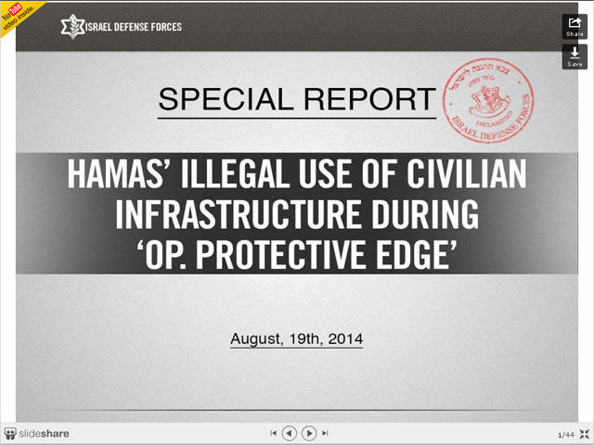IDF report: Hamas Illegally used public infrastructure during Operation Protective Edge
Copyright: IDF Spokesperson
The report shows Hamas’ use of UN facilities, schools, graveyards, mosques and power plants, among other civilian areas. According to the report, Hamas has launched over 1,600 rockets from civilian sites.
The report concludes: Hamas' tactics flagrantly violate international law and the most basic of moral precepts. Given these tactics, the ultimate resopnsiblity for the damage done to civilians as well as the civilian infrastructure of Gaza lies with Hamas.

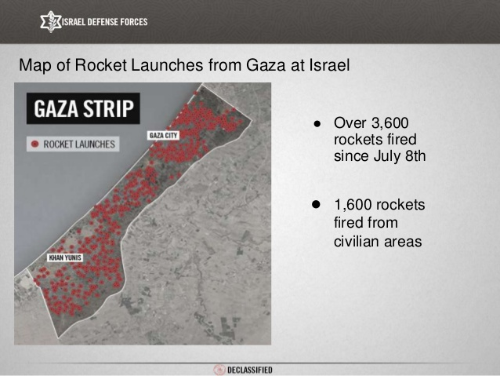
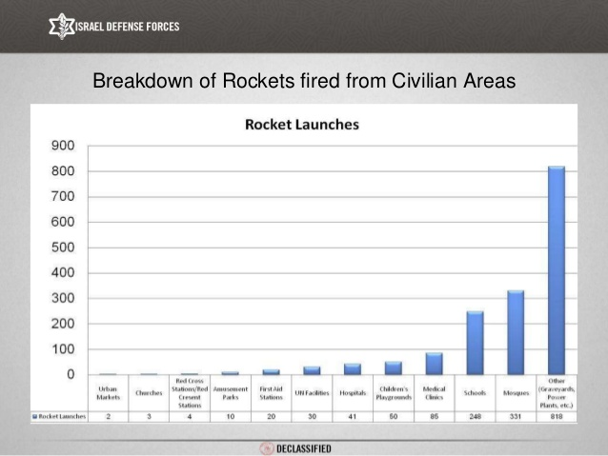
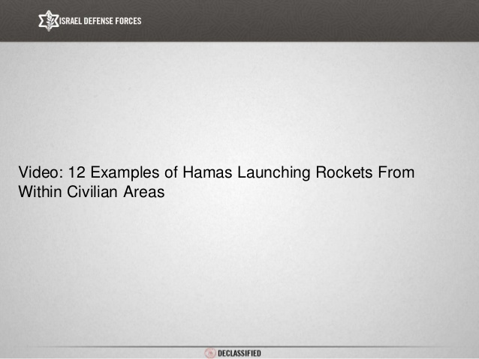
[YOUTUBE VIDEO: https://www.youtube.com/watch?v=IUrDAEgisXM]
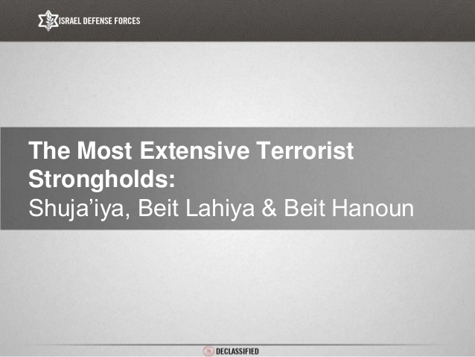
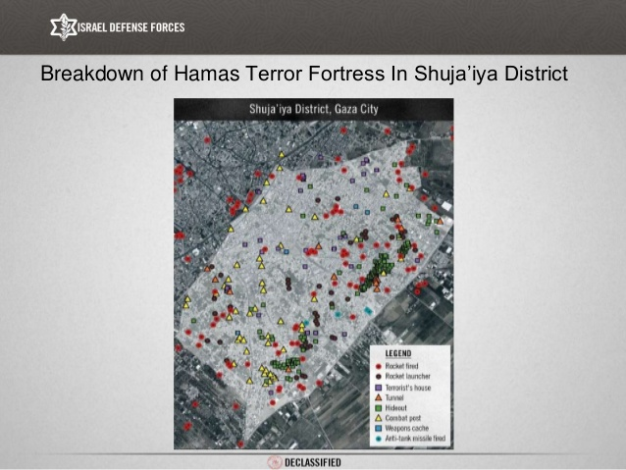
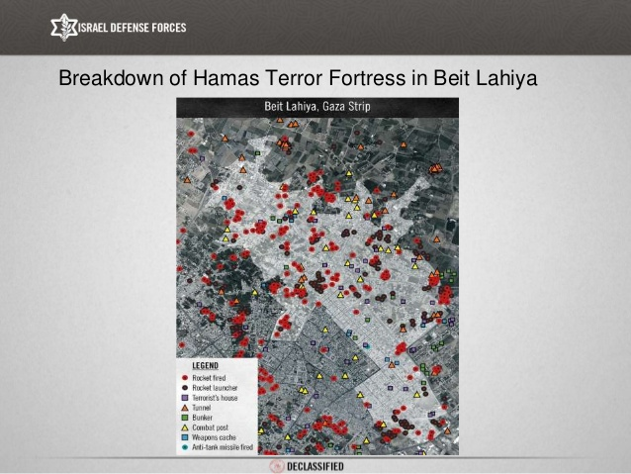
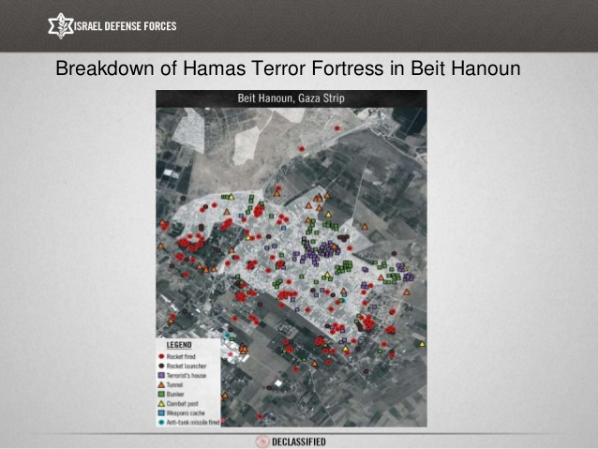
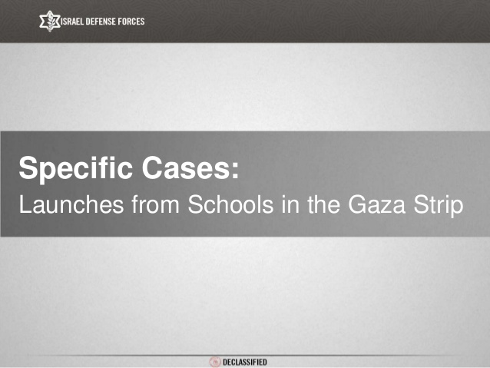
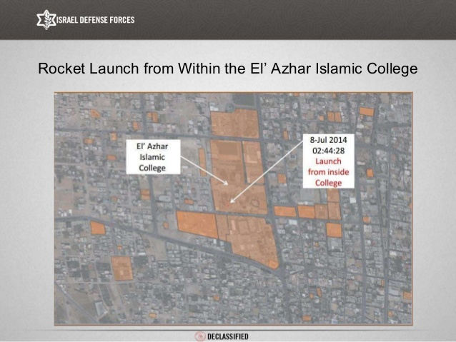
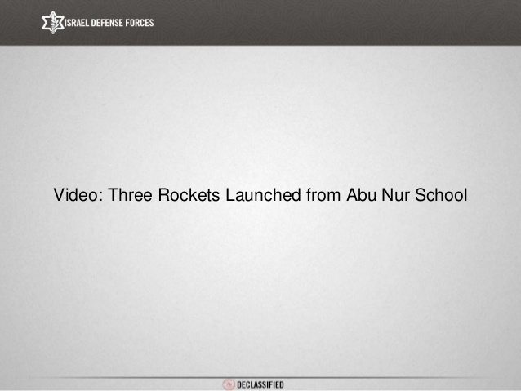
[YOUTUBE VIDEO: https://www.youtube.com/watch?v=J-fh-fRs7To]
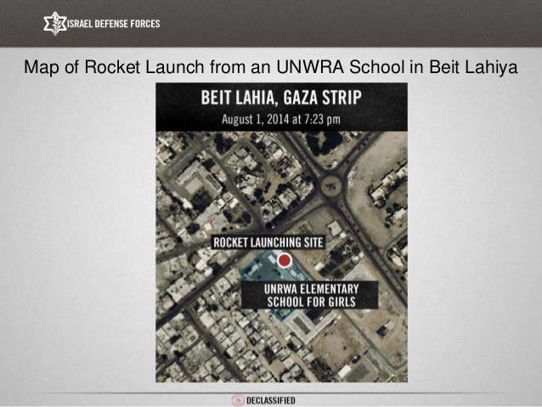
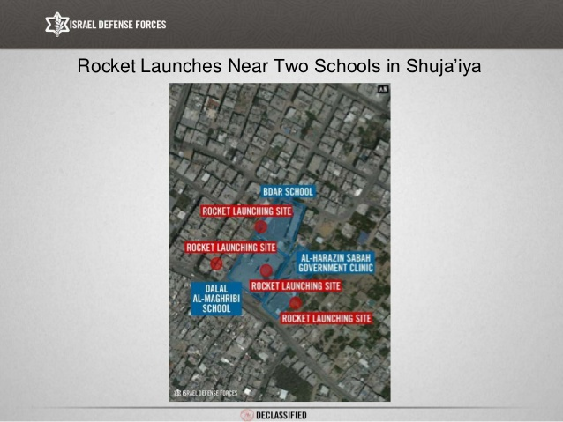
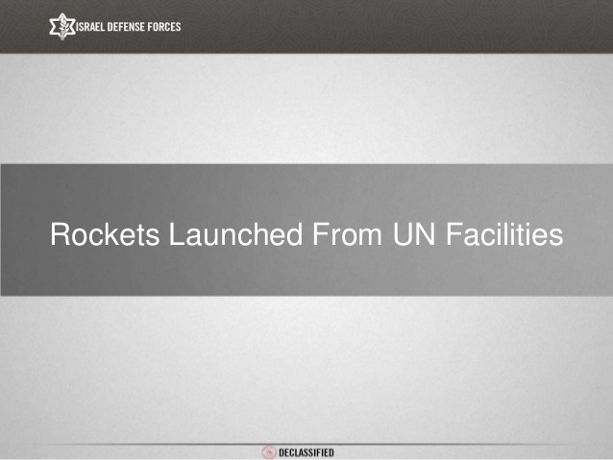
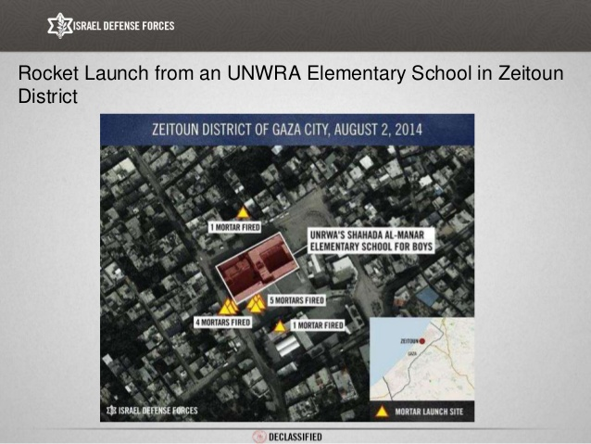
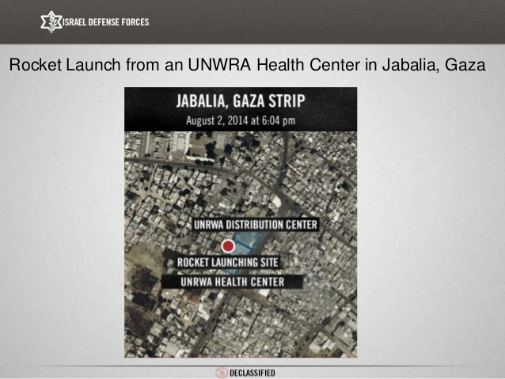
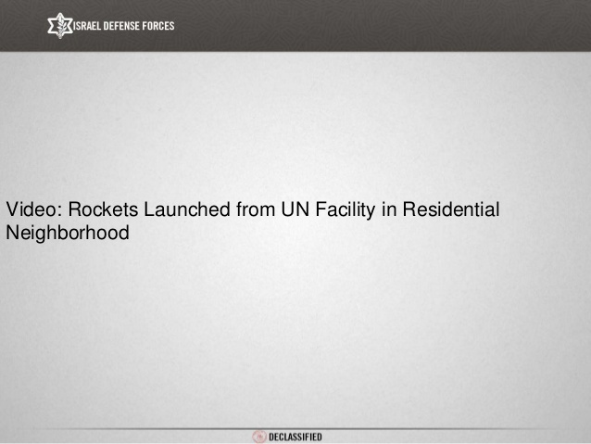
[YOUTUBE VIDEO: https://www.youtube.com/watch?v=uE3feo_b8Cg]
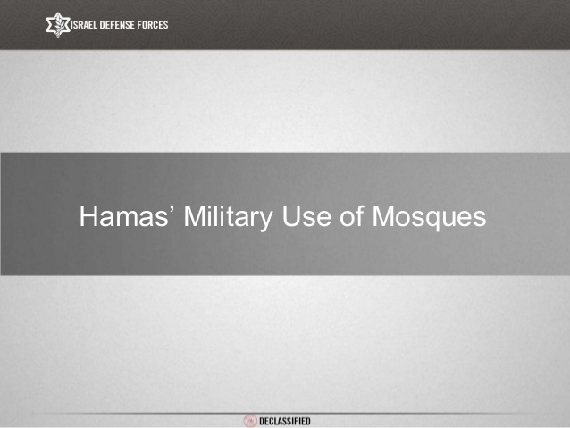
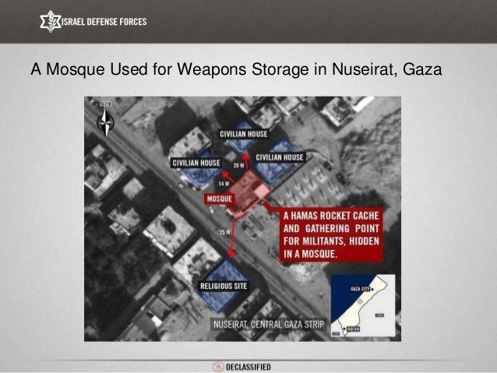
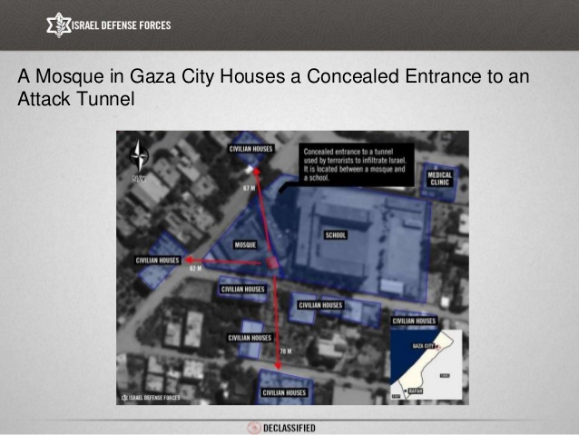
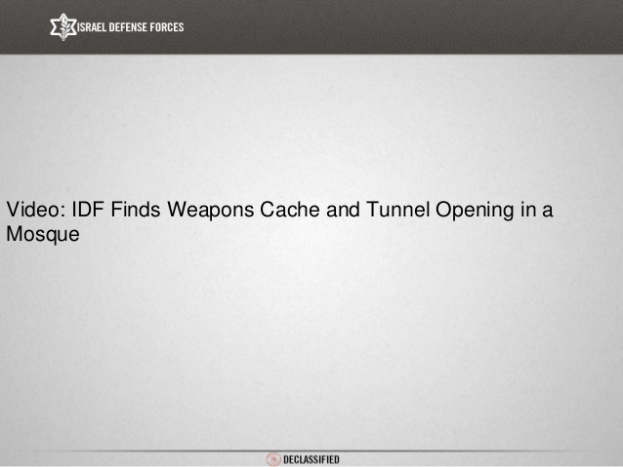
[YOUTUBE VIDEO: https://www.youtube.com/watch?v=aWkjwfkh-qM]
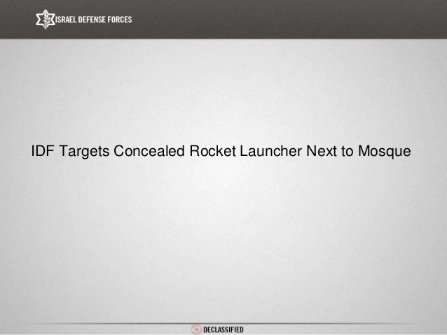
[YOUTUBE VIDEO: https://www.youtube.com/watch?v=gdA34YKNWj0]
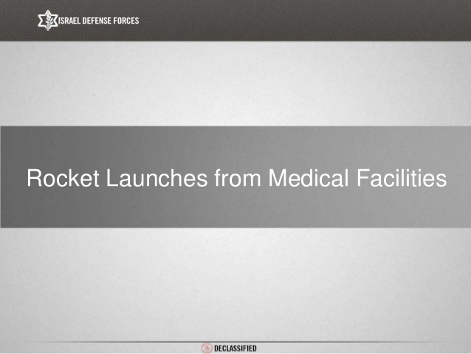
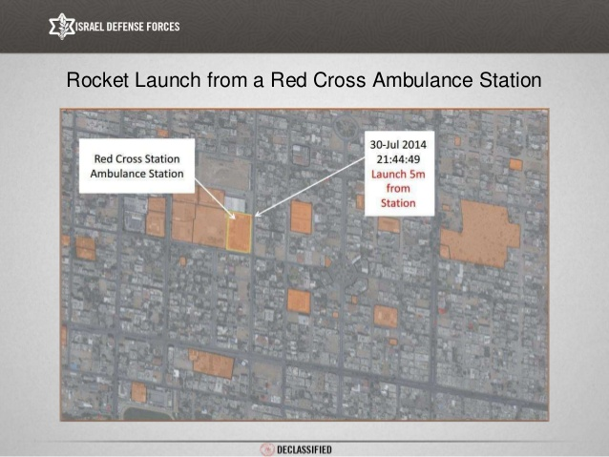
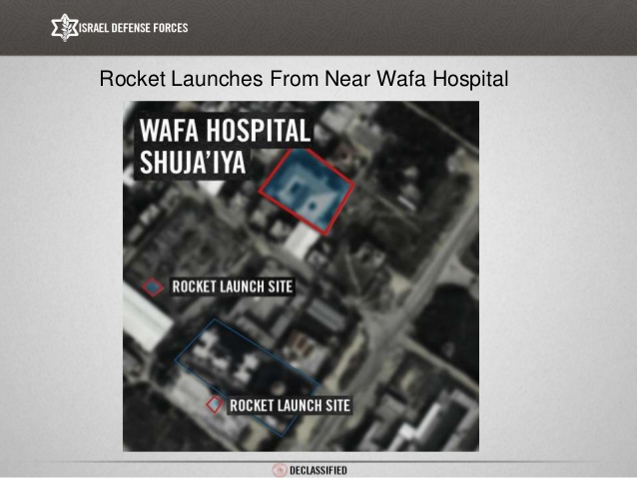
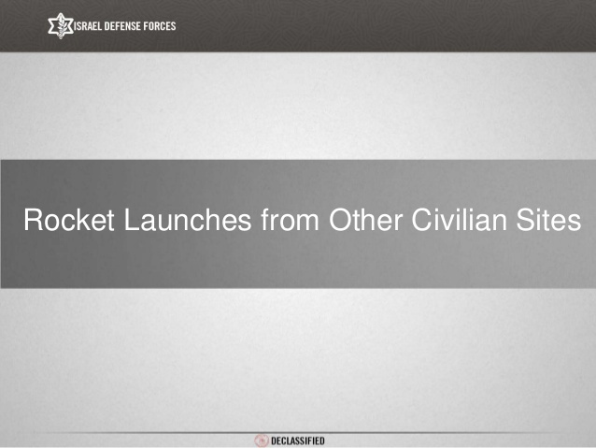
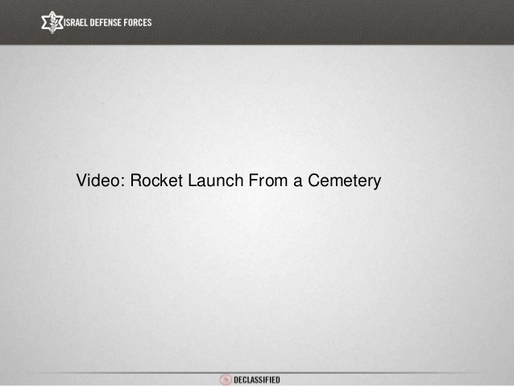
[YOUTUBE VIDEO: https://www.youtube.com/watch?v=J8hmU2GUxUs]
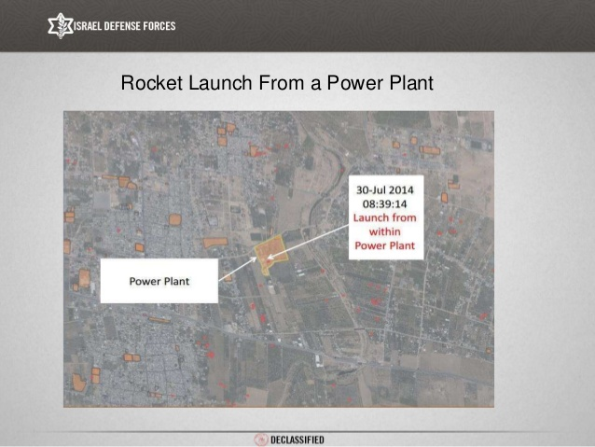
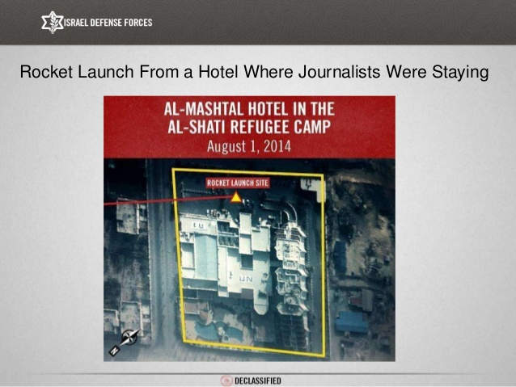
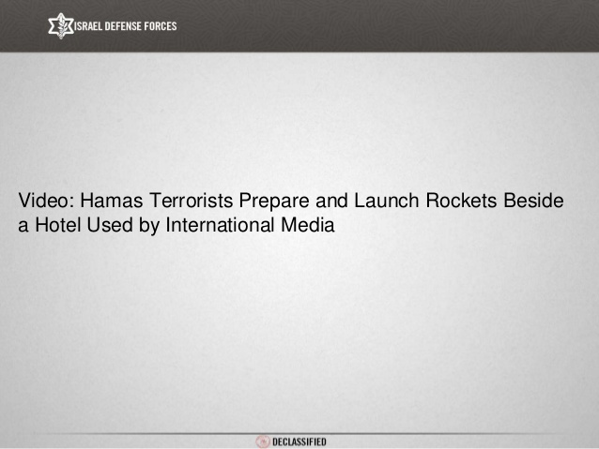
[YOUTUBE VIDEO: https://www.youtube.com/watch?v=A_fP6mlNSK8]
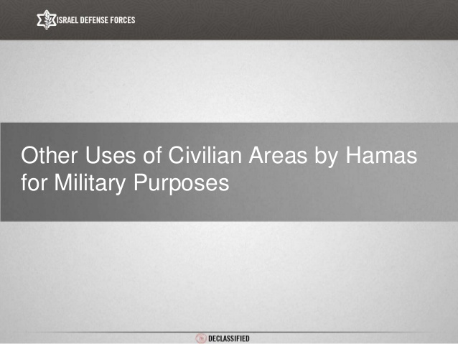
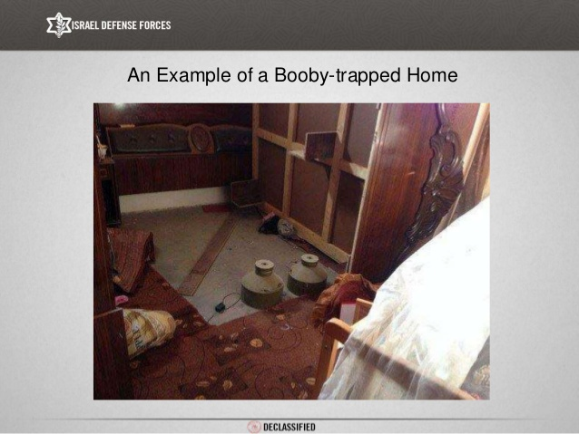
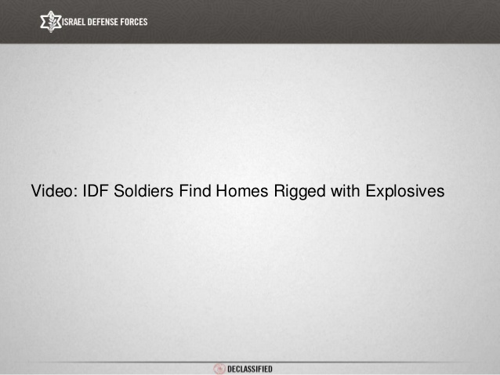
[YOUTUBE VIDEO: https://www.youtube.com/watch?v=0fze6qHvzgQ]
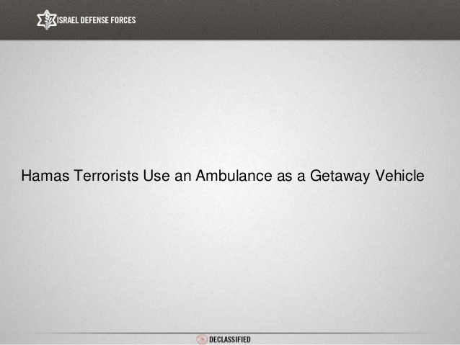
[YOUTUBE VIDEO: https://www.youtube.com/watch?v=7O114V9PdmM]
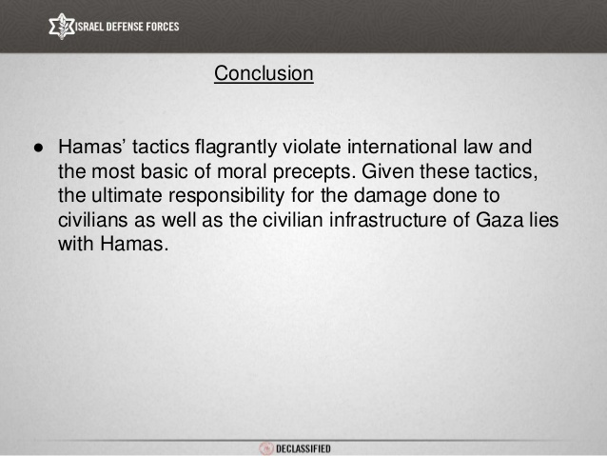
​
New Declassified Report Exposes Hamas Human Shield Policy from IsraelDefenseForces

