“If I’m not back in 5 minutes, I’m dead”: Testimony of Lt. Eitan
IDF Blog
August 15, 2014
http://web.archive.org/web/20140817052317/http://www.idfblog.com/blog/2014/08/15/im-back-5-minutes-im-dead-testimony-lt-eitan/

During Operation Protective Edge, IDF soldiers were faced with deadly risks in the Gaza Strip. Sixty four soldiers were killed and many more were wounded in combat. This is the story of one IDF commander who put his life in danger to rescue a soldier kidnapped by Hamas.
Lt. Eitan, 23, joined the elite unit of the Givati Brigade in March 2010. During the IDF’s prestigious commanders course, he first met Lt. Hadar Goldin, who would later fight by his side in Operation Protective Edge.
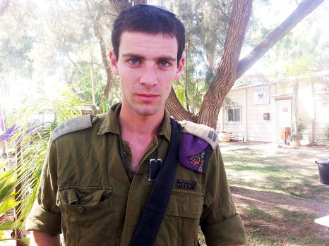
Lt. Eitan
At around 8:00 AM on Friday August 1, it was announced that Israel and Hamas had reached a temporary ceasefire. Taking advantage of the relative calm of the ceasefire, Lt. Eitan and his fellow soldiers, who had not slept for 24 hours, took turns sleeping while others guarded and inspected houses thought to have been used for terror activity.
During one of those inspections, the soldiers’ commander, Maj. Sarel, noticed that a terrorist was watching from the roof of another house. Accompanied by First Sgt. Lial Gidoni and Lt. Hadar Goldin, he approached the terrorist to assess the danger.
Suddenly, terrorists opened fire at the soldiers and the sound of an explosion resonated throughout the area. There was confusion among other forces in the vicinity who did not understand what was happening. Hamas terrorists had violated the ceasefire.

Suddenly someone shouted: “Goldin’s Gone, Goldin’s Disappeared”
We are conducting extensive searches in S. Gaza in order to find a missing IDF soldier. We suspect the soldier was kidnapped by Hamas today
— IDF (@IDFSpokesperson) August 1, 2014

Lt. Eitan and his soldiers, who were not far away, immediately went to assist. “When I arrived, I saw two of our soldiers being taken into a house,” Lt. Eitan said. “It was the same moment that we were told that we had found a tunnel opening at the location. Fearing a possible explosion, I ordered everyone to get away.”
“No one really knew what had happened but suddenly someone shouted: ‘Goldin’s gone, Goldin’s disappeared!’ We quickly started counting soldiers and everyone was present except one: Goldin was missing.”
At that moment, Lt. Eitan realized that terrorists had kidnapped Lt. Goldin by dragging him into a tunnel. He regrouped his unit and told them that two officers had been killed and that another soldier had likely been kidnapped. A deafening silence filled the room. “I have never experienced anything so difficult,” Lt. Eitan said.
We suspect that a group of Hamas terrorists, including a suicide attacker, kidnapped 2nd. Lt. Goldin at 9:30AM & dragged him into a tunnel.
— IDF (@IDFSpokesperson) אוגוסט 1, 2014

“When I realized a soldier had been kidnapped, I went to find him”
“The brigade commander, Col. Ofer Vinter, contacted me on the radio, and I told him that I was going into the tunnel to look for Goldin,” Lt. Eitan recalls. “I went four meters down into the tunnel when it began to collapse. I could hardly see anything; sand and stones were obscuring the light. I returned to the surface, took my equipment, my helmet and gun, and went back into the tunnel with my soldiers.”

“If I’m not back in 5 minutes, I’m dead”
Lt. Eitan lead a group of soldiers into the tunnel, warning them that it could be booby trapped and that if danger arose, they needed to open fire immediately.
“There, I saw Hadar’s blood and his equipment.” To his right, Eitan found bags blocking the passage and a gun. He stepped forward, opened one of the bags and found explosives inside. He immediately sent an expert to defuse them.
Lt. Eitan wanted to reach the end of the tunnel to find Lt. Goldin, but he knew that terrorists could kill him or take him hostage. “I turned around and said to my commander ‘Count how long I’m here. I will run as fast as possible to reach the tunnel’s entrance. During this time, call the other soldiers into the tunnel. If I’m not back in 5 minutes – I’m dead’.” Lt. Eitan started running as he fired. Inside the tunnel, he saw more explosives, weapons, and entrances to other tunnels.
After 10 minutes, Eitan decided to turn back, realizing that the danger was too great. Once he reached the opening of the tunnel, his officers gave him the order to search the Rafah area for Lt. Goldin. During Operation Protective Edge, the area was extensively used by Hamas for terror activity. One incident occurred on the night of July 18, when Hamas sent a donkey rigged with explosives towards IDF forces. Additionally, on the morning of August 3, Special Forces from the Givati ​​Brigade discovered more than 150 mortar shells and a tunnel in the city.
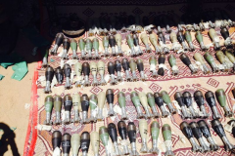

Dozens of soldiers moved toward the main road between the agricultural district and the most populated area of Rafah. Terrorists shot at the soldiers, who returned fire and continued to search the area, but they found no sign of Lt. Goldin.
A day later, on August 2, a special IDF committee concluded that Lt. Goldin was killed in combat. He fought honorably to protect Israelis against the terrorists who ended up taking his life. The brave actions of Lt. Eitan, who risked his life to save Lt. Goldin, embody the IDF’s core value that every human life is worth saving. [EDITOR’S NOTE: LINK GOES TO AN AUGUST 19, 2013 IDF BLOG ARTICLE ENTITLED “IDF Supreme Values: Human Life and Dignity”] His heroism is an example to every IDF soldier.

